The QCAN2 Serial Comm Simulator

The serial comm simulator was developed to automate testing, and expand the range of parameters that can be modified. All text boxes are ‘live’ controls, the typed values take effect immediately.

The Auto Advance system: the states of the QCAN2’s communication are advanced automatically. When the states are at the end state, the auto advance wraps around. The states are stepped forward at the ‘Auto Step Timer’ interval, which assumes a random value at startup.

Description of controls (see screenshot below):

Auto Advance ON | Alt-A | Enables Auto Advance
Auto Step Timer (sec) |  | Specifies the interval between auto step stages
Start | Alt-S | Starts the Communication
Stop | Alt-T | Stops communcation
Mode |  | Mode of operation
Subsys |  | The QCAN2 sub systems
Vehicle |  | Hex number of the current vehicle
Zone | Alt-Z | Hex number of the current zone
Serial Port | Alt-P | Select serial port

Below, is a picture of the updated serial port utility. This way multiple zones are tested, and the testing can be automated with the ‘Auto Advance’ function. The utility provided is fully compatible with the serial input / output of the QcanComm provided by Savant. We tested the QCAN2s with both programs. We enclosed the utility executable for your convenience. (Jump Drive in package) The picture below shows a Request Zone with intersection occupied.

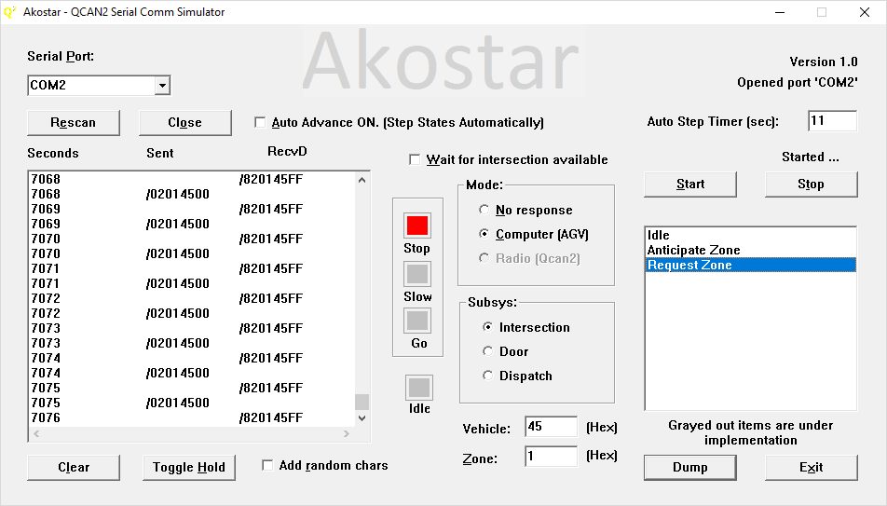

Rescan | Alt-E | Re-scans serial ports
Close | Alt-O | Closes (free-s) current serial port
Wait | Alt-W | Wait for intersection availability on auto step
Dump |  | Save comm details (Not implemented)
Clear | Alt-L | Clear Comm listbox
Toggle Hold | Alt-H | Toggle hold on listbox, hold lets one examine contents
Add random chars | Alt-R | Taint communication with random characters at random places
Exit | Alt-X | Close program

The standard windows keys will operate as expected (like: Alt-F4 to close program)

Simplified operating procedure:

- Select COM port
- Click on desired mode (Computer)
- Click on subsystem (Intersection)
- Click on Start

