

QCAN2

User Manual

Revisions:
Version 1.0 – 3/13/2019

All ideas, concepts, designs, and arrangements communicated within this document are preliminary, and they are subject to change. Information contained within may be propitiatory, only to be shared or used upon the approval of respective owners / holders.

Copyright © 2018-2019-2020 AkoStar Inc.

Revision History
Revision | Date | By | Description | Notes
1.0 | Mar/13/2019 | Peter Glen | Initial Write-up
2.0 | Jan/14/2020 | Peter Glen | Prepare for delivery

Introduction
This is a collection of notes produced during implementation. Comments are welcome.

QCAN2 is the successor of QCAN, implemented with modern processors, and powerful, updated RF technology, while maintaining serial port and command compatibility.

Much like its predecessor - this device implements several modes of operation. It will act as a.) intersection controller, b.) door controller, c.) intersection and/or door controller combo, d.) dispatch processor, and e.) command repeater or communications repeater.

In QCAN2 we managed to resolve most of the challenges of its predecessors. For instance with modern processors we've got more memory, we can have near unlimited contenders at an intersection. We set this limit to 255, which is a reasonable compromise to allow us to allocate static buffers.

We have also been able to remove RF limitations, using a peer to peer RF broadcast subsystem. This gave us a unique flexibility, to keep communication on a single channel, and to empower every unit to act as a natural forwarder. The RF broadcast also enabled us to maintain device state tables across devices, which is instrumental in determining vehicle priority.

With this new RF / CPU technology, we can use hardware features to create a queue of priorities on a first come first serve basis. This priority resolution is failure free, as it is coordinated by the device's operating system (semaphore) functionality.

We also added a powerful simulation software, that sends commands to the QCAN2 serial port. The simulation then observes the QCAN2 responses. The responses are then interpreted, and an on-screen AGV simulates the actions of the physical vehicle. The simulation accurately models the requirements of the AGV control. It has been an instrumental tool to create a protocol and set of state machine states that are immune to RF disturbances, and other anomalies.

In the following chapters we will briefly introduce each and every mode of operation.
Table of Contents
Revision History 2
Introduction 2
Current State of Implementation 4
QCAN2 State diagrams 5
Modernized user interface 6
Extensive logging 7
Command Interpreter 7
The following commands are recognized: 7
Intersection controller 9
QCAN2 Intersection logic chart 10
Simulation 11
Door controller 12
Intersection controller and door controller combo 12
Dispatch 12
Repeater 12
Supplementary tools and troubleshooting 13
Intersection Controller Command Flow. 14
Door Controller Command Flow 15
Dispatch Command Flow. 16
Terminology: 16
AGV to QCAN2 and QCAN2 to AGV communications. 18
Forwarders: 18
Summary: 18
Full Revision History 20

Current State of Implementation
The intersection peer to peer-to-peer logic and the simulation harness is already implemented. The radio frequency infrastructure is in place, state tables and command information are reliably passed between QCAN2s.

QCAN2 State diagrams
This is a preliminary chart, only to serve as a basis of discussion.
RF
Table of
Broadcasts
States and
State
Transitions
Main State
Variables and Processes
Representing
Current State
AGV
Serial Port
Transactions
QCAN_STATUS_IDLE
QCAN_STATUS_LISTEN
QCAN_STATUS_EVAL
QCAN_STATUS_WAIT
QCAN_STATUS_BULLY
QCAN_STATUS_RELEASE

QCAN_STATUS_DOOR_OPEN
QCAN_STATUS_DOOR_WAIT
QCAN_STATUS_DOOR_OPENED
QCAN_STATUS_DOOR_GO
(under implementation)
'WhatsUp'
Supervisory task
Detecting
'Duplicate Bully'
And more

Modernized user interface
The QCAN – wherever possible - will have a zero configuration option. For example, the AGV sends its identity on most commands. The QCAN can decipher that and store this as its host identity or zone.
For safety, the QCAN2 will refuse to take on a second identity. In situations where the QCAN is connected to a different AGV than its original host, recovery is simple. Executing a long reset (hold QCAN2 button for 12 seconds) on the QCAN2 will clear its memory, and it will be ready to adopt its new host.
This way, on most service calls, one can install a new QCAN without any tools or configuration.
The QCAN2 will have several configuration modes. a.) traditional mode; b.) via Command Terminal (like putty) ; c.) via WiFi and Browser, using a cell phone, tablet or computer;
Below is a screen shot of the template page the QCAN2 will display when connected to:

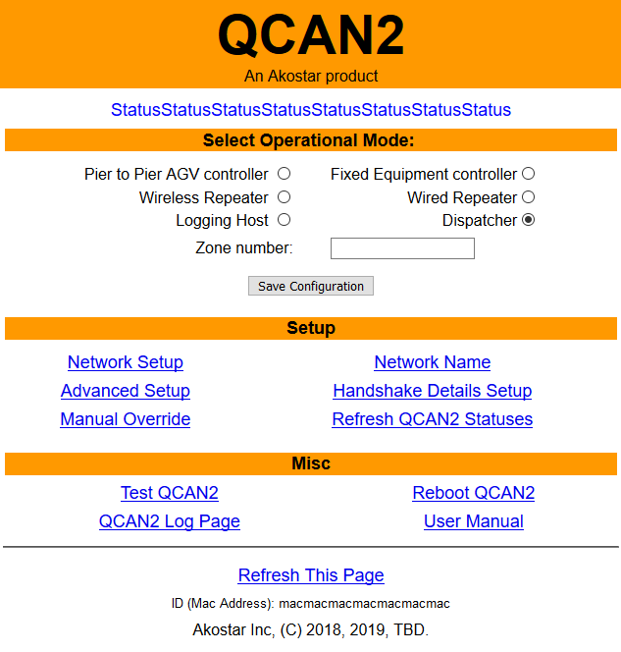

Extensive logging
In the spirit of traceability and troubleshooting, QCAN2 maintains extensive logs. Every state machine transition is logged. Anomalies in RF Transmission / Reception are logged. Duplicate bully resolution, dead RF entry are all in the logs. The log can be accessed from the terminal command line, and from the configuration page. Additionally, the QCAN has a log host mode, where it logs everything that could be relevant to troubleshooting.
There are several levels of logging implemented:
a.) Errors;
b.) Warnings;
c.) Notices;
Below is an example of logging sequence. The first field is the time stamp, the second field is the last digit of the MAC address, and the rest describes the state transition. Interspersed lines are from the supervisory process.
02:47.5 34 QCAN_STATUS_IDLE -> QCAN_STATUS_LISTEN zone=10 (0, 0)
Whatsup: Setting slow state: eval_lim 4
02:54.0 34 QCAN_STATUS_LISTEN -> QCAN_STATUS_EVAL zone=10 (0, 0)
02:55.6 34 QCAN_STATUS_EVAL -> QCAN_STATUS_WAIT zone=10 (0, 255)
Whatsup: Setting bully state: eval_lim 3
02:57.8 34 QCAN_STATUS_WAIT -> QCAN_STATUS_BULLY zone=10 (0, 0)
03:02.2 34 QCAN_STATUS_BULLY -> QCAN_STATUS_RELEASE zone=10 (0, 0)
03:04.0 34 QCAN_STATUS_RELEASE -> QCAN_STATUS_IDLE zone=0 (0, 0)
03:09.3 34 QCAN_STATUS_IDLE -> QCAN_STATUS_LISTEN zone=10 (0, 0)
Whatsup: Setting slow state: eval_lim 3
03:15.4 34 QCAN_STATUS_LISTEN -> QCAN_STATUS_EVAL zone=10 (0, 0)
03:17.2 34 QCAN_STATUS_EVAL -> QCAN_STATUS_WAIT zone=10 (0, 255)
Whatsup: Setting bully state: eval_lim 6
03:21.2 34 QCAN_STATUS_WAIT -> QCAN_STATUS_BULLY zone=10 (0, 0)
03:25.4 34 QCAN_STATUS_BULLY -> QCAN_STATUS_RELEASE zone=10 (0, 0)
03:27.0 34 QCAN_STATUS_RELEASE -> QCAN_STATUS_IDLE zone=0 (0, 0)
03:32.5 34 QCAN_STATUS_IDLE -> QCAN_STATUS_LISTEN zone=10 (0, 0)
Whatsup: Setting slow state: eval_lim 4
03:39.0 34 QCAN_STATUS_LISTEN -> QCAN_STATUS_EVAL zone=10 (0, 0)
03:40.6 34 QCAN_STATUS_EVAL -> QCAN_STATUS_WAIT zone=10 (0, 255)
Whatsup: Setting bully state: eval_lim 4
03:45.0 34 QCAN_STATUS_WAIT -> QCAN_STATUS_BULLY zone=10 (0, 0)

Command Interpreter
The QCAN debug port is equipped with a command interpreter. The commands can be used to simulate operations, simulate failure modes, configure QCAN2, set operational states and query status.

In this paragraph, commands are enclosed in quotes. On the command line, no qoutes are needed.

The following commands are recognized:
"stat"; "check"; "dump"; "set"; "get"; "stop"; "start"; "?"; "help"; "clear"; "echo"; "noop"; "mem"; "reboot"; "list"; "ant"; "req"; "rel"; "auto"; "id";
"zone"; "verbose"; "force";

The 'help [command]' command will deliver information about the specified command, for example 'help stat' will describe the stat command.

The following commands where used extensively, so it is described here in detail:

auto | The auto command will cycle the QCAN states on a randomized timer. With multiple QCAN-s running, this simulates intersection traffic.
stat | Display current status of QCAN state machine, MAC address, and auto status.
dump | Display current RF table, as seen by this particular QCAN
force | Force QCAN into BULLY state. This simulates the error condition on a non reactive QCAN. The test was done to follow the code path of recovery from a condition what we call a “Duplicate Bully” Use the “auto” command to resume normal operation.

An example command line:

QCAN>> auto

The interpreter is connected to a dumb terminal on our development board, (USB Serial Converter), so it has no editing key facilities. (No Back Space and Arrow Keys) In case of an erroneous entry, press the Enter key to start a fresh command line.

Intersection controller
Due to the dynamic nature of the intersections, QCAN2 will resolve AGV crossing priority via radio broadcast. In general, the resolution will proceed on a first-come first serve basis. QCAN2 and the AGV will go through several phases to coordinate intersection priority.

The first phase is called 'anticipate intersection'. In this phase the QCAN2 will listen, and determine if there is a contesting AGV at the same intersection. If there is, the QCAN2 instructs the AGV to slow it's speed by transmitting on its serial port the OCCUPIED status, setting BIT_7 and BIT_6.

The second phase is called 'request intersection'. At this point the QCAN will determine if the intersection is occupied. If intersection is occupied, the AGV will be instructed by the QCAN2 to stop, by transmitting on its serial port the OCCUPIED status BIT_7. If the intersection is NOT occupied, the QCAN2 will continue to respond on the serial port to the ALIVE command, so the AGV will proceed.

The third phase is called 'release intersection'. When the AGV reaches this phase, it instructs the QCAN to release this zone. The QCAN2 signals all other QCAN2s that the AGV cleared the intersection. Then, the other QCAN2s enter into an evaluation phase, and the AGV that has been waiting the longest, proceeds.

QCAN2 Intersection logic chart
This is a preliminary chart, only to serve as a basis of discussion.
Exit Intersection
Enter Intersection
AGV
Anticipate
Message
LISTEN
EVAL
BULLY
WAIT
IDLE
RELEASE
IDLE
AGV
Request
Message
AGV
Release
Message
Others?
No Yes
Delay
Notes:
1.) The Others?
Module consults the RF
2.) The RELEASE Module issues specific release to the first contestant

Simulation

We have added a powerful simulation software, that sends commands to the QCAN2 serial port, much like the AGV would. The simulation then observes the QCAN2 responses. The responses are then interpreted, and an on-screen AGV simulates the actions of the physical vehicle. The simulation accurately models the requirements of the AGV control. It has been an instrumental tool to create a protocol and set of state machine states that are immune to RF disturbances, and other anomalies.

On the screenshot below, five AGVs travel a pre-drawn path. At startup, they all assume a random speed (within range), and they communicate with their respective QCAN2s. The QCAN2s communicate with each other, and respond to the AGVs requests. The simulated AGVs behave like the real AGV, obeying the STOP/SLOW/GO commands. The simulation below depicts five AGVs coordinate over 2 zones, and helped us overcome many of the challenges.

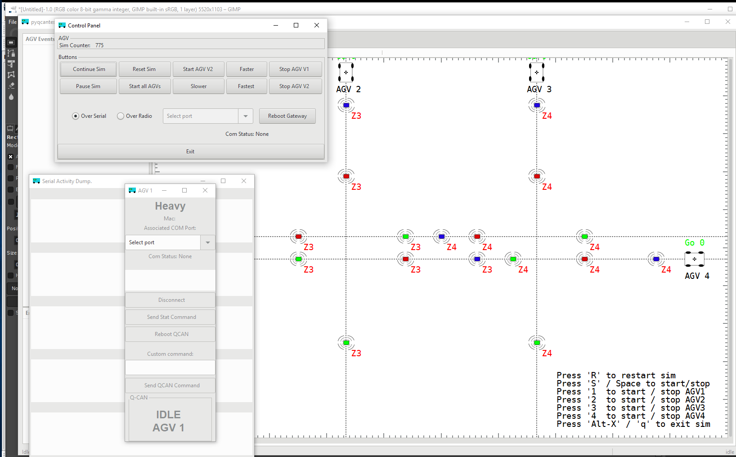
This simulation has yielded us considerable insight onto the challenges we face. We (re) discovered the phenomena of the duplicate bully, could see the delays in communication and response, and could tune the QCAN2 state machine to adapt to the challenges of the real world RF uncertainty.

Ideally, as a basis for better communication, we would both run this simulation to quality test the product. It is much more cost effective than running the real AGVs. The platform requirements are simple: python+pyGobject. We could even make the simulation run on the Raspberry PI.

Door controller
The the QCAN2 door controller will bridge communication between the AGV and a (fixed) door controller mechanism. The AGV communicates with the door controller via the door commands. The QCAN2 door controller has three major functions:

a.) Control the door and
b.) Occupy Door zone
c.) Report the status of the door.

Where Door states are:

1.) Anticipate Door
2.) Request Door

The commands correspond to functions of the door. a.) Open door b.) Close door.
The status reports of the door correspond to: a.) Door in transition. b.) Door opened. c.) Door closed.

Intersection controller and door controller combo
When an AGV approaches an intersection, that is also a door, a special command is needed that will combine the two subsystems into one comprehensive predictable set of states. The outstanding questions in this section are pertinent to making a distinction between intersection, door, and intersection door combo. In the case of the combo situation, separate commands for anticipating / occupying intersection combo, releasing intersection combo, opening and closing the door. (the door control flow table reflects this) As the door is a singular resource, the intersection controller logic may be simplified. This simplified intersection door combo may be deployed where the peer-to-peer intersection controller has difficulty.

Dispatch
Communication with the dispatch. The dispatcher can request an AGV to fulfill a task. To dispatch an AGV, the AGV issues the following commands: a.) Waiting Dispatch b.) Accept Dispatch. To dispatch an AGV, the dispatcher issues the following commands: a.) Anticipate Vehicle b.) Request Vehicle c.) Confirm Vehicle

Repeater
QCAN2 has an advanced packet forwarding mechanism. We coined the term 'mini network', because it operates on a similar principle than the internet. Packets are repeated from QCAN2 to QCAN2, until the time to live field reaches zero. This makes for a very efficient data transmission, and guarantees data will reach every QCAN2 installation.

The repeater will hold the signal that it receives, and repeats it. Three modes.
a.) Wired to Wireless
b.) Wireless to Wired
c.) Wireless to Wireless.
By default the Wireless to Wireless repeater is always on. For most cases, placing a QCAN2 at the point of radio signal starvation should permit perfect communication.

The Mac address can also then be observed as the AGV number, or zone number, or intersection number. Because the QCAN2s communicate with each other based on this Mac address, zero configuration is automatic. The other major aspect of the configuration-less operation of the QCAN2, is that every control command is unique, and pertinent to a specific function, so the QCAN2 will always be able to distinguish what action to perform. (This is addressed further in the door controller / intersection controller combo)

Supplementary tools and troubleshooting
The QCAN2 system is extremely versatile. It has an additional USB port that can be connected to a terminal emulator. For example, a tablet PC with Putty installed. (Putty: Open Source) With this setup, the connected QCAN2 can monitor the status of any other QCAN2's, or it can issue commands to any other QCAN2. The terminal is interacting with a shell like command interpreter, where various commands can be issued. There are a handful of commands to inspect the RF table, the State table, start and stop the AGV, emulate any event coming from the intersection / door controller, the AGV or dispatcher. This command interpreter can also be used as a configuration tool, a testing and troubleshooting tool. An application is under construction to permit interaction with this command interpreter via simple button presses. For more information see QCAN2 command interpreter documentation. (under construction)

Intersection Controller Command Flow

Included, a simplified table of intersection command flow. The rows are staggered, denoting the challenge and response structure of the communication. For full flow chart please see attached document titled: “Intersection Flowchart”. Q. to Roy: Did we interpret the spec as intended?

Keys: (ZZ=zone) (VV=Vehicle) (00-FF=Hex ASCII characters) (OPT=optional)

BIT_7 0x80 = BLOCKED BIT_6 0x40 = IN_CONTROL
BIT_5 0x20 = ERROR BIT_4 0x10 = RESOLVING

Spaces between fields are added for readability.

AGV QCAN Intersection Challenge / Response Table

AGV Sends | QCAN2 Responds | Status BITS | Condition/Comments
0x00 00 VV 00 |  |  | Idle loop
 | 0x80 00 00 00 |  | Idle loop Can we mandate VV?
0x01 ZZ VV 00 |  |  | Anticipate Intersection (OPT)
 | 0x81 ZZ VV 00 |  | Intersection is unoccupied
 | 0x81 ZZ 00 80 | BIT_7 | Intersection is occupied
 | 0x81 ZZ 00 A0/20 | BIT_5 | ? | Radio Error
0x02 ZZ VV 00 |  |  | Occupy Intersection
 | 0x82 ZZ VV 00 |  | Intersection open
 | 0x82 ZZ VV FF | ALL | Intersection occupied (legacy)
 | 0x82 ZZ VV 10 | BIT_4 | Started resolving
 | 0x82 ZZ VV 90 | BIT_7 | BIT_4 | Preliminary NO
 | 0x82 ZZ VV 40 | BIT_6 | Intersection occupied by self
 | 0x82 ZZ VV 80 | BIT_7 | Intersection occupied by other
 | 0x82 ZZ VV C0 | BIT_7 | BIT_6 | Got Zone, but intersection occupied by other
 | 0x82 ZZ 00 20/A0/E0 | BIT_5 | ? | Radio Error
0x00 ZZ VV 00 |  |  | Release Intersection  ZZ VV fields are optional (can we mandate ZZ?)
0x00 00 VV 00 |  |  | Idle loop
 | 0x80 00 VV 00 |  | Idle loop

Door Controller Command Flow

Included, a simplified table of door controller command flow. The rows are staggered, denoting the challenge and response structure of the communication. For full flow chart please see attached document titled: “Door Flowchart” (under construction) .

Keys: (ZZ=zone) (VV=Vehicle) (00-FF=Hex ASCII characters) (OPT=optional) (SS=door status bits: Bit_0=input_1, Bit_1=input_2)

AGV QCAN Door Challenge / Response Table

AGV Sends | QCAN2 Responds | Comments
0x00 00 00 00 |  | Idle loop
 | 0x80 00 00 00 | Idle loop
0x03ZZVV00 |  | Anticipate Door (OPT)
 | 0x83 ZZ VV 00 | Door zone is unoccupied
 | 0x81 ZZ VV FF | Door zone is occupied (AGV Slow)
0x04 ZZ VV 00 |  | Door Request
 | 0x81 ZZ VV 00 | Door zone is unoccupied
 | 0x81 ZZ VV FF | Door zone is occupied  (AGV Stop)
Open / Close Door | Please allocate command  For instance we could use:  0x04 ZZ VV 81 – open  0x04 ZZ VV 82 – close | Open / Close Door
 |  | The 'Read fixed equipment' command can be used to poll the door status
0x0a ZZ VV 00 |  | Read Fixed Equipment
 | 0x81 ZZ VV SS | Door status bits relayed
0x00 ZZ VV 00 |  | Release Door and door Zone  ZZ VV optional
0x00 00 00 00 |  | Idle loop
 | 0x80 00 00 00 | Idle loop

The task I was faced with implementing the ISEC/DOOR combo: how do we know if it is an intersection or a door or a combo at the protocol level. Any insight would be appreciated. A separate door open / door close command would clear it all up.

Dispatch Command Flow.

Included, a simplified table of dispatch command flow. The rows are staggered, denoting the challenge and response structure of the communication. For full flow chart please see attached document titled: “Dispatch Flowchart” (under construction) With this section we do not have complete clarity. Please edit / correct / comment / approve of the flow table.

Terminology:

Dispatch QCAN2 | D-QCAN2 | The QCAN2 that is attached to the dispatch computer.
AGV QCAN2 | A-QCAN2 | The QCAN2 that is attached to the AGV

Table Keys: (ZZ=zone) (VV=Vehicle) (00-FF=Hex ASCII characters) (OPT=optional) (LL=Load Status: 01=Full FF=empty) (PP=Pick/Drop Command: 01=Pick, FF=Drop) (TT=Target / Destination Zone) (MM=Additional [More] Destinations: 00=Done, FF=More) ( ---- denotes state separation)

AGV QCAN Dispatch Challenge / Response Table

AGV Sends | A-QCAN2 Responds to AGV | A-QCAN2 Sends to  D-QCAN2 | D-QCAN2 Sends or Responds  to A-QCAN2 | Comments
0x00 00 00 00
 | 0x80 00 00 00
0x05 ZZ VV LL |  |  |  | Awaiting Dispatch
 | ??? | 0x05 ZZ VV LL |  | Dispatch QCAN2 builds a table of available AGVS
----- | ---- | ---- | ---- | ----
 |  |  | 0x07 TT 00 00 | Anticipate Vehicle
 | Relayed Unmodified
----- | ---- | ---- | ---- | ----
 |  |  | 0x08 ZZ TT PP | Request Vehicle
 |  | Relayed Unmodified |  | Dispatch QCAN2 responds from a table of available AGVS
 | 0x88 ZZ TT PP
0x06 ZZ VV TT
Accept Dispatch
 | ??? | Relayed Unmodified
 |  |  | 0x09 ZZ VV TT | Confirm Vehicle
 | 0x89 ZZ VV TT
 |  |  |  | Dispatch Complete
0x06 ZZ VV FF
Reject Dispatch
 | ??? | Relayed Unmodified
 |  |  | 0x09 ZZ VV TT | Confirm Vehicle
 | 0x89 ZZ VV TT
 |  |  |  | Dispatch Complete
Questions: Does the AGV expect acknowledgment of the Dispatch commands with the Bit _7 set?
This subsystem is not well understood by us, please enlighten us.

AGV to QCAN2 and QCAN2 to AGV communications.

The data format is identical to the legacy QCAN. The command, Zone, Data_1, Data_2 are ASCII Hexadecimal characters, from 0-9 and A-Z. (Please note, in the current Savant serial com test suite, lowercase characters are not accepted)

Start | Command | Zone | Data_1 | Data_2 | Carriage Return
/ | 00-FF | 01-FF | 00-FF | 00-FF | CR

Forwarders:

As mentioned in the earlier section, our new RF empowered us with new features, that every QCAN2 will act as a natural forwarder. Discussion of the wire to RF and RF to wire forwarders will resume when we have more information on the limits of the current implementation, or requirements that exceed the capabilities of the current implementation.

Summary:

There are some outstanding questions on the handshake for the dispatch mechanism. To help us gain better insight, would you please describe a typical dispatch scenario, and maybe some corner cases.

Blank Page

Full Revision History
Revision | Date | By | Description | Notes
1.0 | Mar/13/2019 | Peter Glen | Initial Write-up

