QCAN2 QUICK START

Welcome to QCAN2. This version is in a late prototype stage. We implemented the legacy QCAN specification as best as we could interpret it. If there are any discrepancies, please give us feedback, so we can craft it to your exact specification.
The following chapters describe the initial test connection procedure. All equipment and cables are delivered for quick and easy start.
1.) Connecting the QCAN2s
1.1.) Power; For evaluation / test purposes, the USB connector may be used to power the QCAN2;
1.2.) Serial. The RS-232 DB9 connector connects to the supplied USB to serial connectors via the included USB hub.
For real deployment, there is a power input for on the terminal strip, rated 12V – 24V. The QCAN2 operates the same manner from either or both power sources.
Included, is a DB9 to DB25 conversion cable, which accommodates the connection to the AGV’s legacy DB25 serial connector.
After connecting the QCAN2 to the USB power bus and the Serial Port it is ready to go.
2.) Logging on to the PC
1.1 The PC has the QCAN2 software and QCAN2 documentation the desktop of the ‘akostar’ user. The ‘akostar’ user password is ‘qcan2’ (without the quotes)
1.2 The intersection / door simulation software is named ‘wqcan2’; the dispatch software is named ‘wdisp2’. The documentation is placed in a sub directory call Savant’
The simulation software was created on a legacy toolkit; hence the computer is pulled out of ‘S’ mode. (New feature of windows 10)
3.) Starting the simulation software.
3.1 The delivered equipment contains a pre-installed version of the simulation software. The executable is placed on the desktop, double clicking on the icon should start it.
3.2 Select any available QCAN2 serial port. The idle message of the QCAN2 should appear in the progress window.
3.3 Select desired QCAN2 Mode and Subsys. [for example: “Computer (AGV) / Intersection.”] Press the start button on the right. The communication window should reflect the handshake process, once the right side list box selection is made for a state.
3.4 Repeat the process above for all five QCAN2 connections.
The page below depicts the equipment operating five QCAN2s. The testing of the QCAN2 can be automated with the ‘Auto Advance ON’ feature. The ‘Wait for intersection available’ simulates real life condition as the simulation state will not advance until intersection becomes available. The traffic light metaphor reflects AGV status, only ONE should go at any one time.
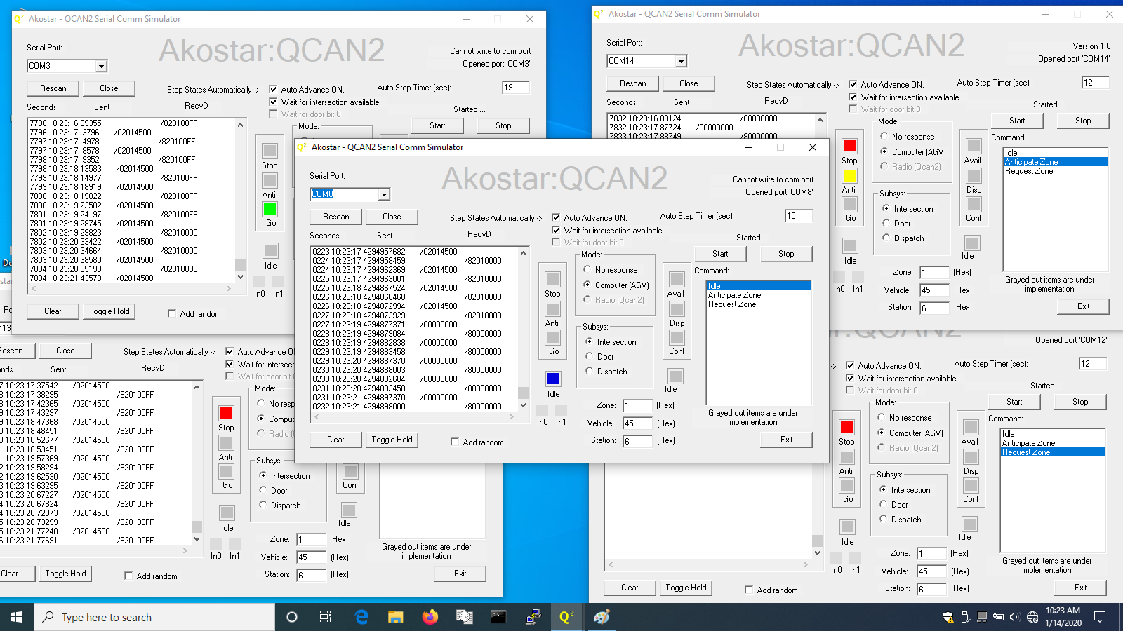
3. List of delivered Items:
- Five QCAN2 Devices
- Five USB cables, Five USB to Serial converters
- Five port USB Hub, Multi port USB power supply
- Laptop, software and documentation pre installed

4. Summary.
We tested the QCAN2 extensively. It implements the intersection logic as specified, and operates at close proximity (12 inches) and at great distances. (100 feet)
Please afford us feedback so we can complete it to your satisfaction.
Akostar Inc.
Jan 16, 2020

