The AirMon utility

We have created several new diagnostic / testing tools for the QCAN2 product line. Also ported some of the existing tools to Linux based utilities using the Python / PyGObject framework. The rationale behind it was to create a unified Embedded / Development / Testing platform. The advantage is cleaner end results and higher productivity.

This particular utility shows all AGV activities within RF range. It uses the familiar traffic light metaphor to represent individual AGV statuses. Red for stop, Green for go, Yellow for anticipate, Yellow/Red for anticipate in slow mode. The utility can filter by zone, so a single intersection in a larger installation can be monitored. The door (FE) activity may be monitored the same way, but currently there are no arrangements made to show switch and relay statuses.

AirMon Setup
The setup is simple, just connect and QCAN2 to a PCs USB port. Connect the AirMon Serial port to the QCAN via the drop down selection, and press … start.

The QCAN2s USB port acts as a command line terminal, and this utility programmatic-ally queries the RF table. It then interprets this information, and parses the result in an easy to read format, including a traffic light like display.

Up to eight AGV statuses are displayed, but there is no limit to the controls one can put on screen. The additional feature of filtering the activity by zone allows even large installations to monitor AGV activity. The UI code and query code can be easily separated, which allows the AirMon utility to be ported to any other Platform / Language.

Installing PyGObject on Windows.
To run most of these utilities, one needs to install the PyGobject dependencies. Installation is trivial, two parts: python 2.7 and PyGObject.
Following, are the download links to the install ready resources.

https://www.python.org/downloads/release/python-2716/
https://sourceforge.net/projects/pygobjectwin32/

These files are also included and installed on the demo laptop to represent a proof of concept.

The advantage of the above toolkit is that it runs on Windows / Linux / Mac / Chrome Book with little or no modification. The added effort to install the PyGObject framework is negligible compared to the productivity gain and feature additions made possible by it. The PyGObject framework exist for Windows 10 as well.

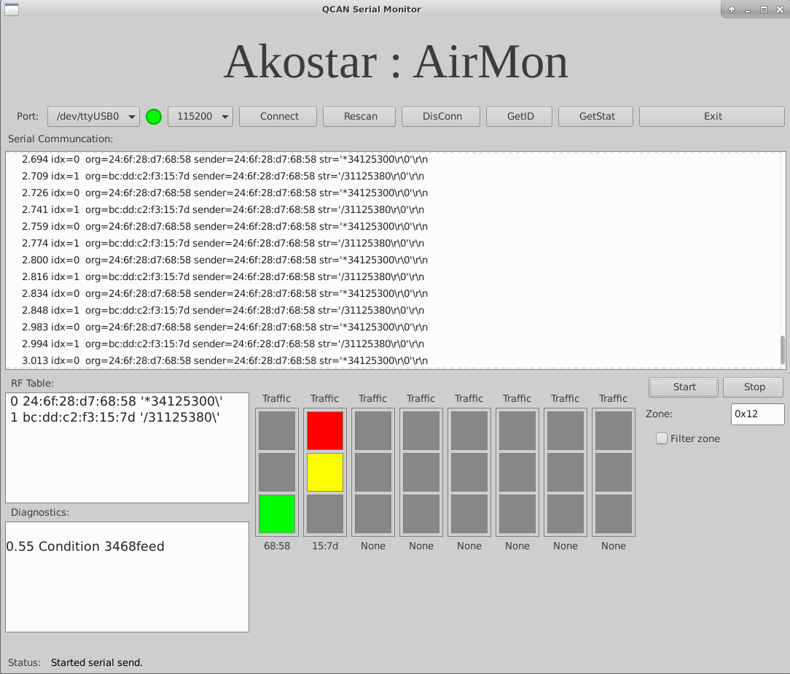

Python QCAN2 Simulator / Control:
This is the familiar simulation software crafted in Linux / Python. Because of the higher level language, we added some new features; more tests, and more detailed reporting. The dispatch code is not included yet; will be completed in the next step.

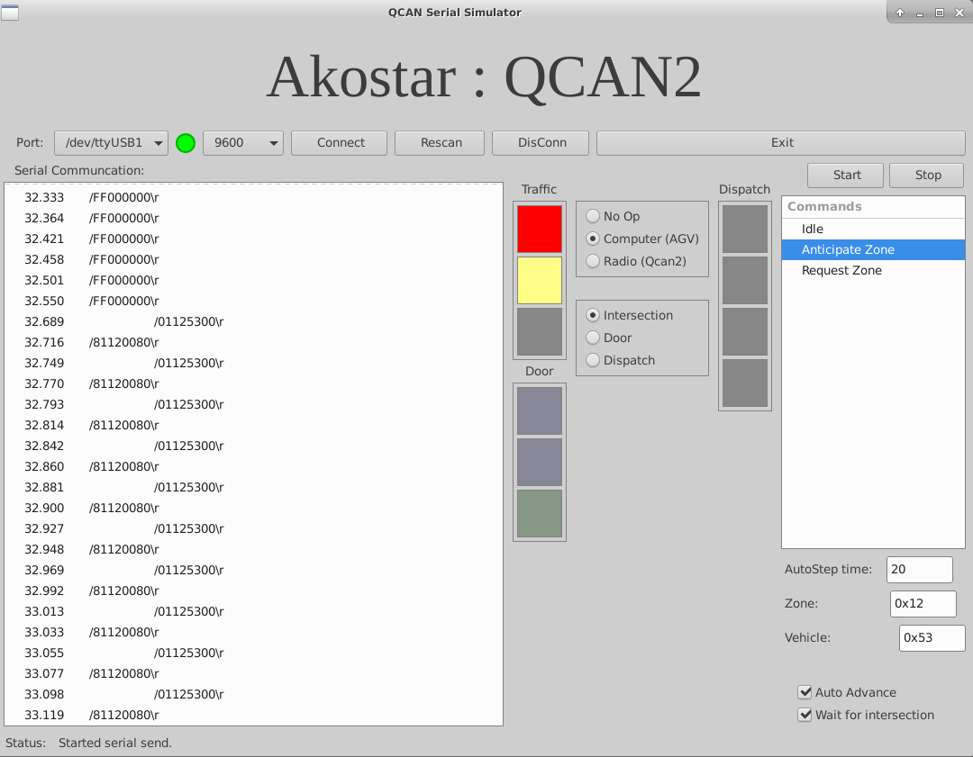

Python QCAN2 Simulation Running on Windows:

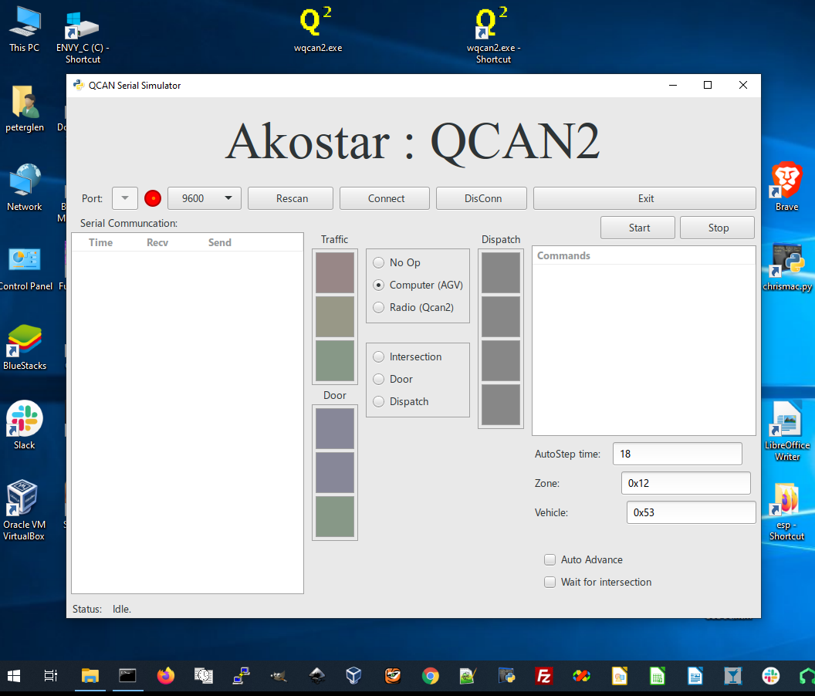 | To the left is a screen shot of the simulation utility running on windows:  It has identical functionality the Linux counterpart, and a similar appearance.  Note: this utility has been partially updated to drive the dispatch subsystem, as per request, we switched back to the windows ‘C’ based utility.

GUI based configuration tool.
While this is not yet in the works, we envision a Graphical window with zone number fields, door-zone number fields, auto-start flag fields. This GUI window can be used to program / configure the QCAN2 via the USB port. The programming then can be automated on a per customer basis or read from a database.

TODO.

