The Central Resource Controller (CR)
This is a new feature added to the QCAN2 units. The intention is to provide an option when considering intersection communication, for as pier to pier has been accomplished and while we expect no stoppages for your users, the end result is that the pier to pier depends upon the fact that all AGVs can transmit and receive, and if an AGV is coming thru a tunnel or an area of no or limited RF, then this concept of having a dedicated intersection controller offering a means for an AGV to request control of an intersection from a fixed piece of equipment will provide a positive means of preventing a stoppage by having an AGV ask permission to have control of an intersection before it takes control ~ rather than look for RF that may not exist due to environmental concerns ~ thereby with the dedicated intersection controller, the AGV will not be able to gain access to an intersection should there be lack of rf communication (hence positive control, rather than negative (for as with pier-to-pier the lack of RF results in control) and with a dedicated intersection controller as an option available to SA you now have a positive means of control wherein lack of RF results in an AGV stopping before entering an intersection.

The Central Resource Controller

The Central Resource Controller is based upon the theory of a dedicated, zone based central controller. The resource is now controlled by a central resource controller, turning the cycle of positive acknowledgment to a positive action. If the communication to the central resource controller is severed, it is interpreted as a negative action, stopping the AGV. This assures that the AGV only goes if it has permission from the central resource controller, which results in a failure less theory of the intersection controller. This theory is now implemented in the QCAN2.
The peer to peer intersection protocol theory has an inherent weakness. The control is established peer to peer, relying on the participants to obey the controlling peer. However, if the communication to the controller is severed, the other peers interpret it as a go signal. The controlled resource relied on positive acknowledgment for a negative action.
AGV
QCAN2
QCAN
CR
AGV
QCAN2
In order to facilitate the Central Resource controller, we added new opcodes to the serial protocol. The new opcodes operate on a similar process theory as the existing protocols. They have a similar bit allocation for the same fields. The Zone; the AGV; etc .. all occupy the same bytes. The only exception is that they are driving the CR subsystem. To keep compatibility with the existing specifications, the other opcodes operate as before, unchanged.
The simulator already contains the opcode drivers, and it contains an added radio button labeled “Central RC”. We updated the wait logic to behave the same way as the other subsystems, the block states wait indefinitely until non-block state is encountered, than stepping resumes until the next blocked state. This can be used for unattended testing. | 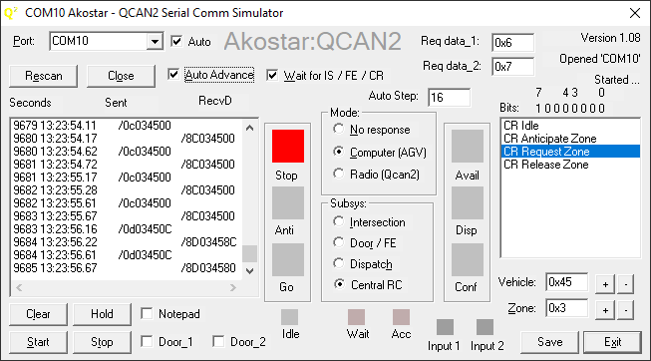

New Op codes
The code allocations for the CR system is as follows: *IPPC = Intersection Pier to Pier Controller
Description | Command | Zone | Data_1 | Data_2 | Notes
CR Idle | 0x00 | 00 | 00 | 00 | Same as IPPC*
CR Anticipate | 0x0c | 01-FF | 00-FF | 00-FF | Same as IPPC Command 0x01
CR Request | 0x0d | 01-FF | 00-FF | 00-FF | Same as IPPC Command 0x02
CR Release | 0x0e | 01-FF | 00-FF | 00-FF | Explicit release

CR Corner cases, power downs.
When the power to the central resource controller goes down, all the AGV QCAN2s preserve their previous state. The currently authorized vehicle keeps going, the stopped vehicles stay stopped. This is to assure that the intersection clears out in case of power interruption to the FE controller.
When the power to the AGV QCAN2 goes down, or Serial Communication to the QCAN2 is interrupted, a 10 second timeout counter is started. If the power / communication is restored before the timeout expires, operation resumes uninterrupted, states are preserved as before the interruption.
If the power / communication stays off longer then the timeout, the AGV QCAN2 releases the zone in the Central Resource Controller, operation on that zone may resume.
Configuring the CR controller. The web page is extended to have a text box with the CR zone field, and a timeout field. The timeout defaults to zero, resulting in no timeout action.
How it all fits together: The new serial command op codes introduced may be used as they are currently implemented. It is presented as a separate subsystem, so the AGV implementer has free range on using Peer to Peer or CR or any combination thereof.
A good option is adding them to the AGV’s control logic. Something along the line of CR resolution and Peer to Peer resolution stacked as dependents. This would take care of any door / intersection combo.
If that method is impractical, we could merge the commands 0x03 and 0x04 into the CR functionality.
Implementation details: the CR identifies the AGVs (QCAN2s) by their MAC address, which is guaranteed to be globally unique. The permission to any particular QCAN2 is identified by the last four digits of the MAC address. This is unique, considering the head part of the MAC address is chip manufacturer specific.

LED-s related to the CR controller
When the CR has an actively authorized AGV, the (metaphoric) traffic LED lights all light up. All three lights, the Red, the Yellow and Green are on for the duration of authorization. The lights go off when the AGV releases the CR zone. If there is another AGV competing for that CR, the lights come back on shortly thereafter. The average time gap is 300ms to 600 ms; he re-authorization takes place rapidly.

Rationale for the CR Controller.
The CR is not offered because the other protocols have a weakness. It is offered to create a solution for corner cases, completing the target task without any allowance for weakness in the underlying protocol. We do recognize the extra effort on installing and deploying the the Central Resource Controller(s), however, the added expense creates a future proof solution. Also, a single QCAN2 can serve both as CR controller and FE controller at the same time. (with almost no limitations)

Deploying the CR controller
One configuration item is needed. The CR zone. This can be configured from the web page, or the command line. A single command sets the zone. Use: crzone <zoneNumber>. As usual, the command line offers help by typing: ‘help crzone’ (without the quotes).

