Built in Command Interpreter
The QCAN2 USB port is equipped with a command interpreter. The commands can be used to simulate operations, simulate failure modes, configure QCAN2, set operational states and query QCAN2 status. The serial terminal connection is available via the USB connector next to the serial port.

The QCAN2 USB port can be used as a debug port, as a Control port, as an AGV port and as a Dispatcher port. There is no settings to configure, as the USB port automatically switches to AGV / Dispatch mode if it recognizes a valid QCAN2 packet. (/00000000\r)

To connect to the QCAN2 USB port use the following configuration:

Baud: 115200 8N1 XON/XOFF disabled

The Command Line
Connecting the USB port to a computer establishes a serial connection. [most computers have the USB drivers already pre-loaded, but if not, they are publicly available; the QCAN2 uses CP2102 USB chip-set]
Upon connection, the serial port is allocated by Windows. For example, the PC sees the device as COM6. One can confirm which port is allocated in the Device Manager. Once the COM port is visible, any terminal program may be used to communicate with the QCAN. We used the open source program ‘putty’. (Installed on the demo laptop)

Configuring putty.
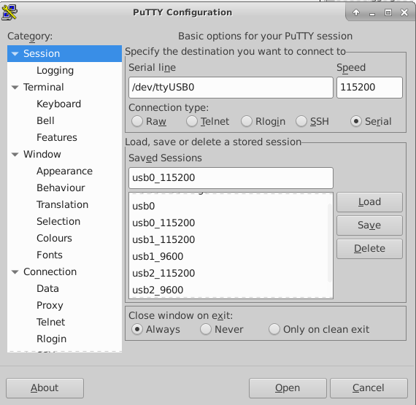 | 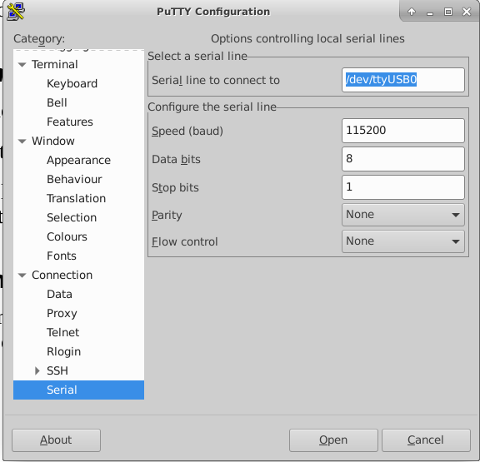
The screen shots above show a typical configuration for connecting to the QCAN2. The baud rate is 115200, the serial parameters are 8N1 XON/XOFF disabled.

Once connected, the QCAN2 is ready to operate from the command line. It issues a prompt in a form of ‘QCAN2>>’ (without the quotes)
Typing help at the QCAN2 command prompt will deliver a list of commands. Typing help <command> will deliver a short introduction to the command. For instance, to set the door zone, you may use the command: ‘zone’ (no quotes) To set the door zone to 5, use: ‘zone 5’ An alias is provided to make it more intuitive, the alias is called … ‘door’
It is worthy to mention that the firmware was developed on a Linux Host, but every operation is tested on windows as well.

Commands Short List
The following commands (and more) are recognized:
"id" "stat" "zone" "ls" "dump" “rfmon” …
The 'help [command]' command will deliver information about the specified command, for example 'help stat' will describe the stat command.

Command Short List Details
The commands below we used extensively, so it is described here. For more information see the detailed command descriptions later in the document.

id | Show the identity of this QCAN2
stat | Display current status of QCAN2 state machine, MAC address, and auto status.
conf | Show QCAN2 current configuration
zone [zz] | Set the QCAN2’s own zone, alias for doorzone or fezone – zz=new zone; zone optional, if not specified QCAN2 will show the current zone
ls | List RF table entries
rfmon | Monitor the RF transmissions, print to the command line
xrfmon | Monitor the Transmit side of RF transmissions, print to the command line. This command theme of ‘x’ prefix stands as an abbreviation for ‘TX”, an multiple commands have ‘x’ versions of them.
ser | Monitor serial port transmissions, print to the command line
dump | Display current RF table, as seen by this particular QCAN2
force | Force QCAN2 into BULLY state. This simulates the error condition on a non reactive QCAN2. The test was done to follow the code path of recovery from a condition what we call a “Duplicate Bully” Use the “auto” command to resume the testing operation.
auto | The auto command will cycle the QCAN2 states on a randomized timer. With multiple QCAN2-s running, this simulates intersection traffic. This function is available as a quad click on the QCAN2’s push button. TESTING ONLY

The interpreter is connected to a dumb terminal. (via USB Serial Converter) It has minimal editing key facilities. The Backspace key operates as expected, and the up arrow key recalls the last command. In case of an erroneous entry, press the Enter key to start a fresh command line. The QCAN2 will re-issue its prompt: “QCAN2 >>”

Full command list
The following list was created on Jul 29 2020 from a device terminal session.
ls dir bt conf stat version ver verbose macs id name zone door crzone remon remid remdis remcomp remsin can xcan forwmon xforwmon repeat xrfmon check ddump dump stop start ? help clear dellog showlog cpu nvs mem m reboot deepreset aclose forward ant req rel auto azone force rfmon doorcom serial xserial stale switch relay stoprf leak
Use help [function_name] for more details on specific functions.
Many of commands involve testing. For instance the command ‘auto’ will start an intersection simulation on zone 200. This was used during development, but can also be used as a tool for QC, or a tool for field test without any additional hardware.
If the QCAN2 is set to an unexpected mode, as simple reboot will restore default state, default operation. One may use the command ‘reboot’ to facilitate that. If the QCAN2 has been misconfigured, long pressing the top button for 10+ seconds will reset the QCAN to its manufacturer’s defaults.

Command Example:
An example command line:
QCAN>> stat
The output of the stat (short for status) command listed below:
QCAN2 version 1.15  States:  Mainstate: Q_STATUS_IDLE zone=0 par1=0x0 par2=0x0  Doorstate: Q_STATUS_IDLE zone=0 par1=0x0 par2=0x0  Dispstate: Q_STATUS_IDLE zone=0 par1=0x0 par2=0x0  CR state: Q_STATUS_IDLE zone=0 par1=0x0 par2=0x0  Configs:  Forwarder: 0 Repeater: 1  Autoclose: 1 Autorelease: 1  Door Zone: 2 Cent. Res. Zone: 3  Legacy Mode: 0 Cent. Res. Tout: 0  Properties:  Mac: c4:4f:33:1c:23:61  AGV Name: AGV-2361  Last Mon: 686578 Boot count: 517  Diagnostics:  rfmon: 0 xrfmon: 0  forwmon: 0 xforwmon: 0  canmon: 0 xcanmon: 0  sermon: 0 xsermon: 0  doormon: 0  Serial Send / Recv: 27183 / 0 Serial Bad Packets: 0  Auto step status: 0 Leak test: 0  QCAN2>> | 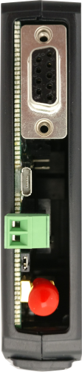  RS-232  USB  CAN  RF Connector
This output was captured during development, but as the output has evolved, more fields are added. Please see device output for the up to date format.

Command Help Details
The following list describes all the commands in no particular order; However for the initial setup, and basic diagnosis a couple of commands are sufficient. They are: zone; stat; conf; ver; crzone; ls;

Command list:
switch: show switch states;
relay: [rel_num rel_state] set / show relay states;
stale: show inactive (stale/dead) QCAN2 table entries;
version: show QCAN2 version number;
serial: show serial recv activity;
xserial: show serial send activity;
doorcom: show door communications activity;
stat: show QCAN2 internal tables and statistics;
cong: show QCAN2 internal configuration;
bt: show QCAN2 local bully table;
check: sanity check for internal use, also, automated QC.;
ls: list (dump) current RF table;
dump: dump current RF table;
ddump: dump current door table;
stop: issue STOP command to AGV;
start: issue START command to AGV;
help: show help on command;
clear: clear/rebuild RF table and statuses;
leak: continually monitor free memory amount (for testing);
nvs: [prot] show QCAN2 NVS memory details;
mem: show QCAN2 memory consumption (leak detection);
cpu: show QCAN2 cpu consumption (diagnostic: load trace);
log: [start_point] show QCAN2 logs);
logdel: delete QCAN2 logs (disabled, use web interface);
reboot: reboot QCAN2 device;
deep: deep reset QCAN2 device. Restores manufacturing defaults;
ant: [zone_num] instruct QCAN2 with anticipate intersection;
req: [zone_num] instruct QCAN2 with request intersection;
rel: [zone_num] instruct QCAN2 with release intersection;
force: toggle to bully state with no consideration (for testing);
id: print QCAN2's identity; mac address and firmware version;
remon: toggle Remote Call enable flag (default=0) [OFF];
remdis: toggle Remote Call dispatch enable flag (default=0) [OFF];
remid [id_num]: Get / Set remote id. Range 0 .. 255 (default=0) [OFF];
remcom: toggle remote output compatibility flag;
remsin: toggle remote output single flag;
azone [none_num]: get or set zone for auto (test) functions (default=100);
aclose: toggle both autoclose / autorelease;
forward: toggle QCAN2 forwarder mode (default=0) [OFF];
zone [zone_num]: get or set this QCAN2's FE zone (Door Zone)\n
Range: 0 .. 255; 0 -> FE function off; (default=0);
crzone [zone_num]: get or set this QCAN2's CR (Central Resource) zone. \n
Range: 0 .. 255; 0 -> CR function off; (default=0);
door [zone_num]: get or set this QCAN2's FE zone (alias for zone function);
name [new_agv_name]: get or set this QCAN2's AGV name. (Friendly Name);
auto [delay]: (toggle) Q2 cycle. QCAN2 states cycled:\n
ant -> req -> rel - > delay -> ant .... ;
verbose: [ver_num] get or set verbosity; Range: 0-8\n
0 -> silent ... 8 -> noisy; (default=1);
macs: list known macs in RF table;
repeat: toggle repeater mode [mini network mode] (default: ON);
forwmon: print forwarded RS-232 data to terminal;
xforwmon: print forwarded RF data to terminal;
rfmon: print incoming RF data to terminal;
xrfmon: print outgoing RF data to terminal;
can: print incoming CAN data (diagnostics);
xcan: print outgoing CAN data (diagnostics);
stoprf: toggle RF STOP state (!! For testing only !! disables RF);

Informative sign on banner
This is what the serial port (on the USB side) shows on bootup.

QCAN2 Compile Time: (BUILDDATE) 21/09/20 11:25

=---------------------------------------------------=
QCAN2 Copyright (C) Akostar Inc. 2019, 2020.
=---------------------------------------------------=

QCAN2 1.5, Built on Tue 15.Sep.2020 ready for action.

Mac: 24:6f:28:d7:68:5c

FE Zone: 5 CR Zone: 0
Rem ID: 0 Rem Disp: 0
SER Cache: 0 Deadline: 0
Q2 Mode: 0 Forwarder: 0
Boot count: 754 Packet size: 20 Last Mon: 878

AGV Name: AGV-685C

Type 'help' (or '?') for a list of QCAN2 commands.
Dumb terminal; Backspace OK, Key-Up recalls last entry, Tab Completes.

Use Ctrl-C to abort one command, Ctrl-] to abort session.

QCAN2>>

Split config screen to config / status:
Grouped information based upon its origination. Status and configuration.

Status screen printout:

QCAN2>> stat

=---------------------------------------------------=
QCAN2 1.5 Copyright (C) Akostar Inc. 2019, 2020.
=---------------------------------------------------=

States:
Main state: Q_STA_IDLE zone=0 par1=0x0 par2=0x0
F.E. state: Q_STA_IDLE zone=0 par1=0x0 par2=0x0
Disp. state: Q_STA_IDLE zone=0 par1=0x0 par2=0x0
CR state: Q_STA_IDLE zone=0 par1=0x0 par2=0x0

Properties:
My Mac: 24:6f:28:d7:68:5c
AGV Name: AGV-685C

Quick stats:
Uptime: 903063 ms -- 0 days, 00:15:03.063
Boot count: 754 Last Mon: 903068 ms
RF (Rec): 34977 RF (Tr): 10877
RF Err (Tr): 0 RF Skip (Tr): 0
RF Repe (Tr): 1 SER (Rec): 0
SER (Tr): 0

QCAN2>>

Config screen printout:

QCAN2>> conf
QCAN2 version: 1.5

Configs:
Forwarder: 0 Repeater: 0
Autoclose: 1 Autorelease: 1
FE. Zone: 5 CR. Zone: 0 CR. Timeout: 0 ms
Ser. Cache: 0 Ser. Dline: 0 ms
Remote Call:
Rem.Call On: 0 Rem.Call ID: 0 (RCB)
Rem.Disp On: 0 Compat Flag: 0 (RDISP)
Single Flag: 0
Diagnostics:
rfmon: 0 xrfmon: 0 forwmon: 0
xforwmon: 0 canmon: 0 xcanmon: 0
sermon: 0 xsermon: 0 doormon: 0
Stats:
SER Send / Recv: 218673 / 0 -- Serial Bad Packets: 0
RF Send / Recv: 11737 / 37730
Diag. Status:
Auto step status: 0
Leak test status: 0

The stat command output:

QCAN2>> stat
=---------------------------------------------------=
QCAN2 1.4 Copyright (C) Akostar Inc. 2019, 2020.
=---------------------------------------------------=

States:
Main state: Q_STA_IDLE zone=0 par1=0x0 par2=0x0
F.E. state: Q_STA_IDLE zone=0 par1=0x0 par2=0x0
Disp. state: Q_STA_IDLE zone=0 par1=0x0 par2=0x0
CR state: Q_STA_IDLE zone=0 par1=0x0 par2=0x0
Properties:
My Mac: bc:dd:c2:f1:99:41
AGV Name: AGV-9941

Curr Time: 189700770 micro sec.

Quick stats:
Boot count: 4452 Last Mon: 189705
Uptime: 189709 ms -- 0 days, 00:03:09.709
Packets RF: 3859
Packets SER: 0

