QCAN2

Document under process of revision, once released, this notice will be removed.

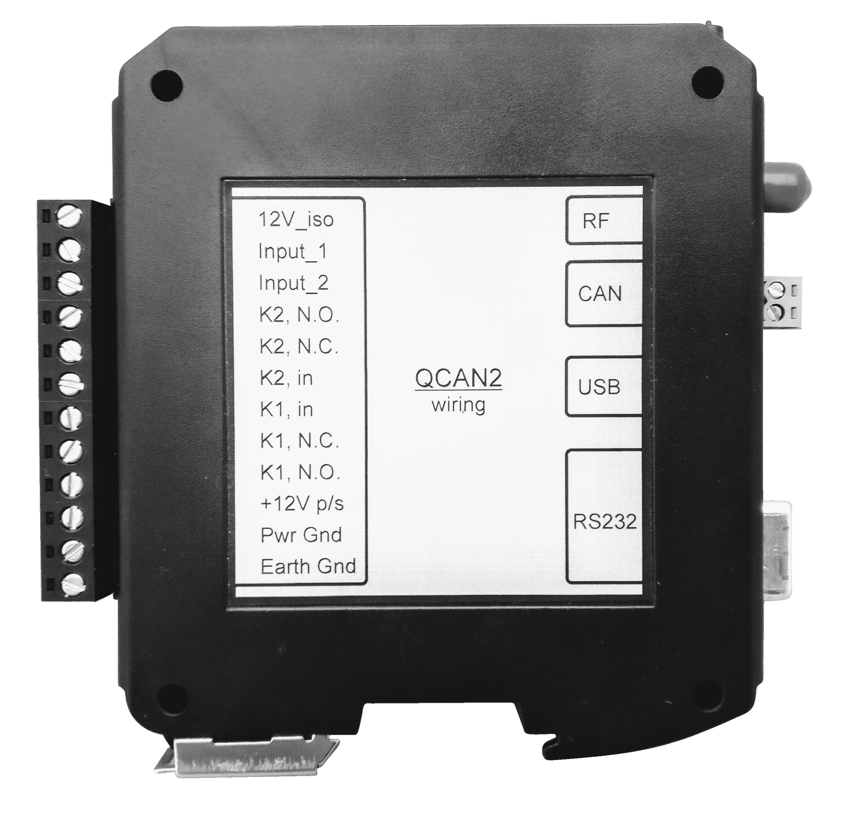
Akostar
Developer’s Manual
Document Version 3.7
Copyright © 2019-2021 Akostar Inc.
Intellectual property notice:  All ideas, concepts, designs, and arrangements communicated within this document are preliminary, and they are subject to change. Information contained within may be proprietary, only to be shared or used upon the approval of respective owners / holders. | 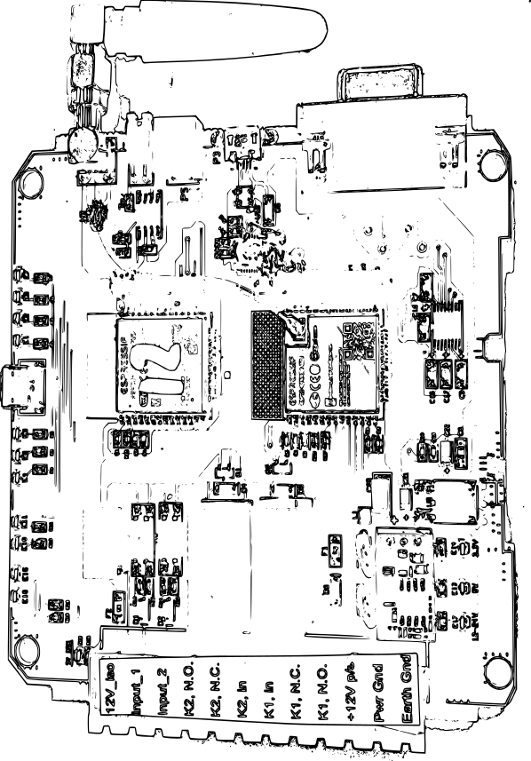 | Revision and updates:  The developer and manufacturer reserves the right to change and review the design and implementation of said device, at the sole discretion of the intellectual property owner. In case of dispute, the order of resolution is fitness for purpose, compatibility, functionality, aesthetics.

Document Revision History:
Doc Revision | Date | By | Description | Notes
1.0 | Mar-13-2019 | Peter Glen | Initial Write-up
1.2 | Oct-2019 / Dec-2020 | Team | Code base
1.x | Dec-2019 / Jan-2020 | Team | Updated descriptions
2.0 | Jan-15-2020 | Peter Glen / Chris Bogue | Review
3.0 | Mar-24-2020 | Peter Glen | Doc release
3.1 | Mar-31-2020 | Peter Glen | Master Doc | Re-structure
3.2 | Apr-22-2020 | Peter Glen | Doc for Rel #5 | Firmware 1.10
3.3 | May-5-2020 | Peter Glen | Doc for Rel #6 | Firmware 1.11
3.4 | May-20-2020 | Peter Glen / Chris Bogue | Doc for Rel #8,9 | Firmware 1.14
3.5 | Jul-1-2020 | Added Rem Call | Doc for Rel #10 | Firmware 1.18
3.6 | Dec-18-2020 | Finalized some | Doc for Rel #14 | Firmware 2.0
3.7 | Mar-15-2022 | Savant release | Doc for Rel #15 | Firmware 2.2

