Event Logging
In the spirit of traceability and troubleshooting, QCAN2 maintains extensive logs. Every state machine transition is logged. Anomalies in RF Transmission / Reception are logged. Duplicate bully resolution, dead RF entry are all in the logs. The log can be accessed from the terminal command line, and from the log configuration web page. Additionally, the QCAN2 has a log host mode, where it logs everything that could be relevant to troubleshooting.
There are several levels of logging implemented:
a.) Errors;
b.) Warnings;
c.) Notices;
Below is an example of logged items in a sequence. The first field is the time stamp, the second field is the last two digits of the MAC address, and the rest describes the state transition. Interspersed lines are from the supervisory process. (This screenshot is from an older version of the code, the later versions have 4 digit MAC printout and some other minor differences)
02:47.5 34 QCAN_STATUS_IDLE -> QCAN_STATUS_LISTEN zone=10 (0, 0)
Whatsup: Setting slow state: eval_lim 4
02:54.0 34 QCAN_STATUS_LISTEN -> QCAN_STATUS_EVAL zone=10 (0, 0)
02:55.6 34 QCAN_STATUS_EVAL -> QCAN_STATUS_WAIT zone=10 (0, 255)
Whatsup: Setting bully state: eval_lim 3
02:57.8 34 QCAN_STATUS_WAIT -> QCAN_STATUS_BULLY zone=10 (0, 0)
03:02.2 34 QCAN_STATUS_BULLY -> QCAN_STATUS_RELEASE zone=10 (0, 0)
03:04.0 34 QCAN_STATUS_RELEASE -> QCAN_STATUS_IDLE zone=0 (0, 0)
03:09.3 34 QCAN_STATUS_IDLE -> QCAN_STATUS_LISTEN zone=10 (0, 0)
Whatsup: Setting slow state: eval_lim 3
03:15.4 34 QCAN_STATUS_LISTEN -> QCAN_STATUS_EVAL zone=10 (0, 0)
03:17.2 34 QCAN_STATUS_EVAL -> QCAN_STATUS_WAIT zone=10 (0, 255)
Whatsup: Setting bully state: eval_lim 6
03:21.2 34 QCAN_STATUS_WAIT -> QCAN_STATUS_BULLY zone=10 (0, 0)
03:25.4 34 QCAN_STATUS_BULLY -> QCAN_STATUS_RELEASE zone=10 (0, 0)
03:27.0 34 QCAN_STATUS_RELEASE -> QCAN_STATUS_IDLE zone=0 (0, 0)
03:32.5 34 QCAN_STATUS_IDLE -> QCAN_STATUS_LISTEN zone=10 (0, 0)
Whatsup: Setting slow state: eval_lim 4
03:39.0 34 QCAN_STATUS_LISTEN -> QCAN_STATUS_EVAL zone=10 (0, 0)
03:40.6 34 QCAN_STATUS_EVAL -> QCAN_STATUS_WAIT zone=10 (0, 255)
Whatsup: Setting bully state: eval_lim 4
03:45.0 34 QCAN_STATUS_WAIT -> QCAN_STATUS_BULLY zone=10 (0, 0)

Logging Example:
The log is visible from the QCAN2s logging page. The displayed items are :
- Boot Count - The number of boots (power ups)
- Event - The event that triggered the log
- Parameters / Zone - The zone the event happened – or relevant parameters
- Time from boot - The time elapsed from last boot in seconds

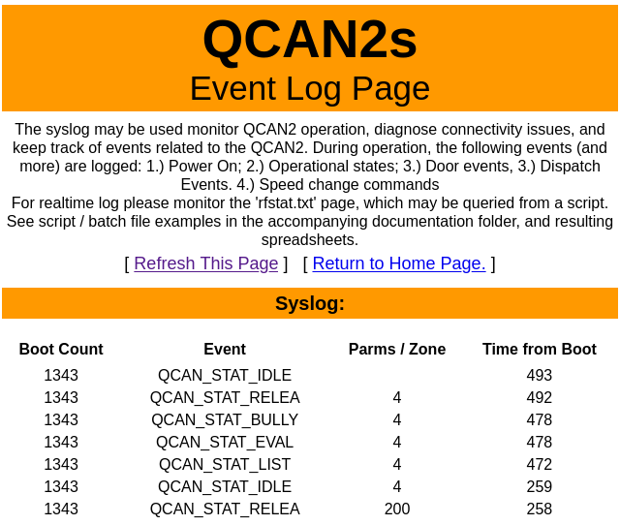 | The QCAN2 has no knowledge of real time, but the time of the event can be calculated from inferring the time of last boot up (shift change or event with power cycle) plus the seconds from the table added.  The entries in the table are in reverse chronological order; the example to the left shows an AGV approaching and occupying zone 4. Noteworthy to see that the AGV was leaving zone 200, which is a self test zone. (Self test procedure described elsewhere in this document.)

There are additional means to see the log, described later in this document. Every QCAN is capable of reading all the RF events, and the events can be saved to a file. See: ‘Creating Logs’ later in this document.

