Remote Call Functions
This is a new feature of the QCAN2 units. The objective is to provide the remote call facility substituting / replacing / extending the remote call function with a QCAN2 device. The rationale behind this feature is to take advantage of the QCAN2-s larger range, use the added functionality that is empowered by the mini network and the added coverage afforded by the forwarder. In addition, a significant cost saving by using uniform equipment to fulfill multiple functions and simplifying logistics by stocking fewer number of items.
The remote call feature consist of two parts:
1.) The Remote Call Transmitter unit. (Remote Call Button) [ RCB ]
2.) The remote Call Receiver / Dispatcher / Responder unit. (Remote Call Dispatch) [ RCD ]

Remote Call Functions, Transmitter (RCB)
There are two versions of the call function the QCAN2 emulates:
1.) Wired buttons for fixed installation. 2.) Wireless remote, handheld installation.
The wired installation accommodates four push buttons. The button state change is transmitted to the configured Receiver. The state change transfer is in real time with the following propagation time specifications: : Button de-bounce: 80 msec Transmit latency: < 12 msec Receive latency: < 14 msec. The Button press and Receiver response delay is within human perception limits, it looks and feels ‘instantaneous’.

QCAN2
In
REMOTE CALL
mode
Remote Call Buttons
Remote Controlled Relays
The Remote Call Button (RCB) mode also listens for incoming RF on its Remote Call ID. The incoming transmission that associated with this ID; will control the four relays. The same interpretation as the switches. For instance, the string ‘wxyz’ turns all relays off, ‘WXYZ’ turns all relays on. See a more detailed description on the protocol later in this document.

Remote Call Receiver Responder / Dispatch.
The receiver has two distinct modes.
1.) Remote Call Dispatch mode
2.) Remote Call Compatibility mode.

Remote Call Dispatch mode (RCD)
The Remote Call Dispatch mode coexists with the existing dispatching and AGV data streams. The RCD uses a compatible RS-232 format, all fields are arranged in the same order, and occupy the same position. Two new commands (or new op-codes) are introduced to accommodate the RCD events. One command is signaling the dispatch computer that a switch changed (button pushed / released). The other command is used to send to the Remote Call Button Unit a new relay / LED status. The commands have the following format (in ‘C’ notation):
/cczzwxyz\r\n
where:
cc | The new command (op-code) (0x20 for button event, 0x21 for relay event)  The QCAN2 will set Bit 7 on all replies, so the simulator shows the opcode with bit 7 set. (0x20 - > 0xa0)
zz | The caller’s identity from 0-255 (0x0 .. 0xff) This ID is also used in replying.
wxyz | switch state / relay state string. Lower case letter is open switch / open relay, upper case is closed switch / closed relay. (open=off closed=on)
Examples:
/0A02wxyz\r\n All Switches off
/0A02WXYZ\r\n All Switches on
/0A02wXyz\r\n Switch 2 on
The new commands are picked to be out of range from the existing ones. The dispatch computer may be programmed to receive these op codes in conjuncture with the existing ones, and respond accordingly fulfilling both dispatch and call functions.
The QCAN2 may be connected to a computer host though a USB connector. When the USB connector receives a QCAN2 compatible instructions (for example the IDLE message), the USB communication channel switches to QCAN2 mode. (from terminal mode) This way, the QCAN2 dispatch function can be fulfilled via a simple USB connection to any PC.Call Dispatch Compatibility mode
The compatibility mode was designed to be a direct substitution for the Akostar Remote AGV call unit. The QCAN2 can be configured to output a serial stream matching the stream output by the Akostar unit. It also outputs a compatible stream to control the Remote Control Button units. The QCAN2 AGV Serial Port operates as the input / output for the remote call compatible function.
Input format: (‘C’ notation)
zzwxyz\r\n zz=caller identity 0-255; wxyz = switch string
Input format, single shot: (‘C’ notation)
zzs\r\n zz=caller identity 0-255; s= one of w, x, y, z = switch string letter
Output format:
zzwxyz\r\n zz=caller identity 0-255; wxyz = relay string

Intentionally left blank

Configuring Remote Call
The Remote Call function is dormant unless it is explicitly enabled. This is to separate operations from interfering with each other. For example, a dispatch computer that might not be ready to interpret the extra op codes, may signal error when an unknown op code arrives.
The remote call consists of two major parts: the sender and the receiver. Even though both parts are capable of sending and receiving, we make the following terminology assumption:
- The sender is the Remote Call Button Unit (RCB)
- The receiver is the Remote Call Dispatch Unit (RCB)
Please make sure that only one of these functions are activated, as the RCB overrides other operations. This may not be desirable if one wants the Remote Call Dispatch function.
The Remote Call Functions may be configured from both the web interface and the command line. The command line commands for the remote control functions are:
remon | To toggle the enable / disable RCB mode | remid | Get / set remote id
remdisp | To toggle the enable / disable RCD mode | Remcomp | To toggle the enable / disable RCD Compatibility mode

Activating Remote Call mode will put the QCAN2 into Remote Call Button (RCB) mode. All the other QCAN2 functions will stop, this makes the unit a dedicated RCB.  Activating Remote Call Dispatch mode will put the QCAN2 into Remote Call Dispatch (RCD) mode. The QCAN2 now will inject the remote call requests into its RS-232 data stream. The injected data stream is atomic, (queued) and will not interfere / modify any other data already in the steam.  The QCAN2 Remote Dispatch compatibility will force the Remote control Dispatch to output an Akostar compatible serial stream. | 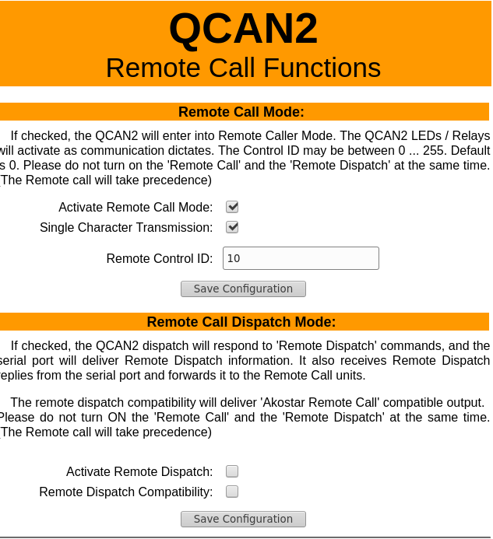

Remote Control Op codes summary:
The code allocations for the RCD system is as follows:
Description | Command | Zone | Data_1 | Data_2 | Notes
RCD Received | 0x20 | 00-FF | wx | yz | Upper case denotes ON  Lower case denotes OFF
Send RCD Request | 0x21 | 00-FF | wx | yz | As above
Opcodes are allocated beyond current opcode range, please give feedback if the opcode is acceptable, or revision is needed.

Deploying the Remote Call
The QCAN2 needs to be configured for the Remote Call function. On the initiator side, the RCB has to enabled, and it needs to be configured with the Remote Call Function ID.
On the receiver side, the RCD has to be enabled, and the compatibility mode chosen.

