Creating RF Logs
In troubleshooting the QCAN2, it is useful to have a log of QCAN2 activities. The QCAN2 provides a dynamic snapshot of the RF Table when the file ‘rfstat.txt” is accessed from it via the web interface. Simply connect a PC to the QCAN2 WiFi Interface, and load the file into a browser or use the open source ‘wget’ from the command line. (http://gnuwin32.sourceforge.net/packages/wget.htm)

While this file can be seen from the browser, true usefulness reveals when accessed from a script. One can create a log file of all activities by continually querying the RF Table, and appending it to a file.

Below, a LibreOffice (**OpenOffice) import of the created text file. The contents of the file mirrors the RF Table at the time of capture, indexed by time. The first column is QCAN2 processor time in seconds. Any event’s time can be calculated from referencing the script start time from the second line, with the time of event. [**LibreOffice the import was achieved with two clicks, OpenOffice asked for several options]

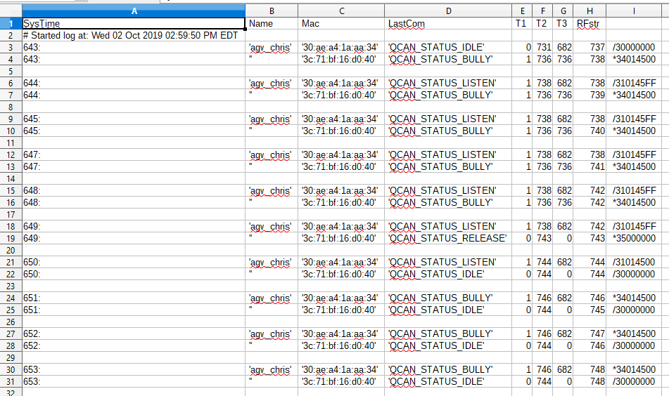

The script (below) is delivered with the QCAN2’s prototype package, and it is quoted below for reference. It is native to Linux, but a Windows version is provided as well. (see mon_qcan2.bat)

#!/bin/bash
#
# Script to monitor QCAN2 status, and create a logfile
# Written for Linux, but same programs are available for windows.
# Results are in rflog.txt
#
LOGFILE=rflog.txt
echo "SysTime, Name, Mac, LastCom, T1, T2, T3, RFstr" >> rflog.txt
echo -n "# Started log at: " >> rflog.txt
date >> rflog.txt
echo
echo "Log started, saved to $LOGFILE. Stop with Control-C"
while [ 1==1 ] ;
do
wget -q 192.168.4.1/rfstat.txt -O - >> $LOGFILE
# Adjust for desired sampling frequency (in seconds, floating point OK)
sleep 1
done
# EOF

(Script delivered as file: ‘monitor_qcan2.sh’, live version is ‘monitor_qcan2_stdout.sh’)

Windows version: mon_qcan2.bat:

@echo off
rem #
rem # Script to monitor QCAN2 status, and create a logfile
rem # Written for Linux, ported to windows.
rem #
rem # Results are in rflog.txt
rem #

@echo *
@echo * Log started, saved to rflog.txt. Stop logging with Control-C
@echo *

:again
rem # Get the latest table, append to file
wget -q 192.168.4.1/rfstat.txt -O - >> rflog.txt
rem # Adjust for desired sampling frequency (in seconds, floating point OK on Linux)
sleep 1
goto again

rem # EOF

