Setup
QCAN2 features a modernized configuration and user interface. It has several configuration modes.
- WiFi / Browser, using a Cell Phone, Tablet Device or Computer; Chromebook, iPhone
- Command Terminal configuration (like putty)
- Traditional configuration mode

Dip Switch - less implementation
Configuring the QCAN2 via the web interface is extremely convenient. The QCAN2 will expose itself on the WiFi name space as “QCAN2-NNNN” (without the quotes), where NNNN is the last four digits of the QCAN2’s MAC address. The WiFi password is pre-set to ‘12345678’ (no quotes) The QCAN2 will listen on this interface for one to two minutes after power up, then the WiFi interface goes dormant.

Configuration main page
To the right, is a screen shot of the initial page the QCAN2 displays when connected to.  On this page, the AGV name can be changed. The name is advisory, as it does not effect operational parameters.  The auto release will allow this AGV to resume after any QCAN2 unexpectedly goes silent. The timeout for resume is 30 seconds. If this checkbox is not checked, the AGV holds it previous status indefinitely. | 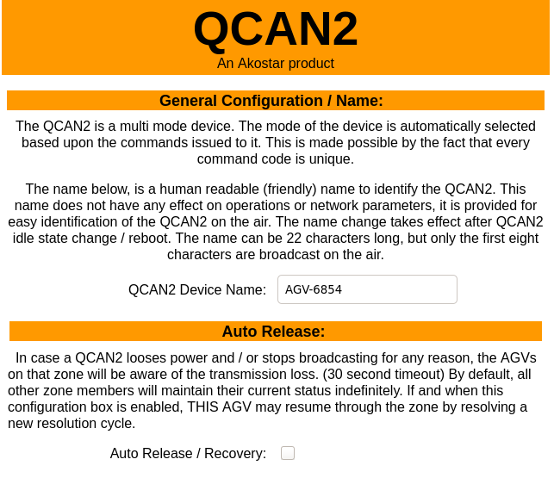

Configuration Items
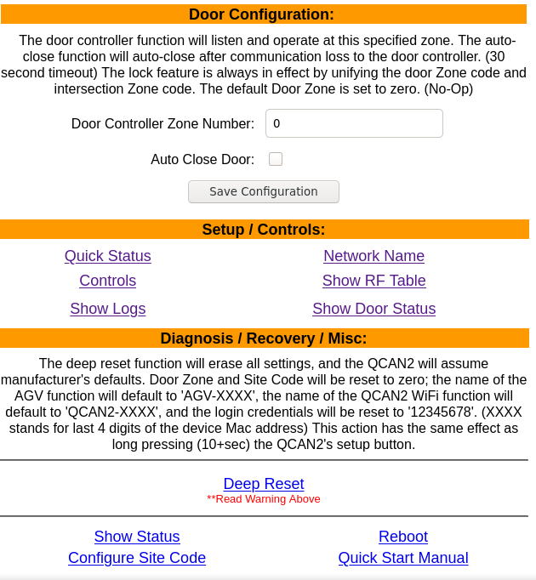 | The following items (left) can be configured on the QCAN2:  Door Zone. This is the zone the door controller listens to. The default is zero, which means no door controller function is active.  Controls. Open / Close Door; Start / Stop AGV. This control is advisory, instructions from RF override it.  Network Name: Configure WiFi Network parameters.

Show Logs: | Logging feature. Example log:  1343 QCAN_STAT_IDLE 493  1343 QCAN_STAT_RELEA 4 492
Show RF table: | List RF communication details visible by this QCAN2
Quick Status: | Show this AGVs state machine state.

Informational Items
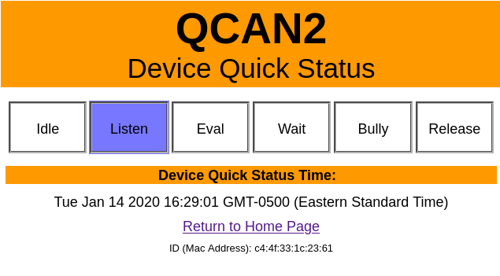  The device status represents the current state machine state of the AGV intersection.  The RF table is a snapshot of the RF as this device sees it.  Both Statuses and Tables are live. | 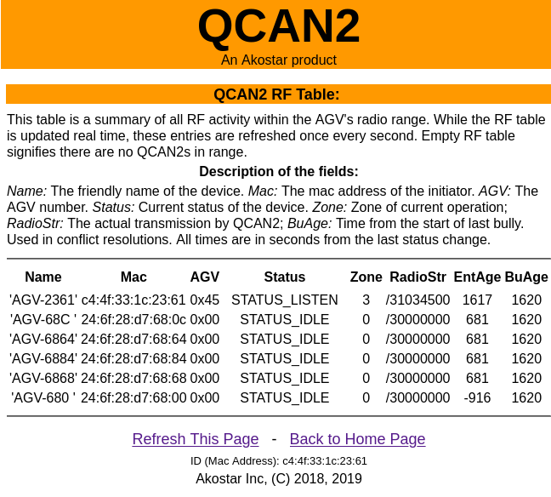

Control Items
The QCAN2 can be controlled from the WiFi interface. The AGV will receive start stop commands from the web interface without the priority resolution mechanism.  Same is true with the door open / close function. The web interface acts as an override, and it can be utilized when an override is required. For instance in case of stoppages or door testing.  During development we found it useful to quickly identify which QCAN2 we are interfacing with by operating the relay, and listening for the mechanical noise. | 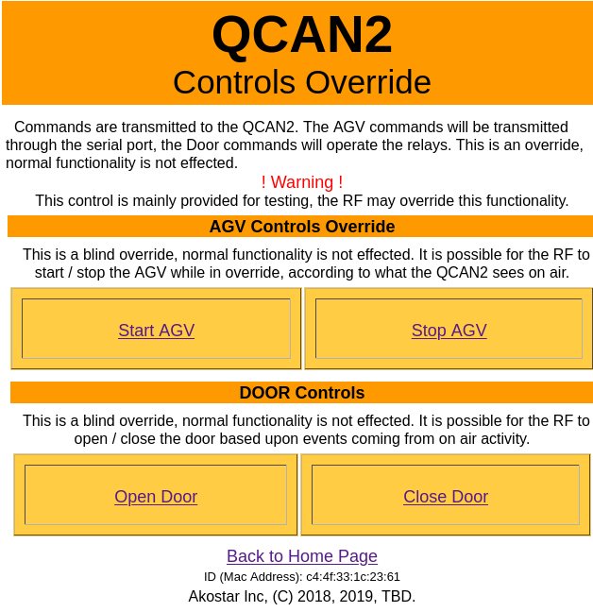

Button codes:
The QCAN2 has a push button accessible under the front panel. The button can interpret several combinations of press codes.

Press code | Description | Function
Single click |  | Wake up device’s Wifi function
Double click |  | No function
Triple(3) click | Like the mouse double click, but 3 clicks instead of two | Reboot device.
Quad (4) Click | Start AGV pairing | With this mode one can pair an AGV remote. I signal arrives in 20 seconds, the pair is successful.
Penta (5) Click | Start intersection auto test mode. Four clicks in rapid succession. (like the mouse double click, but four clicks) | With this mode one can simulate serial commands without external equipment. See ‘Auto test function’ below.
Long press | Press and hold for 12+seconds, then release. | Manufacturer’s reset. All zones are cleared, QCAN2 defaults to AGV mode.

Auto test function
With the intersection auto test mode one can simulate serial commands without external equipment. The simulated serial commands auto cycle every 10+ seconds simulating the AGV idle / listen / occupy cycles. The cycles then repeat indefinitely. The timing of the cycles is randomized, so the test is mimicking real life scenarios. The zone of the auto test is set to 100. When this test is executed on multiple QCAN2s, they show intersection negotiation. The QCAN2s LEDs should show the negotiation process, with only one AGV allowed (Green) an any one time. His test can also be used as a range test, testing the compound of radio range + negotiation range.
The auto test is exited by subsequent quad click or power cycle / reboot. This will restore normal operation.

