AGV Visual Simulation Setup
The AGV Visual Simulation is a useful tool to verify and demonstrate AGV intersection interactions. We installed it on the laptop, so it is ready to go with a click of a button.

Setup process:
o Connect QCAN2s USB ports to the PC
o Start simulation (shortcut icon on desktop called ‘Visual Sim’)
o Visually connect the AGVs to serial ports (see Serial Setup Screen Shot)
o On the Control Panel of the Simulator, Click the ‘Start all AGVs’ button.
One may use the Alt-Tab key to navigate between the Visual Simulator’s windows. Alt-X key will set focus to the main screen, and if foxus is already on the main screen, Alt-X will exit the Visual Simulator.

Visual Simulation
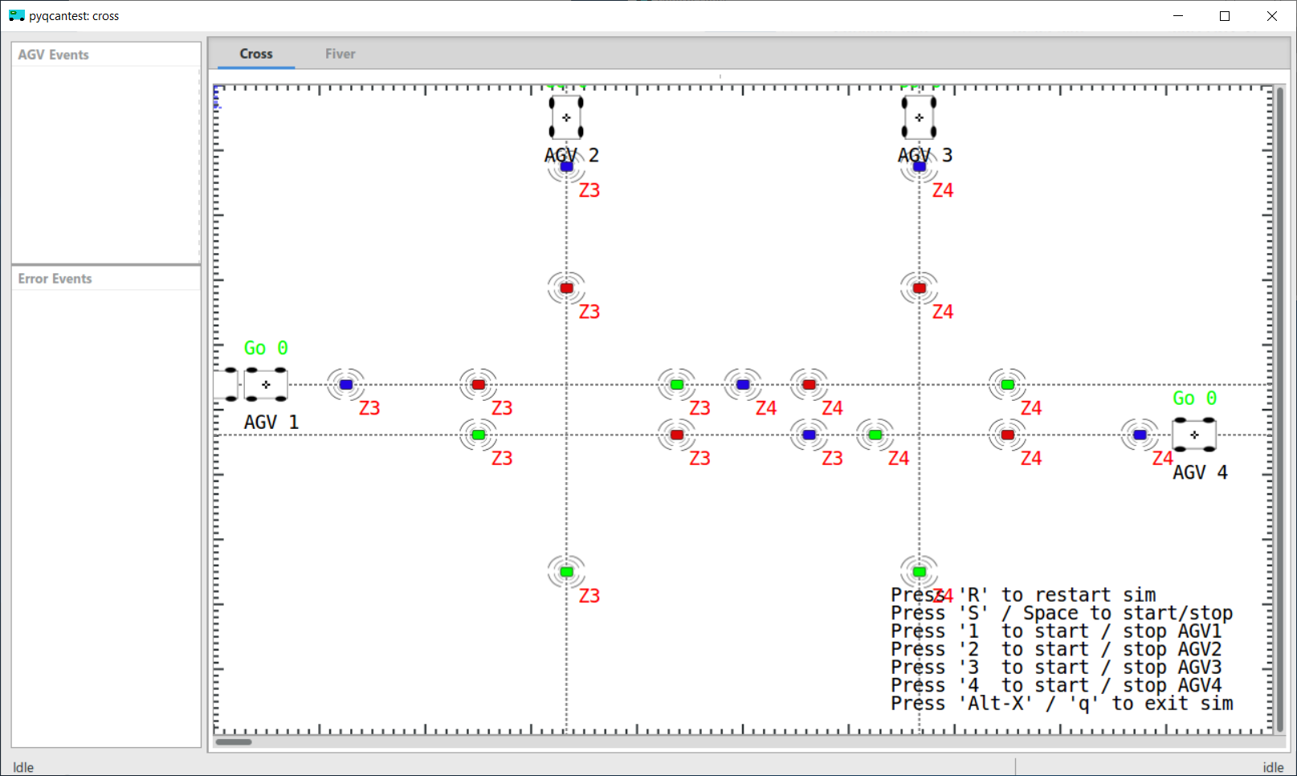

The Visual Simulation was meant for a multi-screen desktop computer, where all the controls, configurations and views can be shown at once. However, all the functionality can be exercised from a single screen. Use Alt-Tab to pan between them There is a tab control on top of the screen where a different scenario is pre-loaded.
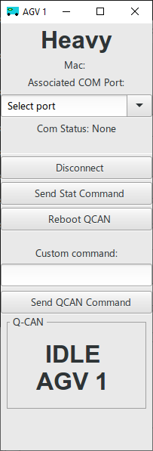 | The Serial Screen  Setting up the Visual Simulator is relatively simple. All one has to do is assign serial ports to AGVs. The screen short on the left is the Serial Setup window, depicts the ‘Select port’ item. Pull the combo box’s selection list down, and select a serial port from the listed items.  The AGVs can have simulation names, this particular one is called ‘Heavy’, because it is the double AGV on screen. The names have no influence of the workings of the Visual Simulator.  This window can also be used as a control window for the QCAN2, issuing reset, and send any command via the USB serial port.

Starting / Stopping the Simulation / AGVs

The simulator can be controlled from this panel. There are buttons to Start / Stop the simulation, to restart / reset the simulation, speed things up, slow things down.  This panel represents the evolution of the Visual Simulator where we tested different aspects of the system, they where relevant for development. | 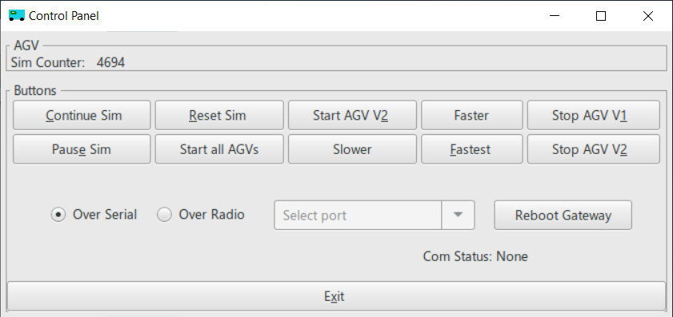

There are several more windows in the Visual Simulator, most of which was needed during development. One of the panels show serial communication between the Visual Simulator and the QCAN2. While all this was essential during development, it is safe to ignore for demonstration purposes.
The following screen shot depicts all the process windows on my current system. Please note the windows that belong to the Visual Simulation.
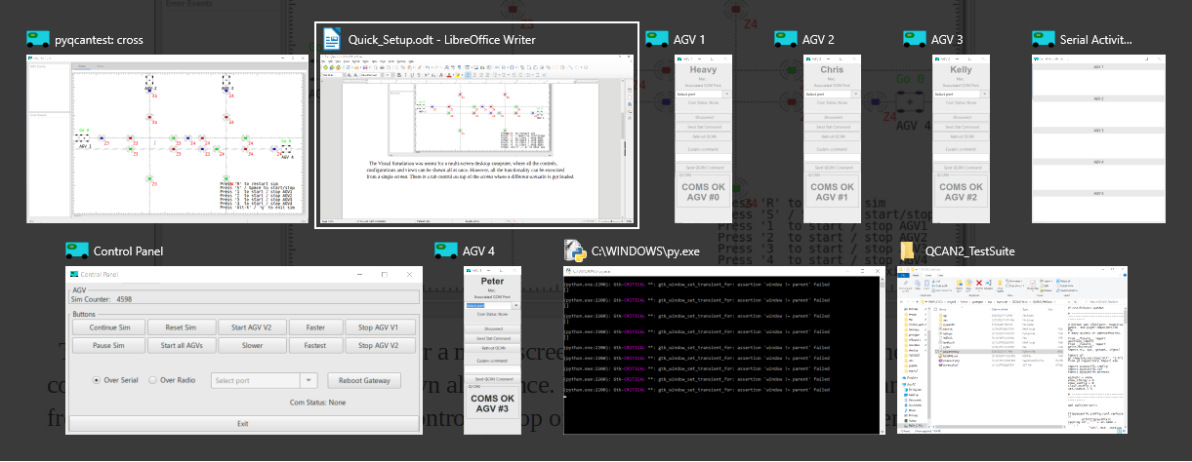

Dependencies:
The dependencies of the Visual simulation are all open source components. They are in use by a wide array of audiences, including large corporations. Here is a short list for Windows:

- python (any version);
- pygi;
- pygobject;
- pyserial;

The dependencies are installed on the laptop, and included in the QCAN2 directory on the desktop.

Multi Platform:
The simulation works on every platform that has python / pygi. This includes:
- Windows (All versions after Vista)
- Linux (All major distributions) – Tested on Ubuntu and Fedora
- Chrome Book – on older versions one can side install Linux, newer versions have Linux support built in
- Mac – Untested, but given that all other platforms work, it usually works well

Tool Summary:
The Visual Simulation was a great tool for testing during development, and it may serve as a powerful addition for Quality Control and Demonstration. There are versions for the door subsystem, and versions that drive the internals of the QCAN2 in more detail. New version for the Dispatch exists.

