Supplementary Tools
The QCAN2 system is extremely versatile. It has an additional USB port that can be connected to a terminal emulator. For example, a tablet PC with **Putty installed. With this setup, the connected QCAN2 can monitor the status of any other QCAN2's, or it can issue commands to any other QCAN2.

The terminal is interacting with a shell-like command interpreter, where various commands can be issued. There are commands to inspect the RF table, the State table, optionally Start and Stop the AGV, emulate any event coming from the Intersection / Door controller, or the dispatcher. This command interpreter can also be used as a configuration tool, a testing and troubleshooting tool. An application is under construction to permit interaction with this command interpreter via simple button presses. For more information see QCAN2 command interpreter documentation.

** (Putty: Open Source terminal program)

Simulation
(This section is informational)

Windows Based Simulation

This simulator has matching functionality to the Savant QcanComm program. Technically it is qualified as a controller. The Akostar Simulator / Controller has some additional functionality to aid automated testing. (screenshot may differ from image due to updates)

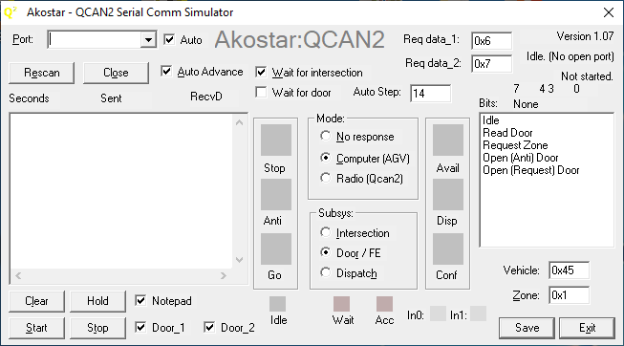

The serial comm simulator was developed to automate testing, and expand the range of parameters that can be modified. All text boxes are ‘live’ controls, the typed values take effect immediately. However, most of the QCAN2 commands operate on a ‘delta’ (that is, it is sensitive to command change), so some ‘live’ parameters are only acted upon if the command has changed. This is especially visible on the dispatch command, where the except / reject dispatch takes effect after command change. In other words, to emulate the command change on request vehicle, one needs to switch back to anticipate and than change the parameter. Switching back to request, the new parameter takes effect.

The Auto Advance system: the states of the QCAN’s communication are advanced automatically. When the states are at the end state, the auto advance wraps around. The states are stepped forward at the ‘Auto Step Timer’ interval, which assumes a random value at startup. The ‘Wait intersection’ feature stops the auto-advance from switching until the AGV acquires the resource.

Description of controls (see screenshot for details):

Auto Advance ON | Alt-A | Enables Auto Advance
Auto Step Timer (sec) |  | Specifies the interval between auto step stages
Start | Alt-S | Starts the Communication
Stop | Alt-T | Stops communcation
Mode |  | Mode of operation
Subsystem |  | The QCAN sub systems
Vehicle |  | Hex number of the current vehicle
Zone | Alt-Z | Hex number of the current zone
Serial Port | Alt-P | Select serial port

Rescan | Alt-E | Re-scans serial ports
Close | Alt-O | Closes (free-s) current serial port
Wait | Alt-W | Wait for intersection availability on auto step
Dump |  | Save comm details (Not implemented)
Clear | Alt-L | Clear Comm listbox
Toggle Hold | Alt-H | Toggle hold on listbox, hold lets one examine contents
Add random chars | Alt-R | Taint communication with random characters at random places
Exit | Alt-X | Close program

The standard windows keys will operate as expected (like: Alt-F4 to close program)

Simplified operating procedure:

- Select COM port
- Click on desired mode (Computer)
- Click on subsystem (Intersection)
- Select desired Command (Idle)
- Click on Start

The selections can be executed in any order.

Updates to the Simulator(s):
Back-porting the QCAN2 python simulator for Windows.
Updated text boxes / numeric entries, they now accept both decimal and hexadecimal numbers. Hexadecimal numbers have the 0x prefix. (0x20 = 32)
o Bit field display for easy reading of status_2 bits. (reading set / reset states)
o Save file as 4 digit name templates → wqcan2_0000.txt
o The simulation sends real time entries to the program notepad.exe
o Shrunk the GUI, so four QCAN2s fits on one screen.
o Added fields for data_1 and data_2 for dispatch requests. The field values are transmitted on Dispatch → Request Vehicle.
o Saved state of most every action, the simulation attempts to restart in its previous state
o The simulation auto connects to the next available port (if ‘Auto’ checkbox next to port is checked)
To activate the notepad feature, start the windows notepad program, and in the simulation click on the check box titled ‘Notepad’. The simulator will broadcast the event string to the running notepad program. The lines are prefixed with the name of the serial port, the transaction serial number and the (semi) real time of the entry to be displayed.
Once the data is in notepad, one is free edit / save / delete. The notepad feature does not have any limits testing, and notepad will easily take several tens of megabytes of data. All the other features have limits testing, they can be run indefinitely, supporting regression test cases.
Please note, that on testing the dispatch functions, that the system operates on command delta (change of command). So if one wants to test a different parameter, it has to be via transition to / from a different command. (implementing parameter delta would be contrary to current theory of operations)
For example:
wait dispatch to -> accept dispatch positive (green)
or
wait dispatch to -> accept dispatch negative (red)
one can switch back and forth between wait→accept pos→wait→accept neg

Python Based Simulators
We have also added a powerful simulation software, that sends commands to the QCAN2 serial port, much like the AGV would. The simulation then observes the QCAN2 responses. The responses are then interpreted, and an on-screen AGV simulates the actions of the physical vehicle. The simulation accurately models the requirements of the AGV control. It has been an instrumental tool to create a protocol and set of state machine states that are immune to RF disturbances, and other anomalies.

On the screenshot below, five AGVs travel a pre-drawn path. At startup, they all assume a random speed (within range), and they communicate with their respective QCAN2s via real RS-232. The QCAN2s communicate with each other over RF, and respond to the AGVs requests. The simulated AGVs behave like the real AGV, obeying the STOP/SLOW/GO commands. The simulation below depicts five AGVs coordinate over 2 zones. This simulation has helped us overcome many of the challenges associated with development.

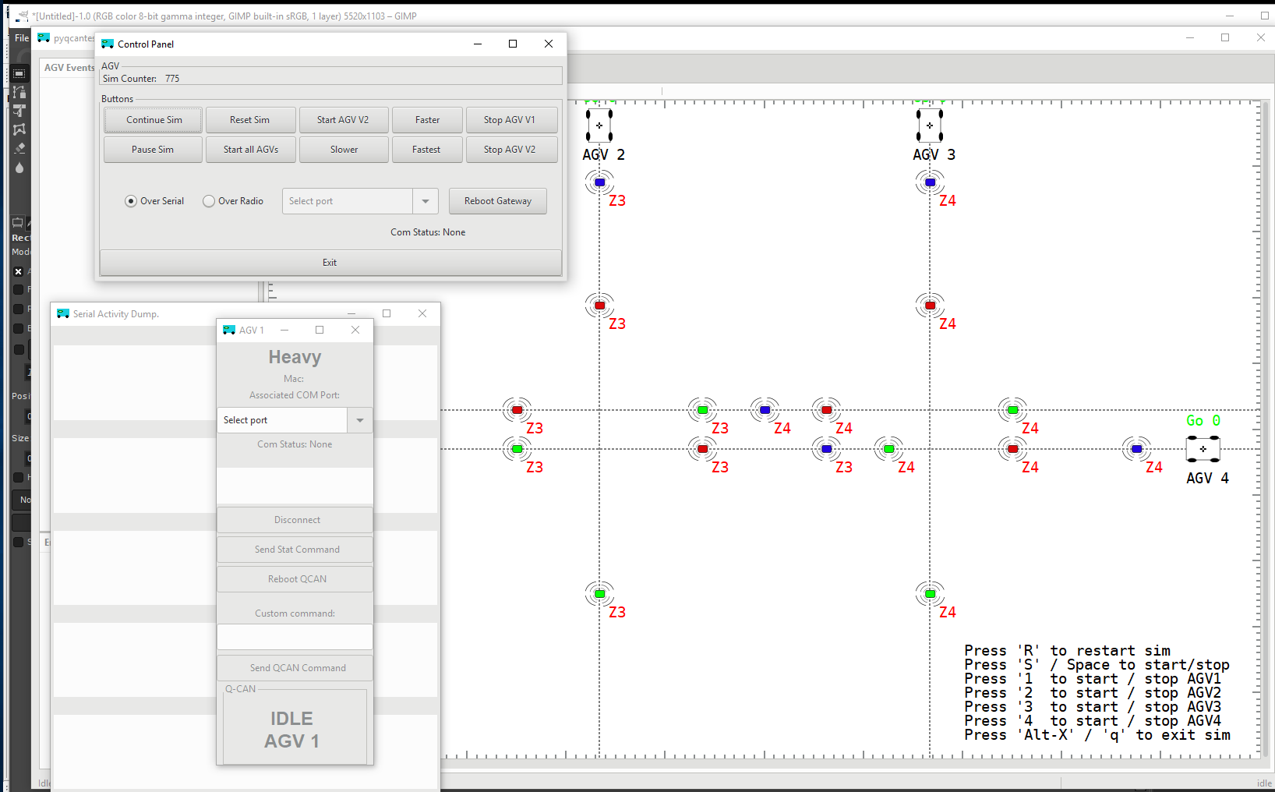
This simulation has yielded us considerable insight onto the challenges we face. We (re) discovered the phenomena of the duplicate bully, could see the delays in communication and response, and could tune the QCAN2 state machine to adapt to the challenges of the real world RF uncertainty. It is also included and installed in the provided laptop.

