TRADELINE AFRICA HOLDINGS
BUSINESS OPERATING SYSTEM
Tradeline BOS
Development & Implementation Proposal
A complete Business Operating System blueprint covering strategy, KPIs, pipeline, payments, proposals, cross-selling, security, delivery timeline, commercial terms and acceptance criteria — approval-ready for budgeting and development contracting.
Prepared for: BAPX & Tradeline Consult Group
Prepared by: Sam Atiemo, Founder & CEO, Tradeline Africa Holdings Ltd.
Date: 14 July 2026
Version: 2.0 (Approval-Ready)

Contents
1. Executive Summary & Business Case
2. Current Operational Problems & Financial Consequences
3. BOS Architecture & Modules
4. Scope of the Current Development Phase
5. Roles & Permissions
6. Data Model & Integration Architecture
7. Detailed KPI Framework
8. Dashboard Specifications
9. Payment & Receivables Module
10. Proposal & Opportunity Deadline Management
11. Cross-Selling & Client Intelligence
12. Alerts, Escalation & Approvals
13. Security & Data Governance
14. Delivery Timeline & Sprint Plan
15. Commercial Proposal & Payment Milestones
16. Testing, Training & Deployment
17. Support, Maintenance & Service Levels
18. Acceptance & Sign-Off Criteria
Appendix A: Workstream Technical Detail & Acceptance Checklists

1. Executive Summary & Business Case
Tradeline Africa Holdings operates six companies — BAPX, Tradeline Consult, Alpha Africa, Finance Factory, Community Finance, and Akoteq — each generating deals, KPIs and revenue on disconnected spreadsheets and informal tracking. This document proposes the Tradeline Business Operating System (BOS): a single group-wide platform for staff management, KPI accountability, pipeline visibility, payment tracking, proposal control, and executive intelligence.

The Problem
- Deal and revenue data lives in separate, inconsistent spreadsheets per company — no group-wide view exists.
- KPI tracking is informal; targets are rarely set, verified, or audited.
- Proposal deadlines are tracked manually, creating a real risk of missed submissions and lost revenue.
- Cross-selling between the six companies happens by accident, not by design — high-value referral revenue is left on the table.
- Executives cannot see group-wide revenue, risk, or performance without manually consolidating six sources.

The Business Case
A working BOS converts fragmented company operations into a single accountable system. The financial case rests on four levers:
Lever | Mechanism | Estimated Impact
Proposal deadline control | Automated alerts prevent missed submissions | Recovers opportunities currently lost to missed deadlines
Cross-selling engine | Systematic referral tracking across 6 companies | New revenue stream from existing client base
KPI accountability | Verified targets vs actuals, on-track/at-risk flags | Earlier intervention on underperforming BDOs/companies
Receivables visibility | Structured payment plans + ageing analysis | Faster collection, reduced overdue balances

What This Document Covers
This is Phase 2 of the Tradeline BOS: the performance, accountability and executive intelligence layer, built on the existing User/BDO/KpiScorecard/deal data model. It is scoped, timed, priced and sequenced for formal approval. Sections 3–4 place this phase within the full BOS architecture so leadership can see how it connects to CRM, finance, HR and document management in later phases.

2. Current Operational Problems & Financial Consequences
Problem | Where It Shows Up | Financial Consequence
No group-wide revenue view | Executives manually consolidate 6 spreadsheets monthly | Delayed decisions; risk hidden until month-end
No proposal deadline tracking | BDOs track submissions informally | Missed deadlines = 100% loss of that opportunity's value
Inconsistent KPI definitions | Each company reports differently | Cannot compare performance or allocate resources rationally
No payment schedule tracking | Revenue booked as one number, not a plan | Overdue receivables go unnoticed until cash is tight
No cross-selling mechanism | Referrals happen informally, if at all | Group-wide revenue potential unrealized
No audit trail on KPI entries | Actuals self-reported without verification | Risk of inflated or inconsistent performance data
Each of these is addressed directly by a workstream in Section 4 and governed by the frameworks in Sections 7–13.

3. BOS Architecture & Modules
The full Tradeline Business Operating System spans five architectural layers. This document delivers Layers 3–5 in complete form and lays the data foundations that Layers 1–2 will build on.
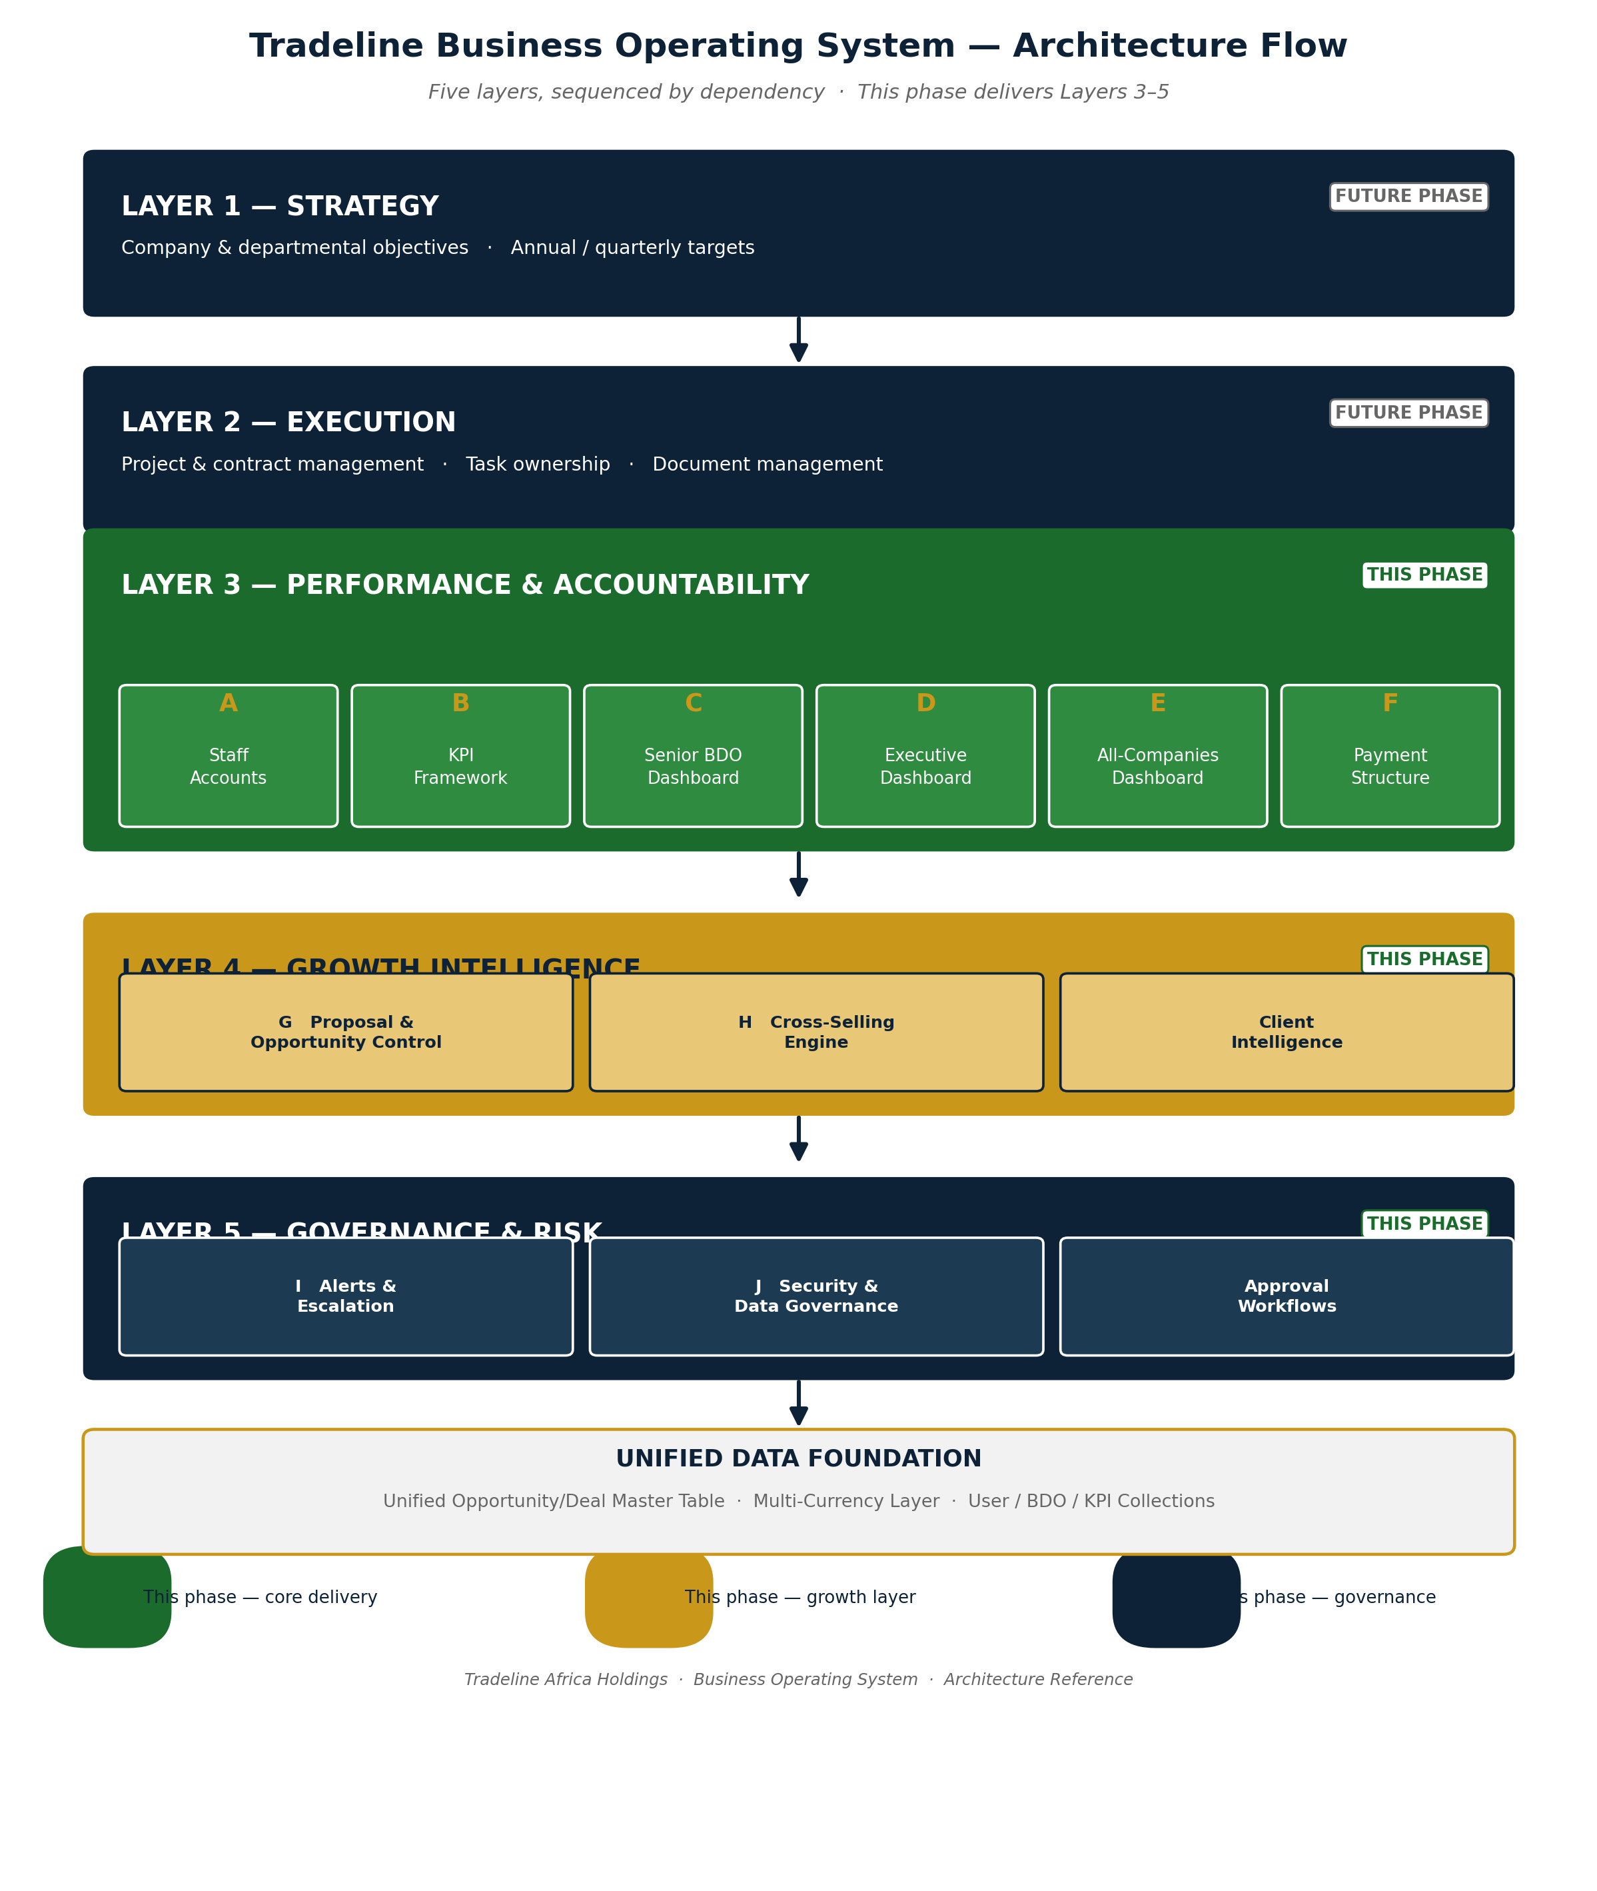
Layer | Modules | Status
1. Strategy | Company & departmental objectives, annual/quarterly targets | Future phase
2. Execution | Project & contract management, task ownership, document management | Future phase
3. Performance & Accountability | Staff accounts, KPI framework, dashboards (Senior BDO / Executive / All-Companies), payment structure | This phase
4. Growth Intelligence | Proposal & opportunity control, cross-selling engine, client relationship management | This phase (Sections 10–11)
5. Governance & Risk | Alerts/escalation, security & data governance, approval workflows | This phase (Sections 12–13)
This phase therefore delivers substantially more than dashboards alone: it establishes the KPI, revenue, and payment data model that Layers 1 and 2 will read from when built.

4. Scope of the Current Development Phase
Six core workstreams, sequenced by dependency, plus the four governance layers required for approval-readiness (proposal control, cross-selling, alerts, security).
# | Workstream | One-Line Description | Depends On
A | Staff Accounts | Invite & manage all staff logins with correct role & company | —
B | KPI Framework | Group, company and per-BDO KPIs — targets vs actuals, verified | A
C | Senior BDO Dashboard | Team-lead view: pipeline & KPIs for direct reports | A, B
D | Executive Dashboard | Group-wide revenue, KPI health, top deals & risks | B
E | All-Companies Dashboard | Side-by-side comparison across all six companies | B, D
F | Payment Structure | Structured payment plans, receivables & ageing | —
G | Proposal & Opportunity Control | Deadline tracking, bid/no-bid, escalation | A, B
H | Cross-Selling Engine | Referral tracking across the six companies | B, D
I | Alerts & Escalation | Automated notifications across all workstreams above | A–H
J | Security & Governance | Access control, audit trail, data protection compliance | A (runs throughout)

5. Roles & Permissions

Current State
- ADMIN — full access, manages BDOs & users.
- CEO — executive read access.
- BDO — own dashboard, own pipeline & tasks.
A login (User) optionally links to a BDO profile via bdoId; the BDO profile carries the company.

Proposed Addition: Senior BDO
- SENIOR_BDO — a BDO who also leads a team within a company.
- Sees their own numbers plus every BDO they supervise.
- Requires managerId on the BDO profile, linking team members to their lead.

Access Matrix (Target)
Capability | BDO | Senior BDO | CEO / Exec | Admin
Own dashboard, pipeline & tasks | ✔ | ✔ | ✔ (all) | ✔
Team members' pipeline & KPIs | — | ✔ (their team) | ✔ (all) | ✔
Company & per-BDO KPI scorecards | Own | Team | All | All
Executive / all-companies dashboards | — | — | ✔ | ✔
Proposal & opportunity control centre | Own | Team | All | All
Manage staff accounts & KPIs | — | — | — | ✔
Payment plans & receivables | Own deals | Team deals | All | All
Security & audit configuration | — | — | View only | ✔

6. Data Model & Integration Architecture
Page 7 of the prior draft proposed aggregating BapxDeal, TradelineDeal and CompanyDeal directly. Different companies currently use separate deal models with potentially different field names, pipeline stages and revenue definitions — aggregating them as-is risks duplicate clients, inconsistent reporting, and expensive future maintenance.

Recommended Fix: Unified Opportunity / Deal Master Table
A single group-wide Opportunity/Deal model, with company-specific detail sitting in extension tables rather than fully separate deal systems.
Master Table Field | Purpose
Company, Client, Opportunity Owner | Identity & ownership
Country, Sector, Service Line | Segmentation for group reporting
Deal Stage, Probability | Pipeline position
Currency, Deal Value, Expected Revenue | Financial sizing (see Section 7 for definitions)
Expected Close Date, Contract Status | Timeline & conversion tracking
Payment Status, Risk Status | Links to payment module (Section 9)
Last Action Date, Next Action | Feeds proposal control & alerts (Sections 10, 12)
Cross-Selling Potential | Feeds cross-selling engine (Section 11)

Multi-Currency Handling
Tradeline operates across Ghana, Rwanda, Kenya and Nigeria, with deals in GHS, USD, EUR, NGN and RWF. Every financial record must carry both the original transaction currency and a converted reporting figure — the prior draft's group revenue totals did not account for this.
Field | Purpose
Original Currency | As transacted
Original Amount | As transacted
Exchange Rate | Rate applied at conversion
Reporting Currency | Group standard (USD or GHS — decision needed, see Section 18)
Converted Amount | For group roll-ups
Exchange-Rate Date | For audit and reconciliation
Existing structures — User, BDO, KpiScorecard, MonthlyKpi and current deal collections — are reused, not rebuilt, keeping development cost and time down.

7. Detailed KPI Framework
Generic activity metrics (deals won, calls, meetings) are insufficient on their own for Tradeline's advisory- and outcome-driven model. KPIs are structured in three levels: group-wide standard, company-specific, and individual role-specific.

Level 1 — Group-Wide Standard KPIs (all roles)
Commercial Outcomes
- Revenue target vs. revenue collected
- Value of opportunities generated
- Value of proposals submitted
- Value of contracts won
- Gross margin generated
- Outstanding payments recovered
Pipeline Management
- Number of qualified opportunities
- Pipeline value and weighted pipeline value
- Proposal conversion rate
- Average deal cycle
- Number of stale opportunities / % updated on time
Client Development
- New clients acquired; existing clients retained
- Client meetings; cross-selling opportunities identified
- Referrals generated; client satisfaction
Execution & Accountability
- Tasks completed on time; proposals submitted before deadline
- Reports submitted on time; data completeness
- Follow-up compliance; management action items closed
Strategic Impact
- Funding raised for clients; jobs created; SMEs supported
- Access-to-market value; investments facilitated; partnerships secured

Level 2 — Company-Specific KPIs
Company | Primary KPIs
Tradeline Consult | Advisory revenue, finance facilitated, SMEs supported, proposals won
BAPX | Placements, recruitment revenue, time-to-fill, talent retention
Alpha Africa | Commodity volumes, gross margins, stock turnover, receivables
Finance Factory | Investments originated, capital raised, portfolio returns
Community Finance (Cofi) | Loan disbursements, repayment rate, portfolio at risk
Akoteq | Projects delivered, recurring technology revenue, system uptime

Level 3 — Role-Specific KPI Templates
The system supports distinct KPI templates for BDOs, company heads, finance officers and project leads, rather than one generic set applied to every role.

KPI Ownership, Approval & Audit Workflow
The prior draft did not define who sets, enters, verifies or approves KPI data — a significant risk of manipulated or inconsistent performance figures. The following workflow closes that gap:
Target proposed → Manager approves → Actual submitted → Evidence attached → Manager verifies → Scorecard locked
Every change to a locked scorecard is logged with: editor, date/time, previous value, new value, and approval status. BDOs cannot silently edit past results.

8. Dashboard Specifications

Dashboard Hierarchy
BDO (own numbers) → Senior BDO (their team) → Executive (whole group), with an All-Companies comparison view sitting alongside the Executive dashboard.

C. Senior BDO Dashboard
- Team pipeline: combined deals, stages, health, potential vs. received revenue.
- Team KPI board: each member's target vs. actual, ranked, with team totals.
- Task rollup: open / overdue / completed tasks across the team.
- Drill-down into any team member's individual dashboard.
- Scoped strictly to members linked via managerId — no visibility into other teams or companies.

D. Executive Dashboard
- Group headline tiles: total potential / received / outstanding revenue across all six companies, in the standard reporting currency (see Section 6).
- Revenue & deal trend charts over time.
- KPI health summary: on-track vs. at-risk vs. off-track counts.
- Top deals and top risks (largest at-risk or stale deals) pulled from every pipeline.
- Proposal deadlines at risk, pulled from the Proposal & Opportunity Control Centre (Section 10).
- Per-company snapshot strip linking through to company detail.

E. All-Companies Dashboard
Where the Executive dashboard answers "how is the group doing?", this view answers "how do the companies compare to each other?" One row per company, sortable and exportable.
Company | Active Deals | Closed Won | Potential Rev. | Received | Outstanding | KPI Health
BAPX | … | … | … | … | … | …
Tradeline Consult | … | … | … | … | … | …
Alpha Africa | … | … | … | … | … | …
Finance Factory | … | … | … | … | … | …
Community Finance | … | … | … | … | … | …
Akoteq | … | … | … | … | … | …

Revenue Definitions (Standardized)
The previous draft used "potential revenue" ambiguously — it could mean pipeline value, weighted pipeline, signed contracts, or invoiced amounts. Every dashboard in this system uses the following fixed definitions, and unsigned opportunities are never treated as recognised revenue:
Term | Definition
Unqualified Opportunity Value | Raw value of a lead before qualification
Qualified Pipeline Value | Value of opportunities that have passed qualification
Weighted Pipeline Value | Pipeline value × stage probability
Contracted Revenue | Value of signed contracts
Invoiced Revenue | Amount invoiced to date
Cash Collected | Amount actually received
Accounts Receivable | Invoiced but not yet collected
Overdue Receivables | Receivables past due date

9. Payment & Receivables Module
Deal collections already track revenue, received amounts and outstanding balances as single numbers. This module adds the how — payment method, instalments/milestones and schedule — so a deal's money is tracked against a defined plan rather than a lump figure.

Structure
Layer | Purpose
1. Commercial Agreement | The underlying contract terms
2. Payment Plan | Milestones, instalments, schedule
3. Invoice | Formal request for payment against a milestone
4. Payment Transaction | Actual payment received, incl. partial payments
5. Outstanding Receivable | Unpaid balance, with ageing
6. Commission / Profit-Share Allocation | Introducer fees, profit splits, recruitment placement fees

Elements Covered
- Invoice generation, commitment fees, success fees, retainers
- Milestone payments, recruitment placement fees, profit-sharing arrangements, commissions
- Taxes and withholding; payment evidence; partial payments; credit notes
- Payment reminders; ageing analysis; collection responsibility
This distinction matters because Tradeline's six companies earn revenue through different models — advisory retainers, recruitment placement fees, commodity margins, and investment returns — and a single generic "amount paid" field cannot represent all of them accurately.
Input Required
The payment Excel sheet referenced in the original workflow is still needed to finalize the exact schema. The structure above is fully specified and ready to build; the sheet only determines field-level mapping, not the architecture.

10. Proposal & Opportunity Deadline Management
One of the strongest business cases for the BOS is preventing revenue loss from missed deadlines, delayed proposals and weak follow-up — yet this was absent from the original workflow. This is treated as a Phase 1 priority, not deferred.

Proposal & Opportunity Control Centre
- Opportunities closing within 7, 14 and 30 days — visible group-wide and per company.
- Drafting status, responsible team member, reviewer and approver.
- Bid/no-bid decision recorded against every opportunity.
- Missing documents flagged automatically.
- Submission confirmation logged with timestamp.
- Probability of success and revenue at risk shown per opportunity.
- Automated reminders and escalation of overdue proposals (see Section 12).
This module feeds directly into the Executive Dashboard's "top risks" tile and the alerts engine in Section 12.

11. Cross-Selling & Client Intelligence
The All-Companies dashboard lets leadership compare the six businesses side by side, but comparison alone does not make them work together. This module is designed to become one of the highest-value features in the BOS by systematically surfacing referral opportunities that today happen only by chance.

Example Opportunities the System Surfaces
- A Tradeline Consult client needing recruitment support → routed to BAPX.
- A BAPX client requiring technology systems → routed to Akoteq.
- A Tradeline Consult client requiring finance → routed to Finance Factory or Community Finance.
- A commodity client requiring aggregation/supply support → routed to Alpha Africa.

Fields Added to the Deal Master Table
Field | Purpose
Cross-Selling Opportunity Flag | Marks a deal as having referral potential
Recommended Group Company | Which of the six companies could serve the need
Referral Owner | Who is responsible for making the introduction
Referral Status | Identified / introduced / converted / declined
Referral Revenue | Value generated from the referral
Group Companies Serving Same Client | Visibility into existing overlap
Untapped Services by Client | Services the client hasn't been offered yet

12. Alerts, Escalation & Approvals
Dashboards only create value when someone acts on them. The system actively pushes alerts rather than waiting for managers to check dashboards manually.

Alert Triggers
Trigger | Escalation Path
Proposal deadline approaching | BDO → Senior BDO (if unactioned in 48h)
Opportunity not updated for 7 days | BDO → Senior BDO
Overdue payment | BDO → Senior BDO → Company Head
KPI below target | BDO → Senior BDO
BDO without sufficient pipeline | Senior BDO → Company Head
High-value deal at risk | Senior BDO → Executive
Task overdue | Owner → Manager
Contract expiring | Account owner → Senior BDO
Client follow-up overdue | BDO → Senior BDO
Company revenue below monthly target | Company Head → Executive
Escalation severity increases automatically the longer an item remains unactioned, moving from BDO → Senior BDO → Company Head → Executive.

13. Security & Data Governance
The system handles highly sensitive information: employee performance data, deal values, client data and payment records. The following controls are mandatory, not optional, given this scope.

Access & Authentication
- Two-factor authentication for all Admin and Executive accounts.
- Session expiry after a defined period of inactivity.
- Temporary passwords delivered via secure activation links, never displayed or manually handed over.
- User deactivation process for departing staff, with immediate access revocation.

Data Protection
- Data encryption at rest and in transit.
- Daily backups with tested disaster recovery procedure.
- Defined data retention policy per record type.
- Full audit trail on all KPI, deal and payment record changes (see Section 7 workflow).
- Compliance with the Ghana Data Protection Act, and per-country data residency requirements for Rwanda, Kenya and Nigeria operations.
Open Legal Item
Per-country data residency requirements for Rwanda, Kenya and Nigeria still require legal research before multi-country rollout — this is a standing gap carried from the SME-OS Product Bible and applies equally here.

14. Delivery Timeline & Sprint Plan
Phasing is dependency-based — each phase unblocks the next — mapped here to calendar weeks so management knows when the system is operational and what the minimum viable release looks like.
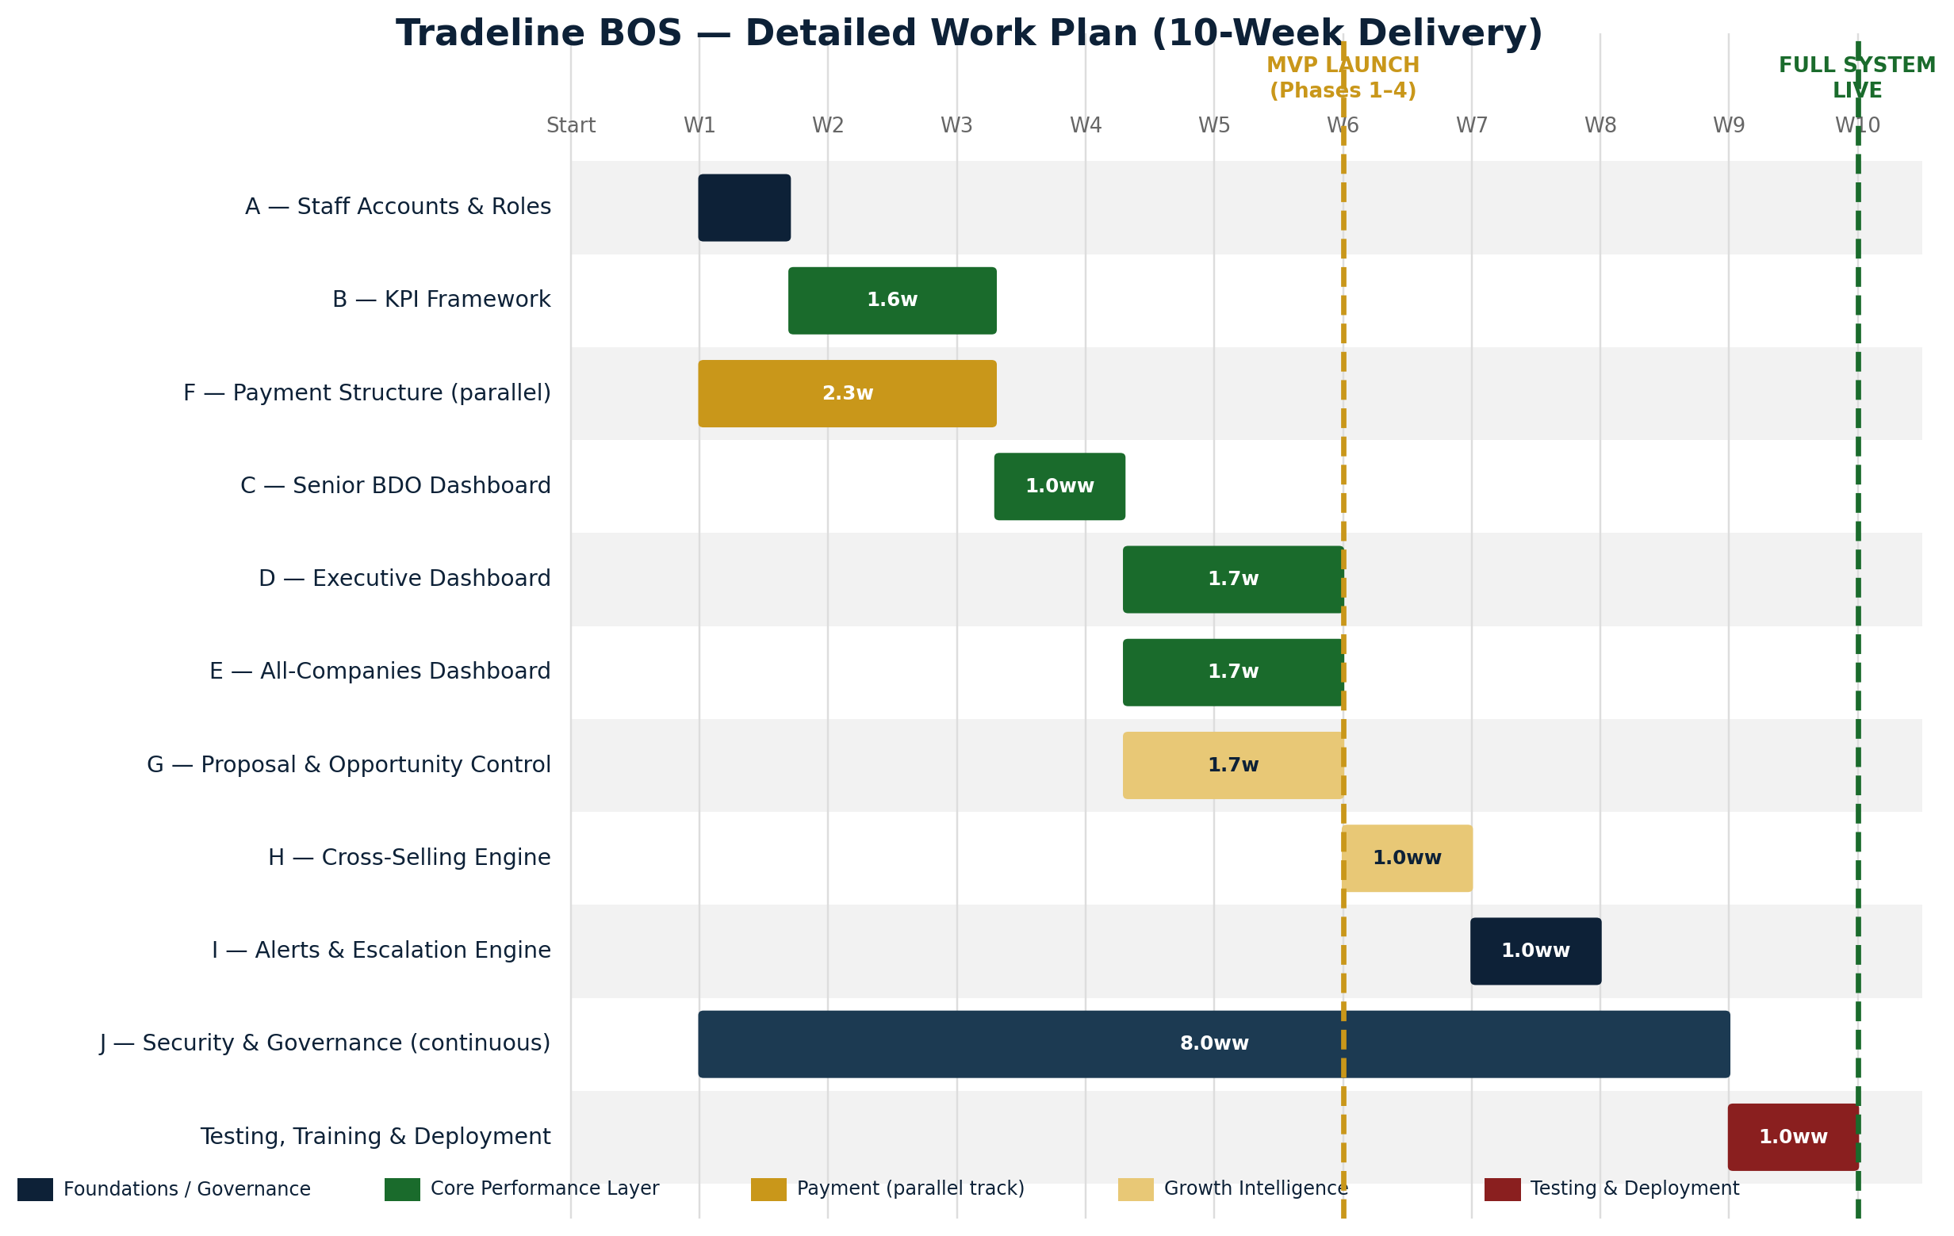

Phase Summary
Phase | Deliverable | Duration | Target | Dependency
1 | Staff accounts & roles (incl. Senior BDO, managerId) | 5–7 working days | Week 1 | None
2 | KPI framework (6 companies + per-BDO) | 7–10 working days | Weeks 2–3 | Phase 1
3 | Senior BDO dashboard | 5–7 working days | Week 4 | Phases 1–2
4 | Executive & All-Companies dashboards | 10–14 working days | Weeks 5–6 | Phase 2
5 | Payment structure module | 7–10 working days | Parallel from Week 1* | Excel sheet
6 | Proposal & opportunity control centre | 7–10 working days | Weeks 5–6 | Phases 1–2
7 | Cross-selling engine | 5–7 working days | Week 7 | Phase 4
8 | Alerts & escalation engine | 5–7 working days | Week 8 | Phases 1–7
9 | Security hardening & audit trail | Ongoing from Phase 1 | Weeks 1–9 | Runs throughout
10 | Testing, training, deployment | 7–10 working days | Week 9–10 | All phases
*Payment module starts immediately once the Excel sheet is received; if not received by Week 1, it moves to run parallel with Phase 4.

MVP Launch Target
Minimum viable release = Phases 1–4 (staff accounts, KPI framework, Senior BDO dashboard, Executive dashboard) — targeted for end of Week 6. Full system (all 10 phases) targeted for end of Week 10.

Detailed Work Plan — Ownership & Sign-Off
Each phase carries a named accountable owner, a reviewer, and an explicit sign-off gate before the next dependent phase begins. Names in brackets are recommended defaults pending confirmation.
Phase | Workstream Lead | Reviewer / Approver | Sign-Off Gate
1 | Development lead (external/BAPX-assigned) | Sam Atiemo | Admin can provision all 6 companies + all roles
2 | Development lead | Ebo Awortwe (metric validation) | Scorecards live for all 6 companies; per-BDO targets visible
3 | Development lead | Wendy (as pilot Senior BDO) | Pilot Senior BDO confirms team view accuracy
4 | Development lead | Sam Atiemo | Executive dashboard matches manual month-end consolidation
5 | Development lead | Sam Atiemo (on Excel sheet receipt) | Payment plan reconciles against source sheet, zero variance
6 | Development lead | Forster Gomashie (ops sign-off) | All open proposals visible with deadline + owner
7 | Development lead | Sam Atiemo | First cross-company referral logged end to end
8 | Development lead | Sam Atiemo | All 10 alert triggers verified in test data
9 | Development lead + external security review | Sam Atiemo | 2FA, backups, audit trail independently verified
10 | Development lead | Sam Atiemo + 2 users per role (UAT) | UAT sign-off across all roles before go-live

15. Commercial Proposal & Payment Milestones
The prior draft mentioned a payment-structure module for the client's own deals but did not state how the developer would be paid for building the BOS itself. This section closes that gap with a milestone structure tied to delivery acceptance.

Payment Milestones (% of Total Development Price)
Milestone | Trigger | % of Total
Mobilisation | Contract signing | 30%
Staff accounts & access | Phase 1 acceptance | 20%
KPI framework | Phase 2 acceptance | 20%
Executive & All-Companies dashboards | Phase 4 acceptance | 20%
Testing, training & deployment | Go-live sign-off | 10%

Commercial Terms Requiring Definition
- Total development price, or price per workstream (alternative pricing approach for easier approval).
- Deposit requirement (recommend aligning to the 30% mobilisation milestone above).
- Ongoing hosting cost, separate from development price.
- Monthly/annual maintenance fee post-launch.
- Change-request cost for scope added after sign-off.
- Warranty / bug-fix period following go-live (recommend minimum 30 days at no additional cost).
Decision Needed
Confirm whether pricing will be quoted as one total development price or itemized per workstream (A–J). Itemized pricing is recommended — it lets you approve and sequence phases independently if budget is constrained.

16. Testing, Training & Deployment

Acceptance Criteria — Functional (per workstream)
Each workstream in Section 4 carries its own "done when" checklist (see Appendix A). These are necessary but not sufficient on their own.

Acceptance Criteria — Non-Functional (system-wide)
☐ Dashboard loads within an agreed period (target: under 3 seconds).
☐ Role permissions tested against the access matrix in Section 5 — no unauthorised cross-company access.
☐ Mobile and tablet responsive, given Sam's mobile-first working style.
☐ Export matches on-screen data exactly.
☐ Audit log retained and queryable for all KPI, deal and payment changes.
☐ Backups completed daily and restore tested at least once before go-live.
☐ Calculation results (revenue roll-ups, weighted pipeline, KPI attainment) tested against sample data.
☐ At least two users per role complete User Acceptance Testing (UAT).

Training & Change Management
- Pilot group identified before full rollout (recommend: one Senior BDO team).
- Role-specific training: BDO, Senior BDO, Company Head, Executive, Admin.
- System administrator training, separate from end-user training.
- KPI orientation session so staff understand the target-approval-verification workflow before go-live.
- Data migration from existing spreadsheets, with a validation pass before cutover.
- User manuals per role.
- Two- to four-week stabilisation period post go-live with weekly adoption monitoring and data-quality audits.

17. Support, Maintenance & Service Levels
Item | Recommended Standard
Bug-fix warranty period | 30 days post go-live, no additional cost
Post-warranty support | Defined monthly retainer or per-incident rate
Critical issue response time | Same business day
Non-critical issue response time | Within 3 business days
Monthly system utilisation review | Ongoing, first review at 30 days post go-live
Backup verification | Monthly restore test

18. Acceptance & Sign-Off Criteria
This document is ready for formal approval once the five items below are confirmed. All architectural, KPI, financial-definition, and governance content is already complete in Sections 3–13.

Outstanding Inputs Before Development Begins
# | Input Needed | Blocks | Owner
1 | Payment Excel sheet | Workstream F (Payment Structure) | Sam Atiemo
2 | Confirm standard BDO KPI metric list (Section 7 provides the recommended set) | Workstream B (KPI Framework) | Sam Atiemo
3 | Team structure — which BDOs report to which Senior BDO | Workstreams A & C | Sam Atiemo / Wendy
4 | Executive dashboard vs. current CEO home page — replace or run alongside | Workstream D | Sam Atiemo
5 | Standard reporting currency (USD or GHS) for group roll-ups | Section 6 (Multi-Currency) | Sam Atiemo
6 | Pricing approach — total price vs. itemized per workstream | Section 15 (Commercial Terms) | Sam Atiemo

Approval
Approved for development by:

Sam Atiemo — Founder & CEO, Tradeline Africa Holdings Ltd.

Date

Appendix A: Workstream Technical Detail & Acceptance Checklists
Retained from the original technical workflow for engineering reference. Each workstream's steps, data-model impact and completion criteria.

A. Staff Accounts
Move from "invite a BDO" to "invite any staff member" with the correct role and company.
- Add SENIOR_BDO to the User.role enum and to the invite form's role selector.
- Add managerId (nullable) to the BDO profile so members can point to their Senior BDO.
- Extend the Manage Users screen: filter by role & company, show status, resend invite / reset password.
- On invite, deliver temporary credentials via secure activation link (see Section 13).
Data model: User.role enum → ['ADMIN','CEO','SENIOR_BDO','BDO']. BDO: add managerId: string | null.
☐ Admin can create an account for any role and any of the six companies.
☐ A Senior BDO can be linked to the members they supervise.
☐ New staff are forced to set a password on first login.

B. KPI Framework — Companies & BDOs
- Widen KpiScorecard.company enum to all six company keys.
- Update KPI Scorecard page filters/form to list all companies (currently hardcoded to BAPX/Tradeline).
- Build a per-BDO KPI editor on top of MonthlyKpi (metric, month, target, actual, notes).
- Surface per-BDO KPI tiles (target vs. actual, % attainment, on-track/at-risk/off-track) on the BDO dashboard.
- Apply the standard metric set from Section 7 so every BDO is measured consistently.
- Implement the target-approval-verification workflow from Section 7.
☐ Company KPI scorecards can be entered for all six companies.
☐ Each BDO has monthly targets vs. actuals visible on their dashboard.
☐ Attainment status (on-track / at-risk / off-track) is computed, not typed.
☐ KPI changes after lock require manager approval and are logged.

C. Senior BDO Dashboard
- New route /senior/[id] (or a "team" tab on the BDO dashboard when role = SENIOR_BDO).
- API: list deals/tasks/KPIs where the BDO's managerId = the senior BDO (plus the senior's own).
- Reuse existing pipeline charts & stat tiles; add a per-member leaderboard table.
- Sidebar: show a "My Team" link when the logged-in user is a Senior BDO.
☐ A Senior BDO logs in and sees their team's combined pipeline, revenue and KPIs.
☐ They can drill into any team member's own dashboard.
☐ They cannot see other teams or other companies.

D. Executive Dashboard
- New route /executive, restricted to CEO/Admin.
- API aggregation endpoint summing across the unified Deal Master Table and KPI collections (Section 6).
- Build tiles + trend/health charts; reuse revenue formatting from Section 8.
- Add to the CEO sidebar as the landing view (pending decision in Section 18, item 4).
☐ The CEO sees group-wide revenue, trends and KPI health without opening each company.
☐ Top deals and top risks surface automatically.
☐ Proposal deadlines at risk surface automatically (from Section 10).

E. All-Companies Dashboard
- New route /companies (or a tab on the Executive dashboard).
- Reuse the aggregation endpoint from D, grouped by company key instead of summed.
- Comparison table (sortable/exportable) + bar chart comparing revenue across companies.
- Each row links through to that company's pipeline/dashboard.
☐ All six companies appear in one comparison view with revenue & KPI health.
☐ The view is sortable and exportable, and each row drills through.

F. Payment Structure Module
- Map the payment Excel sheet columns to a PaymentPlan/PaymentSchedule model (milestone, due date, amount, %, status).
- Attach payment plans to deals; compute received vs. outstanding from the schedule.
- Optional one-time importer to load existing Excel rows so history isn't retyped.
- Surface a payment tab on the deal/pipeline view; roll paid/overdue amounts into dashboards above.
☐ A deal can carry a structured payment plan matching the source sheet.
☐ Received vs. outstanding is computed from the schedule, not entered by hand.
☐ Overdue payments surface on the relevant dashboards and trigger alerts (Section 12).

G. Proposal & Opportunity Control Centre
- New route /proposals with filters for 7/14/30-day deadline windows.
- Fields: drafting status, owner, reviewer, approver, bid/no-bid, missing documents, submission confirmation.
- Link every record to its parent Deal in the Master Table.
☐ Every open opportunity shows a deadline, owner and bid/no-bid status.
☐ Overdue or at-risk proposals surface on the Executive dashboard.

H. Cross-Selling Engine
- Add the cross-selling fields from Section 11 to the Deal Master Table.
- Build a referral tracking view: identified → introduced → converted → declined.
- Report referral revenue by originating and receiving company.
☐ A BDO can flag a deal as having cross-selling potential and route it to another company.
☐ Referral status and revenue are tracked end to end.

I. Alerts & Escalation Engine
- Implement the trigger table from Section 12 as scheduled jobs / event listeners.
- Notification delivery via in-app + email at minimum.
- Escalation logic: severity increases with time unactioned, per the paths in Section 12.
☐ All ten alert triggers from Section 12 fire correctly in test data.
☐ Escalation moves to the next role after the defined unactioned period.

J. Security & Governance
- Implement 2FA for Admin/Executive roles.
- Session expiry, encryption at rest/in transit, daily backups.
- Audit log covering all KPI, deal and payment changes.
☐ Security checklist in Section 13 fully implemented and independently tested.
☐ Data residency legal research completed for Rwanda, Kenya and Nigeria (see open item, Section 13).

