## Mean Counts of Top 20 Cells per Annotation ID

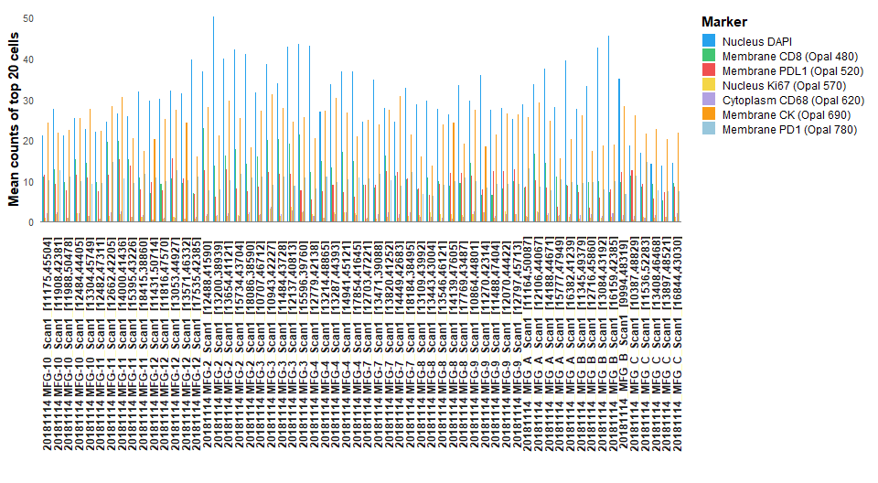

## Mean Counts of Bottom 10% Cells per Annotation ID

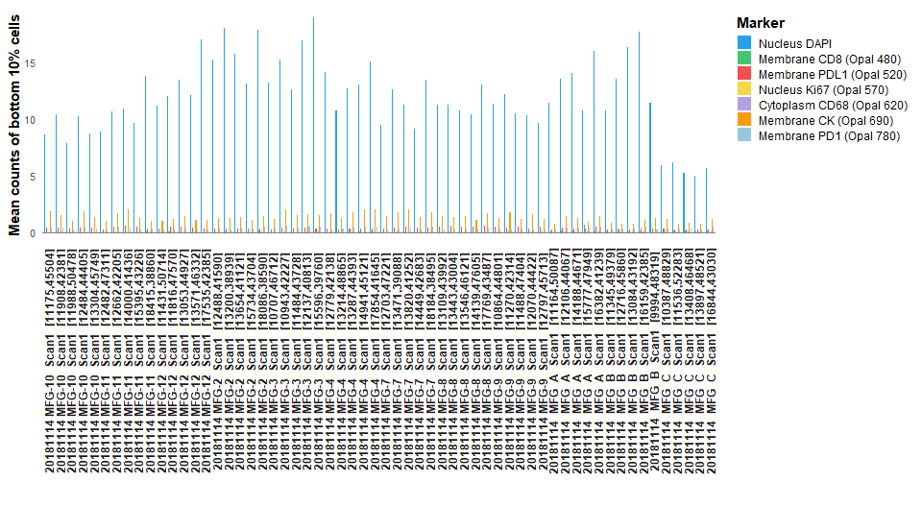

## Opal 780 Ratio (Top 20 / Bottom 10%) per Annotation ID

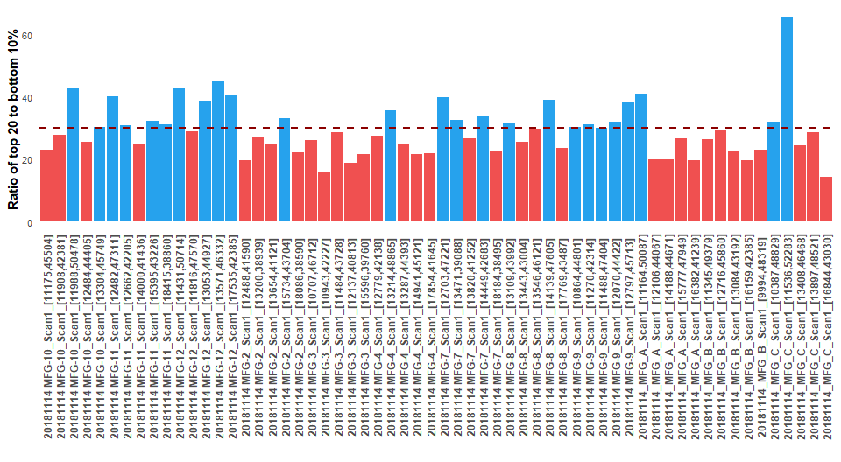

## Ratio of Top 20 Cells in Adjacent Fluors

