Assignment 1: Analysis
Alexander Kozin · OIM 3641 AI-Driven App Development · Fall 2026

Reflection: Making the Same Change Twice

1. What did you have to change in each version, and where?
In the demo, everything lived in one file, so the change was three small edits: a second slider in the sidebar, a second rolling().mean() line inside the if run_analysis: block, and 'MA_long' added to the px.line call, about 8 lines in total. In my version, the change was split across two files. In stock.py, the class learned how to compute a second average: I added an optional long_window argument and let _calc_ma write to a column other than 'MA'. In assignment_1.py, I added the second slider, passed it into the cached load_stock function (and both places that call it), and drew the extra line on the price chart. More lines changed in my version, but each file only handled its own part of the job.
demo_modified.py
mv_avg = st.sidebar.slider("Short Moving Average",
min_value= 1,
max_value= 100,
value= 20,
step= 1)
mv_avg_long = st.sidebar.slider("Long Moving Average",
min_value= 1,
max_value= 200,
value= 50,
step= 1)
...
df['MA'] = df['Close'].rolling(window=mv_avg).mean()
df['MA_long'] = df['Close'].rolling(window=mv_avg_long).mean()
...
fig = px.line(df, x=df.index, y=['Close', 'MA', 'MA_long'],
title=f"{ticker} Close with {mv_avg} and {mv_avg_long} day Moving Averages",
stock.py
def __init__(self,symbol, start, end, ma_window=10, long_window=None):
...
self.long_window = long_window # optional second MA, stored as MA_long
...
data = self._calc_ma(data, self.ma_window)
if self.long_window:
data = self._calc_ma(data, self.long_window, column='MA_long')
...
def _calc_ma(self, df, window, column='MA'):
df[column] = df['Close'].rolling(window=window).mean()
assignment_1.py
def load_stock(ticker, start_date, end_date, ma_window, long_window):
"""Create (and therefore download) a Stock. Cached on its arguments."""
return Stock(ticker, start_date, end_date,
ma_window=ma_window, long_window=long_window)
...
long_window = st.sidebar.slider("Long Moving Average (days)",
min_value=5, max_value=200, value=50, step=1)
if ma_window >= long_window:
st.sidebar.warning("The short window should be smaller than the long window.")
...
for column, window, dash in [("MA", ma_window, "dash"),
("MA_long", long_window, "dot")]:
# The first window - 1 rows of each MA are NaN, so drop them
ma = data[column].dropna()
price_fig.add_trace(go.Scatter(x=ma.index, y=ma, name=f"{window}-day MA",
line=dict(width=2, dash=dash)))

2. Which version was easier to change without breaking something?
The class version felt safer to change. Because long_window defaults to None, nothing that already worked could break: a call like Stock("AAPL", start, end, ma_window=10) still returns the same columns ending in 'MA', and only a call with long_window=50 adds MA_long. The demo was quicker to change, but there was nothing protecting me. When I copied its slider for the second average, I noticed it allows min_value= 0, and rolling(window=0) doesn't raise an error; it quietly returns all NaN, so the moving-average line just disappears. I fixed that by setting min_value= 1 on both demo sliders. The easy mistake in my version would have been forgetting to pass the new slider value through load_stock; the Stock would then be built without MA_long and the chart would ask for a column that doesn't exist.
>>> pd.Series(range(5), dtype=float).rolling(0).mean().tolist()
[nan, nan, nan, nan, nan]

3. Where did the class make the change harder, or force a design decision?
The class forced me to decide how Stock should accept a second average, while the demo let me skip that decision and just add another df[...] line. _calc_ma hard-coded the column name 'MA', so I had three options: rename the columns (e.g. MA_short / MA_long), accept a list of windows, or add one optional argument. I chose the optional long_window=None argument because it doesn't break existing code: plot_performance, plot_return_dist and anything that reads stock.data['MA'] keep working exactly as before. The downside is that the class now only handles two averages; a third would need a redesign, and at that point a list of windows would be the better choice.
def _calc_ma(self, df, window, column='MA'):
df[column] = df['Close'].rolling(window=window).mean()

4. Which version would you rather start from in six months?
I would start from the class version. In assignment_1.py both tabs get their data from the same call, stock = load_stock(ticker, start_date, end_date, ma_window, long_window), so the Portfolio tab reuses exactly the same download, return and moving-average logic as Tab 1 instead of duplicating it. A new feature such as annualized volatility would be one new method on Stock that both tabs can use. In the demo, the calculations are mixed into the Streamlit code inside the if run_analysis: block, so adding a feature means untangling them or copying them. To be fair, the demo is easier to read top to bottom if all you need is one chart, but the class version makes it obvious where a change belongs.
returns = {}
for symbol in tickers:
with st.spinner(f"Downloading {symbol}..."):
stock = load_stock(symbol, start_date, end_date, ma_window, long_window)
if stock.data is None:
st.error(stock.message)
continue
returns[symbol] = stock.data['return']

Portfolio Comparison: MSFT vs JPM (last 6 months)
I compared Microsoft (MSFT) and JPMorgan Chase (JPM) from April 2 to October 2, 2026 using the Portfolio tab; both lines start at exactly 0.0 on April 6, the first common trading day after the class drops the first row. For most of the summer JPM led, and by July 29 MSFT's cumulative return was only 4.9% versus 15.9% for JPM. The lines crossed on July 30, 2026, when MSFT posted a single-day log return of +14.4% (versus +1.8% for JPM), lifting it to 19.3% against JPM's 17.6%; JPM had also fallen 3.6% the day before. MSFT kept rising with +3.0% and +4.8% on July 31 and August 3, the first trading days after Microsoft released its fiscal fourth-quarter 2026 earnings after the market closed on July 29. Over the full window MSFT finished at about 32.7% cumulative return versus 11.9% for JPM, but with much higher daily volatility (2.30% vs 1.31% standard deviation of daily returns).
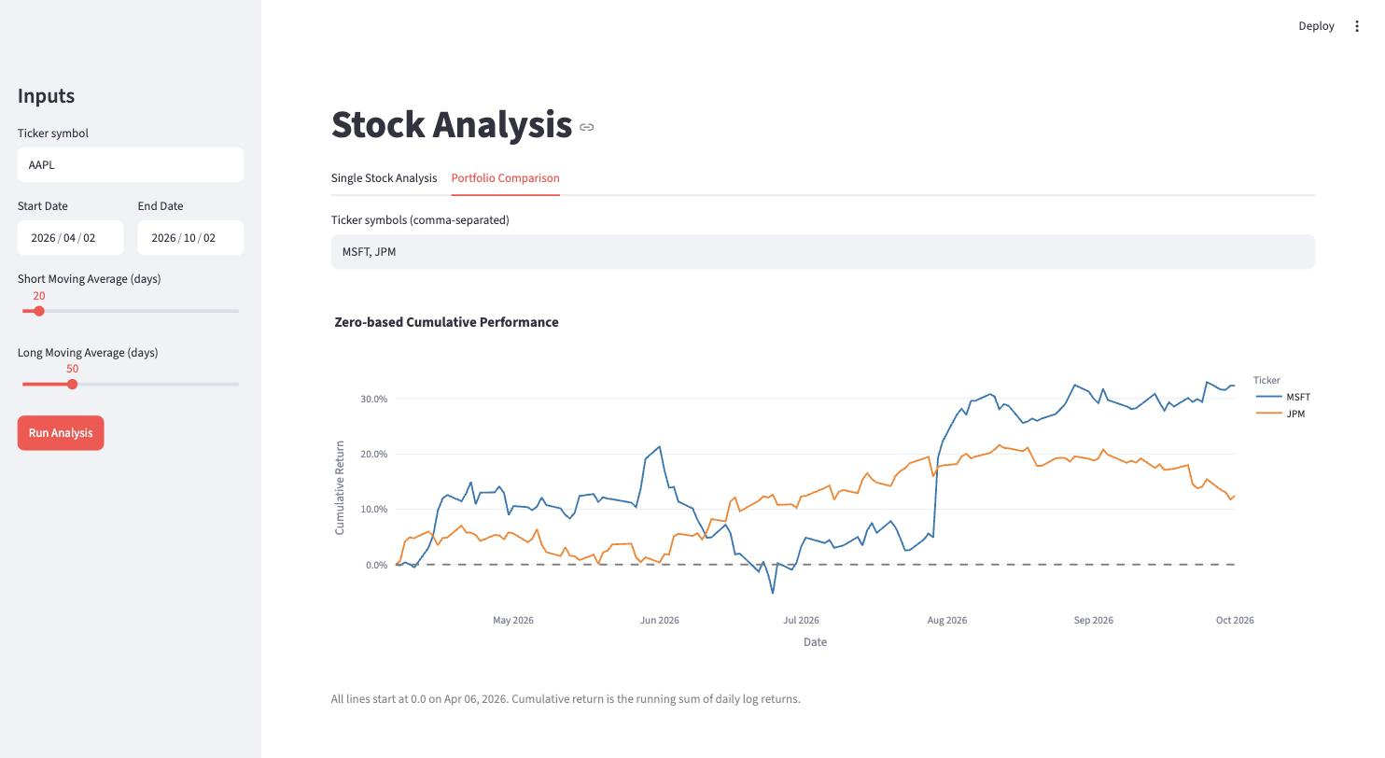
Figure 1. Portfolio tab: zero-based cumulative performance of MSFT and JPM, Apr–Oct 2026.

