

*Journal Geophysical Research – Earth’s Future*

Supporting Information for

**Skillful spring forecasts of September Arctic sea-ice extent using passive microwave sea ice observations**

**A. A. Petty1,2, D. Schröder3, J. C. Stroeve4,5, T. Markus2, J. Miller2, N. T. Kurtz2, D. L. Feltham3, D. Flocco3**

1Earth System Science Interdisciplinary Center, University of Maryland, College Park, MD, USA.

2Cryospheric Sciences Laboratory,NASA Goddard Space Flight Center, Greenbelt, MD, USA.

3Centre for Polar Observation and Modelling, Department of Meteorology, University of Reading, Reading, UK.

4National Snow and Ice Data Center, Cooperative Institute for Research in Environmental Sciences, University of Colorado, Boulder, Colorado, USA.

5Centre for Polar Observation and Modelling, University College London, London, UK.

**Contents of this file**

Text S1 and Figures S1 to S3

**Introduction**

This supplemental section provides a detailed description of the forecast methodology used in our study (explained more briefly in the primary manuscript) and more figures to increase the scope of the information included in the main manuscript.

**Text S1**

Here we provide a more detailed explanation of the forecast methodology used in this study. Our approach is based closely on the method presented in *Drobot et al.,* [2006, 2007] and implemented more recently by *Lindsay et al*., [2008] and *Schröder et al.,* [2014].

For making a forecast in a given year, *Yf*:

(1) Calculate the linear trend in the September Arctic sea ice extent (SIE) index from 1979 to (*Yf -1)* using a least-squares linear regression model. Subtract the trend line to generate a detrended SIE time series up to and including year *Yf -1*. Note that we should not have information regarding SIE in year *Yf*, so we only calculate the trend using data up to *Yf -1*.

(2) Fit all grid cells of the given predictor data (e.g. sea ice concentration) with a least-squares linear regression model (across the years 1979 to *Yf -1*). Subtract the trend line calculated from the predictor data at each grid cell to generate a de-trended/gridded predictor time series up to *Yf -1.* Note that we require at least three years of valid predictor data prior to the given forecast year (in a given grid-cell) to utilize that grid-cell in the given forecast.

(3) Use the linear regression model in each grid cell to calculate the detrended predictor values of the given forecast year, *Yf*, expected from linear trend persistence. Subtract this value from the predictor data at *Yf* to calculate the detrended/gridded predictor data for the given forecast year, *Yf*..

(4) Calculate the Pearson product-moment correlation coefficient (*r-*value) between the gridded/detrended predictor time series with the detrended September SIE (up to *Yf -1*) using a least-squares linear regression model. For the SIC (MO) data, set negative (positive) *r*-values to 0, as these are assumed to be physically inconsistent (e.g. one does not expect higher sea ice concentration in spring to result in lower September SIE). Note that negative MP data are also set to zero using the same logic.

(5) Multiply the gridded/detrended predictor time series up to *Yf -1* by the *r*-values (spatial weightings) and average, to generate a weighted/detrended predictor time series. Fit the weighted/detrended predictor time series to the detrended SIE time series with a least-squares linear regression model. This is our SIE prediction model for the given forecast year.

(6) Multiply the gridded/detrended predictor data for the current forecast year, *Yf ,* by the r-values (spatial weightings) calculated in step 4 and average, to generate a weighted/detrended predictor data point. Apply this value to the linear regression prediction model (calculated in step 5) to predict the detrended September SIE of the given forecast year, *Yf*.

(7) Use the linear regression of September SIE calculated in step 1 to calculate the SIE expected from linear trend persistence in year *Yf*. This value can be added to the forecast of detrended SIE (calculated in step 6) to provide our forecast of absolute SIE.

(7) The forecast error ($ε_{ferr}^{Y}$), is calculated as the difference between the observed SIE and the forecast SIE. The reference error ($ε_{anom}^{Y}$) is calculated as the difference between the observed SIE and the SIE from linear trend persistence (the detrended SIE).

To calculate the forecast skill, the root mean squared errors of the forecast and the reference value (linear trend persistence) are calculated by summing together the relative errors, $σ_{ferr}^{2}=\sum_{Yrs}{{\left(ε_{ferr}^{Y}\right)}^{2}}$ and $σ_{anom}^{2}=\sum_{Yrs}{{\left(ε_{anom}^{Y}\right)}^{2}}$ over the relevant forecast evaluation time period (e.g. Yrs=1985-2016 or 2008-2016) to estimate the forecast skill as .

**Macintosh HD:Users:aapetty:GitRepos:BitBucket:reports:MELT_PREDICTION:Figures:FigureS1.pdf**

Figure S1 . As in Figure 2, but for the May sea ice concentration (SIC), melt onset (MO, day 151), and melt pond (MP, May 1st- 31st) forecasts.

Macintosh HD:Users:aapetty:GitRepos:BitBucket:reports:MELT_PREDICTION:Figures:FigureS2.pdf

Figure S2: Forecast skill for the various forecast models as a function of forecast month for (a) all years of forecasts (1985-2016), and (b) recent forecast years (2008-2016). SIC: sea ice concentration, MO: melt onset, MP: melt pond model. The triangles (squares) indicate the multivariate forecast model skill using two (three) of the SIC/MO/MP datasets.

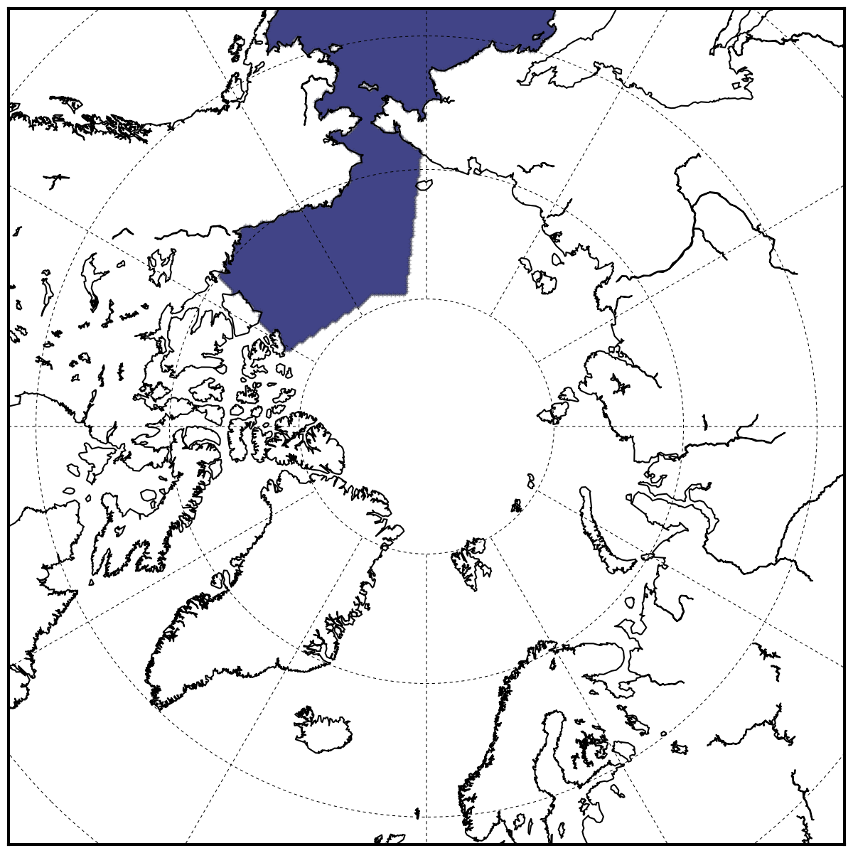

Figure S3: Alaskan region used to produce the regional forecast shown in Figure 7 is highlighted in purple. Region includes the Beaufort, Chukchi and Bering seas, as defined by the NSIDC Arctic region mask (http://nsidc.org/data/polar-stereo/tools\_masks.html). Note that the September Arctic sea ice edge rarely extends into the Bering Sea region, so this provided only a negligible impact on the Alaskan sea ice extent estimate.