# MA374 – Financial Engineering II

# LAB 01 Report

# -Aman Kumar (200123007)

***Question 1***

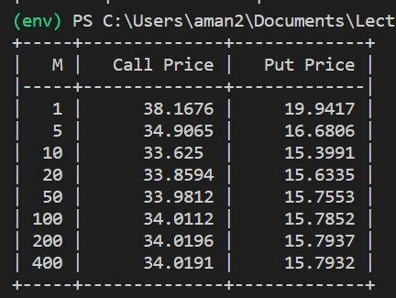

Observation –

1. The value of call option and put option starts to converge to a specific value as the number of subintervals i.e. M increases.
2. The value of call price is always greater than the put price which is obvious from the put call parity formula also.

The largest value of M –

1. In terms of computational time limit depending on the implementation M should have a max value of 5e4 or 1e9 because if we take M more than that then the calculations will take much more time. The numbers depend on the system on which code is run.
2. In terms of computer error, the max value is around 1e30, after this the u = d because of error, causing the value of p* to undefined.
3. In terms of mathematics, the value can be as large as we want.
4. But having M = 1000 or 10000 is good enough because at this point the option price has negligible error.

***Question 2***

Graphs – 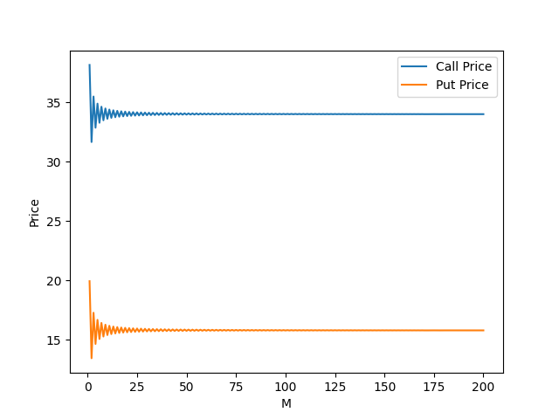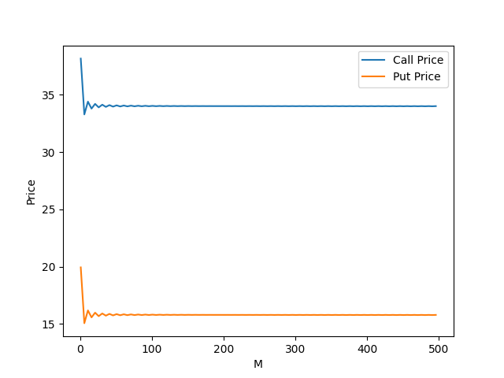

Steps = 1 Steps= 5

Observation –

1. The price oscillates around the true value for lesser values of M.
2. Once M is more than 100 there is no visible change in the graphs, it has converged.

***Question 3***

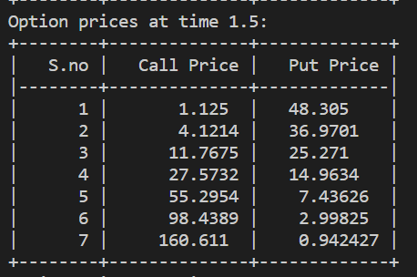Tables –

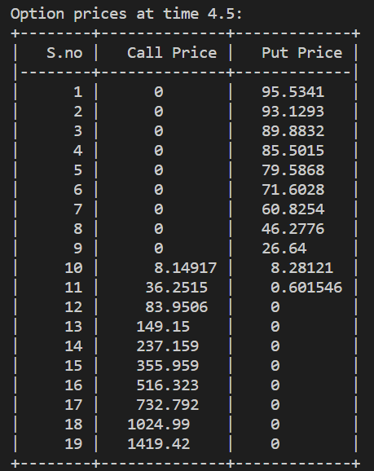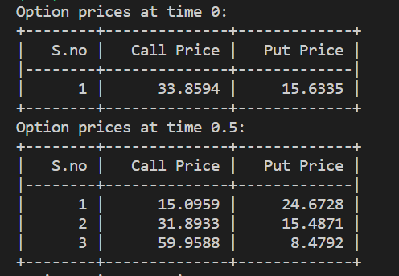

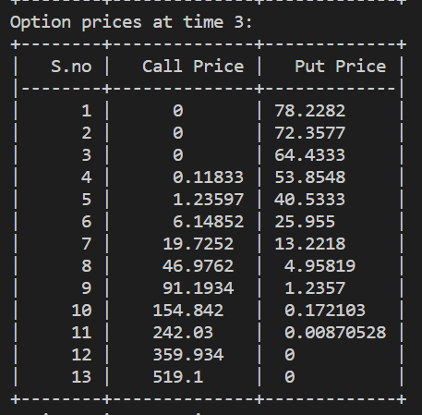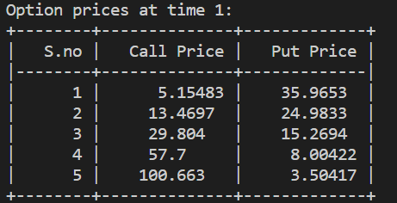

Observation – At time t the number of unique values of option is int(t/delta_t).