MA-473 Computational Finance
Assignment 1

-Aman Kumar
200123007
Question 1

a) Forward–time and central space (FTCS) discretization scheme plots look like this -
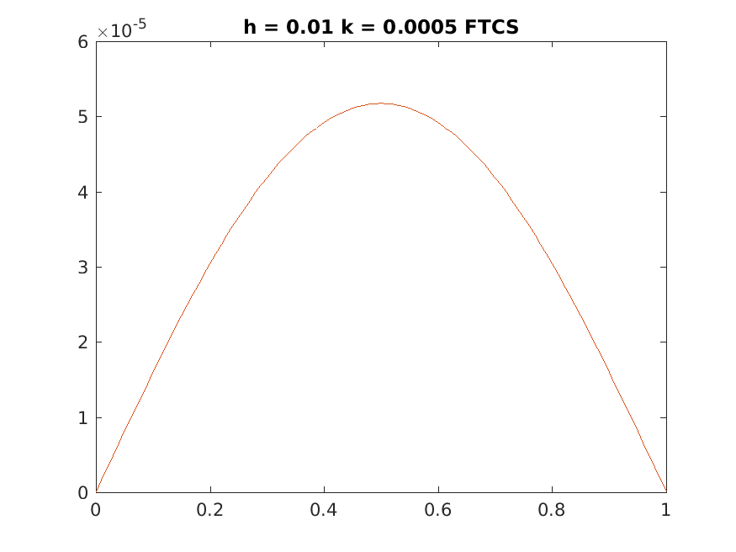


Note – Here the Orange Line in the second plot is of the actual solution and not that of FTCS.

This is because FTCS requires dt/dx^2 < 0.5 for stability whereas in the question we are provided with values of dt and dx which results in ratios above 5. There for all the FTCS solutions calculated are inaccurate.

b) Backward–time and central space (BTCS) discretization scheme

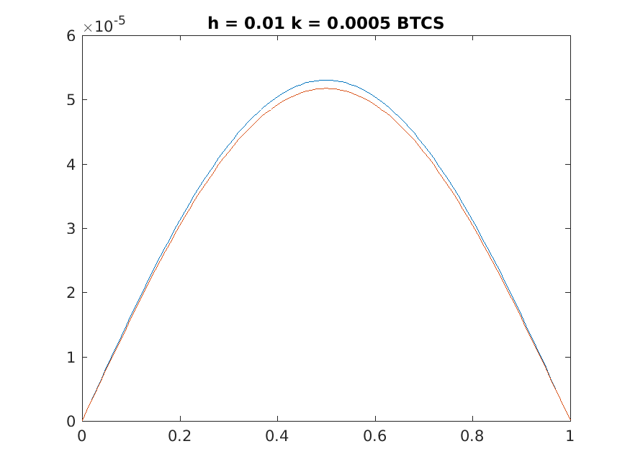
The plots are -
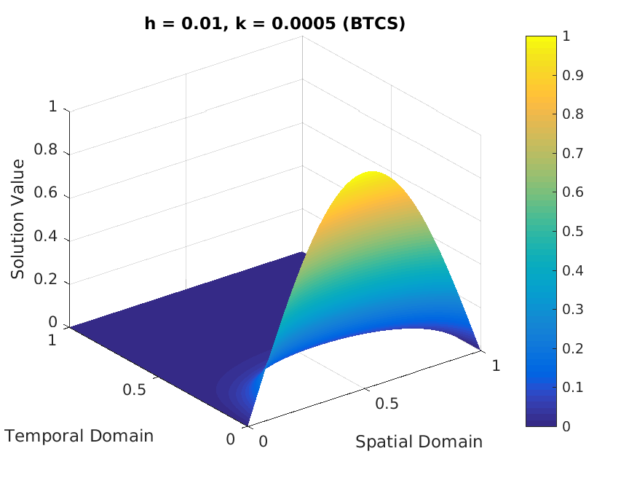
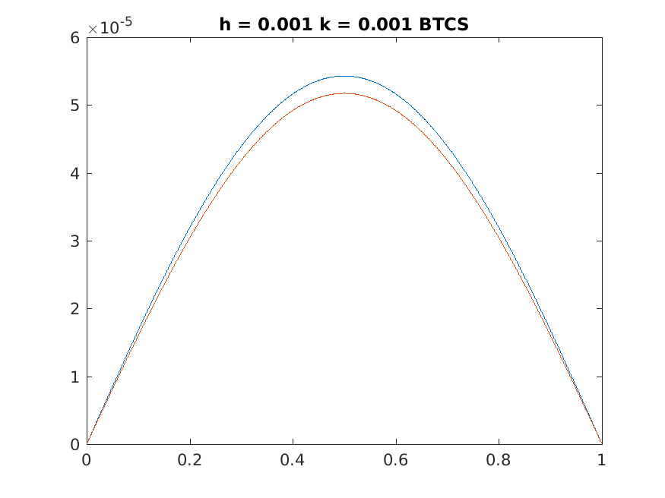
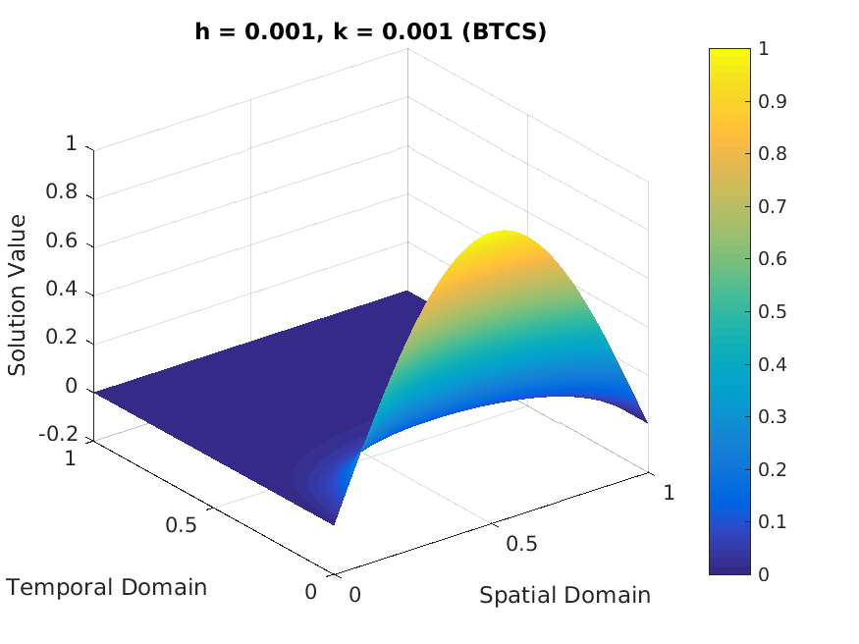

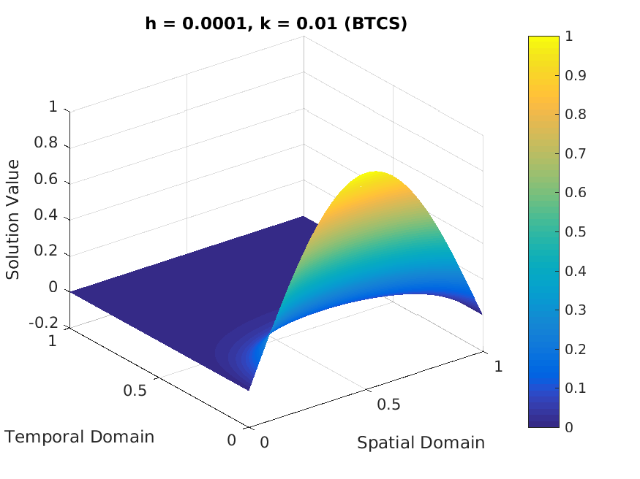

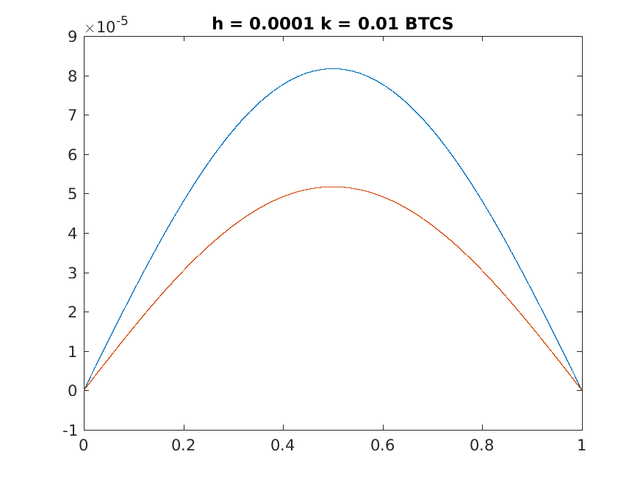

c) Crank–Nicolson scheme
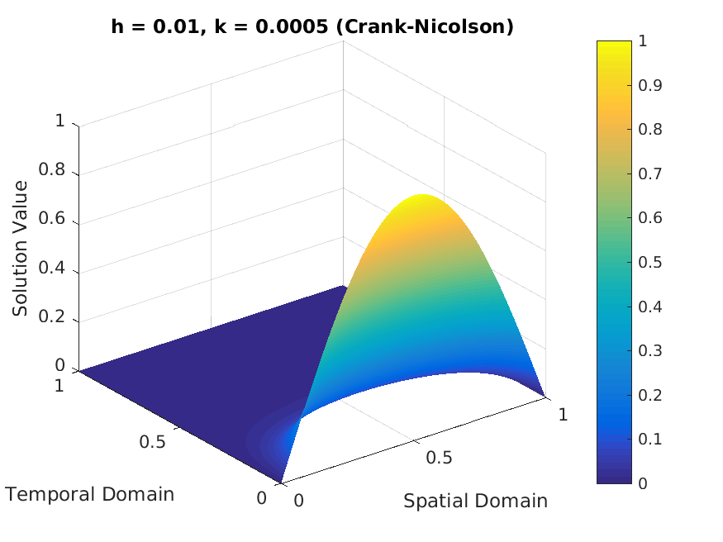
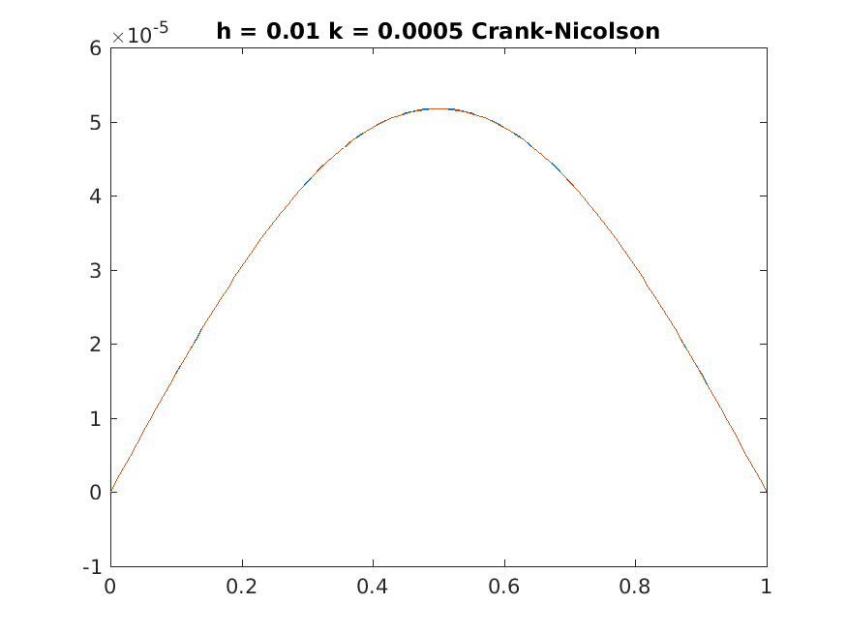

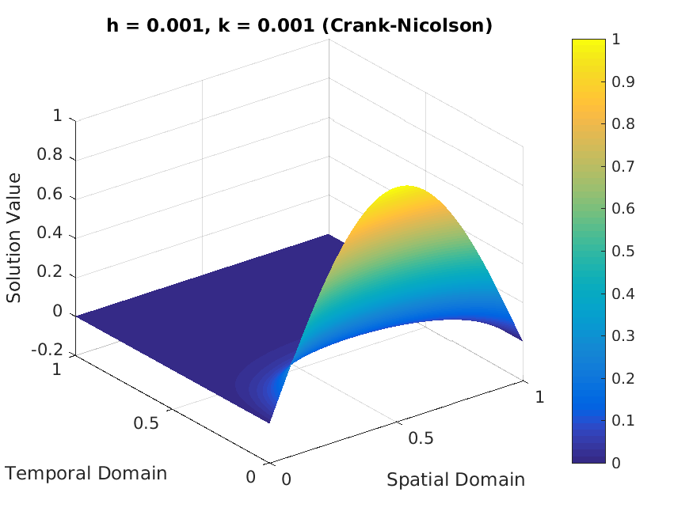
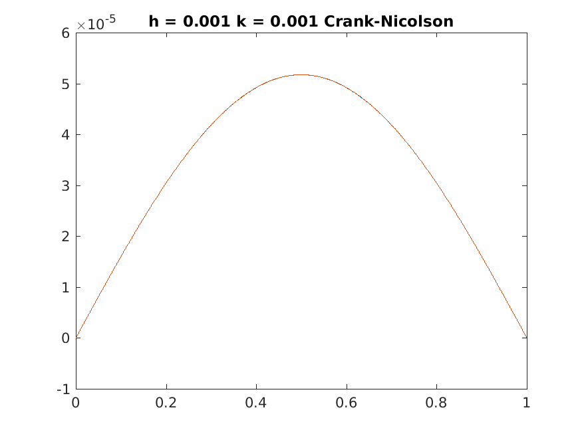

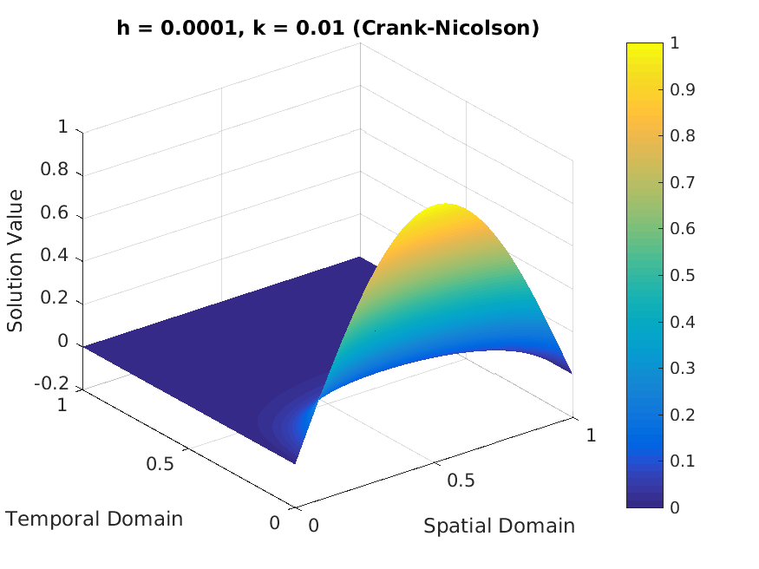
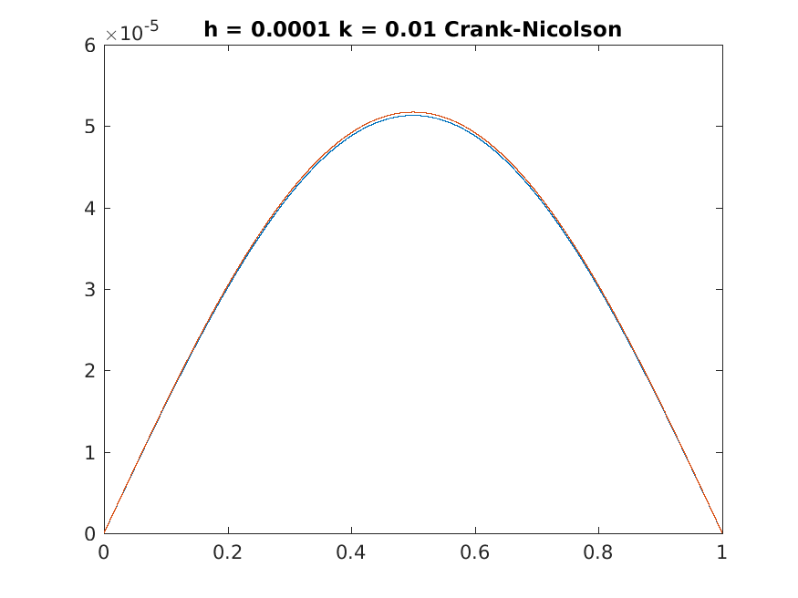

Observation -
The BTCS plots are close to the actual solution but the plots of CN literally overlaps with the actual solution. For FTCS the given parameters were not good enough to get a stable solution.

