MA-473 Computational Finance
Assignment 2

-Aman Kumar
200123007
Question 1

a) Forward–time and central space (FTCS) discretization scheme
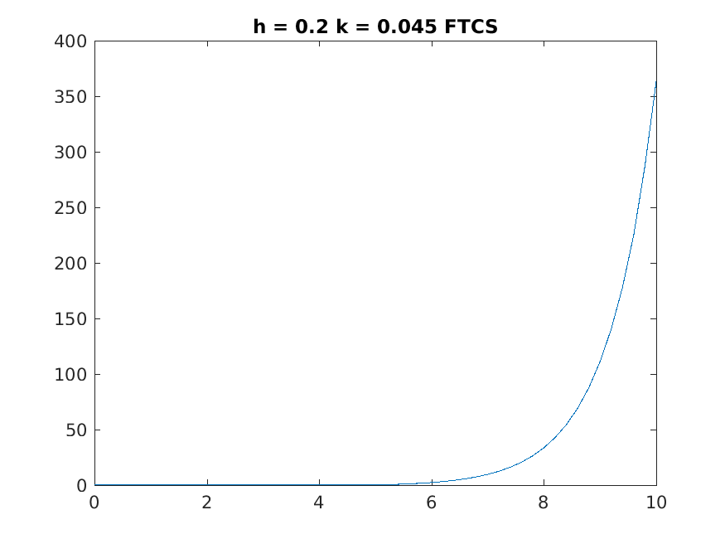

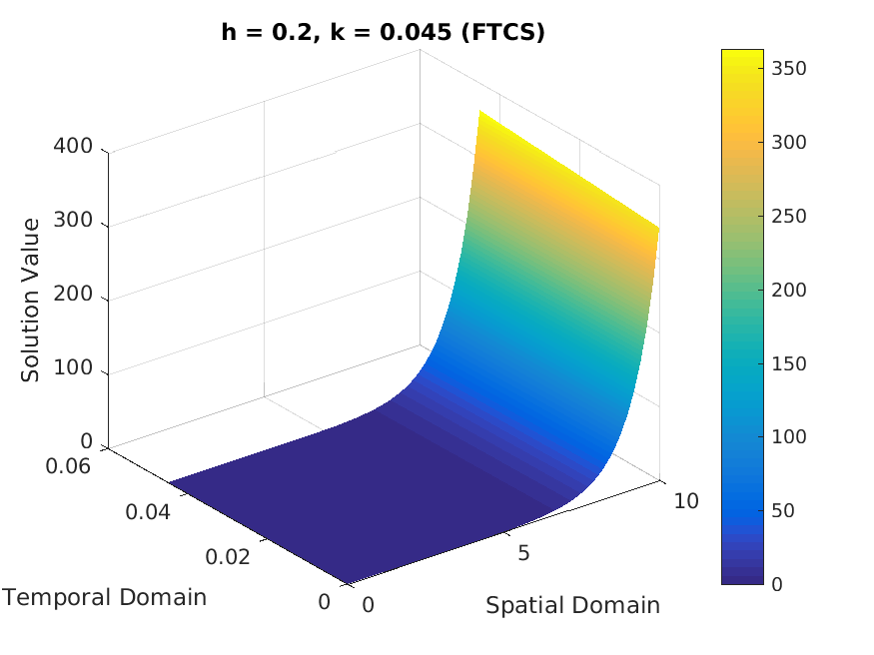

b) Backward–time and central space (BTCS) discretization scheme

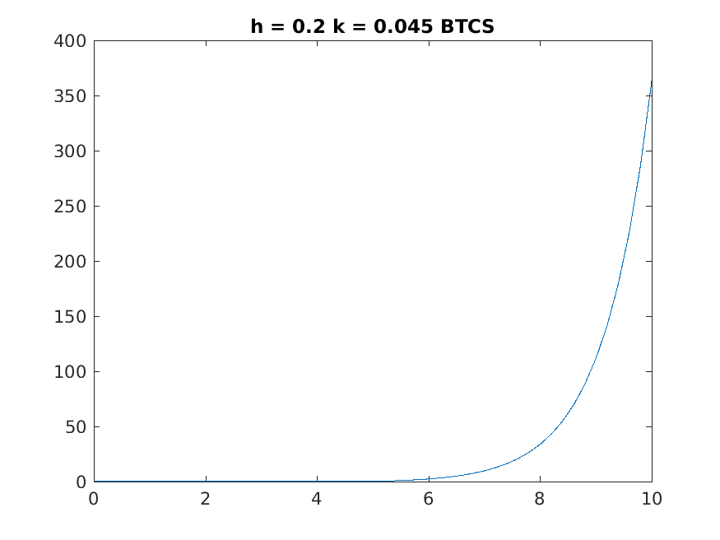

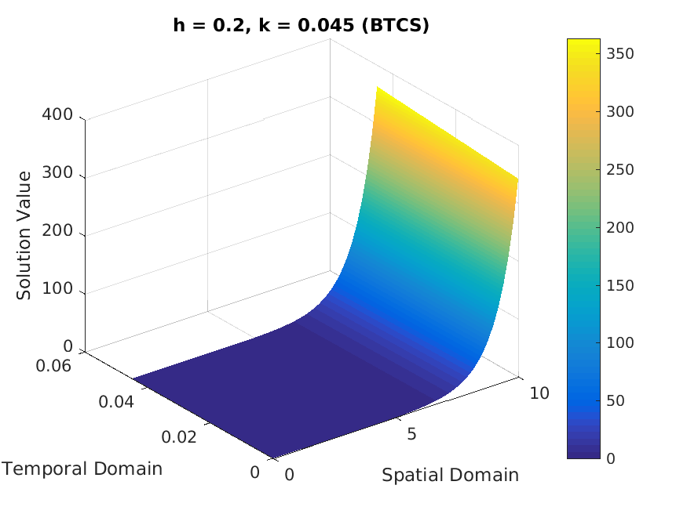

c) Crank–Nicolson scheme

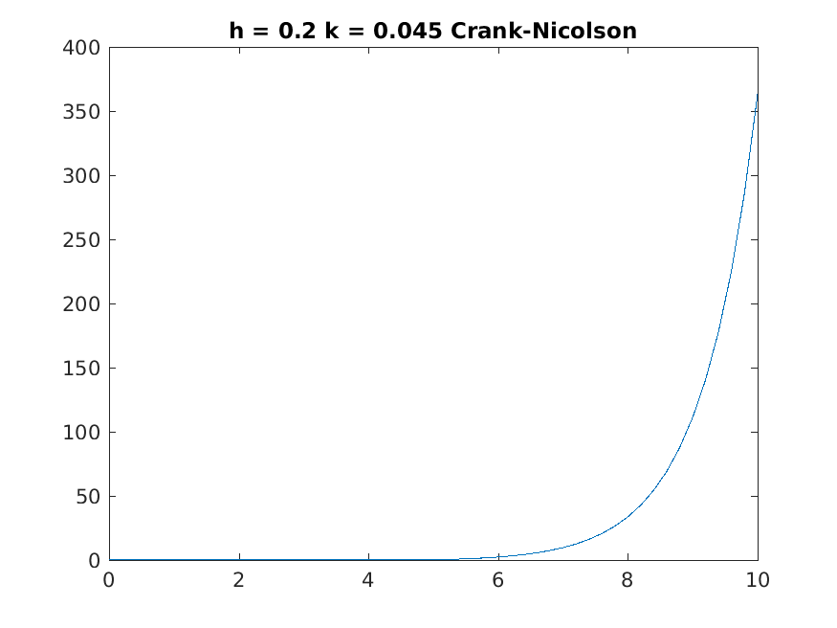

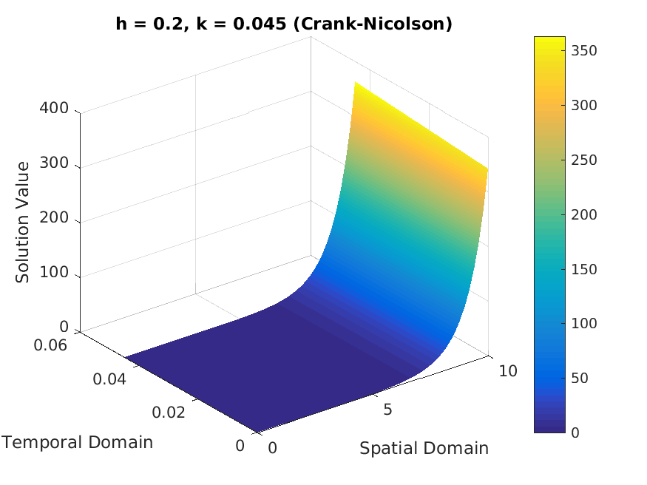

Observation -

All the solutions obtained are almost similar and look correct. The values of dx and dt are choosed such that FTCS gives a stable solution. The min and max value of x taken is -5 and 5 respectively.

