Computational Finance MA473
Lab Assignment 3

Aman Kumar
200123007

Question 1
These are the plots obtained -
All the three methods give similar results.

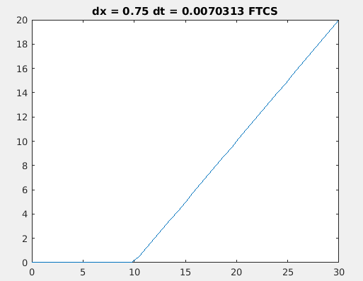
FTCS -

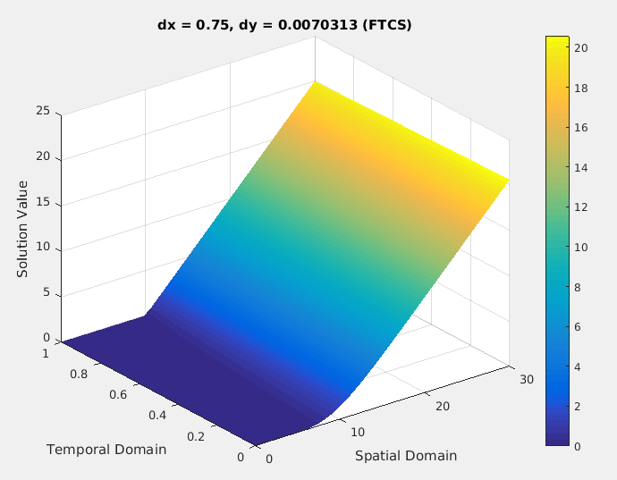

BTCS -

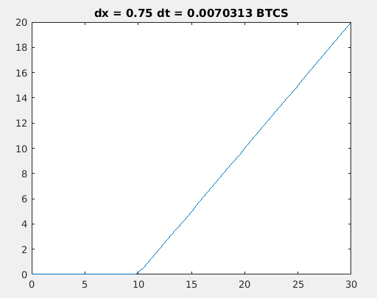

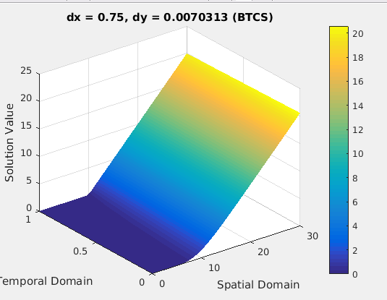

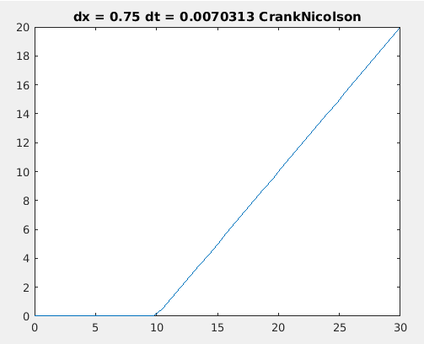
CrankNicolson-

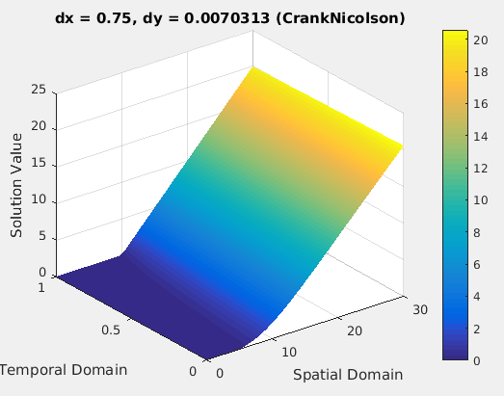

Question 2 -

These are the plots obtained for all the greeks -

They all are pretty accurate when compared with the analytical solutions.

