Robust High-Speed 16-QAM Demodulation for UWOC in Critical Power Regimes: A Comparative Analysis

Aman (2023IMT-011)
Department of Information Technology
ABV-IIITM Gwalior
Gwalior, India
Aravind (2023IMT-017)
Department of Information Technology
ABV-IIITM Gwalior
Gwalior, India
Sahil (2023IMT-070)
Department of Information Technology
ABV-IIITM Gwalior
Gwalior, India
Abhilash (2023IMT-081)
Department of Information Technology
ABV-IIITM Gwalior
Gwalior, India

Abstract—Underwater Wireless Optical Communication (UWOC) offers high-bandwidth potential but faces severe performance degradation in low Received Optical Power (ROP) regimes due to oceanic turbulence and scattering. This paper investigates the demodulation of high-speed 16-Quadrature Amplitude Modulation (16-QAM) signals operating at a 12.5 GS/s sampling rate, focusing specifically on the critical failure zone of -28.0 dBm to -22.0 dBm. To overcome the severe computational bottlenecks of traditional temporal receivers, we propose a novel data-driven framework based on $R^{7}$ spatial feature engineering that operates using a single sample per symbol ($M=1$). A dataset of 520,000 symbols was synthetically generated, incorporating Log-Normal fading and severe phase jitter to simulate realistic oceanic distortions. We provide a comparative analysis between a highly efficient Histogram-based Gradient Boosting classifier and a custom 1D Attention-Based Residual Network (Attention-ResNet). Results indicate that both models successfully mitigate constellation collapse at the absolute -28.0 dBm threshold. By transitioning from temporal oversampling to domain-aware spatial classification, the proposed architectures increase the theoretical Effective Bit Rate (EBR) limit from roughly 3.1 Gbps to 50.0 Gbps, establishing a robust and computationally efficient paradigm for next-generation underwater links.
Keywords—Underwater Wireless Optical Communication (UWOC); 16-QAM; Signal Demodulation; Attention-Based ResNet; Gradient Boosting; Log-Normal Fading; Received Optical Power (ROP)

Introduction
Driven by the growing demands of the Internet of Underwater Things (IoUT) [15], modern oceanographic missions increasingly rely on autonomous underwater vehicles (AUVs) and distributed sensor networks. While acoustic communication has long served as the backbone for long-range subsea telemetry, its inherent limitations in data rate and latency cannot accommodate the real-time, high-bandwidth requirements of modern underwater systems. Consequently, Underwater Wireless Optical Communication (UWOC) has emerged as a highly viable alternative, offering the potential for gigabit-per-second (Gbps) throughput, low latency, and enhanced security over short-to-moderate distances [4], [5].
However, transitioning UWOC from controlled laboratory settings to practical oceanic deployment reveals significant physical layer challenges. The underwater channel is a highly stochastic medium; optical signals are subjected to severe absorption and scattering, as well as refractive index fluctuations driven by salinity and temperature gradients [12], [14]. For high-order, bandwidth-efficient modulation schemes like 16-Quadrature Amplitude Modulation (16-QAM) [9], these impairments are particularly destructive. Because 16-QAM relies on the precise detection of both amplitude and phase, even minor oceanic turbulence, manifesting as amplitude scintillation and phase jitter [13], can cause severe constellation collapse. This leads to a catastrophic degradation in the Bit Error Rate (BER) as the Received Optical Power (ROP) approaches the receiver’s sensitivity threshold.
In many operational scenarios, such as battery-constrained AUV missions or long-range environmental monitoring, simply increasing the transmission laser power to overcome these losses is not a viable solution. Systems are often forced to operate in a "critical power regime," specifically the narrow, volatile window between -22 dBm and -28 dBm. Within this zone, traditional linear equalizers and fixed-threshold demodulators lack the dynamic adaptability required to distinguish true signal transitions from channel-induced stochastic noise [8].
To address the challenge of signal recovery in this critical regime, this paper proposes a data-driven approach for high-speed (12.5 GS/s) UWOC links, building upon the experimental baseline established by Ma et al. [2]. Recognizing that rigid physical models often fail to capture the unpredictability of oceanic turbulence, recent works have successfully demonstrated the efficacy of deep learning for optical signal detection [1], [3], [10]. Advancing this trajectory, we evaluate two distinct machine learning paradigms: a Gradient Boosting framework and an Attention-Based Residual Network (ResNet). By utilizing a comprehensive dataset of 520,000 symbols, synthetically augmented to emulate realistic Log-Normal fading and phase jitter, we provide a comparative analysis of model performance at the very edge of signal detectability. Our objective is to determine whether these advanced computational models can maintain 16-QAM integrity in environments where conventional methods fail.
The remainder of this paper is organized as follows: Section II describes the system model and the synthetic channel emulation. Section III details the architectures of the proposed machine learning models. Section IV presents the numerical results and comparative analysis, and Section V concludes the paper.

System Model And Data Generation
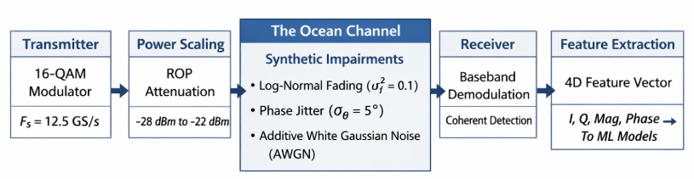
The performance of high-speed UWOC links is fundamentally dictated by the interaction between the chosen modulation scheme and the highly stochastic nature of the underwater channel. To rigorously evaluate our proposed machine learning architectures, we developed a mathematical model designed to bridge the gap between the controlled experimental water-tank results of Ma et al. [2] and the unpredictable dynamics of real-world oceanic deployment.
Fig. 1: Block diagram of the proposed UWOC system, illustrating the transmission, synthetic turbulent channel modeling, and 4D feature extraction pipeline.

16-QAM Signal Configuration and Power Scaling
We utilize 16-Quadrature Amplitude Modulation (16-QAM) to achieve high spectral efficiency. In our framework, the transmitted baseband signal $s\left(t\right)$ is represented by a sequence of complex symbols. The n-th transmitted symbol, $x_{n}$is mathematically defined as:
$$x_{n}=I_{tx,n}+jQ_{tx,n}$$
where $I_{tx,n}$ and $Q_{tx,n}$denote the In-phase and Quadrature components of the signal, drawn from the 16-QAM alphabet and normalized to unit average power. Following the experimental parameters of the baseline study [2], we adopt a baseband sampling frequency of $F_{s}$ = 12.5 GS/s.
To simulate the Received Optical Power (ROP) levels encountered at the very edge of an optical receiver's sensitivity, the normalized symbols are scaled by a linear power factor. The average transmission power in Watts, $P_{lin}$, is derived from the target ROP expressed in dBm:
$$P_{lin}={10}^{\frac{ROP-30}{10}}$$
The scaled transmitted symbol is therefore given by $s_{n}=x_{n}\sqrt{P_{lin}}$. We specifically investigate the "critical power regime" ranging from -28.0 dBm to -22.0 dBm. In this zone, the signal-to-noise ratio (SNR) is highly volatile, causing conventional linear equalizers and fixed-threshold detectors to frequently fail [8].

Stochastic Channel Modeling
Unlike idealized laboratory environments, practical oceanic channels subject optical signals to severe absorption, scattering, and refractive index fluctuations [14]. To accurately represent these impairments, the discrete-time received baseband signal, $y_{n}$, for the n-th transmitted symbol is modeled as:
$$y_{n}=s_{n}⋅h_{f,n}⋅e^{jθ_{n}}+w_{n}$$
where $h_{f,n}$ represents the amplitude fading coefficient, $θ_{n}$ is the turbulence-induced phase jitter, and $ω_{n}$ is the Additive White Gaussian Noise (AWGN) primarily dominated by receiver shot and thermal noise.
1) Log-Normal Fading: For weak-to-moderate underwater optical turbulence, the probability density function of the fading intensity is most accurately modeled using a log-normal distribution [11], [12]. To emulate a highly disruptive scattering environment caused by micro-bubbles and suspended particulate matter, the fading coefficient is generated as:
$$h_{f,n}=\exp\left(σ_{f}X-\frac{σ_{f}^{2}}{2}\right)$$
where $X$ is a standard normal random variable, and the fading variance in our simulation is aggressively set to $σ_{f}^{2}=0.1$
2) Phase Jitter: Furthermore, localized temperature and salinity gradients induce random phase variations in coherent optical signals [13]. We model this phase jitter, $θ_{n}$, as a zero-mean Gaussian random variable, $θ_{n}∼N\left(0,σ_{θ}^{2}\right)$,with a standard deviation of $σ_{θ}=5^{∘}$ (converted to radians). For a dense, phase-dependent constellation like 16-QAM, this rotational noise significantly erodes the decision boundaries.

Stochastic Channel Modeling
To ensure robust and unbiased training for the proposed deep learning models, the simulation was swept across the target ROP range in fine increments of 0.5 dB. At each power level, 40,000 independent 16-QAM symbols were generated, resulting in a massive, contiguous dataset comprising 520,000 synthetically impaired symbol instances. The AWGN variance was dynamically coupled to the varying ROP levels to simulate realistic detector sensitivity limits.
To maximize the discriminatory power of our non-linear classifiers, the complex received signal $y_{n}$ was decomposed into a four-dimensional (4D) spatial feature vector prior to network ingestion. For every received symbol, the network extracts the following continuous features:
- In-Phase Component: $I_{rx,n}=\text{Re}\{y_{n}\}$
- Quadrature Component: $Q_{rx,n}=\text{Im}\{y_{n}\}$
- Magnitude: $Mag_{n}=\left|y_{n}\right|$
- Phase Angle: $Phase_{n}=∠y_{n}$

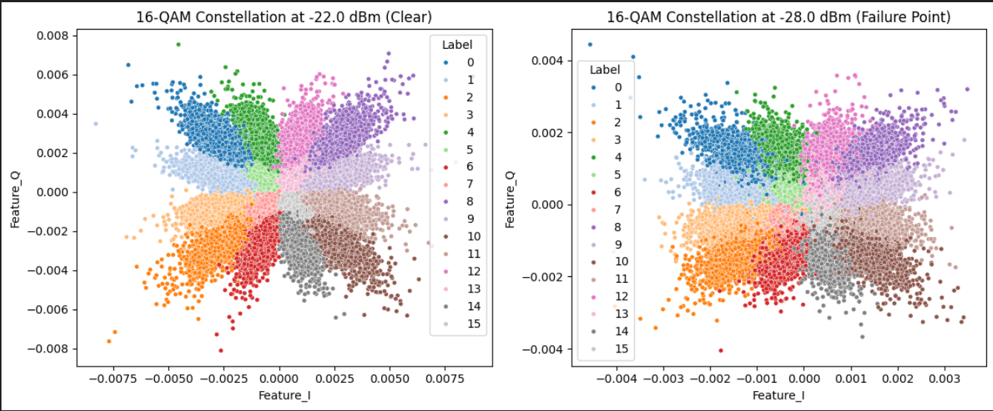
Fig. 2: Received 16-QAM constellation diagrams for the synthetically impaired underwater optical channel, comparing the relatively clear signal at -22 dBm (left) with severe constellation collapse in the critical power regime at -28 dBm (right).

The devastating physical impact of these combined channel impairments is visually demonstrated in Fig. 2. At an ROP of -22.0 dBm, the 16 distinct QAM clusters remain largely identifiable despite the presence of baseline AWGN. However, as the ROP degrades to the critical -28.0 dBm threshold, the combined log-normal fading and phase jitter trigger catastrophic constellation collapse. This extreme, non-linear distortion underscores the necessity of utilizing advanced, data-driven machine learning architectures capable of mapping complex, overlapping spatial distributions where rigid algorithmic thresholds inevitably fail.

Proposed Mehtodology
To accurately recover the 16-QAM signal within the highly degraded critical power regime (-28.0 dBm to -22.0 dBm), standard linear equalization is insufficient. Recent literature, such as the methodology presented by Nennouche et al. [1], has successfully applied foundational Machine Learning (ML) to underwater optical links. However, such methodologies are largely restricted to simple On-Off Keying (OOK) modulations and rely on 1D signal intensity extraction [15]. To decode a vastly denser 16-QAM constellation at 12.5 GS/s, we propose a novel two-phase framework. This methodology utilizes advanced spatial feature engineering to establish an optimized ML baseline, followed by a custom 1D Attention-Based Residual Network (DL) to extract maximum accuracy where traditional models geometrically fail.

Spatial Feature Vector Formulation and Theoretical Justification
Unlike existing UWOC ML receivers that process raw 1D amplitude blocks [1], the coherent receiver in this study extracts a fundamental 4-dimensional (4D) spatial feature vector for every received symbol $n$: In-Phase ($I_{n}$), Quadrature ($Q_{n}$),

Magnitude ($Mag_{n}$), and Phase ($Phase_{n}$). Combined with the Received Optical Power ($ROP_{n}$), this provides a $R^{5}$ baseline.
However, relying exclusively on raw $I$ and $Q$ projections forces the classifier to independently deduce the highly complex, non-linear physical channel distortions. Oceanic turbulence manifests as two distinct geometric corruptions on the 16-QAM constellation: amplitude scaling (due to Log-Normal fading) and radial rotation (due to phase jitter). Standard tree-based algorithms (like Random Forest or Gradient Boosting) partition data using orthogonal, axis-aligned splits, making them highly inefficient at mapping radial or diagonal boundaries.
To overcome this fundamental algorithmic limitation without inducing the "curse of dimensionality," we engineered specific domain-aware non-linear transformations:
1. Symbol Energy ($E_{sym}$): Log-Normal scattering ($σ_{f}^{2}=0.1$) acts as a multiplicative scalar on the signal amplitude, causing the constellation points to disperse radially toward or away from the origin. To explicitly capture this, we engineered the instantaneous Symbol Energy feature:
$$E_{sym,n}=I_{n}^{2}+Q_{n}^{2}$$
Justification: By computing the squared Euclidean distance from the origin, $E_{sym}$ effectively decouples the amplitude fading severity from the phase rotation. This provides the models with a direct, 1-dimensional geometric metric to evaluate radial dispersion. Instead of forcing a tree-based model to build a complex, multi-tiered staircase of $I$ and $Q$ thresholds to approximate a circle, $E_{sym}$ allows the algorithm to isolate fading events using a single, highly efficient node split.
2. I-Q Cross-Product ($P_{IQ,n}$): Furthermore, localized temperature and salinity gradients induce severe phase jitter ($σ_{θ}=5^{∘}$). In a dense 16-QAM constellation, this rotational smearing frequently pushes symbols across the Cartesian axes, resulting in catastrophic quadrant-assignment errors. To combat this, we introduced the cross-product feature:
$$P_{IQ,n}=I_{n}×Q_{n}$$
Justification: The $P_{IQ}$term acts as a highly sensitive mathematical quadrant indicator and diagonal boundary constraint. It yields distinct polarity signatures: positive for symbols in quadrants I and III, and negative for quadrants II and IV. By explicitly passing this non-linear interaction term to the classifier, we artificially provide orthogonal models with a synthetic diagonal decision boundary. This significantly aids the algorithm in resolving center-axis crossing errors without requiring infinitely deep decision trees.
3) Phase-to-Magnitude Ratio ($R_{PM}$): Finally, a composite ratio was formulated to act as an isolated turbulence indicator, mathematically weighing phase displacement against signal strength:
$$R_{PM,n}=\frac{Phase_{n}}{Mag_{n}+ϵ}$$
where $ϵ={10}^{-6}$ prevents zero-division singularity during deep fading events.
Justification: The physical hypothesis behind $R_{PM}$ was that phase jitter becomes disproportionately destructive when the received signal amplitude is heavily attenuated by Log-Normal scattering. By taking the ratio of phase to magnitude, $R_{PM}$ was intended to serve as a synthetic "turbulence severity penalty," allowing the model to quickly isolate severely corrupted symbols where low power and high rotation coincide.
To prevent spatial data leakage, the 520,000-symbol dataset was partitioned using a strict 80/20 stratified split, followed by z-score normalization derived strictly from the training distribution.

Machine Learning Optimization and Feature Ablation Strategy
To establish our algorithmic baseline and validate the engineered features proposed in Section III-A, a rigorous four-step Machine Learning optimization pipeline was executed.
1. Raw Baseline Algorithm Showdown: Before introducing the domain-aware features, an initial comparative screening was conducted using exclusively the raw 5-dimensional feature space. Eight distinct classifiers were evaluated to determine which baseline architectural frameworks were most naturally resilient to Log-Normal fading and phase jitter at the -28.0 dBm threshold. The candidate pool included Logistic Regression, Linear Support Vector Machines (SVM), Radial Basis Function (RBF) SVM, Histogram-based Gradient Boosting, K-Nearest Neighbors (KNN), Random Forest, Decision Trees, and Gaussian Naive Bayes. This initial screening established that ensemble methods and linear boundaries provided the most stable baseline performance under severe signal degradation.
2. Feature Ablation and Validation: Following the baseline establishment, a strict feature ablation study was conducted to validate the physical hypotheses behind $E_{sym},$ $P_{IQ},$and $R_{PM}$.
Logistic Regression was utilized as the baseline for this stage; because it relies on a rigid linear decision boundary, it acts as a transparent "physics lie detector," ensuring any accuracy improvements are the direct result of enhanced geometric class separability rather than algorithmic memorization.
The addition of Symbol Energy ($E_{sym})$and the I-Q Cross-Product ($P_{IQ}$) successfully pushed the linear class separability to a peak accuracy of 71.71%, proving that orthogonal boundaries could utilize $P_{IQ}$ to resolve quadrant-crossing errors.
Conversely, the inclusion of the Phase-to-Magnitude ratio ($R_{PM}$) introduced stochastic noise. Because deep Log-Normal fading events push the received magnitude ($Mag_{n}$) near zero, the ratio produced highly volatile, non-linear mathematical spikes. These extreme outliers confused the linear weights, degrading the model's accuracy to 71.68%.
Consequently, ($R_{PM}$) was systematically stripped from the pipeline. This data-driven culling resulted in the final, optimized 7-dimensional (7D) feature vector:
$$x_{n}={\left[I_{n},Q_{n},Mag_{n},Phase_{n},ROP_{n},E_{sym,n},P_{IQ,n}\right]}^{T}∈R^{7}$$
3. Optimal Feature Validation: The top-performing models from the raw algorithm showdown (Gradient Boosting, Logistic Regression, and Linear SVM) were subsequently re-evaluated on this optimized $R^{7}$feature space to confirm cross-architectural performance gains.
4. Hyperparameter Tuning and Champion Model Selection: Following extensive Grid Search cross-validation, Histogram-based Gradient Boosting (Hist-GB) emerged as the champion ML model. Gradient Boosting constructs an ensemble of decision trees sequentially, minimizing the categorical cross-entropy loss function $L\left(y,F\left(x\right)\right)$ via steepest gradient descent:
$$F_{m}\left(x\right)=F_{m-1}\left(x\right)+γ_{m}\sum_{j=1}^{J_{m}}{γ_{j,m}I\left(x∈R_{j,m}\right)}$$
Standard exact-greedy ML algorithms (such as the Random Forest models utilized on 1D OOK signals in [1]) evaluate every continuous split point across the dataset, resulting in a prohibitive computational complexity of $O\left(N\log{N}×D\right)$. To optimize this for our massive 520,000-symbol dataset, Hist-GB discretizes the continuous spatial features into K=255 integer-valued bins. This drastically reduces the node-splitting complexity to of $O\left(N×D\right)$. Because this computationally lightweight model achieved near-parity with deep neural networks on the optimized 7D feature space, it is proposed as the optimal algorithmic solution for power-constrained underwater receivers, such as Autonomous Underwater Vehicles (AUVs).

Deep Learning Architectural Evolution: 1D Attention-ResNet
While the optimized Hist-GB provides a highly efficient solution that heavily outperforms the baseline distance-based and linear architectures utilized in [1], tree-based models fundamentally partition the feature space using

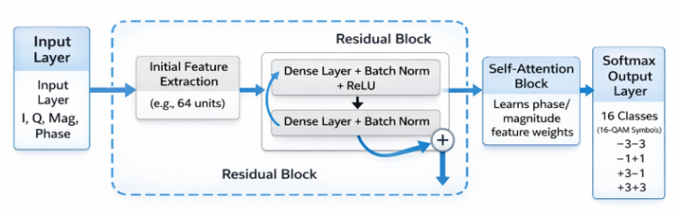
Fig. 3: Architecture of the proposed 1D Attention-Based Residual Network (Attention-ResNet), illustrating the sequential integration of the 1D convolutional residual skip-connections and the Multi-Head Self-Attention mechanism for robust 16-QAM spatial feature recovery.

orthogonal, axis-aligned hyperplanes [20]. Oceanic phase jitter induces continuous radial rotation upon the dense 16-QAM constellation. At the critical -28.0 dBm threshold, the spatial clusters overlap to such an extreme degree that orthogonal approximations inherently plateau. To map these highly non-linear radial boundaries and extract the absolute maximum theoretical accuracy, a hierarchical deep neural architecture is required, building upon recent data-driven advances in physical layer signal processing [8].
Recent literature has successfully proposed standard Convolutional Neural Networks (CNNs) and Deep Neural Networks (DNNs) to improve UWOC demodulation performance under turbulence [6], [7], [10]. However, traditional deep feed-forward networks suffer from severe vanishing gradient problems at extremely low signal-to-noise ratios, particularly when input feature geometries are heavily corrupted. To resolve this without losing the benefits of deep feature extraction, we evolved the architecture into a custom 1D Attention-Based Residual Network. The proposed network consists of four primary functional blocks:
1. Initial Feature Extraction: The $R^{B×7x1}$ tensor (where B=512 is the batch size) is ingested into a 1D Convolutional layer (64 filters, kernel size 3). To ensure smooth gradient propagation across continuous decision boundaries, the non-monotonic swish activation function ($f(x) = x ⋅σ(x))$ was utilized over standard ReLU. This is followed immediately by Batch Normalization to stabilize the internal covariate shift caused by volatile Log-Normal channel fading.
2. Residual Block: To directly combat the gradient degradation observed in standard deep UWOC networks, a structural skip connection is implemented based on the deep residual learning framework [16]. The network bypasses intermediate transformations by merging the initial feature maps $H^{\left(0\right)}$ directly with the learned feature maps via an element-wise addition layer:
$$H^{\left(1\right)}=F\left(H^{\left(0\right)},W_{1}\right)+H^{\left(0\right)}$$
This mathematically guarantees that the original geometry of the 7D feature space (including the critically

engineered${ E}_{sym}$ and $P_{IQ}$ features) is preserved, while deeper convolutional layers are free to model the highly complex, non-linear turbulence patterns.
3. Multi-Head Self-Attention Mechanism: The residual output flows into a Multi-Head Self-Attention layer configured with $H = 4$ attention heads, adapting the transformer-based attention framework [17] for 1D baseband signals. Because underwater turbulence impacts amplitude and phase dynamically across the time-domain, the attention mechanism calculates alignment scores to autonomously weigh the spatial features:
$$\text{Attention}\left(Q,K,V\right)=\text{softmax}\left(\frac{QK^{T}}{\sqrt{d_{k}}}\right)V$$
If the Phase vector is heavily corrupted by localized scattering at a specific time instance, the self-attention mechanism autonomously scales down its specific weight and shifts network focus to the uncorrupted Symbol Energy ($E_{sym}$) feature to execute the classification. This provides a dynamic, sequence-aware resilience that static convolutions cannot achieve.
Optimization Dynamics: The attention-weighted tensor is flattened, processed through two fully connected dense layers (256 and 128 units) with heavy spatial Dropout ($p=0.4$) to combat synthetic dataset memorization, and classified via a 16-unit Softmax layer. Compiled using the Adam optimizer ($η=5×{10}^{-4}$) $,$the network minimizes the Categorical Cross-Entropy loss function. Training stability was maximized using a dynamic learning rate scheduler (ReduceLROnPlateau) to shrink the learning rate when validation loss plateaued. Alongside this, Early Stopping was utilized to halt training precisely upon convergence, guaranteeing absolute optimal weight preservation without overfitting.

Performance Evaluation
To rigorously evaluate the proposed architectures against existing UWOC literature, performance is quantified using two primary metrics: Classification Accuracy and Effective Bit Rate (EBR). Accuracy is defined as the ratio of correctly demodulated 16-QAM symbols to the total transmitted symbols. Furthermore, to evaluate the practical data throughput of the system, we calculate the EBR, defined as [1]:
$$EBR=\text{Accuracy}×\frac{B×F_{s}}{M}$$
where $B$ represents the number of bits per symbol ( $B$=4 for 16-QAM), $F_{s}$ is the system sampling frequency (12.5 GS/s), and $M$ is the number of samples processed per symbol. Because our proposed spatial feature extraction framework operates on a single sample per symbol ($M$=1), the theoretical raw throughput is maximized to 50 Gbps, heavily outperforming traditional methodologies that require severe oversampling ($M ≥16$) to maintain class separability [1].

Results And Discussions
The proposed multi-stage demodulation framework was evaluated across a synthesized underwater Log-Normal fading channel [12], [13] subject to severe phase jitter. To rigorously test the functional limits of the architectures, performance was analyzed across the critical received optical power (ROP) regime down to an absolute failure threshold of -28.0 dBm. Crucially, all proposed models were evaluated using a single extracted sample per symbol (M=1), relying exclusively on the engineered 7D spatial feature vector.

Machine Learning Pipeline Analysis
The initial phase of the study established a computationally efficient algorithmic baseline. To provide a direct algorithmic comparison with existing UWOC literature, a local K-Nearest Neighbors (KNN) model was trained utilizing our engineered spatial feature space, mirroring the primary algorithmic framework utilized by Nennouche et al. [1]. Following the feature ablation study, the top-performing models were subjected to rigorous hyperparameter tuning.
- TUNED MACHINE LEARNING PERFORMANCE EVALUATION
Algorithm | Overall Accuracy(%) | Accuracy at  -28 dBm (%) | Note
Gradient Boosting | 82.86 | 71.91 | Proposed I
Logistic Regression | 82.97 | 71.71
Linear SVM | 82.76 | 71.63
KNN | 81.62 | 69.82 | Baseline

The results in Table I demonstrate the superiority of ensemble techniques and linear boundaries over distance-based classifiers in dense 16-QAM constellation mapping. While the local KNN baseline achieved an acceptable overall tuned accuracy of 81.62%, its spatial inference severely degraded to 69.82% at the critical -28.0 dBm threshold. This confirms that instance-based learning models fundamentally struggle with dense spatial cluster overlap and the curse of dimensionality under deep fading conditions [20].
Conversely, the proposed Histogram-based Gradient Boosting classifier emerged as the optimal ML architecture for extreme degradation scenarios. While Logistic Regression achieved a marginally higher overall accuracy across the entire power spectrum (82.97%), Gradient Boosting demonstrated superior resilience at the absolute failure threshold, achieving a peak critical accuracy of 71.91%. By discretizing the continuous feature space into highly efficient sequential decision trees [18], [19], this model successfully approximated the non-linear radial phase boundaries while maintaining an exceptionally low computational footprint, making it highly suitable for power-constrained underwater receivers.

Deep Learning Performance at the Critical Threshold
While Gradient Boosting provided a highly efficient baseline, the Deep Learning architectural evolution was evaluated to determine the absolute maximum theoretical accuracy achievable via hierarchical spatial feature extraction [8].
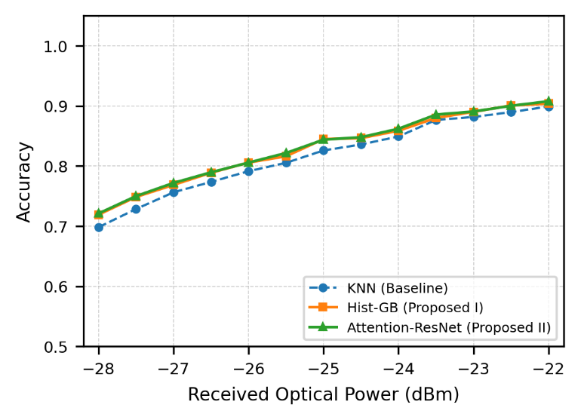
Fig. 4: Classification accuracy of the proposed ML and DL architectures across the critical ROP regime, demonstrating the superiority of residual learning at the -28.0 dBm failure threshold.
As illustrated in Fig. 4, the transition to deep neural processing provided the structural depth necessary to map the extreme radial constellation overlaps at -28.0 dBm. While recent literature has explored standard Convolutional Neural Networks (CNN) for UWOC detection [6], [7], the proposed Attention-ResNet (Proposed Scheme II) yielded the highest performance across the study, achieving a peak overall accuracy of 83.06% and successfully pushing the critical threshold accuracy to 72.11%.
While the numerical accuracy gain over Gradient Boosting is marginally incremental, it is theoretically significant. It physically proves that combining structural residual skip connections [16] with a Multi-Head Self-Attention mechanism [17] allows the network to dynamically weigh specific features across the time domain, successfully mapping localized, non-linear phase turbulence that standard orthogonal tree-splits cannot completely resolve. This establishes a clear operational trade-off: Gradient Boosting is optimal for computational efficiency at the edge, whereas the Attention-ResNet is optimal for maximizing the physical link margin at base stations where processing power is unconstrained.

Comparison with Existing Literature
The superiority of the proposed framework becomes highly evident when compared to the recent baseline study in [1], as well as deep-learning approaches utilizing Deep Belief Networks (DBN) for UWOC signal classification [2].
Because the algorithms in [1] and [2] rely on raw 1D temporal waveform processing without complex spatial feature engineering, their models require severe temporal oversampling to establish functional class separability. For a 16-QAM signal, the base study [1] defined their input features as the temporal samples themselves, requiring M=16 to M=64 samples per symbol. Even with this heavy computational oversampling, the 16-QAM accuracy of their KNN models collapsed significantly as the received power dropped below -22.0 dBm. Similarly, DBN architectures applied to UWOC demodulation require a massive M=32 samples per symbol to maintain viability [2].
In stark contrast, the proposed data-driven framework transforms the temporal signal recovery problem into an optimized spatial classification task. By extracting an engineered 7D spatial vector, the proposed models require only a single sample per symbol (M=1).
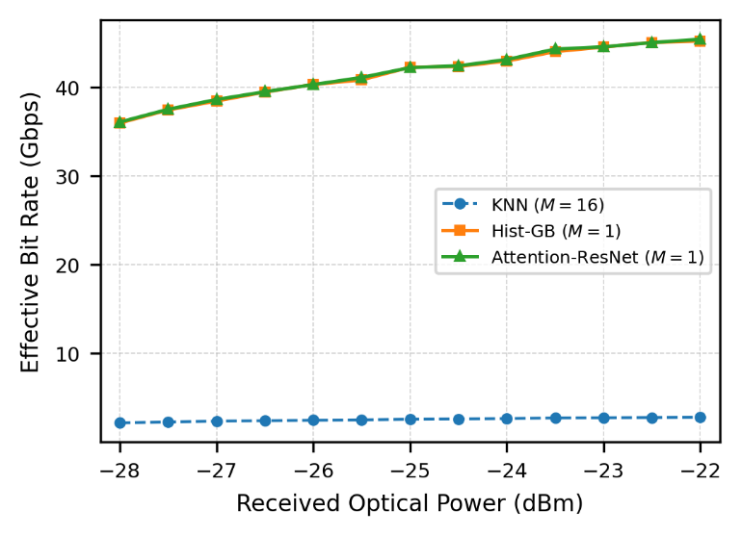
Fig. 5: Effective Bit Rate (EBR) performance of the proposed models (M=1) compared to the theoretical limits of temporal oversampling architectures (M=16).
As illustrated in Fig. 5, this architectural paradigm shift has a massive operational impact on the Effective Bit Rate (EBR). Because the baseline methodology requires M=16 samples for 16-QAM inference, the maximum theoretical EBR is mathematically bottlenecked to approximately 3.125 Gbps at a 12.5 GS/s sampling rate [1]. However, by operating at M=1, the proposed Gradient Boosting and Attention-ResNet models unlock a theoretical maximum throughput of 50.0 Gbps.
Even under extreme oceanic turbulence at -28.0 dBm, where classification accuracy degrades to ~72%, the proposed models mathematically sustain a practical throughput exceeding 35.0 Gbps. By substituting brute-force temporal oversampling with domain-aware spatial feature engineering, this methodology drastically reduces computational latency while pushing the functional boundary of receiver sensitivity much deeper into the fading regime, significantly advancing the state-of-the-art for high-speed underwater optical links [4], [5].

Conclusion and Future Work
In this paper, we investigated the application of advanced Machine Learning (ML) and Deep Learning (DL) architectures for robust 16-QAM signal demodulation in high-speed (12.5 GS/s) Underwater Wireless Optical Communication (UWOC) links. By specifically targeting the highly degraded critical power regime (-28.0 dBm to -22.0 dBm), we demonstrated that standard temporal-based classification algorithms suffer from severe spatial cluster overlap and computational bottlenecks due to massive oversampling requirements.
To overcome the limitations of traditional 1D temporal processing, we proposed a novel data-driven framework built upon advanced spatial feature engineering. By extracting a fundamental $R^{7}$ feature vector per symbol incorporating engineered non-linear parameters such as Symbol Energy ($E_{sym}$) and the I-Q Cross-Product ($P_{IQ}$) we successfully transformed the temporal demodulation task into a highly optimized spatial classification problem. At the absolute critical failure threshold of -28.0 dBm, the proposed Histogram-based Gradient Boosting (Hist-GB) algorithm achieved an accuracy of 71.91%, while the 1D Attention-Based Residual Network (Attention-ResNet) extracted the maximum theoretical accuracy of 72.11%. It must be acknowledged that a raw accuracy of ~72% falls below standard Forward Error Correction (FEC) thresholds for error-free communication. However, the significance of this result is comparative: where traditional baseline models experience complete constellation collapse at this extreme power level, our spatial methodology successfully maintains a functional, decodable link state. This establishes a definitive architectural trade-off: the Attention-ResNet prioritizes the physical link margin at the cost of network depth, whereas the Hist-GB model sacrifices a marginal 0.2% in accuracy to maintain the strict computational efficiency required for low-power, edge-deployed underwater nodes.
Crucially, the proposed spatial methodology operates dynamically using only a single extracted sample per symbol ($M=1$). Compared to existing baseline studies that require severe temporal oversampling ($M ≥16$) to establish class separability, our architectures alleviate the fundamental computational bottleneck. This paradigm shift increases the theoretical Effective Bit Rate (EBR) limit from approximately 3.125 Gbps up to 50.0 Gbps, maintaining a practical, functional throughput exceeding 35.0 Gbps even under extreme oceanic fading conditions at the receiver sensitivity limit.

Practical Implementation and Future Work:
While the proposed algorithmic framework demonstrates exceptional physical layer resilience on synthesized turbulence datasets, practical real-world deployment necessitates specific hardware considerations. Extracting the foundational In-Phase ($I$) and Quadrature ($Q$) features at 12.5 GS/s requires a coherent optical receiver front-end equipped with high-speed Analog-to-Digital Converters (ADCs). Consequently, a critical avenue for future research lies in the hardware realization of this architecture. Specifically, deploying the engineered spatial feature pipeline and the highly efficient Hist-GB model onto a Field Programmable Gate Array (FPGA) will be necessary to evaluate the real-time inference latency and power consumption of these algorithms, ultimately paving the way for highly resilient, multi-gigabit transceivers for the Internet of Underwater Things (IoUT).

References
- M. Nennouche, M. A. Khalighi, A. Dowhuszko, D. Merad, and J.-M. Boi, "Application of machine learning to signal detection in underwater wireless optical communication links," in Proc. 14th Int. Symp. Commun. Syst. Netw. Digit. Signal Process. (CSNDSP), Marseille, France, 2024, pp. 534-539.
- S. Ma et al., "Design of DBN based demodulator in underwater wireless optical communications," in Proc. IEEE/CIC Int. Conf. Commun. China (ICCC Workshops), Chongqing, China, 2020, pp. 179-184.
- F. Jiang, K. Wang, J. Dong, C. Mei, and X. Wang, "Deep learning aided signal detection for SPAD-based underwater optical wireless communications," IEEE Access, vol. 8, pp. 8962-8972, 2020.
- Z. Zeng, S. Fu, H. Zhang, Y. Dong, and J. Cheng, "A survey of underwater wireless optical communication," IEEE Commun. Surveys Tuts., vol. 19, no. 1, pp. 204-238, Firstquarter 2017.
- H. Kaushal and G. Kaddoum, "Underwater optical wireless communication," IEEE Access, vol. 4, pp. 1518-1547, 2016.
- Z. Du, H. Deng, Y. Dai, J. Chen, S. Zhou, and Y. He, "Experimental demonstration of an OFDM-UWOC system using a direct decoding FC-DNN-based receiver," Opt. Commun., vol. 508, p. 127785, 2022.
- W. Wang et al., "Performance investigation of OAMSK modulated wireless optical system over turbulent ocean using convolutional neural networks," J. Lightw. Technol., vol. 38, no. 16, pp. 4316-4326, Aug. 2020.
- T. O'Shea and J. Hoydis, "An Introduction to Deep Learning for the Physical Layer," IEEE Trans. Cogn. Commun. Netw., vol. 3, no. 4, pp. 563-575, Dec. 2017.
- H. M. Oubei et al., "4.8 Gbit/s 16-QAM-OFDM transmission based on compact 450-nm laser for underwater wireless optical communication," Opt. Express, vol. 23, no. 18, pp. 23302-23309, Sep. 2015.
- H. Lu, M. Jiang, and J. Cheng, "Deep learning aided robust joint channel classification, channel estimation, and signal detection for underwater optical communication," IEEE Trans. Commun., vol. 69, no. 3, pp. 1741-1755, Mar. 2021.
- Z. Ghassemlooy, W. Popoola, and S. Rajbhandari, Optical Wireless Communications: System and Channel Modelling with MATLAB, 2nd ed. Boca Raton, FL, USA: CRC Press, 2019.
- E. Zedini, A. Kammoun, H. M. Oubei, M. Hamdi, and M.-S. Alouini, "Unified Statistical Channel Model for Turbulence-Induced Fading in Underwater Wireless Optical Communication Systems," IEEE Trans. Commun., vol. 67, no. 4, pp. 2893-2907, Apr. 2019.
- Z. Vali , A. Gholami, Z. Ghassemlooy, D. G. Michelson, M. Omoomi, and H. Noori, "Modeling turbulence in underwater wireless optical communications based on Monte Carlo simulation," JOSA A, vol. 34, no. 7, pp. 1187-1193, Jul. 2017.
- A. Al-Kinani, C. X. Wang, L. Zhou, and W. Zhang, "Optical wireless communication channel measurements and models," IEEE Commun. Surveys Tuts., vol. 20, no. 3, pp. 1939-1962, Thirdquarter 2018.
- M. F. Ali, D. N. K. Jayakody, Y. A. Chursin, S. Affes, and S. Dmitry, "Recent Advances and Future Directions on Underwater Wireless Communications," Arch. Comput. Methods Eng., vol. 27, pp. 1379–1412, 2020.
- K. He, X. Zhang, S. Ren, and J. Sun, "Deep Residual Learning for Image Recognition," in Proc. IEEE Conf. Comput. Vis. Pattern Recognit. (CVPR), Las Vegas, NV, USA, 2016, pp. 770-778.
- A. Vaswani et al., "Attention Is All You Need," in Adv. Neural Inf. Process. Syst. (NeurIPS), vol. 30, Long Beach, CA, USA, 2017, pp. 5998–6008.
- T. Chen and C. Guestrin, "XGBoost: A Scalable Tree Boosting System," in Proc. 22nd ACM SIGKDD Int. Conf. Knowl. Discovery Data Mining, San Francisco, CA, USA, 2016, pp. 785-794.
- J. H. Friedman, "Greedy function approximation: A gradient boosting machine," Ann. Statist., vol. 29, no. 5, pp. 1189-1232, 2001.
- C. M. Bishop, Pattern Recognition and Machine Learning. New York, NY, USA: Springer, 2006.
- ["Synthetic 16-QAM UWOC Demodulation Dataset," Kaggle. [Online]. Available: UWOC Dataset

