**What can I do with Azure RBAC?**

Here are some examples of what you can do with Azure RBAC:

* Allow one user to manage virtual machines in a subscription and another user to manage virtual networks
* Allow a DBA group to manage SQL databases in a subscription
* Allow a user to manage all resources in a resource group, such as virtual machines, websites, and subnets
* Allow an application to access all resources in a resource group

**How Azure RBAC works**

The way you control access to resources using Azure RBAC is to assign Azure roles. This is a key concept to understand – it's how permissions are enforced. A role assignment consists of three elements: security principal, role definition, and scope.

**Security principal**

A *security principal* is an object that represents a user, group, service principal, or managed identity that is requesting access to Azure resources. You can assign a role to any of these security principals.

Q: Explain multiCloud:

A:

**Multicloud vs. hybrid cloud**

To understand how multicloud differs from hybrid in [cloud computing](https://azure.microsoft.com/en-us/resources/cloud-computing-dictionary/what-is-cloud-computing), you first need to understand the difference between [public clouds](https://azure.microsoft.com/en-us/resources/cloud-computing-dictionary/what-is-a-public-cloud), [private clouds](https://azure.microsoft.com/en-us/resources/cloud-computing-dictionary/what-is-a-private-cloud), and [hybrid clouds](https://azure.microsoft.com/en-us/resources/cloud-computing-dictionary/what-is-hybrid-cloud-computing):

**Public cloud.**In a public cloud computing model, an organization obtains cloud services over the internet from a third-party cloud provider, often on a pay-per-usage basis. Third-party cloud providers offer products and services—including storage, networking, data, analytics, app development, containers, and AI solutions—to multiple customers at once. This cloud model is sometimes referred to as a multitenant cloud due to the cloud provider’s hosting of resources that multiple customers use.

**Private cloud**. A private cloud consists of dedicated cloud resources and infrastructure that are exclusively delivered to a single organization. Private cloud computing services can be delivered over the internet or on-premises through an organization’s private internal network. A private cloud can give an organization greater control, customization, and security than a public cloud. A downside of private clouds is that they may require more internal IT resources to manage and maintain than public clouds.

**Hybrid cloud**. This type of cloud computing combines an organization’s on-premises private cloud with the public cloud offerings of a third-party provider. In a hybrid cloud, an organization’s data and apps can consistently travel between its private and public cloud environments. Organizations often choose a hybrid cloud approach to maximize the performance and value of their on-premises IT investments.

In short, hybrid clouds consist of **multiple cloud environments**—usually a combination of private and public clouds that allow data and apps to be shared between them. Multicloud environments, on the other hand, involve an organization using the cloud services of multiple public cloud providers.

For example, a retail business using a multicloud strategy might choose the services of one cloud provider to process a greater volume of transactions during peak sales seasons, another provider’s AI services to make personalized customer recommendations, and a third provider’s data analytics tools to manage inventory. By selecting best-in-class cloud services from multiple providers, the retailer increases its agility, optimizes operations, and delivers a better customer experience.

In a multicloud approach, the cloud services offered by different providers may not be integrated with each other, which may require additional oversight on your part. However, as you’ll see in the next section, the advantages of cherry-picking cloud services from different providers to suit your particular needs can make multicloud a worthwhile strategy.

**Advantages and challenges of multicloud**

Like any IT investment, there are pros and cons to adopting a multicloud strategy. Let’s look at the advantages of using multicloud platforms first:

* **Elimination of vendor lock-in**. By diversifying across multiple providers, organizations mitigate the risk of being dependent on any single vendor's services and pricing. This gives organizations other options if one provider’s offerings decline in quality or no longer meets their business needs or budget.
* **Enhanced reliability and redundancy**. Distributing your workloads across clouds hosted by more than one provider helps reduce the impact to your network and business operations if any one provider undergoes an outage or service disruption.
* **Access to best-in-class services.** Rather than confining yourself to the products and services of one cloud vendor, a multicloud approach allows you to select the cloud services, infrastructure, and solutions that best fit your particular business requirements, no matter who the provider is.
* **Optimized performance**. Multicloud environments help organizations and IT teams efficiently store, process, and analyze enormous quantities of data using automation, real-time data synchronization, and AI-assisted services and features.
* **Increased flexibility and scalability**. With multicloud, organizations can easily scale storage, compute, and other resources up or down as business needs change instead of committing to a predetermined amount of resources and risking paying for more than they need.
* **Geographic diversity and compliance**. Using multiple cloud providers helps organizations replicate and distribute data across various geographic regions. It also makes it easier for organizations to adhere to specific regional regulations, ensuring data sovereignty and compliance in diverse locations.

At the same time, adopting a multicloud architecture adds a number of complexities to your IT strategy, including:

* **Cloud administration and management.** Managing more than one cloud provider means dealing with different interfaces, APIs, security models, and service levels. All this can make orchestration and monitoring more intricate.
* **Interoperability and integration**. Variations in technologies, standards, and architectures can make it harder to ensure seamless interoperability and compatibility between different cloud services and platforms.
* **Data security and compliance.** Coordinating security measures like data encryption, access controls, and compliance across multiple clouds requires robust strategies to maintain consistent security standards.
* **Cost control and management.** Because pricing structures and services differ among vendors, optimizing costs across multiple cloud providers requires continuous monitoring to prevent unexpected expenses.
* **Potential latency issues**. Communication between apps and services distributed across various clouds can lead to network delays. The increased complexity of coordinating data transfers and ensuring optimal routing in a multicloud setup can result in higher latency than in a single-cloud environment.
* **Governance and control.** Centrally governing and controlling resources and policies across various cloud providers is more involved and can lead to more problems with compliance, auditing, and resource allocation.

**Multicloud management**

Managing a multicloud environment requires meticulous attention and planning to mitigate any challenges that may arise. Overseeing your cloud services across vendor platforms using a unified solution like [Azure Arc](https://azure.microsoft.com/en-us/products/azure-arc) helps streamline a number of aspects of this process, including:

**Governance and resource orchestration**. Managing resources in a multicloud environment means orchestrating workloads, optimizing resource allocation, and streamlining operations. Establishing a unified governance framework can help your organization maintain control, visibility, and consistency across your entire cloud infrastructure.

**Cost optimization**. Ensuring that your organization has allocated its resources judiciously across different cloud platforms will help prevent overspending. To eliminate unnecessary expenses, continuously monitor your company’s resource usage and employ optimization techniques like rightsizing, autoscaling, and using reserved instances.

**Security and compliance**. With data scattered across multiple clouds, maintaining robust security measures is crucial. This involves implementing consistent security protocols, encryption standards, and access controls. In addition, ensuring compliance with industry regulations like GDPR, HIPAA, and PCI DSS across all of your cloud platforms will help your organization avoid penalties and data breaches.

**Performance monitoring**. Monitoring your organization’s resource usage, app performance, and network latency helps identify bottlenecks and optimize workflows. Continuous, proactive monitoring is essential to ensure high availability, reliability, and the best possible user experience across your multicloud infrastructure.

**Disaster recovery**. A well-managed multicloud can greatly improve your [disaster recovery](https://azure.microsoft.com/en-us/resources/cloud-computing-dictionary/what-is-disaster-recovery) capabilities. Ensuring redundancy across multiple cloud providers helps you mitigate the risk of a single point of failure. Plus, implementing comprehensive backup and recovery strategies helps ensure business continuity by minimizing downtime and data loss in the event of a catastrophe.

Q: Epxlain “Pricing Calculator”?

A:

**Pricing calculator**

The pricing calculator is designed to give you an estimated cost for provisioning resources in Azure. You can get an estimate for individual resources, build out a solution, or use an example scenario to see an estimate of the Azure spend. The pricing calculator’s focus is on the cost of provisioned resources in Azure.

With the pricing calculator, you can estimate the cost of any provisioned resources, including compute, storage, and associated network costs. You can even account for different storage options like storage type, access tier, and redundancy.

Q: Explain TCO calculator?

A:

**TCO calculator**

The TCO calculator is designed to help you compare the costs for running an on-premises infrastructure compared to an Azure Cloud infrastructure. With the TCO calculator, you enter your current infrastructure configuration, including servers, databases, storage, and outbound network traffic. The TCO calculator then compares the anticipated costs for your current environment with an Azure environment supporting the same infrastructure requirements.

With the TCO calculator, you enter your configuration, add in assumptions like power and IT labor costs, and are presented with an estimation of the cost difference to run the same environment in your current datacenter or in Azure.

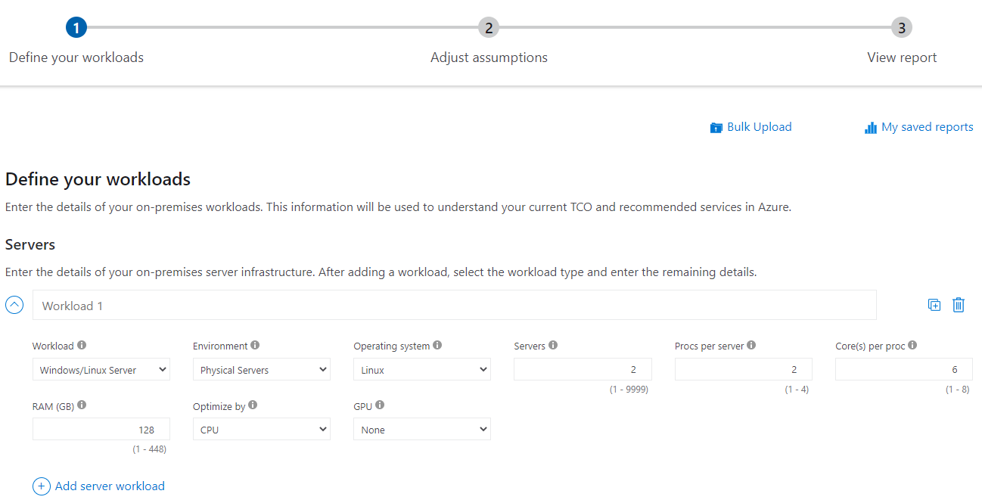

**TCO calculator**

The TCO calculator is designed to help you compare the costs for running an on-premises infrastructure compared to an Azure Cloud infrastructure. With the TCO calculator, you enter your current infrastructure configuration, including servers, databases, storage, and outbound network traffic. The TCO calculator then compares the anticipated costs for your current environment with an Azure environment supporting the same infrastructure requirements.

With the TCO calculator, you enter your configuration, add in assumptions like power and IT labor costs, and are presented with an estimation of the cost difference to run the same environment in your current datacenter or in Azure.



Q: Capex vs OPEx in Azure?

A:

**Capital Expenditure (CapEx)**

* Upfront cost on physical infrastructure
* You need to plan your expenses at the start of a project or budget period.
* CapEx computing costs:
  + **Server costs** – server clustering, redundant power supplies, and uninterruptible power supplies.
  + **Storage costs** – centralized storage and fault-tolerant storage for critical applications.
  + **Network costs** – cabling, switches, access points, routers, wide area networks, and Internet connections.
  + **Backup and archive costs** – backup maintenance and consumables like tapes.
  + **Organization continuity and disaster recovery costs** – recover from a disaster and continue operating using backup generators.
  + **Datacenter infrastructure costs** – costs for construction and building equipment.
  + **Technical personnel**– technical expertise and workforce to install, deploy, and manage the systems in the data center and at the DR site.

Azure scalesets:

