Fall 2015

A short guide highlighting Polish holiday (Christmas and Easter) traditions and top recipes to inspire people planning holiday parties

A Guide to Polish Holiday Traditions

Anna Raciborska

“This document was completed as the final requirement for the Technical Writing Certificate at Bellevue College, Technical Writing Capstone, [Summer, 2015]”

All graphics are licensed under creative commons

Table of Contents

Polish Traditions 4

Christmas (Wigilia) 4

Setting an ambiance 4

Sample Menu 5

Easter 10

Fun holiday activities 10

Sample Menu 13

Desserts 14

Finding Ingredients In The Seattle Area 16

**Style Sheet** 17

References 19

Year after year, holiday after holiday… Often times we end up stuck in the same old rut of tradition, food and activities. This year, why not change things up?

In this age of globalization, why not borrow traditional elements from other parts of the world and make the holidays more magical?

In this edition, let us focus on incorporating some of the ancient holiday traditions of Poland, an eastern European nation bordered by the Baltic Sea, Germany and some of the old soviet republics.

# Polish Traditions

Poland is a predominantly catholic nation. As such, Christmas and Easter are among its most noted holidays. Polish holidays rely heavily on the Christian ideals of sharing and hospitality. Borrowing from these ancestral traditions will help bring back the magic of these holidays to your table as well as find new activities over which to bond with friends and family.

## Christmas (Wigilia)

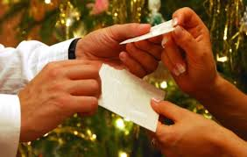 Christmas Eve is perhaps the most important and beloved holiday in Poland. It is a time to feast and celebrate with good friends. Wigilia comes from the Latin term wigilare, meaning to await. Tradition dictates that as we await the arrival of Baby Jesus, an extra place at the table is always set for any unexpected visitor. This is to remind us that Josef and Mary were also looking for shelter on the night of Jesus’ birth, and no one should be turned away. As soon as the first star appears in the sky, the festivities can begin.

Traditional Wigilia starts with the breaking of the blessed Oplatek (Christmas wafer). Give each of your guests a fairly large piece of Oplatek. The hosting couple will then open the ceremony by presenting their wafer to each other and exchanging good wishes and success in the coming year as they break a piece of each other’s wafers and eat them, then turn to the guest sitting next to them, present their Oplatek and make their wishes as the guest breaks a small piece of Oplatek of and eats it. The guests say thank you and present their own wishes and Oplatek. And so it goes until everyone has exchanged wishes of good fortune for the coming year.

### Setting an ambiance

#### Decorations

Set the table with a white tablecloth. As you decorate your house and tree for Christmas, a fun and creative way to prepare for a Polish Wigilia party is to make your own Christmas nativity scene (though you can also buy them). Get your kids or significant other to join you, as you create your very own easy crèche and figurines out of common materials (see attached link [DIY creche project](http://tipy.interia.pl/artykul_5418,jak-zrobic-szopke-bozonarodzeniowa.html)

#### Music

Poland has a fine repertoire of carols, some dating back as far the fourteenth century. Polish carols are very cheerful, tender and even slightly humorous. Click on the links to have a listen

[Polish Christmas carols playlist 1](https://www.youtube.com/watch?v=SN5949d-bkc)

[Polish Christmas /carols playlist 2](https://www.youtube.com/playlist?list=PLpBJkz6gKAAU3L56bDXssDTiDZ0hhgTBB)

### Sample Menu

Polish tradition dictates Wigilia be meatless, but with a variety of soup, fish and vegetable recipes, you can create a cornucopia of delicious food to impress all your friends and relatives. Barszcz, carp and Bigos are some of the staples of the Wigilia table.

#### Soups

##### **Barszcz** (serves 6) with **Uszka** (beet soup with tortellini)

* Ingredients

| ***Soup*** *(cook time: about 1/2hr)* | ***Tortellini*** *(prep time: about 1 hr)*  *You can prep these ahead of time* |
| --- | --- |
| * 4 squares of beef or vegetable broth | * Dumpling dough |
| * 8 cups of water | * 2 Tp butter |
| * 6 medium beets | * 1lb finely chopped mushrooms |
| * 2 tp apple or red wine vinegar | * ½ cup finely chopped onion |
| * 2 Tp sugar | * 1 egg yolk |
| * 3 cloves peeled garlic | * ¼ tp salt and freshly ground pepper |

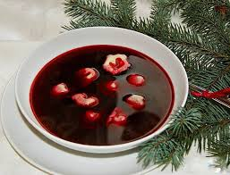**Soup Instructions**

1. Wash and boil beets until soft. Dry and peel them
2. Run them through a food processor to chop into fine pieces.
3. Combine beef and vegetable broth with water and heat until the broth is completely dissolved.
4. Add the beets and garlic. Cook on low heat for about 10 minutes.
5. Add sugar and vinegar. Add salt and pepper to taste

**Tortellini Instructions**

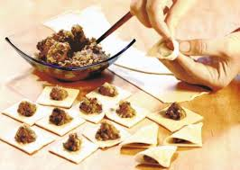

1. Lightly fry the onion in butter. Add mushrooms and spices and cook until all liquid has evaporated
2. Add pepper and wait until the mixture has cooled down. Add the egg yolk and mix well. Then refrigerate for 30 minutes.
3. Add a tp of mixture to the center of each square of dough. Fold the dough and press tightly on the edges to seal your tortellini. You should have a stuffed triangle. Take both edges of the triangle and press tightly to each other. You now have a tortellini in the shape of an ear with a small hole in the middle.
4. Cook in boiling water for 10 minutes until soft.

#### Entree

##### **Bigos** (serves 10-15)

* Ingredient *Prep time: about 1 1/2 hrs*

| * 1lb kielbasa | * 2 squares of beef stock( dissolved in 3 cups of water) | * 3 Tb butter or margarine |
| --- | --- | --- |
| * 2lb pork or beef shoulder | * 4 apples | * 2Tp sugar |
| * 1lb cured and smoked bacon | * 4 medium sized onions, cut into quarters | * 1/2cup dry wine (white or red) |
| * 1lb cooked ham | * 4lb pickled cabbage | * 1Tp caraway seeds |
| * 4 ounces dried mushrooms | * 1 can of tomato paste | * Salt and pepper |

1. 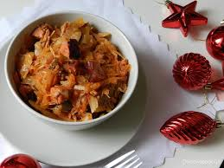Set the oven to 300F. Add the mushrooms to the dissolved broth and set aside
2. Rub the pork or beef shoulder with butter, salt and pepper, set in a deep roasting pot and cover with ½ cup of water, then put it in the oven.

**While the meat is roasting:**

1. Chop the bacon and put it in a small pan. Cook on medium heat until slightly brown.
2. Rinse the pickled cabbage to remove excess vinegar and dry using paper towel
3. Peel, core and chop the apples
4. After 1hr of soaking, remove mushrooms from the broth, setting them on a paper towel to dry. Chop finely. Set the broth aside.
5. In a deep pot, combine bacon, cabbage, mushrooms, tomatoes and apples in layers, starting with the bacon. In between layers add the spices. Cook on low heat for 1.5 hours.

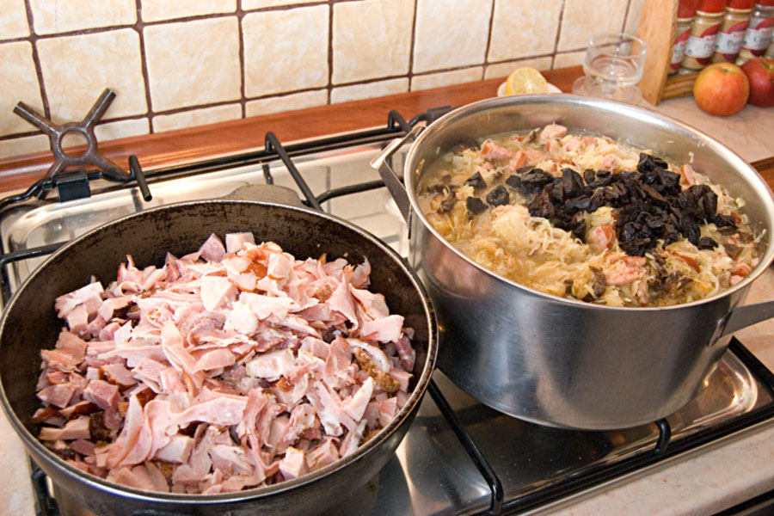

**After 1hr of roasting:**

1. Add the onion. If needed, add more water. Raise the temperature to 350F and keep roasting for another hour, until the meat is tender.

**While the meat is roasting:**

1. Skin and dice the kielbasa into small pieces, then fry it on low heat for 10 minutes. Set aside.
2. Dice the ham and set it aside.
3. When the meat is done roasting. Remove from the oven and allow to cool. Once the meat is cool, dice it.
4. When the cabbage mixture is done cooking, remove from heat and add the broth, diced roast, kielbasa and ham. Mix thoroughly and cook on low heat for another 30 minutes. Add salt or more broth to taste

Be careful! Don’t let the Bigos burn.

#### Dessert

##### **Makowiec**

* Ingredients:

| **Cake** *(prep time: about ½ hr)* | **Filling** *(prep time: about 1 ½ hr)* | **Icing** *(about 5 minutes)* |
| --- | --- | --- |
| * 4 eggs | * 2 ¼ cups grinded poppy seeds | * 5Tp orange juice |
| * 3/4 cup sugar | * 4 eggs | * 1 cup sugar |
| * ½ cup All Purpose flour | * 2/3 cups butter |  |
| * ½ cup potato flour | * ½ cup almonds * ½ cup raisins |  |
|  | * 2 Tp honey |  |

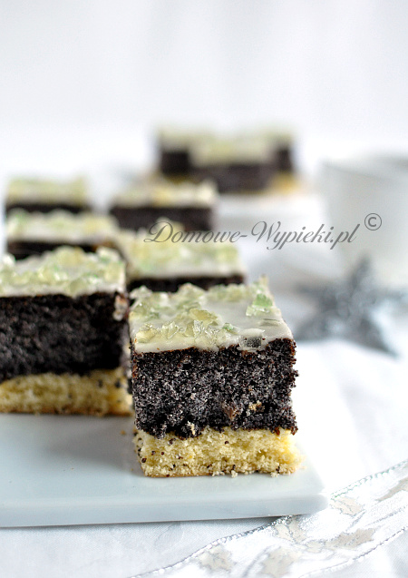First prepare the **poppy seed filling**.

1. Cover the poppy seeds in boiling milk. Let stand for 30 minutes
2. Preheat the oven to 350F
3. Separate the whites from the yolks. Beat butter and sugar until fluffy. While beating, slowly incorporate egg yolks one at a time.
4. Combine raisins, almonds and poppy seeds with honey.
5. Beat egg whites until they are stiff, then combine with the poppy seed filling.
6. Line a baking pan with wax or baking paper. Pour poppy seed filling and bake for 40minutes

At the 15minute mark, **prepare the dough:**

1. Separate the yolks from the whites. Beat the whites until they are stiff and add sugar.
2. Keep beating as you add 1 egg yolk at a time.
3. Combine the All Purpose and potato flours and slowly add to the egg mixture, mixing until fully combined.
4. Remove the filling from the oven. Lay the dough over the filling and continue baking for another 25 minutes. Check if the dough is fully baked by inserting a toothpick. If the toothpick is clean, turn off the oven and open the door. Allow your cake to cool in the oven.
5. Once cool, remove the cake from the pan and carefully turn it upside down. Prepare the icing by combining the sugar with the orange juice and mixing well. Spread your icing on the poppy filling.

You can decorate with candied lemon or orange peel.

## Easter

### Fun holiday activities

#### [Image result for pisanki sample designs](http://www.google.com/imgres?imgurl=http://www.ukrainianmuseum.org/thumbs/060323ukrainianmuseum_pysanky450344.jpg&imgrefurl=http://pattere.net/ukrainian-easter-egg-patterns/&h=344&w=450&tbnid=yOwlp24ekgYQUM:&docid=5GK-pswhnfQKEM&ei=8WTNVeyuLsXHogS7yoXYAg&tbm=isch&ved=0CCsQMygPMA9qFQoTCKzrp4zVp8cCFcWjiAodO2UBKw)

#### Pisanki (Beeswax etching)

Pisanki is the traditional way of decorating eggs using wax and food or synthetic color dyes

*Materials: beeswax, a straight pin stuck in a pencil eraser, food dye*

1. Melt some beeswax in a small jar lid in a larger lid over low heat on a stove top or hot plate. *Don’t use candle wax: it is too soft for the design to stick*.
2. Dip the straight pin into the beeswax, then apply onto your egg.

*Roll the egg as you draw your design. This makes creating your design easier as having a steady hand is much less important. The wax will just roll off your tool onto the egg*.

When you are finished drawing, your egg is now ready to be dyed.

1. Simply dip it into the dye and wait for your egg to dry. You can use an egg carton or a simple piece of plywood with a series of nails hammered in.
2. You can remove the wax by holding the egg over a lit candle to melt the wax off, or dip it into mineral water. Rub your egg with a soft cloth to have shiny, beautiful eggs.

You can also repeat the process with multiple color dyes, using 1 dye at a time, should you want more colorful eggs.

#### [Image result for pisanki wyklejanki](http://www.google.com/imgres?imgurl=http://www.beskid.com/images/pisanki/Image12.jpg&imgrefurl=http://www.beskid.com/pisanki.html&h=296&w=400&tbnid=FoPw40ejYN7AHM:&docid=bC26sLSdA69grM&ei=8WbNVfn-Ks_goASOwIiYDw&tbm=isch&ved=0CDkQMygVMBVqFQoTCLm7toDXp8cCFU8wiAodDiAC8w)

#### Wyklejanki (decorating with stickers)

You can also choose to decorate Easter eggs by gluing decorative elements and stickers.

After dying your eggs, wait until they are fully dry. Gather sprigs of straw, small pieces of ribbon or colored crepe paper, small art jewels and glue. Choose the materials you wish for your egg and decide on a pattern, then simply glue onto your egg

##### **Common designs**

several pictures outlining common line and flower designs, for inspiration


https://s-media-cache-ak0.pinimg.com/236x/06/0b/09/060b092a6cfff514b1e7d67110b04b7e.jpg

[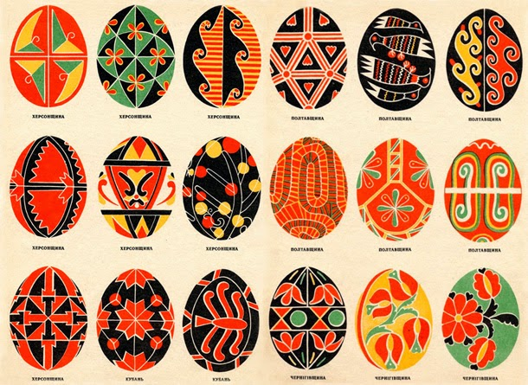](http://1.bp.blogspot.com/-vJ-eASqqWSY/U0KrglFsGQI/AAAAAAAABwQ/M2Y9GSpHI1E/s1600/610_ukranian_easter_egg_collage2.jpg)

#### Make an Easter basket

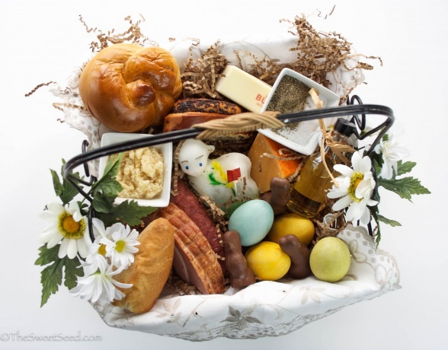 There is usually an Easter basket called Swieconka present at the table during Easter. Line a small basket with a white linen or lace napkin. In the basket, in addition to colored eggs, put a small sample of east foods. Namely, you should include some bread, sausage or ham, salt and pepper/horseradish, vinegar or fruit and wine. Easter baskets usually contain an Easter lamb, made from sugar, butter or plaster, nestled among the offerings. You can also put a small sprig of boxwood or pussy willow.

### Sample Menu

Easter is a time for family and friends. Staples at the Easter table include pate, eggs, bread, soup and desserts

#### **Stuffed Eggs**

Faszerowane jajka (appetizer) – serves 6

* Ingredients *prep time: 25 minute*

|  |  |  |
| --- | --- | --- |
| * 6 eggs | * 3 tp chives | * 3Tb breadcrumbs |
| * 3 Tp softened butter | * 2 tp parsley | * Salt and pepper to taste |

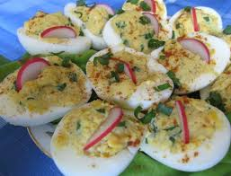

Hard boil the eggs (to prevent cracking of the shell, make a tiny hole on the bottom of the egg using a straight pin) approx. 14 minutes

1. Cool the eggs and cut them in half using a very sharp knife.
2. Empty the egg shells and using a food processor, chop the hardboiled egg and mix with 2 TB of softened butter, chives, parsley, salt and pepper.
3. Put the mixture back into the egg shells. Holding the shell, dip it into the breadcrumbs (or you can sprinkle the breadcrumbs on the top).
4. Heat the remaining butter on a skillet on medium heat. Slowly put the eggs breadcrumbs down into the butter and heat for a couple minutes. Scoop out and serve, breadcrumbs up, on a nice plate.

### Desserts

#### King’s Mazurek

* Ingredients *prep time: about 50 minutes*

|  |  |  |  |
| --- | --- | --- | --- |
| * 6 eggs | * 1.5 cups Apricot or orange or cherry marmalade.   You can also use melted chocolate or coffee cream | * 1 cup Sugar | |
| * 2 ¾ cups flour | * 2.5 cups powdered sugar | * ¼ cup Water | |
| * 1.5 cups Butter | * 1 lemon (juiced)(or 1 tp lemon extract | * 1 lemon | |
| * 1 ¼ cups ground almonds | * 8 Tp hot water | |  |

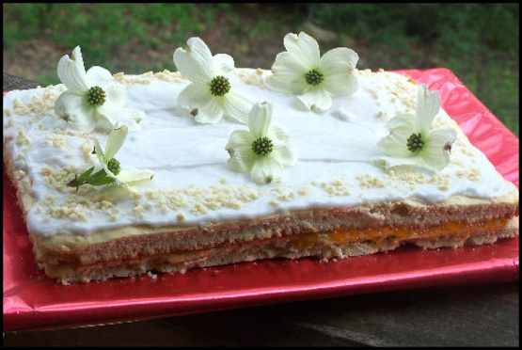**Preparing the dough:**

1. Heat the oven to 350F
2. Mix hot water with lemon juice. Melt the butter on low heat.
3. Beat eggs and sugar until a creamy mixture forms.
4. Slowly pour the lemon water into the mixture as you continue to beat the eggs. Keep beating until mixture is cool.
5. Mix almonds and flour with the egg mixture, while pouring the melted butter into the dough.
6. Lay out the dough onto baking sheet covered in greased wax paper. Bake approximately 30 minutes until the cake is golden brown.

**Icing:**

1. Add sugar and lemon juice to boiling hot water. Keep on low heat and cook until your icing has a thick consistency, just short of caramel. You may add more lemon to taste and water to make it easier to spread
2. Let cool and cut in half.
3. Spread the marmalade on one piece of the cake. Then cover with the other half of the cake, lightly pressing down. Cover your cake with icing

You can decorate with a pattern of flowers made from halved almonds and lemon/orange peel.

# Finding Ingredients In The Seattle Area

* GEORGE'S SAUSAGE & DELICATESSEN

Open M-F: 9 am - 5 pm, Sat: 10 am - 3 pm

907 Madison St., Seattle, WA 98104

206-622-1491

* International Deli

15015 Main St. Ste 110, Bellevue, at the mall at 148th and Main

425-865-0439,

* Delicatessen of Europe,

129 - 106th Avenue, Bellevue,

425-865-0439

* From Russia with love,

1424 156th Ave. NE., Bellevue, at the Crossroads Mall (Top Food store plaza)

425-603-0701,

* Polish bazaar – TBD

Polish Cultural association home, 1714 18th Avenue, Seattle, WA 98122,

# **Style Sheet**

| **Item** | **Description** |
| --- | --- |
| **Organization or project name** | A guide to Polish holiday traditions |
| **Plan author** | Anna Raciborska |
| **Date** | October 7 2015 |
| **Scope** | Website / Print |
| **Owner(s)** | Content manager  technical writer |
| **Reviewer(s)** | Content manager  SME  technical writer |
| **Audience, users** | * Party planners * Bakers/cooks * anyone interested in incorporating Polish and eastern European cuisine and traditions into their holidays |
| **Dictionary** | *Oxford desk dictionary and thesaurus*, American edition, 1997 |
| **Style manual** | * *Microsoft Manual of style for Technical Publications*, 2nd edition * *A pocket style manual*, 5th edition |
| **Grammar book** | *Prentice Hall Reference Guide,* Harris, M. (2006) |
| **Usage guide(s)** | *A pocket style manual*, 5th edition |
| **Thesaurus** | *Oxford desk dictionary and thesaurus*, American edition, 1997 |
| **Other resources** | http://www.polishcenter.org  http://www.polartcenter.com  [cooking unit converter](http://www.convertunits.com/from/grams/to/cups)  [polish_easter_traditions](http://polana.com/polish_easter_traditions) |
| **Location and archiving** | Onedrivelive.com |
| **Updating and version control** | Update as needed and publish quarterly |
| **Permissions:**  **Rights to change**  **Rights to view** | Administrator: content manager/technical writer  Rights to change: content manager/technical writer  rights to view: all |
| **Publishing (print, online)** | Online - blog (printing as a brochure TBA) |
| **Other** | TBA |

# References

<http://www.polishcenter.org/Christmas/CHRISTMAS-ENG.htm>

<http://www.polishcenter.org/polish_easter_traditions.htm>

<http://www.polartcenter.com/Oplatek_Christmas_Wafer_s/81.htm>

<http://tipy.interia.pl/artykul_5418,jak-zrobic-szopke-bozonarodzeniowa.html>

<http://www.convertunits.com/from/grams/to/cups>

<http://polana.com/polish_easter_traditions>

<http://pub8.bravenet.com/forum/static/show.php?usernum=652776809&frmid=150&msgid=528686>

http://easteuropeanfood.about.com/od/polisheaster/ss/How-To-Make-Polish-Pisanki-Easter-Eggs-For-Beginners.htm

<http://www.domowe-wypieki.pl/przepisy-makowce/675-przepis-na-makowiec-na-biszkopcie>

https://holidaytraditionswordpresscom.wordpress.com/

**graphic references (in order of appearance)**

<http://www.niedziela.pl/artykul/80983/nd/Bozonarodzeniowe-zwyczaje>

<http://ogrodybabilonu.blogspot.com/2011/12/barszcz-wigilijny.html>

<http://www.domowabogini.pl/bigos-slodko-kwasny/>

<http://www.beskid.com/pisanki.html>

<http://www.clevelandseniors.com/family/easter-polish.htm>

<http://www.interklasa.pl/portal/dokumenty/m017/zwyczaje_wielkanoc_pisanki.htm>

<http://heartheartseason.blogspot.com/2014/04/easter-eggs.html>

<http://thesweetseed.com/2014/04/11/polish-easter-tradition/>

<http://kuchennewzlotyiupadki.blox.pl/2013/03/Jajka-faszerowane-na-dwa-sposoby.html>

<http://www.food.com/recipe/royal-mazurka-mazurek-krolewski-135038>