**COURSE PROVIDER PANEL**

**WORK DONE BY - MANN**

**Register Page:  
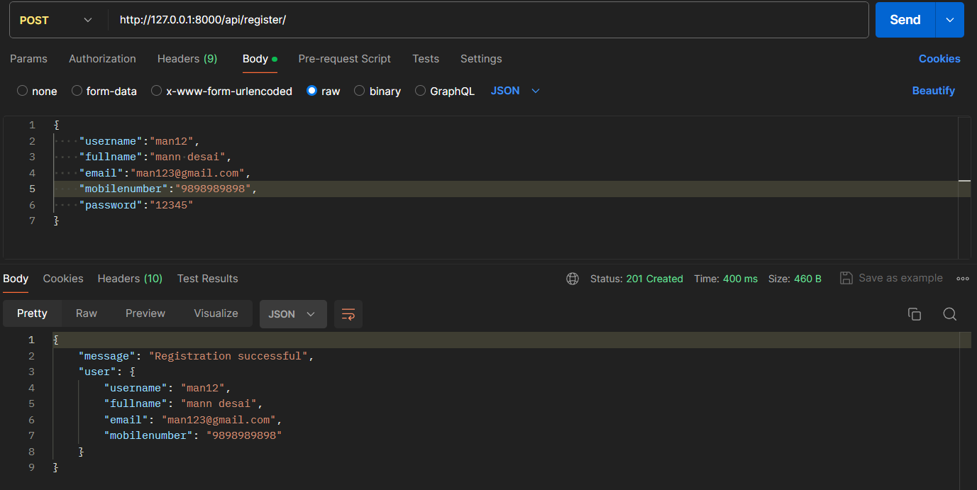**

Login Page:  
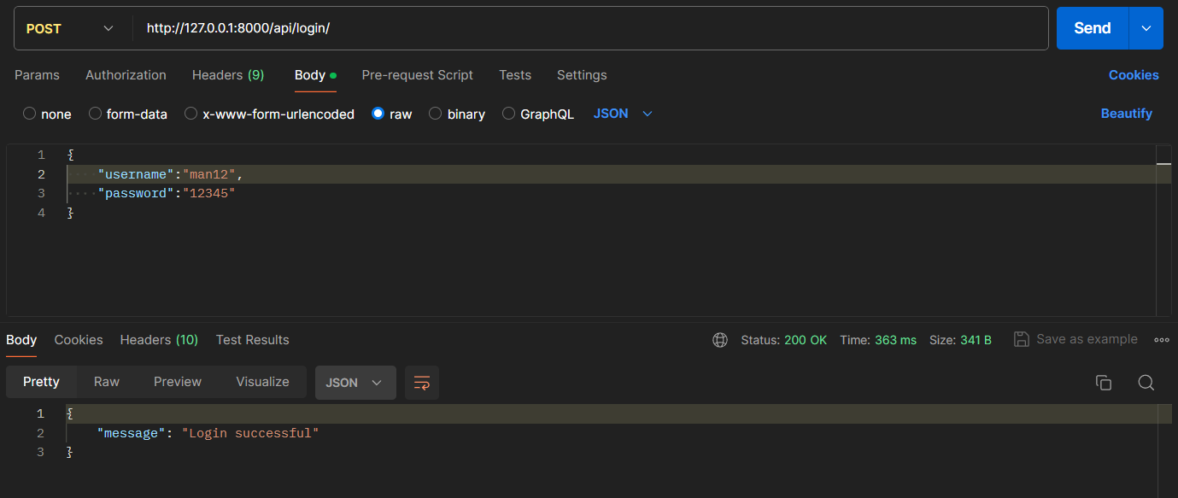

Get User Details:  
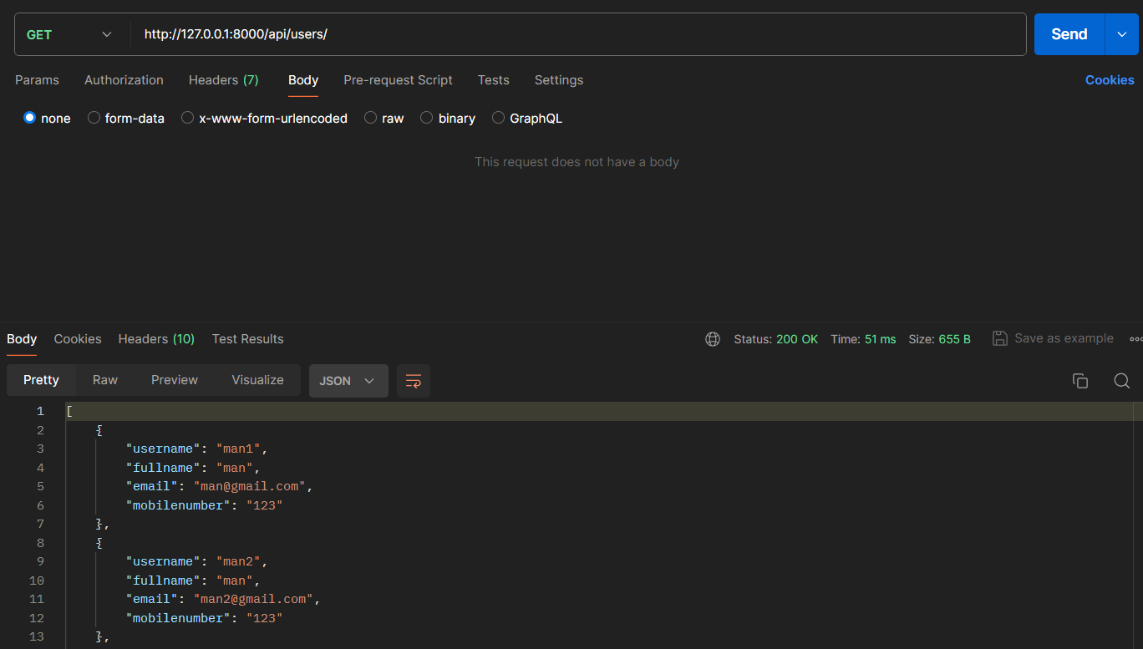

Add Course:  
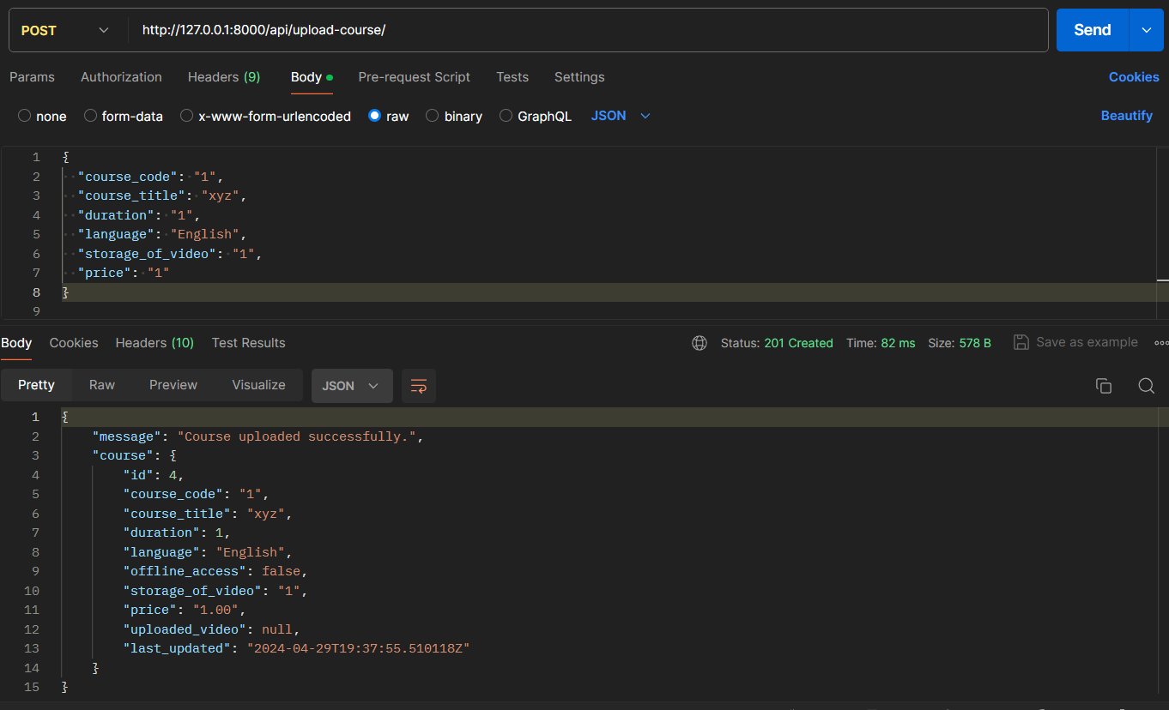

Get Course Details:  
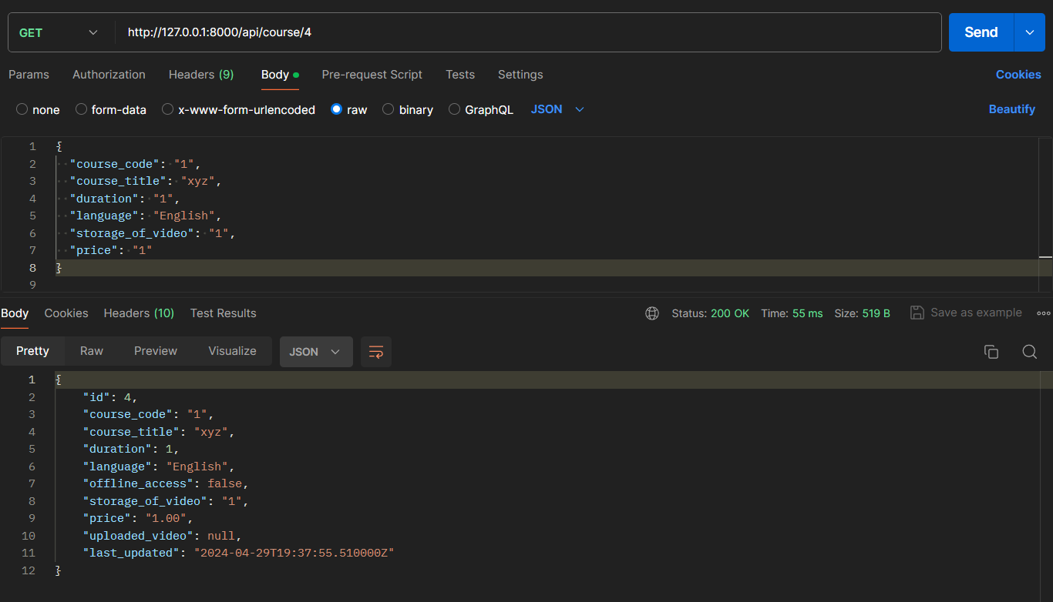

**TEAM MEMBER - Mann, Pritiranjan**

**PENDING WORK:**

Earning

Performance Analysis

Payout Statement

Add quiz, assignment