**Unit Testing**

Introduction:

This is a unit test document for the utility build to parse comic details from API.

A**) Functionality Test**.

B) **End-to-end script test**.

A) **Functionality Test:**

1. Output should have below information

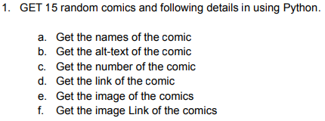

**Output :**

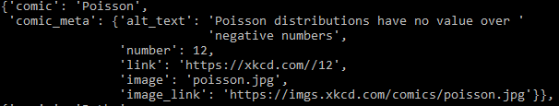



Database Table Data:

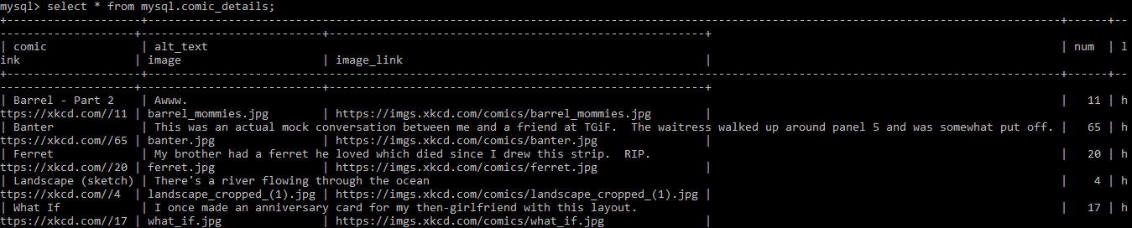

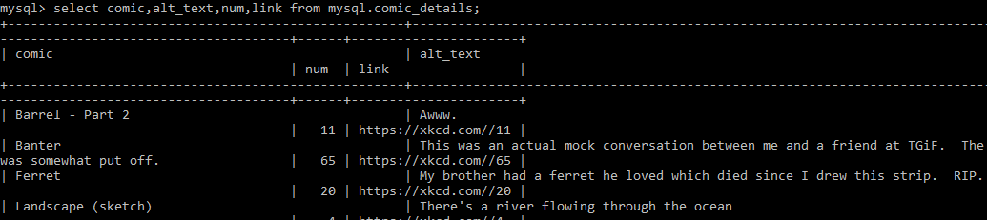



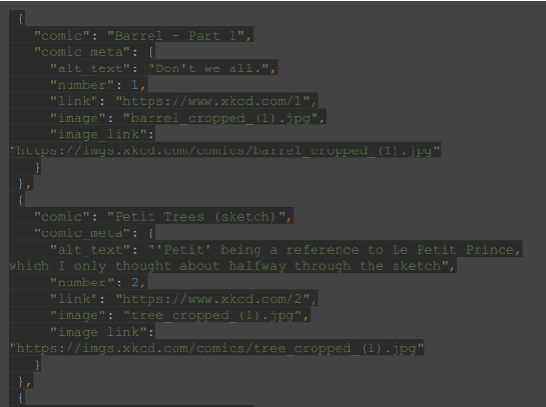

Output:

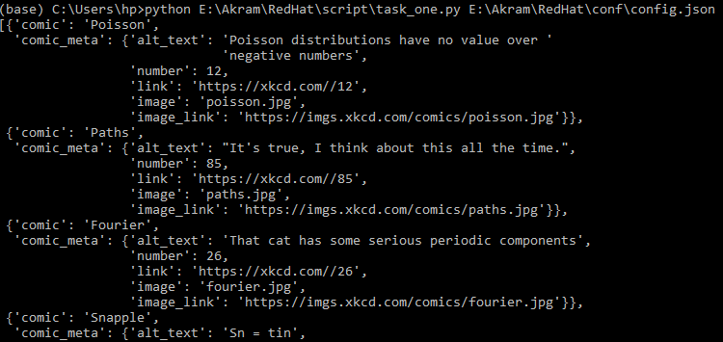

B) End-to-end Test:

1. Script should extract only random 15 comic at a time

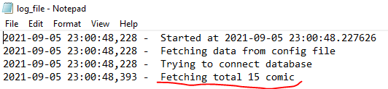

2. Comic Number (ID) should be in range 1-87. The 15 IDs should be within the range and are random.

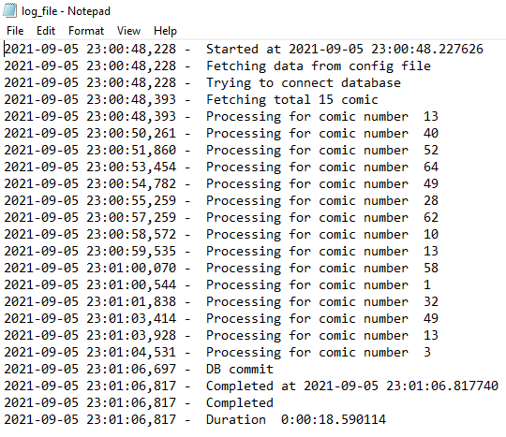

3. **Data quality in database table.**

