Introduction:

This utility will extract the information of different comics available in <https://xkcd.com/>. It is a fully configuration driven utility where use can specify all the property details in a config.json file as a result users are not required to modify any code.

Based on the mentioned properties utility will extract all the comic information along with required metadata and will store in a MySQL database.

Project Setup:

Project structure is look like below:

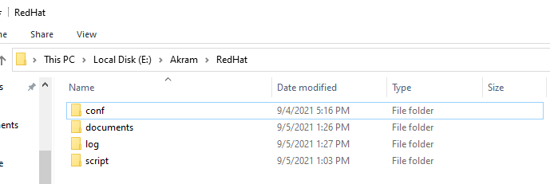

|  |  |
| --- | --- |
| **Folder Name** | **Description** |
| conf | All the configuration files will be stored |
| documents | Holds documents related to the project |
| log | All the log files generated by the script |
| script | Location of the ".py" file |

Prerequisites:

A) Python 3.x setup with below required libraries (mostly available by default):

|  |
| --- |
| sys |
| requests |
| urllib |
| webbrowser |
| json |
| random |
| pprint |
| mysql |

B) MySQL database with CREATE TABLE,SELECT and INSERT privileges.

Configuration Setup:

As per the requirement add or modify the properties in config.json.

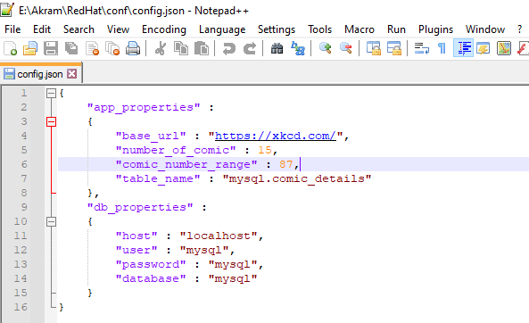

|  |  |  |  |
| --- | --- | --- | --- |
| Property Details |  |  |  |
| **Property Name** | **Description** | **Sample Value** | **Remark** |
| base_url | url of the API to extract data from | https://xkcd.com/ |  |
| number_of_comic | Number of comic need to fetch in **single execution of job** | 15 |  |
| comic_number_range | Comic ID(number) range to be fetch from API | 87 | ID's of the comics fetched will be within this range from 1 to mentioned value |
| table_name | Name of the target table created in Mysql DB |  |  |
| db_properties | MySQL databse details |  |  |

Data Base objects:

Execute below DDL statement in database to create the table.

***create table mysql.comic_details***

***(***

***comic varchar(400),***

***alt_text varchar(400),***

***num integer,***

***link varchar(400),***

***image varchar(400),***

***image_link varchar(400)***

***);***

Script Details:

The script task_one.py takes config.json file as input argument.

Command to execute:

python E:\Akram\RedHat\script\task_one.py E:\Akram\RedHat\conf\config.json

Console output:

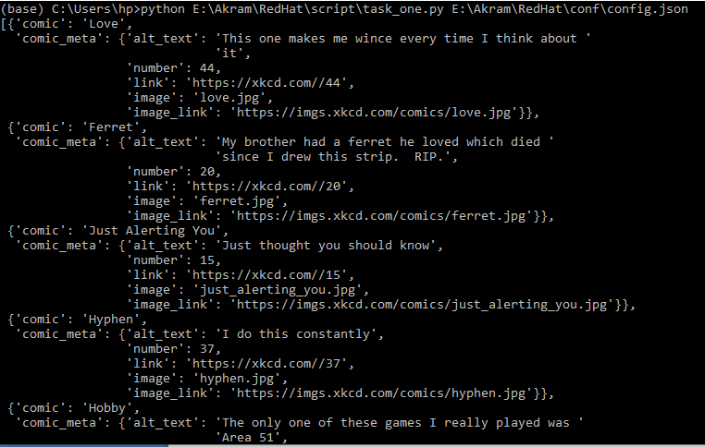

Database Table data:

