Things to fix for excellent launch

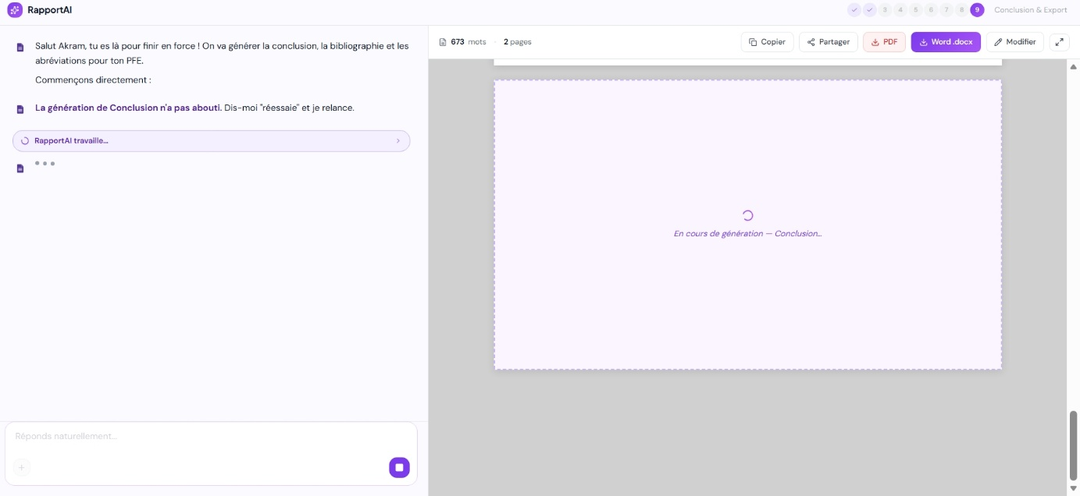
ok for the conclusion as you see the agent include bibilo and abrevaitions in it knowing that abrevaitions some schoolks or 90% of shcools are doing it after remerciment before introduction even also same notice as other sections and steps when doing enc ours ge generation for all sections the preview shouldn’t look like a rectangle it should look like the final a4 fomrat it is not abd but better. There is also something that I want to address is that when I clicked in the rectangle of chat to stop generating I kept clicking three times then the agent stops not from the first time
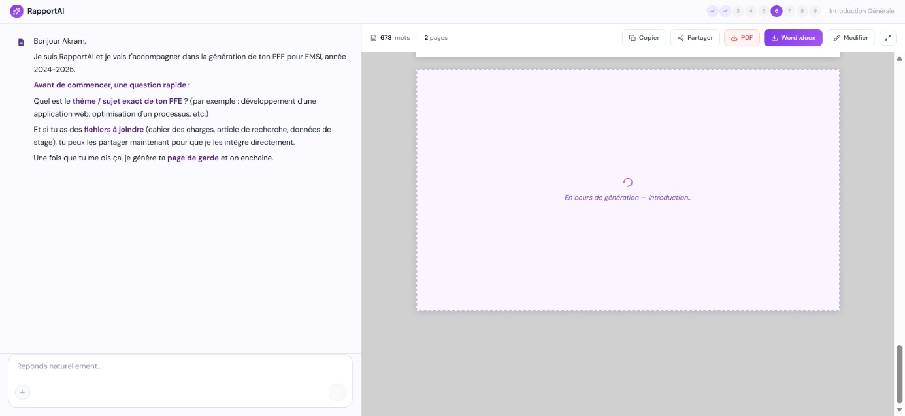
Ok first is the screenshot of introduction step as you see what the agent said to me you will see that it is generic not for introduction umm I think introduction is like sommaire the agent should know the whole context from chat orchestrator or ask the user because the theme is not enough to generate introduction or even sommaire as you know this is worth thinking about also when doing enc ours ge generation for all sections the preview shouldn’t look like a rectangle it should look like the final a4 fomrat it is not abd but better. And as you see in the second screenshot of the itnroduciton I left the page and go back to the intro step and the agent saisd the same thing he said before it is automated so it is weird for the user 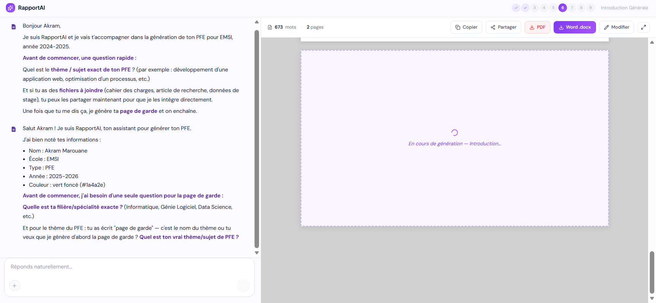

Another thing to see is that the thinking UI and planning stuffs the agents do to be visible to the user is good but not really good like replit agent but ummm in general looks great if you think so 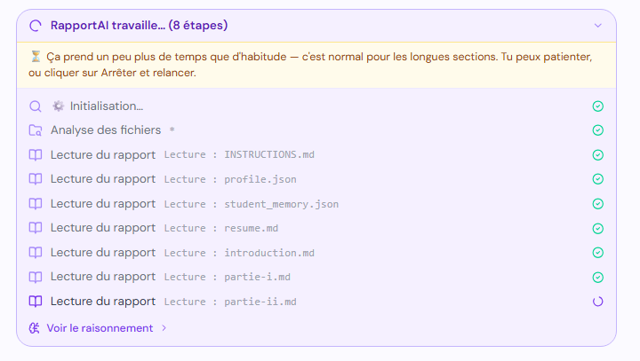
Now we can move to another thing which listes des tableaux et figures it is done after abbreviations in most of the time so in rapportAI we will do it ther ebut for some schools I don’t know they might do it at the end so this iswhy we did the reorgnaizse feature so they can deag steps etc anyway when pressing both of them listes des tableaux et figures it redirectes me to the page of uploading but there are sections as well they need page preview as well as their own agents as well ? they can be liekr esume where their agent will see the whole figures and tables in report and then do them in their page and make sure that their agents conversation is not weird like we did x now let’s move to y because they might not be in same order for some schools and this is what I want toa dress next is that in all chats do not say at the beginning we finished this so elt’s move to this just make it specifically for this step to not look weird for the users and also I have already say it just check it and verify that the figures and tables and images uploaded in the leftsiderbar are automatically sent to their agents with name and number etc inc ase the user uploaded it in another case we can make the figure agents and table agent take screenshots from the documents and pdfs the suer uploaded and make it in the report I mena you can take screenshot right ? so you know exactly how to make agents take screenshots ? so do it
For part 2 the user can upload their files as already done figures has part 1 and part 2 choices we need to make more ability like uploading codes, csv, all possible thing or file you think a students can has because note that a students who have a fpe in medicine can also with rapportAI or a development engineering etc so everything that might be considered as a practical file that the suer can upload and the agents supports I think that’s it for now

Oh yeaah another thing in all agents and chats always make them available after finishing geenrations which means a user can finish the report or a section but he will need refinment and adjustment after meting his professor or just something he deosn’t like so he will want to change it so it deosn’t make sense that the chat beign locked after generating a sction or even when they say ok partie 1 finished go to part 2 button no after part 1 finished he might go for 2 days and come back like add xyz after this paragraphs or delete this and repleace by this etc etc and this is whatw e call revesions

