Mission Impossible – Pine Script v6
TradingView indicator that marks a valid 3-run: three same-colored M1 candles in a row, where the first candle of the run sweeps the extreme of the previous run.
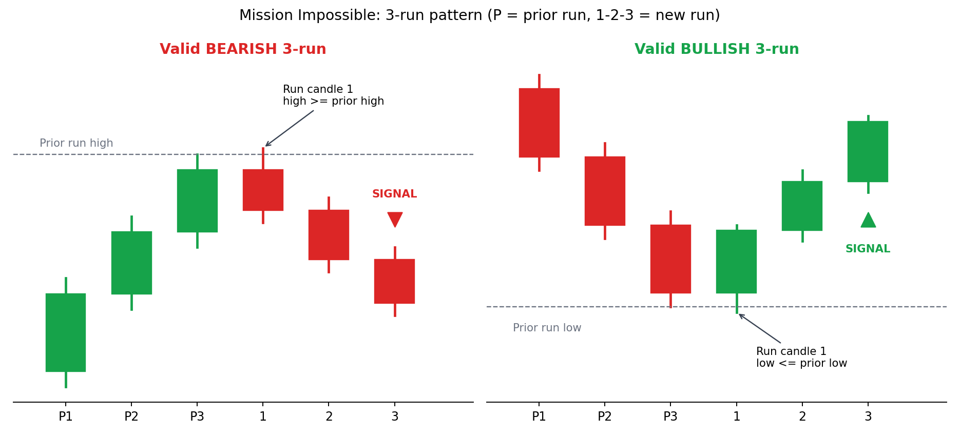

Rules in brief
- Doji: body is 5% or less of the candle range (adjustable). It counts as neutral.
- Bullish run: first candle low is at or below the previous run low.
- Bearish run: first candle high is at or above the previous run high.
- The signal fires once, when the run reaches 3 candles.
- Alerts for bullish and bearish runs can be toggled in the inputs.

Doji examples: 1st, 2nd and 3rd candle
Top row: bearish runs after a bullish prior run. Bottom row: the bullish mirror. A doji is a candle whose body is 5% or less of its range (grey cross).
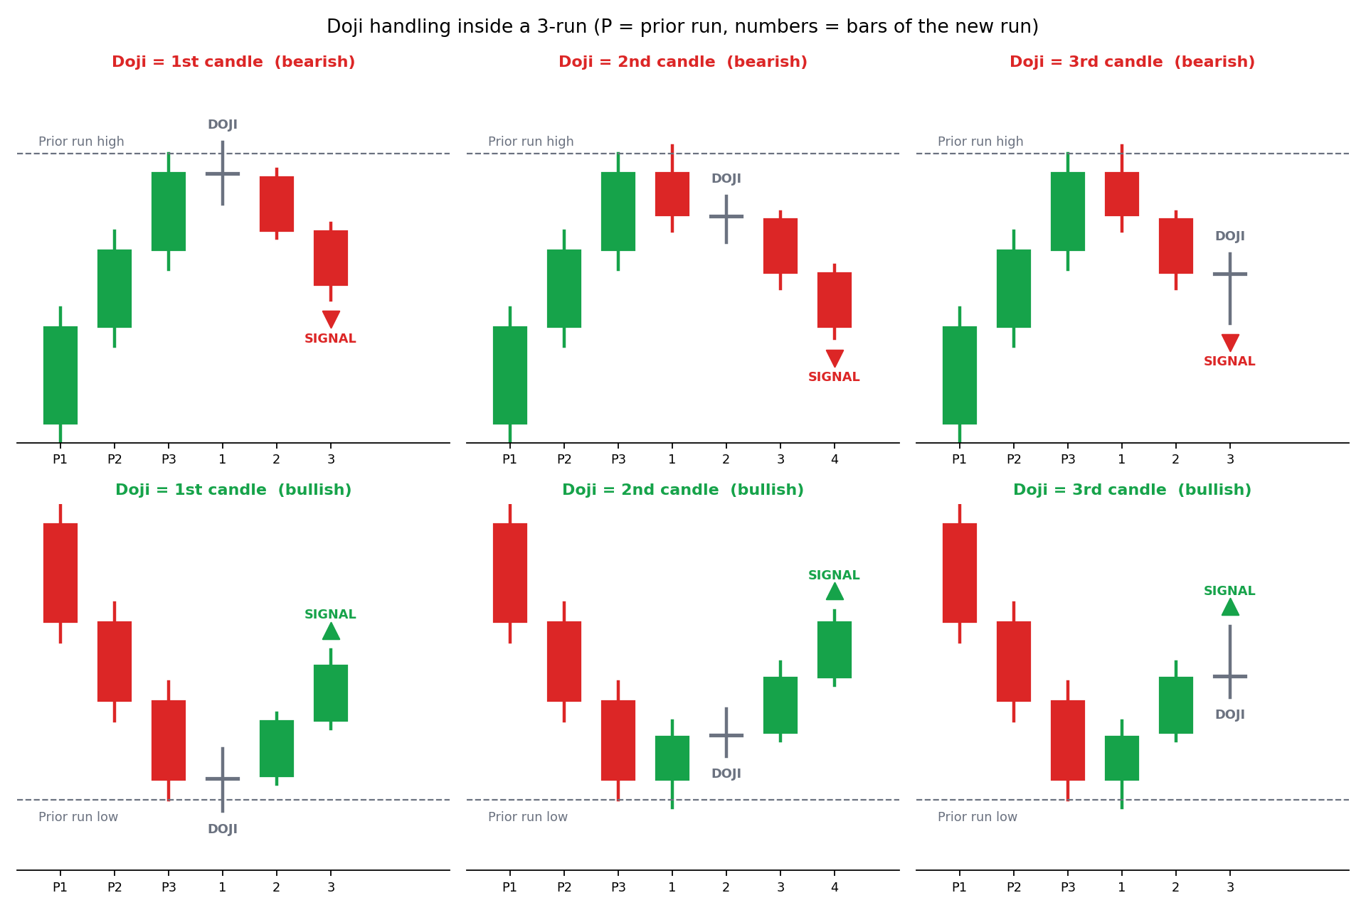
Doji position | What the script does | Signal fires on
1st candle | Doji is held as pending. The next real candle starts the run with count 2 and the doji range is merged in. Eligibility (sweep or equal of the prior run extreme) is tested on the doji, which is the first candle of the run. The following same-color candle makes count 3. | Bar 3 (second real candle)
2nd candle | Real candle 1 starts the run (count 1). The doji is held as pending and does not add to the count, but its high/low is merged into the range when the next real candle arrives (count 2). Eligibility was decided by candle 1 only. | Bar 4 (needs one more real candle)
3rd candle | Two real candles give count 2. A doji arriving at count 2 completes the run (count 3) and its range is merged in. If the run is eligible, the signal fires immediately. | The doji bar itself
Note: up to two dojis can sit in one run (see the two-doji pages). A third doji in a row drops the pending dojis.

Equal high / equal low is also accepted
A new run is eligible when its first candle reaches the previous run extreme. The comparison uses <= and >=, so touching the extreme exactly counts, not only breaking beyond it.
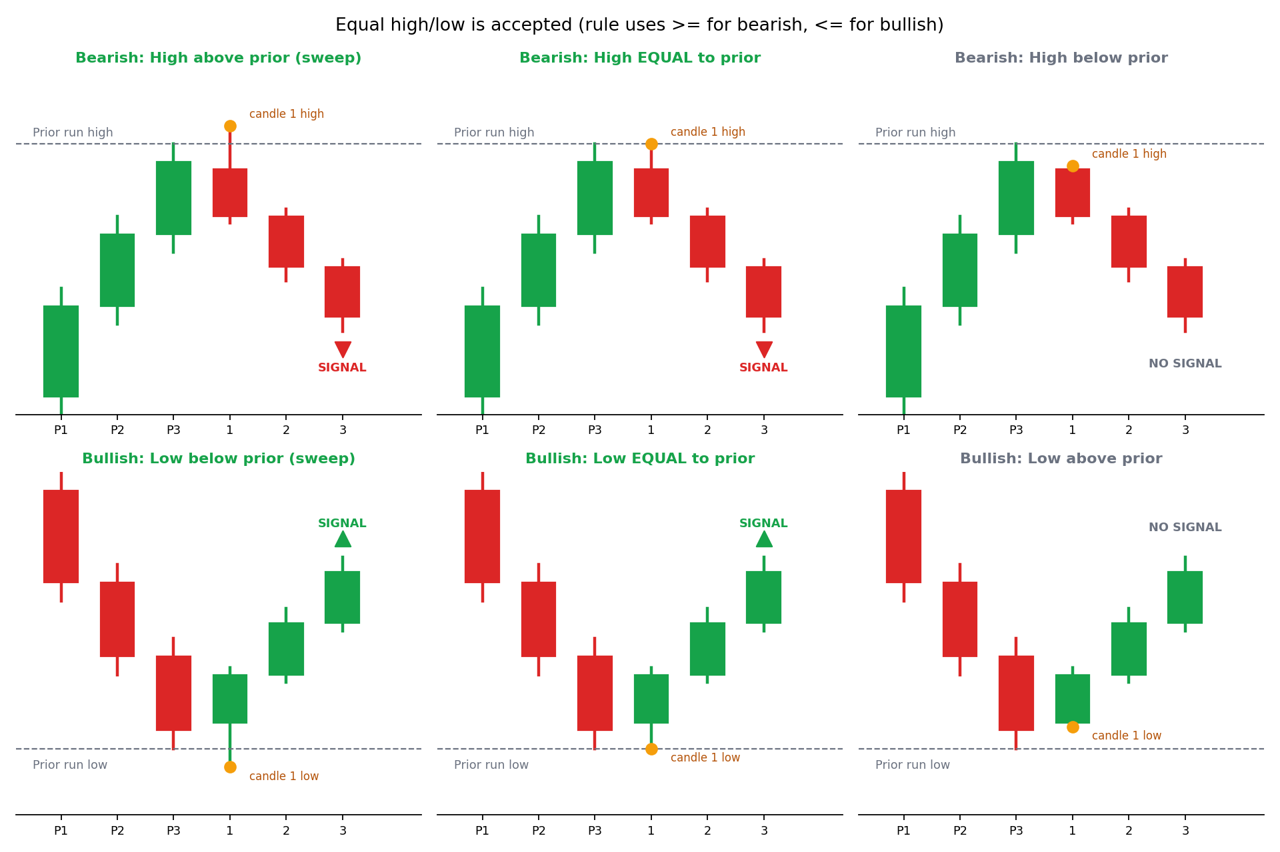
- Bullish run: eligible when the first candle low is below or equal to the previous run low.
- Bearish run: eligible when the first candle high is above or equal to the previous run high.
- Equal means exactly the same price. This script has no tolerance input, so a 1-tick miss is rejected.
Code that does this:
streakEligible := thisColor == 1 ? (not na(prevStreakLow) and newLow <= prevStreakLow) : (not na(prevStreakHigh) and newHigh >= prevStreakHigh)

Two dojis allowed in a 3-run
A 3-run can contain 2 dojis and 1 real candle. The dojis count as candles, and the signal fires on the third candle. The first candle of the run (doji or real) must sweep the previous run extreme or equal it exactly. Bearish signals are shown first, then the bullish mirror.
Order | Rule | Signal fires on
Doji, Bear, Doji | First doji sweeps or equals the prior bullish run high. Bearish candle follows, then a doji completes the run. | Third candle (the last doji)
Doji, Doji, Bear | First doji sweeps or equals the prior high. A second doji follows, then the bearish candle completes the run. | Third candle (the bearish candle)
Bear, Doji, Doji | The bearish candle itself sweeps or equals the prior high. Two dojis then complete the run. | Third candle (the second doji)
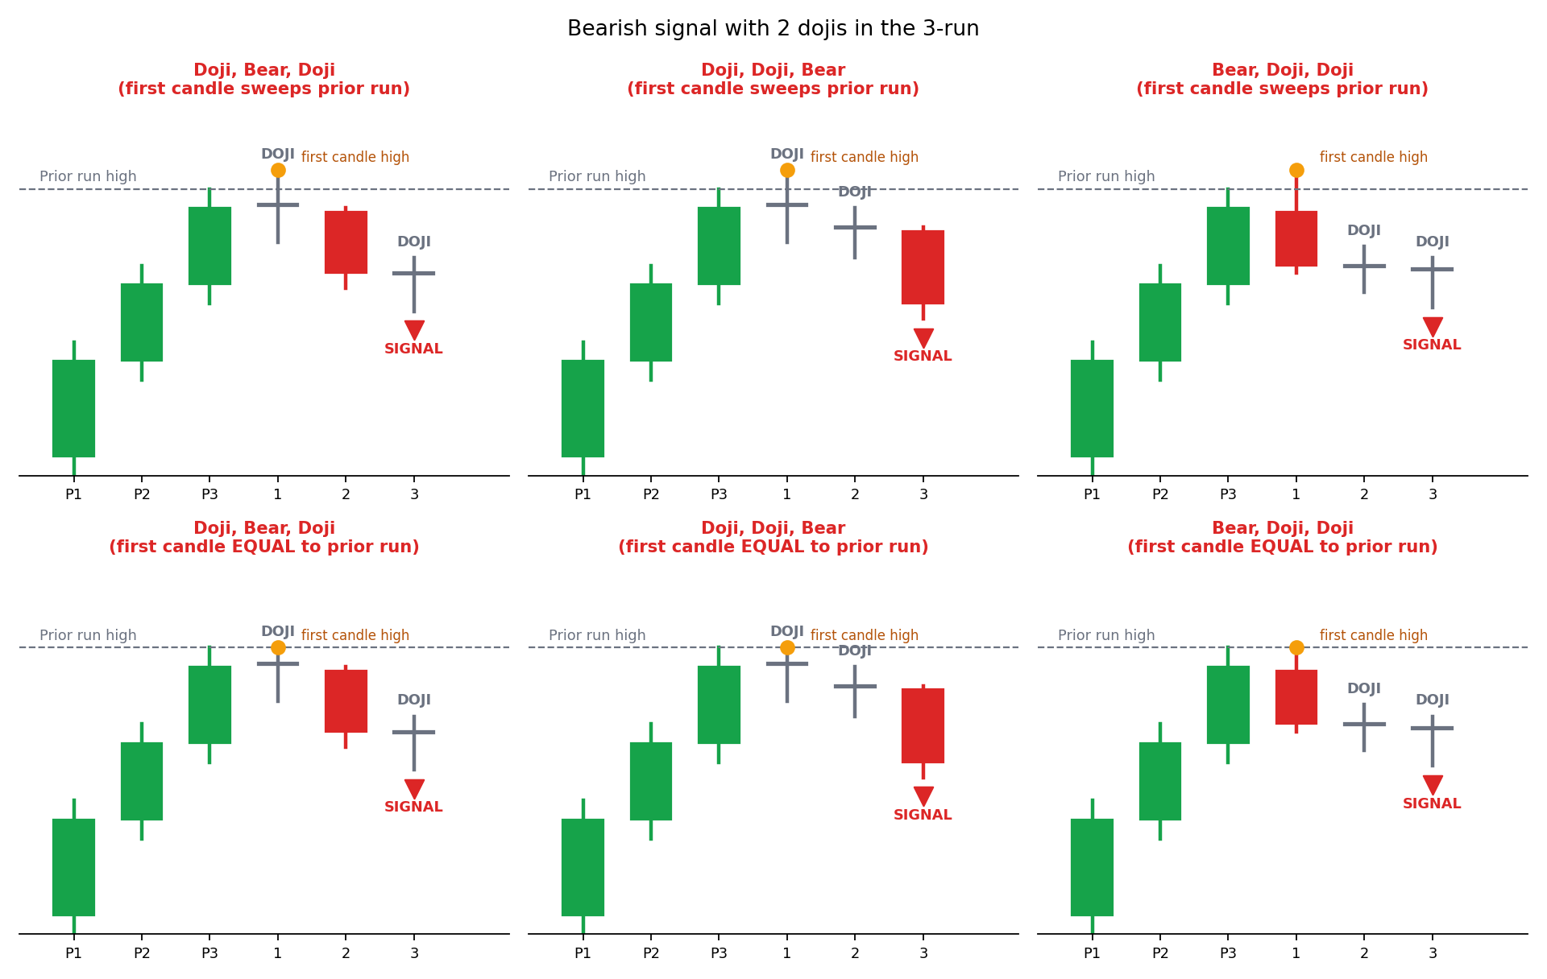

Two dojis: bullish signals
Mirror of the bearish rules: the prior run is bearish, and the first candle must sweep the prior run low or equal it exactly. Doji, Bull, Doji; Doji, Doji, Bull; Bull, Doji, Doji.
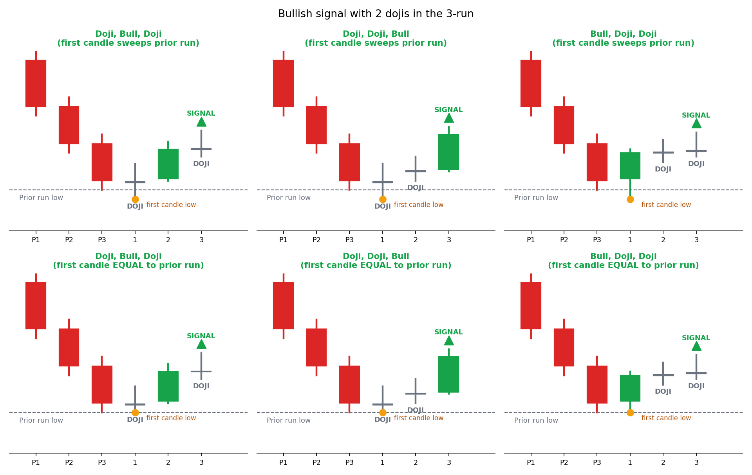
If the first candle stops short of the prior extreme, none of these orders give a signal. Two dojis are dropped if a third doji follows them.
close}}")

