Content

Audience profile 2

Functions and Futures 2

**References:** 6

# Audience profile

Nowadays in our contemporary world, people often facing the problem with traffic jams. Bicycles are becoming one of the most appropriate solution for this issue. Fortunately, there are many types of bicycles, which are suitable for various people. Canyon Uzbekistan offers two types of bicycles: for daily usage and for mountain trips.

The target audience of Canyon are people of both genders and any ages. It is a known fact that a lot of people use their bicycles not only for their journeys but for keeping their health. For purchasing, looking for bicycles or asking any question, there are several links on social media profiles such as Instagram, Twitter, Facebook and official webpages.

One of the most strength sides of the Company is a quality of service. Canyon Company provides six year warranty and guarantee high quality repairing service of costumers bicycles.

# Functions and Futures

The website of Canyon Uzbekistan consist of six links, which are Home page, Road, Mountain, Size chart, Order and link for to the official website. In addition, logo of the webpage is clickable and it moves person to the home page.

The main menu includes a dropdown toggle that allows users to move to Road and Mountain pages. On other webpages there is no dropdown menu to make moving more comfortable.

Also, there is a slider in the homepage of the website. It is based on the Bootstrap library.

<div id="carousel-example-generic" class="carousel slide" data-ride="carousel">

<ol class="carousel-indicators">

<li data-target="#carousel-example-generic" data-slide-to="0" class="active"></li>

<li data-target="#carousel-example-generic" data-slide-to="1"></li>

<li data-target="#carousel-example-generic" data-slide-to="2"></li>

</ol>

<div class="carousel-inner" role="listbox">

<div class="item active">

<img src="img/03.jpg" alt="img-3">

</div>

<div class="item">

<img src="img/01.jpg" alt="img-1">

</div>

<div class="item">

<img src="img/02.jpg" alt="img-2">

</div>

</div>

<a class="left carousel-control" href="#carousel-example-generic" role="button" data-slide="prev">

<span class="glyphicon glyphicon-chevron-left" aria-hidden="true"></span>

<span class="sr-only">Previous</span>

</a>

<a class="right carousel-control" href="#carousel-example-generic" role="button" data-slide="next">

<span class="glyphicon glyphicon-chevron-right" aria-hidden="true"></span>

<span class="sr-only">Next</span>

</a>

</div>

The code of the slider is demonstrated above. All classes are appropriate.

On the right top left side of the menu, there is a login button. When it is clicked it directly moves to another page, which represents registration form. There is a JS code of the registration form:

The Road and Mountain webpages is detailed describes the types of road bicycles. As it could be seen, there are several pictures on the right side of the bikes and on the left side; there are descriptions of each one.

In addition, there is a webpage called Size chart. There is a large table, which consist of all sizes, models and prices for all bicycles.

There is an image of the table mentioned above:

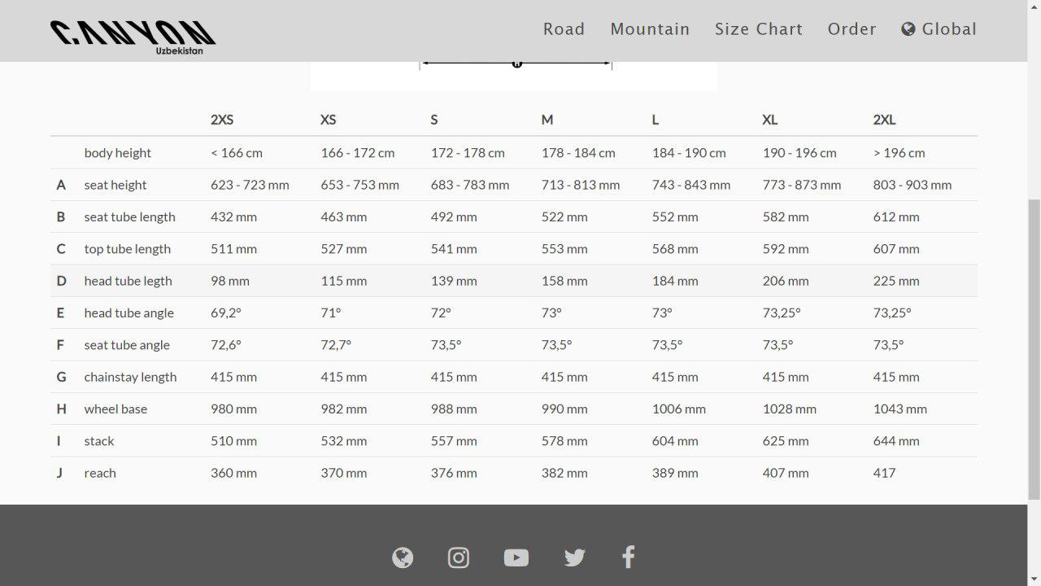

Also, there is a JavaScript code for the order function, which should call a delivery form. There is a JavaScript code:

var call = ***document***.getElementById('call');

***call***.addEventListener('click', function (*event*) {

***event***.preventDefault();

    var name = ***document***.getElementById('name-p').value;

    var email = ***document***.getElementById('email').value;

var phone = ***document***.getElementById('phone').number;

    if (name === '' || email === '' || phone === '') {

        swal({

         type: 'error',

         title: 'Error',

         text: 'Please fill all the required fields',

        })

    } else {

        swal(

            'Sent!',

            'Wait for our call',

            'success'

        )

}

Given website is hosted in https://akrazali.github.io / .

## **References:**

Canyon (2019). *Aeroad*. [image] Available at: https://www.canyon.com/en-us/road-bikes/race-bikes/aeroad/aeroad-cf-slx-disc-9.0-sl/2226.html [Accessed 18 Nov. 2019].

Canyon (2019). *Downloads/Wallpaper*. [image] Available at: https://www.canyon.com/en-us/support-articles/downloads.html [Accessed 17 Nov. 2019].

Canyon (2019). *Dude*. [image] Available at: https://www.canyon.com/en-us/mountain-bikes/fat-bikes/dude/dude-cf-9.0-unlimited/2593.html [Accessed 17 Nov. 2019].

Canyon (2019). *Endurace*. [image] Available at: https://www.canyon.com/en-us/outlet/road-bikes/endurace-cf-sl-disc-8.0-aero-di2/2188.html [Accessed 17 Nov. 2019].

Canyon (2019). *Grail*. [image] Available at: https://www.canyon.com/en-us/road-bikes/gravel-bikes/grail/grail-cf-slx-8.0-etap/2381.html [Accessed 18 Nov. 2019].

Canyon (2019). *Lux*. [image] Available at: https://www.canyon.com/en-us/mountain-bikes/cross-country-bikes/lux/lux-cf-slx-9.0-team/2438.html [Accessed 16 Nov. 2019].

Canyon (2019). *Neuron*. [image] Available at: https://www.canyon.com/en-us/mountain-bikes/trail-bikes/neuron/neuron-cf-9.0-unlimited/2505.html [Accessed 16 Nov. 2019].

Canyon (2019). *The Canyon Guarantee*. [image] Available at: https://www.canyon.com/en-us/buying-tools/buy-at-canyon.html [Accessed 17 Nov. 2019].

Canyon (2019). *Ultimate CF Evo Disc*. [image] Available at: https://www.canyon.com/en-qa/collections/evo-collection.html [Accessed 19 Nov. 2019].

Canyon.com. (2019). *Buy at Canyon*. [online] Available at: https://www.canyon.com/en-us/buying-tools/buy-at-canyon.html [Accessed 15 Nov. 2019].