CSCI-UA.0480-001

Adam Krebs
Spring 2012

Computer Vision Assignment 1

Part 1: Colorizing the Prokudin-Gorskii photo collection.
This assignment involved combining separate RGB channel images into a single color-complete image by convolving a 10x10 pixel kernel image for the Blue and Red channel images against the base Green channel and minimizing its sum-squared differences.
My initial kernel size was 15x15, but after poor results with the photo of the sitting man (part1_3.jpg) I resized the window to 10x10. Given the relative small size of the images I assume the performance impact will be negligible.

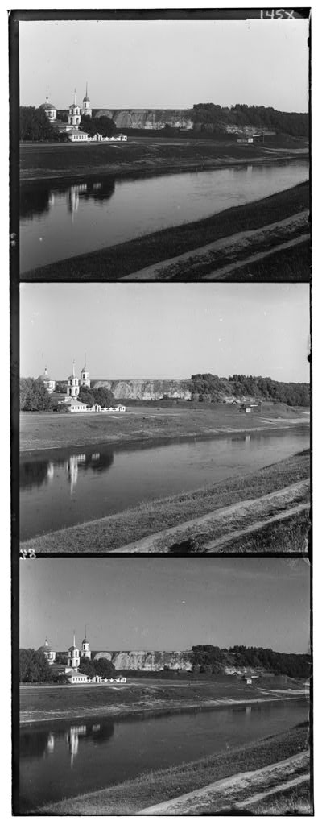
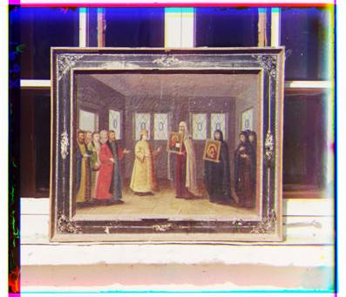
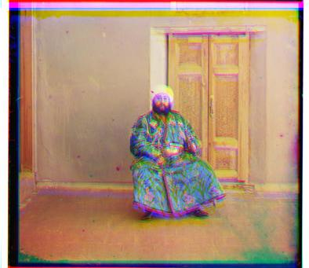
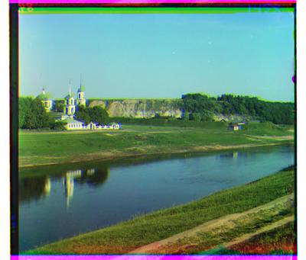
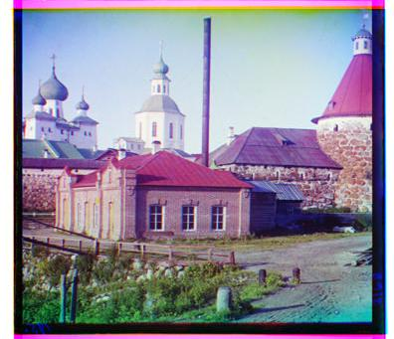
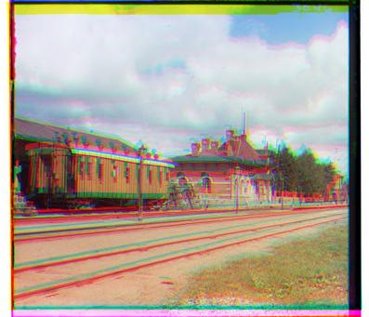
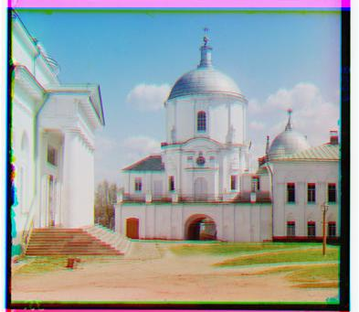

Part 2: Harris corner detector
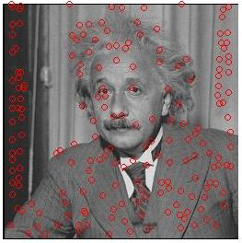 No transformation
Part 2 examined a Harris corner detection implementation on a picture of Albert Einstein, using convolution and Gaussian smoothing to detect the “cornerness” of points in the image. The red circles in the image to the right are discovered corers superimposed over the original image.
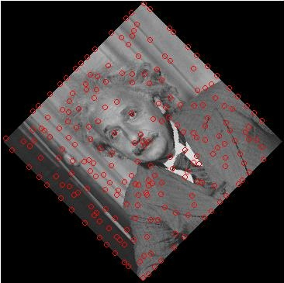45° Rotation
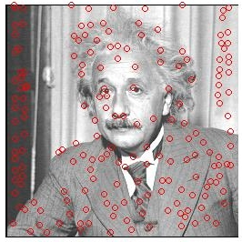1.5 x Intensity
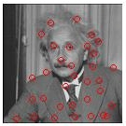1/2 size

Part 3: Scale-invariance
My parts 3 and 4 were much more difficult. Each time I thought I understood how to make it work, there was some difficulty or problem, or stupid error that kept popping up in my way. They didn't appear to be show-stopper bugs, but each time I'd try to fix them I'd uncover another layer of things that I had to learn before I could implement the algorithms.

Part 4: Image alignment with RANSAC
This assignment was also incredibly difficult for me. I tried to follow along with the lecture notes, but when I became fed up that I couldn't understand, I went to Wikipedia for clearer pseudocode. It gave me a concept of the algorithm, but not much in the way of examples on how to call the function, or the format the dataset was in, so from an implementation standpoint it was next to useless. I let my fear of asking stupid questions in class get in the way of understanding this assignment, and didn't realize how problematic the last two problems were until too late. I'll take responsibility for this in the future.

