REPORT
O N

WINE

( Windows Emulator)

BY- ROLL NO
MANASI BOPARDIKAR 13
KOMAL KUMAVAT 46
ASHWINI KUMBHAR 47

TABLE OF CONTENTS

1.WHAT IS EMULATION?

2.INTRODUCTION-WHY WINE IS REQUIRED?

3.HISTORY OF WINE

4. DETAILS OF TOPIC

5.WINE CONFIGURATION

6.FAQs(Frequntly Asked Questions).

7.REFRENCES

So What is all This Emulation Stuff, Anyway?
What is emulation?
When a computer tries to emulate a foreign processor, such as the PowerPC trying to emulate an 80486, some translation of code must happen before Any program can be run on the emulator. When I say translation of code, I mean that the PowerPC processor and the 80486 processor are two very different chips. Because of this fact, they tend to execute computations in different ways. These ÒwaysÓ of executing computations are known as instructions. Obviously, since the two chips have differing instruction sets, the emulation software must find a way to bridge the gap between the two.

BASIC TYPES OF EMULATION :

There are two basic types of emulators out there. The first can be called an interpretive emulator. This type of emulation converts the instructions of the afore mentioned 80486 to PowerPC instructions as it encounters them. But, after the instructions are converted into PowerPC lingo and executed by the PowerPC, they are "forgotten." This can be a huge drawback if the goal is to make the emulation run as fast and smooth as possible. Imagine, for instance, a program that creates numerous looping functions that execute the same code over and over again. With the interpretive emulation scheme, this redundant code must be translated over and over again--an obvious waste of time and computing power. This brings up the second type of emulator, called a dynamic emulator. A dynamic emulator fixes that waste problem in the interpretive scheme. When it encounters the foreign code of the 80486, it translates that code into PowerPC code. Does this sound familiar? Yes, this is just what the interpretive emulator does. But where the interpretive emulator has amnesia, the dynamic one has a memory. So, after completing the conversion to the PowerPC code, the dynamic emulation then stores this converted code in a special area of memory called a buffer. Now, whenever this particular code is needed again, the emulator does not have to retranslate it. Instead, the converted code is accessed within this memory buffer. Needless to say, this process is severely memory intensive, but it increases the speed of emulation quite nicely.

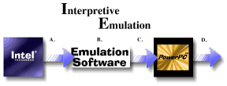
A. Intel Chip instructions are sent to the Emulation Software.
B. The emulation software translates the Intel instructions into Motorola instructions.
C. These instructions are then sent to the Motorola Processor for execution.
D. After the instructions are executed, they are then forgotten.
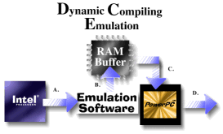
A. Intel Chip instructions are sent to the Emulation Software.

B. The emulation software translates the Intel instructions into Motorola instructions and sends these instructions to a special buffer where they can be stored and reused.
C. Instructions from the buffer can be sent to the Motorola Processor for execution.
D. After the instructions are executed, they can be recalled from the RAM buffer, therefore eliminating the need to recompile them. This makes emulation much faster

WHY WINE IS REQUIRED?

Many people have faced the frustration of owning software that won’t run on their computer.Your windows software won’t run of linux and your linux software won’t run on windows.
A common solution to the above problem is to install both operating systems on the same computer,as a “dual boot” system.If you want to write a document in Msword you can boot up in windows,if you want to run the Gnucash ,GNOME financial application,you can shut down your windows session and reboot into linux.The problem
woth this is that you cannot do the both at the same time.This can get tiresome.
WINE makes it possible to run native windows applications alongside native linux applications on linux (or solaris) system.

HISTORY OF WINE
The Wine project started in 1993 as a way to support running Windows 3.1 programs on Linux. Bob Amstadt was the original coordinator, but turned it over fairly early on to Alexandre Julliard, who has run it ever since. The newsgroup was created in July 1994. Over the years, ports for other Unixes have been added, along with support for Win32 as Win32 applications became popular.

DETAILS OF TOPIC
SUPERIORITY OF LINUX OVER WINDOWS

For the network of 250 users using pre-existing hardware, with all users requiring standard office proficutivity solutions, email, internet services and SQL data access as well as a small number of specialist technical/developer workstations.
Windows Linux
SOFTWARE
Platform Software $56,121.00 $79.95
Office Productivity Applications $222,397.50 $0.00
Specific Technical Applications $4,455.00 $0.00

=========== ========
TOTAL Software Costs $282,973.50 $79.95
=========== ========

WINE CONFIGURATION
Example 5-1. Sections in Wine Configuration File with Windows Partition
[Drive A]
; your floppy drive
Path=/mnt/fd0
Type=floppy
Label=Floppy
Serial=87654321
Device=/dev/fd0
; Don´t give raw device access to any drive if
; you do not really need it. Giving device raw
; device access with the "Device"-entry means
; that a user can format a drive with
; any windows tool.

[Drive C]
; your Windows/Dos partition
; please adjust to the path where it is mounted!
Path=/dos
Type=hd
Label=MS-DOS
Filesystem=msdos
; if vfat partition: Filesystem=win95
; NO device-Entry here!

[Drive D]
; your cd-rom drive
; please adjust to the path where it is mounted!
Path=/cdrom
Type=cdrom
Label=CD-Rom
Filesystem=win95
; if you want to write CDs, you need
; raw device access here

[Drive E]
; normally this should not be changed
; you need write access here, as it will
; be assigned as temp dir
Path=/tmp
Type=hd
Label=Tmp Drive
Filesystem=win95
; WARNING: do not add a device entry!!!!

[Drive F]
Path=${HOME}
Type=network
Label=Home
Filesystem=win95
; Maybe, you store applications here
; you may add another drive, if you want to install
; applications on your Linux partition
; Filesystem should be "msdos" or "win95"
; if you install or run Windows 95 programs
; win95 is recommended
; WARNING: do not add a device entry!!!!

[wine]
Windows=c:\windows
System=c:\windows\system
Temp=e:\
Path=c:\windows;c:\windows\system;e:\;f:\
GraphicsDriver=x11drv
; GraphicsDriver is new and not for old
; versions of Wine. See section x11drv for it
;printer=on or printer=off
; If you use a windows printer driver this
; should be set to on
;SymbolTableFile=/usr/local/lib/wine.sym
; SymbolTableFile wir normalerweise nicht benötigt
;Profile=c:\windows\Profiles\Administrator
; only for use with Windows NT
; If you have a windows95-System, it would be better,
; to take a clean directory as windows dir, seems there are
; some problems with the windows registry
; please note: Give all paths in dos/windows notation!
; do not change to or add something like
; "/home/windows"
; Wine would not accept that!!!
; locate your "wine.sym" file to ensure the path to
; it (this is to be given in Unix-notation) is
; correct
; wine.sym normally is located in /usr/local/lib or /usr/lib

; The next three sections are only for version of Wine
; after 990323. You do not need to add them if you
; are using an older version!
; Wine has reasonable defaults built in,
; so you are not forced to add them
; for newer versions either.

[DllDefaults]
EXTRA_LD_LIBRARY_PATH=${HOME}/wine/cvs/lib
; This is only needed if you have additional compiled
; dlls; if not, the leave it as is.
DefaultLoadOrder = native, elfdll, so, builtin
; Not used in older Wine versions!
; The default load order for dlls used by Wine, you may
; overwrite it by command line options. Please see "man wine"
; for options

[DllPairs]
; Not used in older Wine versions!
krnl386 = kernel32
gdi = gdi32
user = user32
commdlg = comdlg32
commctrl= comctl32
ver = version
shell = shell32
lzexpand= lz32
mmsystem= winmm
msvideo = msvfw32
winsock = wsock32
; The dll pairs are needed together with the load order.
; these dlls always have to be loaded together as builtin,
; native or whatever
; You may not load one dll of a pair as builtin and the other
; native.

[DllOverrides]
; Not used in older Wine versions!
kernel32, gdi32, user32 = builtin
krnl386, gdi, user = builtin
toolhelp = builtin
comdlg32, commdlg = elfdll, builtin, native
version, ver = elfdll, builtin, native
shell32, shell = builtin, native
lz32, lzexpand = builtin, native
commctrl, comctl32 = builtin, native
wsock32, winsock = builtin
advapi32, crtdll, ntdll = builtin, native
mpr, winspool = builtin, native
ddraw, dinput, dsound = builtin, native
winmm, mmsystem = builtin
msvideo, msvfw32 = builtin, native
w32skrnl = builtin
wnaspi32, wow32 = builtin
system, display, wprocs = builtin
wineps = builtin
; this is the default load order for the dlls
; you may make changes here, but NEVER change the
; first two lines!!!
; WARNING: The big ones, krnl386, kernel32, gdi, gdi32,
; user and user32 cannot be native, but MUST be of
; type "builtin"

[x11drv]
; Number of colors to allocate from the system palette
AllocSystemColors = 100
; Use a private color map
PrivateColorMap = N
; Favor correctness over speed in some graphics operations
PerfectGraphics = N
; Color depth to use on multi-depth screens
;;ScreenDepth = 16
; Name of X11 display to use
;;Display = :0.0
; Allow the window manager to manage created windows
Managed = N
; Use Xfree86 DGA extension if present
UseDGA = Y
; Use XShm extension if present
UseXShm = Y
; Enable DirectX mouse grab
DXGrab = N
; Create the desktop window with a double-buffered visual
; (useful to play OpenGL games)
DesktopDoubleBuffered = N
; Code page used for captions in managed mode
; 0 means default ANSI code page (CP_ACP == 0)
TextCP=0
; Use this if you have more than one port for video on your setup
; (Wine uses for now the first 'input image' it founds).
;; XvideoPort = 43

WINE FAQ(FREQUENTLY ASKED QUESTIONS)

Q1. Which one of the different Wine packages out there is good for me?
Currently there is a broad selection of different Wine packages/versions:
Wine
This is the "standard" source distribution of Wine. Its license is LGPL, it can be downloaded for free.
ReWine
This is a forked Wine tree that got created when Wine changed its license from X11 to the more restrictive LGPL, in order to let people continue to maintain an X11 licensed Wine version. Its license is X11, it can be downloaded for free.
Transgaming's WineX
This is TransGaming's Wine version specially suited for games. It includes Direct3D support (thus its DirectX support is much more complete than Wine's) and copyprotection support. Its license is AFPL, the source distribution can be downloaded for free, but the binary pack ages that include copy protection support and good support are only for subscribed customers ($5/month).
Codeweavers' Wine preview
This is a specially packaged and more stable/older version of Wine which has a nice setup for easy installation. License X11, free download.
Codeweavers' Crossover Plugin
Special Wine installation to be used for running win32 browser plugins such as e.g. Quicktime in Linux browsers. Costs $24.95. Well worth it (very stable and useful packaging).
Codeweavers' Crossover Office
Wine version with special packaging to make sure almost all important Office type programs work pretty well. Costs $54.95. Seems to be well worth it so far according to some comments. (note: you're supporting a company actively contributing to wine if you decide to buy either Plugin or Office.
Other packaged versions of Wine
Various wine packages can be downloaded for free, to be found at Wine HQ. They're not officially packaged by Wine HQ, and as such may have some configuration inconsistencies.
Q2. What is the current Status of Wine?
As of mid 2002, Wine consists of over 1 million lines of C code, written by more than 300 developers from dozens of countries around the world. Wine is in active use by an estimated 100K people. Wine implements more than 90% of the calls in popular Windows specifications such as ECMA-234 and open32.
Q3. Who's responsible for Wine?
Wine is available thanks to the work of many people. Please see the AUTHORS file in the distribution for the complete list. Some companies that are or have been involved with Wine development are Codeweavers, TransGaming, Corel, and Macadamian.
Q4. Under what hardware platform(s) and operating system(s) will Wine(Lib) run?
Wine is being developed specifically to run on the Intel x86 class of CPUs under certain UNIXes that run on the x86 platform.
Q5. How much disk space will the Wine source code and binaries take on my hard drive?
You need approximately 250 megabytes of free hard drive space to store and compile the source code. Wine also needs about 18 megs in your /tmp directory. And about 50 MB are needed to do a make install.
Q6. How much RAM do I need to have on my UNIX system to be able to run Wine and MS Windows applications smoothly?
If you can run X smoothly on your UNIX system now, you should be able to run Wine and MS Windows applications just fine too, depending on how memory hungry the application is. A Wine workstation will work with 16 megabytes of RAM and a 16 megabyte swap partition as long as you have a reasonable graphics card. Most applications will run reasonably with 64/64 Mb, interactive games are likely to need more. You can run Wine with 8/8, but it is going to be unusably slow and very constraining on the applications you can run. If you wish to be part of the development team and program Wine itself, be aware that the debugger is rather memory intensive. Some have suggested that 64 megabytes is the minimum RAM needed for Wine development, although some are able to work (albeit slowly) with 24 megabytes of physical RAM and lots of swap space.
Q7. How long does Wine take to build ?
Wine is getting to be quite large, and building from scratch takes a lot of processing. As of September 2002, compile times were around 20 minutes on an Athlon 1200 with 640 Mb and 45-50 minutes on a Cyrix 300 with 64 Mb.
Q8. Do I need to have a DOS partition on my system to use Wine?
You do not need a licensed and installed copy of DOS or MS Windows to install, configure and run Wine. However, Wine has to be able to 'see' an MS Windows binary (i.e. application) if it is to run it.
Q9. How do I configure Wine to run on my system?
Wine requires that you have a config file as.wine/~/config. The format of this file is explained in the wine.conf man page.
The file documentation/samples/config(http://www.winehq.com/source/documentation/samples/config) contains a config file example.
More explicit directions can be found in the README file ( http://www.winehq.com/source/README) that will be located in the base Wine directory after you gunzip and untar the distribution file.
Q10. How do I upgrade Wine without losing my working configuration?
Upgrading the wine installation does not affect the existing wine configuration. So after upgrading wine you still have the old (working ) wine configuration.
Q11. How do I remove Wine from my Computer?
All you have to do is to type:
rm –fR \[/path/\]Wine*

Make sure that you specify the exact path when using the powerful rm -fR command. If you are afraid that you might delete something important, or might otherwise delete other files within your filesystem, cd into each Wine subdirectory singly and delete the files found there manually, one file or directory at a time.
Q12. How do I run an MS Windows program under Wine?
When invoking Wine, you must specify the entire path to the executable, or by filename only. For example to run Windows' solitaire, type any of the following:
- wine sol or wine sol.exe (using the search path to locate the file).
- wine c:\\windows\\sol.exe (using a DOS filename).
- wine /usr/windows/sol.exe (using a UNIX filename).
- wine "c:\windows\sol.exe" (using quoted DOS filename

WINE SCREENSHOTS

Screenshots taken after running various Windows applications in Linux are presented below :

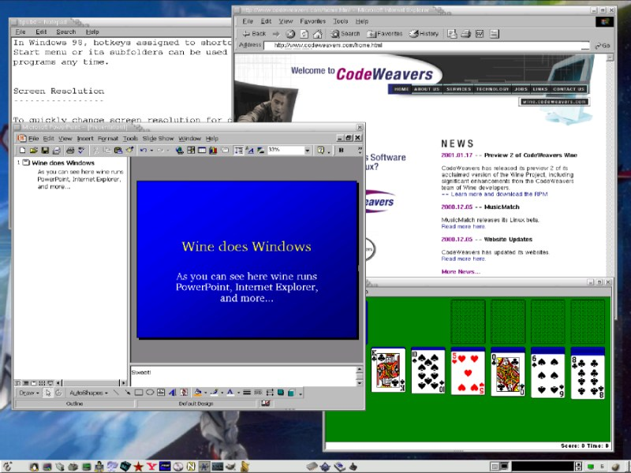Pic.6.1: Powerpoint and IE and more things running through Windows

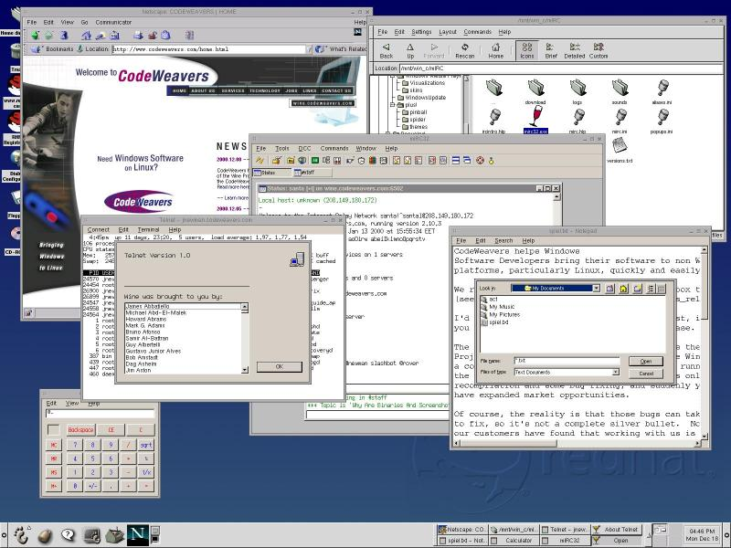

Pic. 6.2 : Word, Notepad, Calci and many more Windows Applications

REFERENCES :
Wine sources Website :
- Wine HQ ( http://www.winehq.com) is the Word Wide Web site.
2. http://www.winehq.com (This is the official website of the wine user and developer group).

3. http://www.codeweavers.com (Download wine from this site)

