SEMINAR ON

Unified Modeling Language

Guide : Prof. Mr. Ganesh Bhutkar

Group No : 6

Group Members :

Name | Roll No.
Swati Balani | 05
Swaradha Deshpande | 20
Abhijit Joshi | 33
Sanjay Thubal | 88
Praveen Tyagi | 89

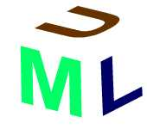

INDEX

INTRODUCTION : -

UML stands for the Unified Modeling Language. It has provided a terrific revolutionary step in the field of software modeling and software engineering (SDLC).

Why UML is called as UML.

Unified :- Before UML was developed in 1996, there was no standardization
in the field of modeling of software development phases. It was the Unified effort made by,

* Grady Booch (Booch Method)
* Ivar Jacobson (Object Oriented Software Engineering i.e. OOSE)
* James Rambaugh (Object Modeling Technique i. e. OMT)

and recognized by the Object Management Group (OMG) that a standard tool for modeling of software engineering phases, UML, was born. Hence Unified.

Modeling Language :- UML is not a programming language but a modeling
language because it works on diagrams only which are composed of something called as models. Models are visualisation of different parts of a system. They show how different parts are related one another and help in understanding the working of a system in a better way.

Goals of UML :

UML is non-proprietary language. It addresses the needs of various kinds of software development. The companies forming a part of UML consortium are incorporating UML as a standard in their development process. The Goals of UML are :

- To provide a simple and ready-to-use expressive visual modeling language.
- To be process independent.
- To be language independent.

What is UML used to represent ?

UML is the modeling language and provides a vocabulary and rules for using the language. They focus on representing Logical and Physical models of the system.

UML is a language used to :

* Visualise the software system in with well-defined symbols. So, the understanding of the system becomes easier.
* Specify the software system and help in building precise, unambiguous and complete models.
* Construct models of software system that can directly communicate with the variety of programming languages.
* Document models of software system by expressing requirements of the system during its development and deployment stages.

Application areas of UML :-

Some of the most common domains where UML is in use are :
  - Banking services.
  - Defense systems.
  - Distributed Web-based applications.
  - Enterprise information systems.
  - Medical systems.
  - Aerospace systems.

VIEWS

Static View :-
It is an aspect of the system that emphasizes the structure of the system.

Dynamic View :-
It is an aspect of the system that emphasizes the behavior of the system.

BUILDING BLOCKS OF THE UML
The vocabulary of the UML has 3 main features,

THINGS :-

1. STRUCTURAL THINGS :-
Structural things are the static parts of a model in UML. They represent the physical parts of the model. There are 7 structural things,
I) Class :- It is the description of the set of objects that share the same attributes, operations, relationships and semantics. Classes can be used to represent the software, hardware, or the conceptual things, Representation of Class,

Name Of The Class
Attributes
Operations
Responsibilities

Class name is unique and is a textual string. Attribute is the property shared by all the objects of the class. Operation is the implementation of the service. Responsibility is the obligation of a class.

Example,

Window
Origin
Size
Open( )
Close( )
Move( )

An object is the instance of the class.

II) Interface :- Interface is the collection of the operations used to specify
the service of the class. Representation of the interface,

(Name of the Interface)

They do not specify the implementation. May contain any number of operations. UML provides the graphical representation of the interface.

III) Collaboration :-
Name of Collaboration

IV) Use Case :- It contains,
Actor :- Actors are the external entities, which lie outside the system. They
are used to represent the role that the human, hardware system or the other system plays with the system. Actors interact directly with the system. They exchange the messages and request for some action to be performed. Actors are not the part of the system. Actors are connected to the use cases by association, which indicates that actor, and the use cases communicate with each other. External entities, which do not directly interact with the system, are not referred as the actors. Actors are represented by a stick person as,

No system exists in the isolation. It interacts with the humans and the other systems. The use case specifies the behavior of such a system and is the description of the set of sequences of the actions. Thus the use cases are nothing but the actions that the system performs to generate results requested by the actors of the system. Use cases are represented by the ellipse with the name inside it. Name may be prefixed by the name of the package.
Name of
Use case

Use case describes what the system does. It does not describe how the system does it. Use case carries out the work that actor initiates to do.
Example :-
If you are working with the bank as a loan officer, then you are the actor doing the work of processing of the loan.
Process the loan.
Loan Officer
(Actor)
(Use Case)

V) Active Class :-

Name of Active Class
Attributes
Functions

VI) Component :-
Name of Component

VII) Node :- Nodes are nothing but the physical elements, which exist at the run time. Nodes depict the hardware components of the system on which the software components are executed. Representation for the node.
Name of Node

Nodes have some memory. Nodes have the processing capability.

2. BEHAVIORAL THINGS :-

I) Interaction :-
(Name of the operation)

II) State Machine :-

Name of the state and substate.

3. GROUPING THINGS :- The grouping things are the organizational part of
the UML model.

I) Package :- In case of the large systems models may be very large. Thus
the concept of the package is introduced which helps to reduce the size of the model. Thus the package is the general-purpose mechanism for organizing the elements of the model into the group. Representation for the package.
Name of the package.

When the elements in the package are shown then the name of the package is placed inside the tab. Packages consist of the classes, interfaces, components, collaborations, use cases, etc. Packages may contain other packages. Thus allows the nesting. Packages allow the same name to be given to the different classes in different packages. They also allow the same name to be given to the elements of the different kind in the same package. Packages are used to arrange the modeling elements into the large groups. Used to control the visibility of the elements so that the elements are either visible or invisible outside the package.

4. ANNOTATIONAL THINGS :-

I) Note :-
Textual or graphical
Comment.

RELATIONSHIPS:

I) Dependency :-

II) Association :-

III) Generalization :-

IV) Realization :-

BASIC STRUCTURE OF UML SYSTEM

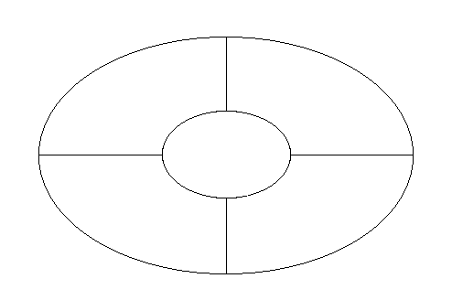
IMPLEMENTATION
VIEW
STRUCTURAL
VIEW

USER VIEW

ENVIRONMENTAL
VIEW
BEHAVIORAL
VIEW

DIAGRAMS : -
A graphical presentation of a collection of model elements, most often rendered (also referred) as a connected graph of arcs (relationships) and vertices (other model elements). UML supports different diagrams, which comes under different views of the UML system.

User view : - Represents the goals and objectives of the system from a
User’s viewpoint. It contains,
Use Case Diagrams.

Structural view : - Represents the static or idle state of the system. It contains,
Class Diagrams.
Object Diagrams.

Behavioral view : - Represents the dynamic or changing state of the system. It contains,
Collaboration Diagrams.
Sequence Diagrams.
State chart Diagrams.
Activity Diagrams.

Implementation View : - Represents the distribution of the logical elements of the system.
It contains,
Component Diagrams.

Environmental View : - Represents the distribution of the physical elements of the system.
It contains,
Deployment Diagrams.

<SPAN class=head3>Use case diagrams</SPAN>
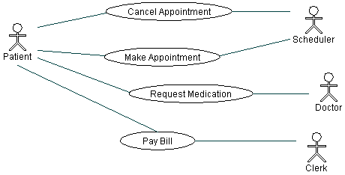
Use case diagram describes the behavior of the system, as seen by its end users and developers, as well as their expectations of the system. In short, the use case diagram represents the functionality provided by the system to external entities.

<SPAN class=head3>Class diagrams</SPAN>
A Class diagram gives an overview of a system by showing its classes and the relationships among them. Class diagrams are static -- they display what interacts but not what happens when they do interact.
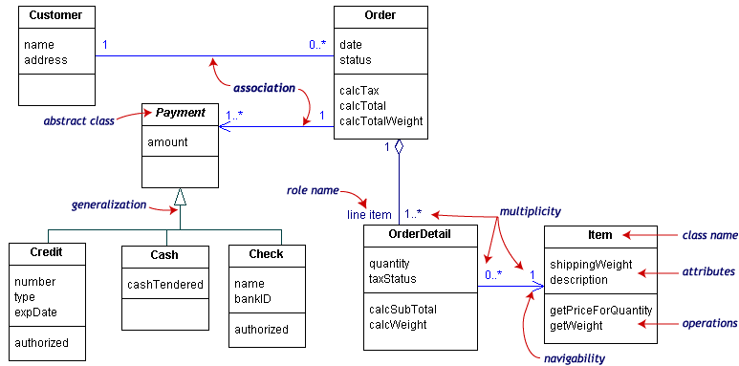
<SPAN class=head3>Object diagrams</SPAN>
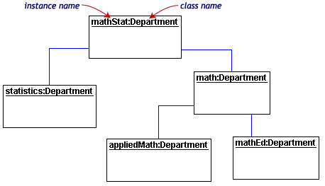
Object diagrams show instances instead of classes. They are useful for explaining small pieces with complicated relationships, especially recursive relationships. An object diagram also describes the static structure of a system at a particular instance in time.

<SPAN class=head3>Sequence diagrams</SPAN>
Class and object diagrams are static model views. Interaction diagrams are dynamic. They describe how objects collaborate. A sequence diagram is an interaction diagram that details how operations are carried out -- what messages are sent and when. Sequence diagrams are organized according to time.
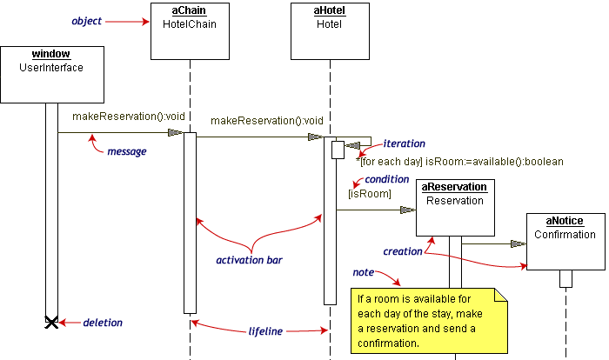
<SPAN class=head3>Collaboration diagrams</SPAN>
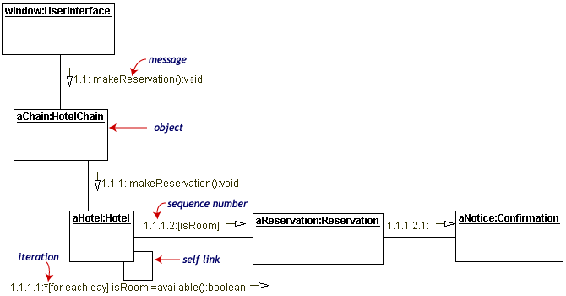
Collaboration diagrams are also interaction diagrams. They convey the same information as sequence diagrams, but they focus on object roles instead of the times that messages are sent. In a sequence diagram, object roles are the vertices and messages are the connecting links.

<SPAN class=head3>Statechart diagrams</SPAN>
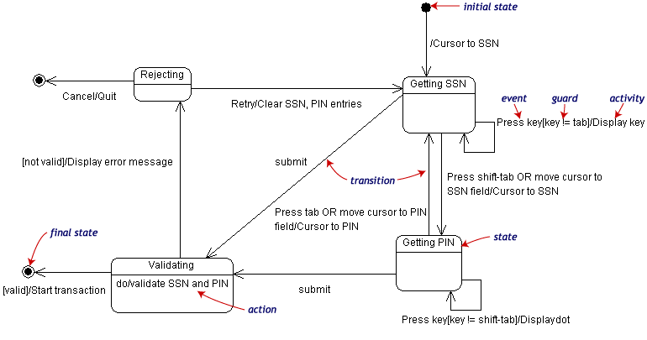
Objects have behaviors and state. The state of an object depends on its current activity or condition. A statechart diagram shows the possible states of the object and the transitions that cause a change in state.
<SPAN class=head3>Activity diagrams
</SPAN>An activity diagram is essentially a fancy flowchart. Activity diagrams and statechart diagrams are related. While a statechart diagram focuses attention on an object undergoing a process (or on a process as an object), an activity diagram focuses on the flow of activities involved in a single process. The activity diagram shows the how those activities depend on one another.

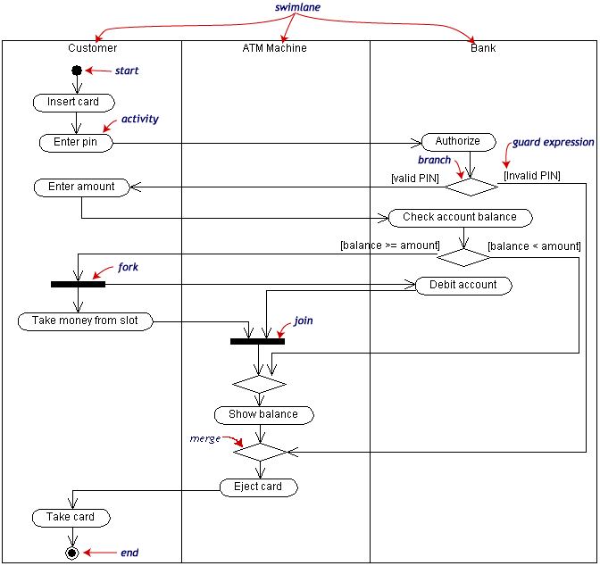

<SPAN class=head3>Component and deployment diagrams</SPAN>
A component is a code module. Component diagrams are physical analogs of class diagram. Deployment diagrams show the physical configurations of software and hardware. The following deployment diagram shows the relationships among software and hardware components involved in real estate transactions.

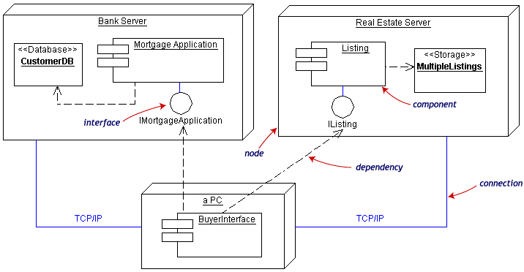

Advantages of UML : -

1. Your software system is professionally designed and documented before it is coded. You will know exactly what you are getting in advance.
2. Since system design comes first, reusable code is easily spotted and coded with the highest efficiency. You will have lower development costs.
3. Logic 'holes' can be spotted in the design drawings. Your software will behave as you expect it to. There are fewer surprises.
4. The overall system design will dictate the way the software is developed. The right decisions are made before you are married to poorly written code. Again, your overall costs will be less.
5. UML lets us see the big picture. We can develop more memory and processor efficient systems.
6. When we come back to make modifications to your system, it is much easier to work on a system that has UML documentation. Much less 'relearning' takes place. Your system maintenance costs will be lower.
7. If you should find the need to work with another developer, the UML diagrams will allow them to get up to speed quickly in your custom system. Think of it as a schematic to a radio. How could a tech fix it without it?
8. If we need to communicate with outside contractors or even your own programmers, it is much more efficient. The more complicated the underlying system, the more critical the communication among everyone involved in creating and deploying the software. In the past decade, the UML has emerged as the software blueprint language for analysts, designers, and programmers alike. It is now part of the software trade. The UML gives everyone from business analyst to designer to programmer a common vocabulary to talk about software design. It is said that the English language is World’s Universal language. Now it is virtually certain that the UML is information systems and technology world’s universal language.
9. Encourages the growth of object oriented tools market.
- Its goal is to be language independent. It is well suited to supporting projects
in modern languages like C++, Java.

CONCLUSION :-

UML does not guarantee project success, but enables you to communicate solutions in a consistent, standardized and tool supported language.
Using the Unified Modeling Language will result in lower overall costs, more reliable and efficient software, and a better relationship with all parties involved. Software documented with UML can be modified much more efficiently. Your software will have a future.

Every other engineering discipline has a standard method of documentation. Electronic engineers have schematic diagrams, architects and mechanical engineers have blueprints and mechanical diagrams. The software industry now has UML.

