Assignment No.: 3
Case Study of Websites related to GIS

- www.intergraph.com
GeoMedia Viewer
About GeoMedia Viewer
Current Product Version: 05.02.20.21
GeoMedia Viewer is an easy to use, FREE GIS software application for desktop viewing and distribution of geospatial data.
It allows an organization to maximize the value of its geospatial data by extending availability to novice users who wouldn’t otherwise have access because of the barriers of purchasing and learning how to use a full GIS software application.
GeoMedia Viewer will benefit:
Large Organizations: GeoMedia Viewer will facilitate enterprise distribution of maps created with GeoMedia to users who do not have access to a full-featured GIS. These users typically do not need access to most of the more advanced capabilities of a GIS, but they do need to be able to view data, manipulate the way in which the data is presented by changing styles or adding and removing data to and from the display, and the ability to ask simple questions and generate output.
Data Producers: Data producers who want to provide data on a CD along with a mechanism for viewing the data would benefit from use of GeoMedia Viewer.

GeoMedia ViewerTM
Key Features
Data Access
Provide read-only access to geospatial data in the following formats:
- Microsoft Access
- MapInfo
- Shapefile
With GeoMedia Viewer you can also create new connections to the above formats if you have other data sets you want to access.
GeoWorkspace Manipulation
GeoMedia Viewer lets you create new geoworkspaces and save any changes you make to existing geoworkspaces.
- New GeoWorkspace
- Open GeoWorkspace
- Save GeoWorkspace
- Close GeoWorkspace
- Data Set Navigation
GeoMedia Viewer includes a powerful set of navigation commands for moving around and exploring your data.
- Pan
- Zoom In
- Zoom Out
- Zoom to Scale
- Zoom Previous
- Fit
- Fit All
- Fit Select Set
- Zoom to Legend Entry
GeoMedia Viewer supports multiple windows including map and data windows.
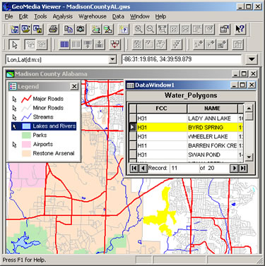
Here, a feature highlighted in the data
window is automatically centered and highlighted.
Presentation
GeoMedia Viewer provides a complete set of tools for controlling how your data is displayed.
- Style manipulations
- All legend capabilities (i.e. display on/off, locatability on/off, display priority)
- Generation of thematic maps
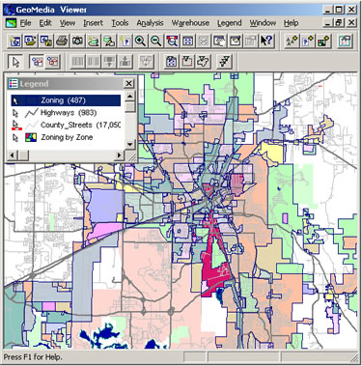
Here, a zone map is created using
thematic map generation in GeoMedia Viewer.
Analysis
GeoMedia Viewer includes powerful analysis tools to help you answer questions, reach new insights and uncover hidden trends into your spatial data.
- Attribute query
- Select Set Properties – click on a feature in a map window to view its attributes
- Measure length and area
- Statistics
- Output
When it comes time to generate paper maps, GeoMedia Viewer supports printing information directly from the map window.
Print from the Map Window
Support for north arrow, scalebar, and legend display

- www.telemorphic.com

Maplicity
Maplicity offers powerful interactive GIS, image analysis, and visualization capabilities to an unlimited number of web browser users accessing an Internet GIS. Designed as an affordable add-on to ESRI's ArcIMS Internet GIS server, Maplicity incorporates our revolutionary client-server geographic imaging technology. Maplicity offers the simplest, most cost-effective way to extend desktop GIS and image analysis capabilities throughout any organization's intranet and/or to a larger audience via the Internet. Live demos here. Internet GIS solutions integrators, check out our complete Java API (MaplicitySDK).
Maplicity™ is a lightweight Java™ applet designed to work with ArcIMS™ Image Services. It provides a feature rich familiar user interface for geospatial analysis and image visualization over the Internet.
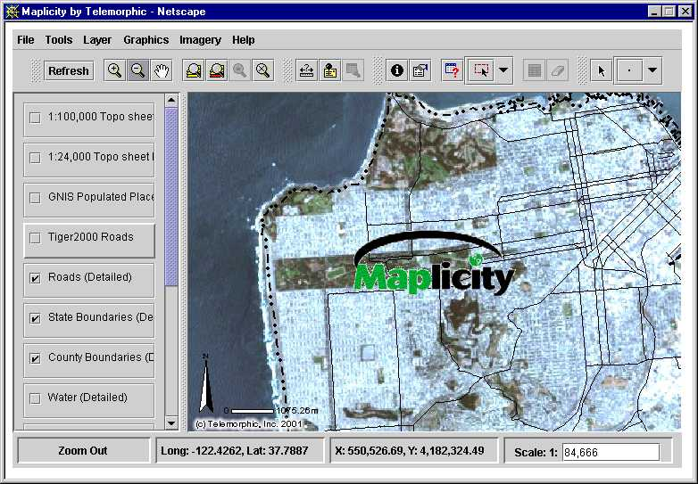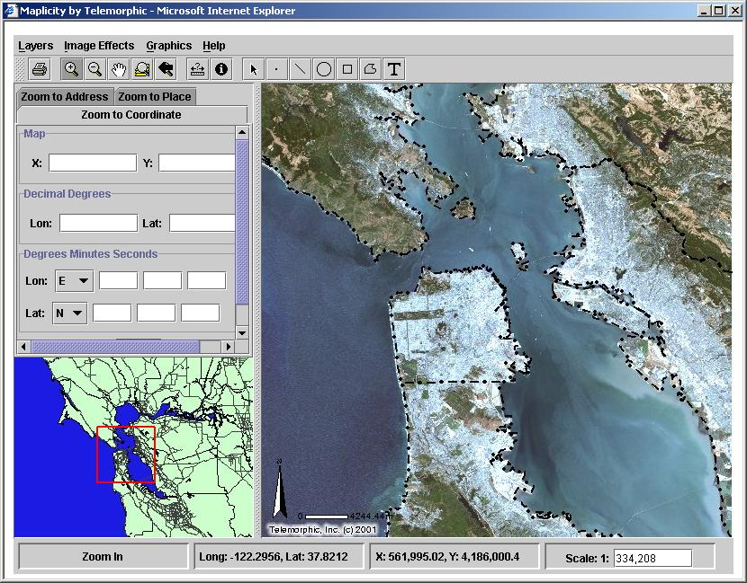
Maplicity can be deployed with either a professional or novice GUI (See images above) so that all users can be effective immediately. For more info, check out our Maplicity FAQ and our Maplicity brochure.
How can your organization benefit from Maplicity for ArcIMS?
- Expanded Functionality with Improved Performance
- Scalable User Interfaces, Enhanced Security and Reduced Maintenance
- Improved Accessibility and Compatibility
- Affordable, Customizable, Expandable
MaplicitySDK
MaplicitySDK™ is the complete software developer's toolkit for quickly and easily creating applets and applications with any or all of the functionality found in the default Maplicity applets. The MaplicitySDK brochure and MaplicitySDK FAQ explain how developers are able to build their own custom solutions.
Maplicity Enterprise
Maplicity Enterprise builds upon MaplicitySDK and extends ArcIMS by enabling Collaborative Geographic Awareness. Users can save their graphics, and extent in sessions on the server. Sessions can be shared with other users or reviewed by managers. They can also create and download shapefiles, as well as upload and display local shapefiles.

