2008 Science Olympiad
Meteorology Test – Severe Weather Team:________________________
41 points – 21 multiple choice (1 pt each), 5 short answer (4 pt each, used as tie breaker)

Fundamentals of Meteorology

- Explain briefly why warm air rises and cold air sinks in the atmosphere.
- What is the primary energy source forcing the atmosphere.
  - Earth’s gravity
  - Sun
  - Geothermal heat
- Which of the following does NOT influence Iowa’s climate?
  - Earth’s relative axial tilt in relation to the sun
  - Iowa’s location away from oceans.
  - Iowa’s extensive cultivation of corn.
  - The phase of the moon.
- What causes the circulation of high and low pressure systems where we live (the mid-latitudes)?
  - Coriolis Effect
  - Gravity waves
  - Rossby wave breaking
  - Friction
- Which concept can best be used to describe why storm systems generally track from west to east across Iowa?
  - Iowa’s topography slopes downhill from west to east.
  - Hadley Cell circulation
  - The sun heats up Eastern Iowa faster, which creates a west to east temperature gradient, with lower pressures in Eastern Iowa.
- About how much energy does the sun deliver to the earth at the top of the atmosphere over the equator?
  - 100 kilo-Joules per square meter
  - 1300 Watts per square meter
  - Scientists do not know.
Weather Forecasting

- Why is forecasting the weather a challenging task? (hint: discuss or list some of the factors that weather professionals consider when forecasting and how these factors are difficult to predict)
- Which conceptual model describes the evolution of surface cyclone systems?
  - Geostrophic Balance Model
  - Norwegian Cyclone Model
  - Canadian Wave Theory
  - Ames Little Cyclones
- Which of the following is NOT a term used to describe an atmospheric boundary?
  - Cold front
  - Warm front
  - Jet stream
  - Dry line
- What term is used to describe a forecast of having the same weather tomorrow that we experienced today?
  - Model Output Statistics (MOS)
  - Persistence
  - A bad forecast
  - Climatology
- Which theory posses a fundamental limitation for our ability to predict weather many days in advance?
  - Chaos Theory
  - Einstein’s Relativity
  - Maxwell Equations
  - Dewey Decimal System

RADAR Meteorology

- Four RADAR presentations are shown below. Assign each image its dominate storm type. Choose from the following:
  - Hurricane
  - Squall Line
  - Statiform Precipitation
  - Supercell

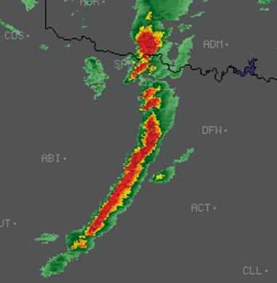 | 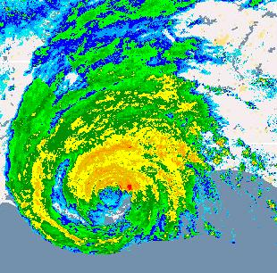
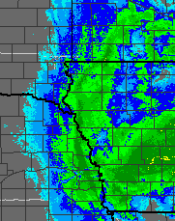 | 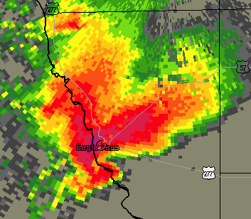

- How frequently do most weather RADARs scan the atmosphere?
  - Once per hour
  - Once per day
  - Continuously, but only during daylight hours
  - Continuously
- RADARs can definitively determine if a tornado occurring.
  - True
  - False
- Which phenomena is an illustration of the Doppler Effect?
  - Mirages seen in the desert
  - The sky appearing as red during sunset.
  - The high pitched sound you hear as a car approaches and then lower pitched as the car has past.
  - How RADAR’s can detect migrating birds

Severe Weather

- Why are tornados so destructive? Don’t just say because they produce large wind speeds, but explain why high wind speeds damage structures.
- Which comes first?
  - Lightning
  - Thunder
- Which of the following is typically NOT a severe weather threat from hurricanes?
  - Damaging winds
  - Storm surge
  - Hail
  - Tornados
- Which scale is used to measure the intensity of a tornado?
  - Saffir-Simpson Scale
  - Enhanced Fujita Scale
  - Mesoscale
- Hail stones grow by which of the following atmospheric motions
  - Vertical
  - Horizontal
  - Sea breeze
  - Down slope winds (some places referred to as Chinook)
- Approximately draw the area on the map below often referred to as “Tornado Alley”
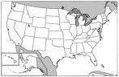

Severe Weather Safety

Evaluate each of these statements on if they are a fact or fiction. Mark your answer by circling the word.

- Fact or Fiction :: Lightning never strikes the same place twice
- Fact or Fiction :: Before a tornado strikes, you should open your windows to reduce the air pressure difference from inside the house and outside.
- Fact or Fiction :: Cars protect you from lightning due to their rubber tires.
- Fact or Fiction :: Cars can safety drive thru flooding waters over 6 inches deep.
- Fact or Fiction :: Tornados only occur during day light hours.

Extra Credit / Tie Breakers

- (3 pts) Suppose global warming is occurring and temperatures are warming in Iowa. Would this warming mean Iowa will experience more frequent and more severe weather events? There is no right answer, but defend your answer with Meteorological science concepts.

