2009 Science Olympiad Practice: Meteorology

Instructions: This test consists of 25 questions (worth 1 point each unless noted) totaling 40 points. You have one hour to complete this exam. Good luck!

- Which of the following provides the main energy source for atmospheric motions?
  - The Sun
  - The Moon
  - The Earth's electromagnetic field
- Which of the following best classifies the climate Iowa experiences:
  - Temperate
  - Tropical
  - Marine
  - Arctic
- (2 pts) Explain why a “Greenhouse” (where you grow plants indoors) is used to describe the phenomena in our atmosphere known as the “Greenhouse effect”.

- The reason for our climate seasons (winter, spring, summer, and fall) is the Earth's relative distance from the sun.
  - True
  - False
- Ocean circulations have very little impact on weather.
  - True
  - False
- (4 pts) For each item, circle the classification that most accurately describes it, either a weather term or climate term:
Today's high temperature is 60 degrees Fahrenheit. | Weather | Climate
Iowa is hit by roughly 70 tornadoes per year. | Weather | Climate
Gardens are planted in the springtime | Weather | Climate
A large snow storm is forecasted this weekend | Weather | Climate
We would expect 6 large snow storms per winter. | Weather | Climate

- (3 pts) Given that Antarctica receives 24 hours of sunlight during their summertime, provide two reasons, besides it is are covered in ice, as to why it's air temperature rarely exceeds 0 centigrade.
- (3 pts) “Snowball Earth” refers to a period of time where scientists believe the Earth was covered in ice and snow. Do you think the atmosphere would contain more or fewer clouds than what we experience in our present climate? Please also provide one reason to justify your answer.
- (3 pts) Why are a majority of the world's major deserts found at approximately 30 degrees north and south latitude?
- (3 pts) Would global mean air temperatures for the year of 2009 go up or down if a major volcano was to erupt tomorrow? Please also provide one reason to justify your answer.
- Which of the following gases is most abundant in our atmosphere?
  - Krypton
  - Helium
  - Water Vapor
  - Oxygen
- The atmosphere is classified into different layers. Which of the following is the correct order of these classifications going from the earth's surface into space?
  - Stratosphere, Mesosphere, Troposphere, Thermosphere, Exosphere.
  - Stratosphere, Troposphere, Thermosphere, Mesosphere, Exosphere.
  - Troposphere, Mesosphere, Stratosphere, Thermosphere, Exosphere.
  - Troposphere, Stratosphere, Mesosphere, Thermosphere, Exosphere.
- Which of these layers contains the majority of the ozone found in the atmosphere?
  - Mesosphere
  - Exosphere
  - Thermosphere
  - Stratosphere
  - Troposphere
- (4 pts) Please label the four earths for which northern hemisphere season they represent:

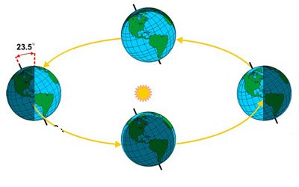
- Which of the following is not a way humans have brought about climate change:
  - Increased atmospheric carbon dioxide concentration through industrial activities.
  - Converted much of the native grassland prairies to agricultural cultivation.
  - Increased amounts of visible light from cities during the night time.
  - Deforestation in places like the Amazon.
- In Iowa, temperatures are warmer during the summer than winter.
  - True
  - False

- Which of the following can’t ice core examination tell us about climate?
  - Concentrations of gases like carbon dioxide.
  - Mean yearly temperatures.
  - Seasonal snowfall amounts.
  - The temperature on April 5th, 3450 BC
- Climate Change has been occurring since the Earth was formed.
  - True
  - False
- Rank these tropical systems from strongest, first, to weakest, last.
  - Hurricane, Tropical Depression, Tropical Storm.
  - Hurricane, Tropical Storm, Tropical Depression.

- The main reason surface air temperatures generally decrease with distance from the equator is?
  - The Coriolis force
  - The decreasing amount of solar radiation toward the poles.
  - Global Circulation
  - Santa requires snow at the North Pole, so it must be colder there.
- During what time of day does the majority of Iowa's rainfall fall?
  - During the night
  - During the day
- What is Iowa's approximate average yearly rainfall?
  - 5 inches
  - 15 inches
  - 30 inches
  - 57 inches
- What is the length of a standard climate record?
  - 10 years
  - 30 years
  - 100 years
  - 1000 years
- (3 pts) Suppose global warming is occurring and temperatures are warming in Iowa. Would this warming mean Iowa will experience more frequent and more severe weather events? There is no right answer, but defend your answer with Meteorological concepts.
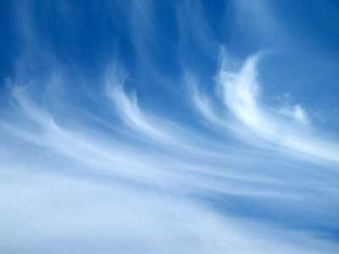
- (4 pts) CLOUD IDENTIFICATION: Please classify the following images with one of these cloud types: mammatus, cumulus, stratus, and cirrus. Place the cloud type name next to the image. There will be one correct answer for each image.
