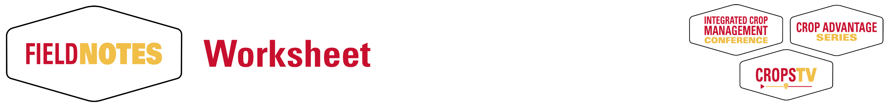

FieldNotes is a new product replacing the ICM Conference proceedings, Crop Advantage proceedings, and supplemental materials used in CropsTV. A FieldNote for each topic will be used across all programs this year. If your topic is a part of one ***or more*** programs, only one paper to prepare.

* FieldNotes can be up to two pages. *Brief, concise and focused*.
* For the ICM Conference and CropsTV, papers will be available as PDF downloads for attendees.
* Crops Advantage Series – selected articles will be combined for a printed, color publication distributed to attendees. Remaining FieldNotes will be available for download.
* If your topic is slightly different across the programs, but the content/focus is the same, one FieldNote will work. Titles don’t have to match the program *exactly.*

**Submission Deadlines**

Based on when your topic is **first** presented.

ICM Conference – **November 8**

Crop Advantage Series – **November 15** (need meet extended printing production timeline)

CropsTV – worksheet is due at your scheduled recording time

**Format**

View an example FieldNote at <https://www.aep.iastate.edu/crops/example.pdf>

* Any combination of graphs, tables, pictures or text that fit in the space.
* Images or figures can be placed in-line with text (do not worry about wrapping or exact placement). Place captions for tables or figures above or below the item, in line with the text.
* For best image quality, it is helpful to also submit graphs, figures or images as separate files along with this worksheet.
* Don’t worry about fonts, spacing, or formatting.
* Please use tables for your tables…NOT tabbed data.

**Learning Objectives**

We are requesting at least 3 learning objectives be provided for each topic. These answer the question “What do I want my audience to understand or learn from this presentation?” It’s also useful for program evaluation and measurement. New to writing learning objectives? Check out the example FieldNote as a good starting point.

**Resources**

A place to list websites, social media, publications…anything that gives your audience more information on your topic or program. All FieldNotes will have clickable links and list the full URL.

**Submit your worksheet and files**

Upload your materials at <https://iastate.app.box.com/f/f0c23cdf2f9c43c3b7bb7f92048494a3> (link is also on the Program Development page at <https://www.aep.iastate.edu/crops/>

**Please upload your files instead of emailing them.**

**Questions?**

[bpring@iastate.edu](mailto:bpring@iastate.edu) or 515.294.9487

**Title:**

**Presenter(s):**

**Learning objectives** (required - list at least 3)

What are your learning objectives for the audience? These are the key points of focus. Short and concise.

1.

2.

3.

(add more if needed)

**Resources**

Online items that support the presentation. Publications. Web pages. Blogs. Social media.  
List them here to give the audience more information after the meeting is over.

1.

2.

3.

4.

(add more if needed)

**Body text:**

[Type or paste the body of your submission below. 2 pages fills up fast.]