2/18/2022

The Location Lab Pvt Ltd. Karachi

Street View Camera

Documentation version 1.3

Contents

Introduction: 2

External Dependencies: 2

Quick Setup: 3

Street View Setting: 3

API/Scripting: 4

# Introduction:

Street view camera is a 3D camera navigation system that solely based on mouse movement and double click. You can move mouse to change the camera rotation and mouse crosshair pointer. By placing crosshair to a specific position and then, double-click to jump at pointer position.

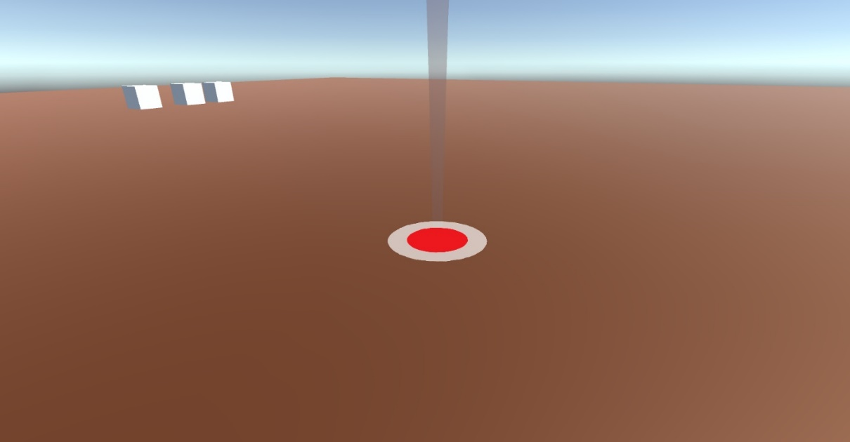

# External Dependencies:

If “TextMeshPro” have not imported then import it from:

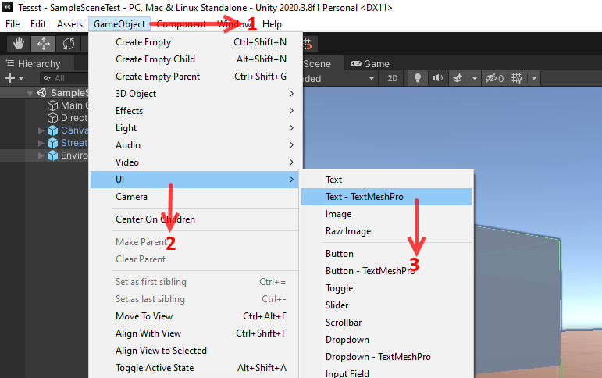

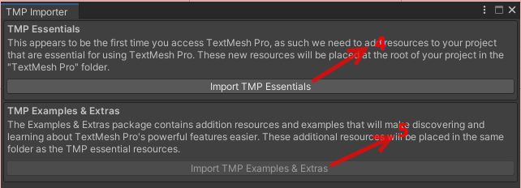

# Quick Setup:

1. First Disable your current Main camera from your hierarchy (if any).
2. Go to **prefab** folder Under **Assets\_Tools\StreetViewCamera\V-1.3\Prefabs** and drag and drop “StreeViewCamera” prefab in the hierarchy.
3. You can change different camera settings (details given in next) by selecting “StreetViewCamera” prefab in the hierarchy.

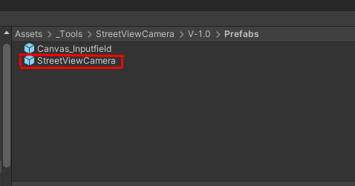

# Street View Setting:

If you want to setting of street view camera then follow this step:

1. Go to **prefab** folder Under **Assets\_Tools\StreetViewCamera\V-1.3\Prefabs** and drag and drop “Canvas_Inputfield” prefab in the hierarchy.
2. You can change street view camera setting from input panel at run time.

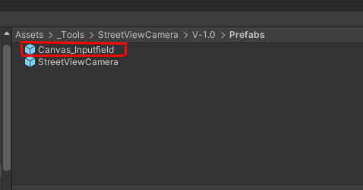

# API/Scripting:

There are two scripts in the package:

1. **DragToPointTarget:** This script allows to rotate street view camera and cross hair according to mouse movement. And it jumps the camera on double click to the crosshair position.

**Important Variables:**

|  |  |
| --- | --- |
| **Variable** | **Description** |
| CrosshairPointer | Mouse pointer. You can customize it according to your requirements |
| **Bezire Line setting** |  |
| lineStartYFactor | Bezier Line starting Height factor. Currently, it is set to 1 which means the line will show from above the camera. You can set it -1 to show the line bottom of the screen. |
| lineHeight | This is the line midpoint height. The height of the curve. |
| lineDeactiveWaitTime | Line deactive time after showing the first time. |
| **Camera Rotation** |  |
| Cam Rotate on Right Click | This bool enables street view camera rotation to mouse right-click.  Street view camera rotation normally depends on mouse movement when mouse movement stops then, street view camera rotation also stops. |
| Rotation on Collider | Street View Camera freely rotates everywhere when check on “Rotation on Collider” then Street View Camera will rotate just on colliders. |
| **Speed** |  |
| camRotationSpeed | This is the camera rotation speed when the mouse is moved. |
| transitionDuration | Time to jump from one position to another |
| **CameraFov** |  |
| DefaultFoV | Normal FoV of the camera |
| ChangedFoVDuringTransition | When camera jump from one position to another the FoV gets changed. This the changed value |
| fieldOfViewResetDuration | After camera transition the time to reset the Fov |

1. **Follow Pointer:** This script moves crosshair on mouse position. There is an option of vertex snapping. Using the X key you can snap cross-hair to object vertex.

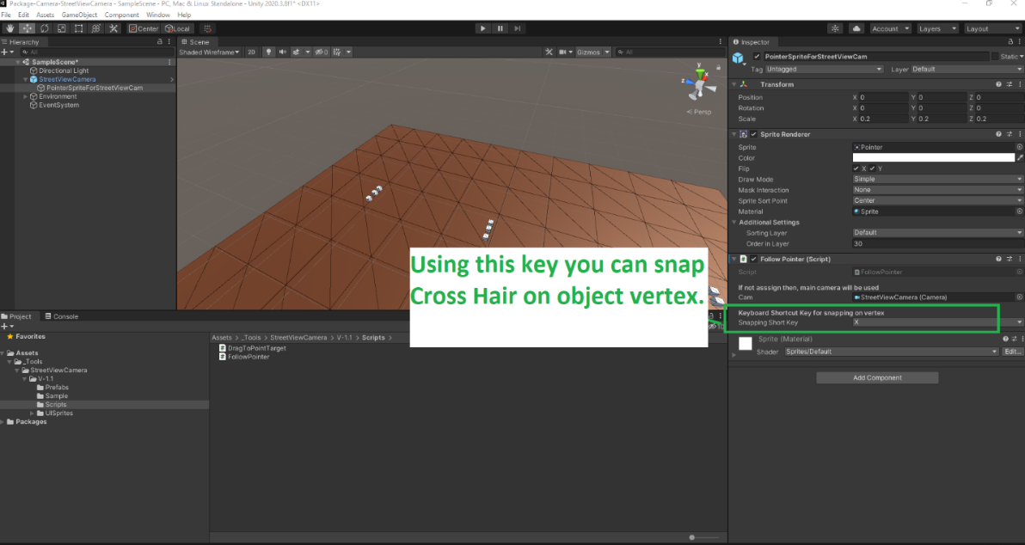

1. **InputController: This script for UI which is control setting of street view camera.**

