2/18/2022

Developers at Location Lab

The Location Lab Pvt. Ltd Karachi

Street View Camera

User Manual version 1.3

Contents

Introduction: 2

How To Use: 2

FAQs: 4

# Introduction:

Street view camera is a 3D camera navigation system that solely based on mouse movement and double click. You can move mouse to change the camera rotation and mouse crosshair pointer. By placing crosshair to a specific position and then, double-click to jump at the pointer position.

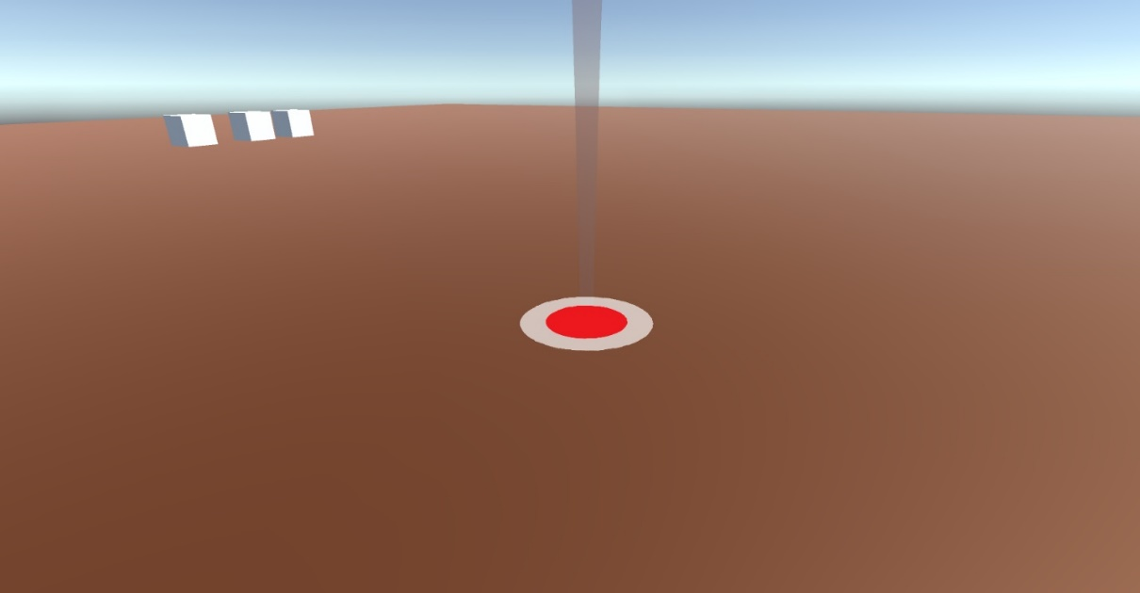

# How To Use:

1. Move Mouse to rotate the camera view.
2. Place mouse Pointer to specific position then, double click (mouse left click) to jump at pointer location.

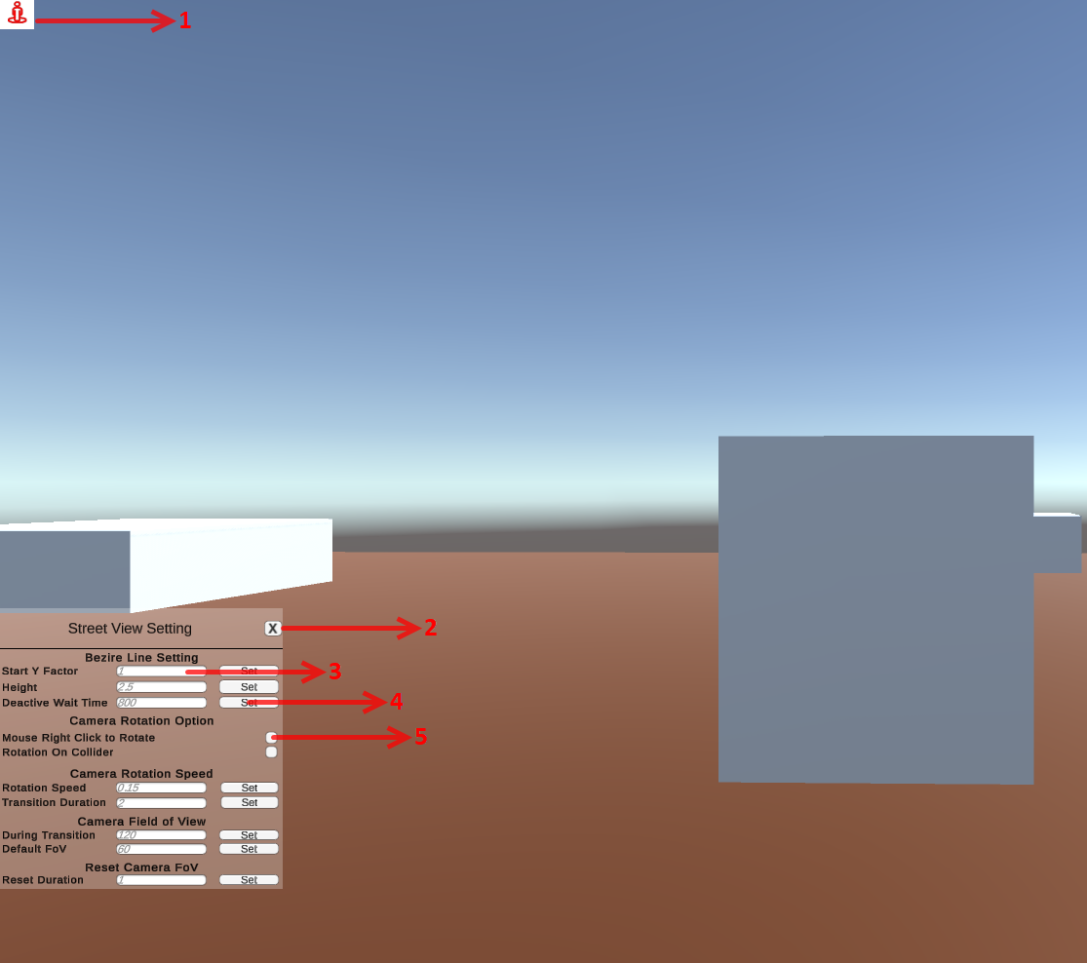

1. Toggle Button to on-off street view setting panel.
2. Cross Button to close street view setting panel.
3. These are input fields to enter the values of street view camera setting. (See below table)

|  |  |
| --- | --- |
| **Variable** | **Description** |
| **Bezire Line setting** |  |
| Start Y Factor | Bezire Line starting Height factor. Currently, it is set to 1 which means the line will show from above the camera. You can set it -1 to show the line bottom of the screen. |
| Height | This is the line midpoint height. The height of the curve. |
| De-active Wait Time | Line de-active time after showing the first time. |
| **Camera Rotation** |  |
| Mouse Right Click to Rotate | Street view camera rotation normal depends on mouse movement. when mouse movement stop then street view camera rotation also stops. When check on “Mouse Right Click to Rotate” then street view camera will rotation to mouse right click. |
| Rotation on Collider | Street View Camera freely rotate everywhere when check on “Rotation on Collider” then Street View Camera will rotate just on collider. |
| Transition Duration | Time to jump from one position to another |
| **Camera Field of View** |  |
| Default FoV | Normal FoV of the camera |
| During Transition | When camera jump from one position to another the FoV gets changed. This the changed value |
| Reset Duration | After camera transition the time to reset the Fov |

1. These are buttons to set each entered value.
2. These Checks for camera rotations.

# FAQs:

Q: Is there any way to control the speed?

**A:** Yes, see the developer documentation for more details. And UI can control it with UI.

Q: Can I rotate the camera using mouse right-click?

A: Yes, Just go to camera rotation section in UI and enable “Mouse right-click to rotate”.