**GIT Tutorial**

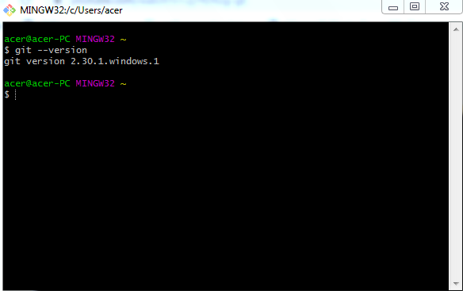

Git config --help

Or

Git help config

Go to the project location u want to add.

Here for example test

Than>>

Git init

Git status

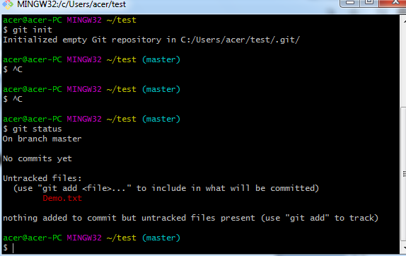here u can see it is untracked ,means it is not saved in git for now.

Step: git add demo.txt

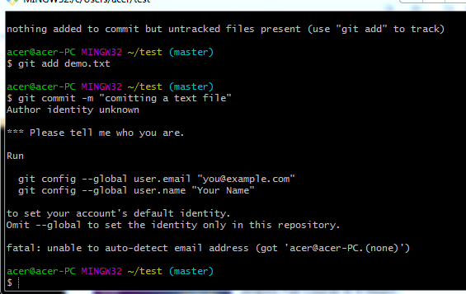

Connect to Git :

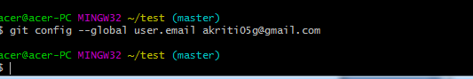

Open git Portal and create new repository.

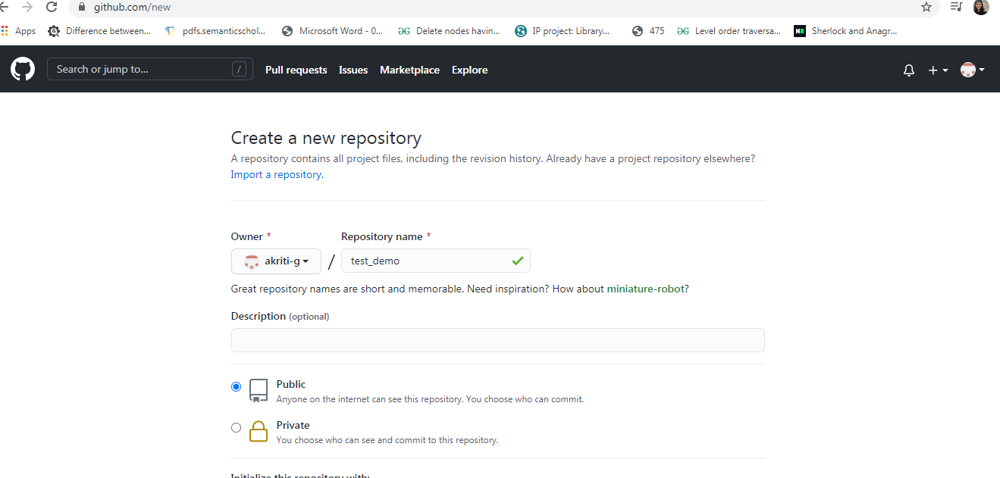

Than Create Repository.

After that this page will open:

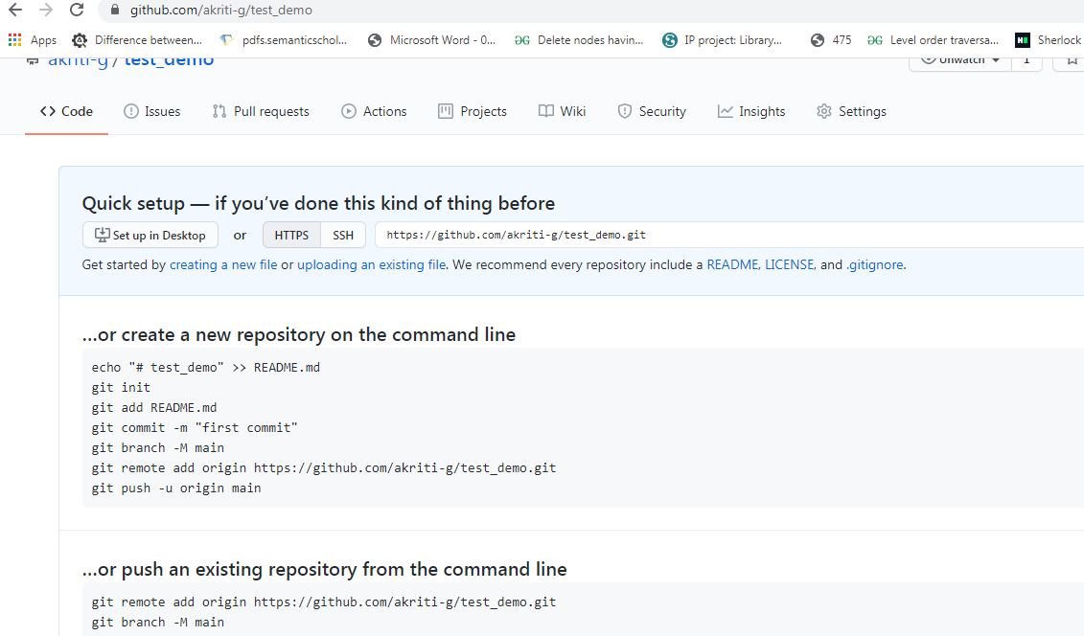

Select the link from above https.

Set Link between local and remote repository.



Push the File to master :

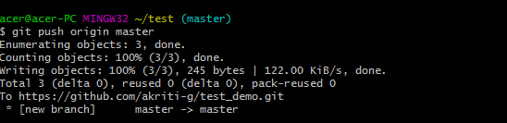

Now you can check the your Repository.

