Q1. Make a list of 10 hotels in Delhi that are looking for a booking engine to ease their work.

1. [**The Lalit New Delhi**](https://www.bing.com/aclick?ld=e8tj1rJTNO9u2ZU9FyRksCDDVUCUw8qHVK6YQ3RqHKkqr3YEsOmxVuzNIsM4R0LxcMfceqD4uo5sDbePPFtfpZ1rh5LPgZHojWOZhIuSzRjdyMVYfV9WBP3ixJY8JS-SvdVs7f4gN2deowFi9tB8c0gG7dFPQzKqi4dBwiiLNtpYtwPj1A&u=&rlid=80288b97b54d10e92e33ed7e1949bcd0)[1](https://www.bing.com/travel/hotels/detail?q=hotels+in+Delhi+looking+for+booking+engine&id=YN4070x1061447969706358411&hotellistid=YN4070x1061447969706358411&hname=The+Lalit+New+Delhi&cin=Sunday%2c+November+03+2024&cout=Monday%2c+November+04+2024&guests=2A&rooms=1&displaytext=delhi&loc=delhi&lat=28.631662&lon=77.227234&type=hotel&form=HTCHAT&entrypoint=HTCHAT)
2. [**The Imperial, New Delhi**3](https://www.booking.com/region/in/delhi.html)
3. [**The Leela Palace New Delhi**3](https://www.booking.com/region/in/delhi.html)
4. [**Maidens Hotel New Delhi**3](https://www.booking.com/region/in/delhi.html)
5. [**Taj Mahal, New Delhi**3](https://www.booking.com/region/in/delhi.html)

These hotels are already using booking.com booking engine. But it’s not reliable anymore.

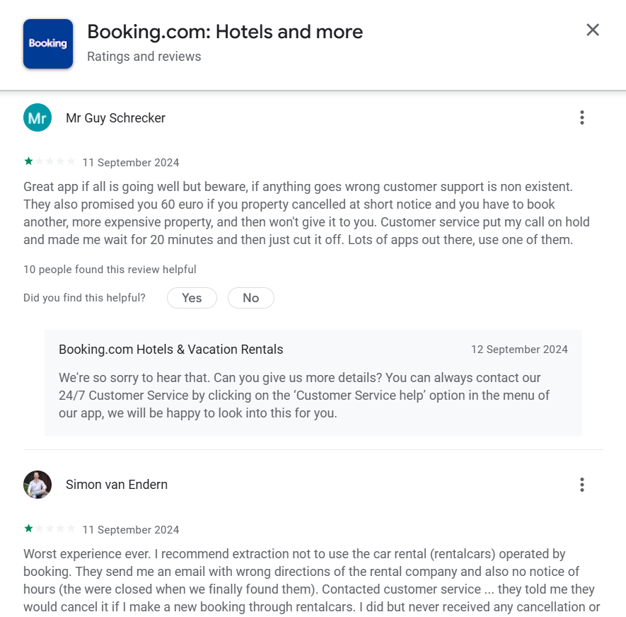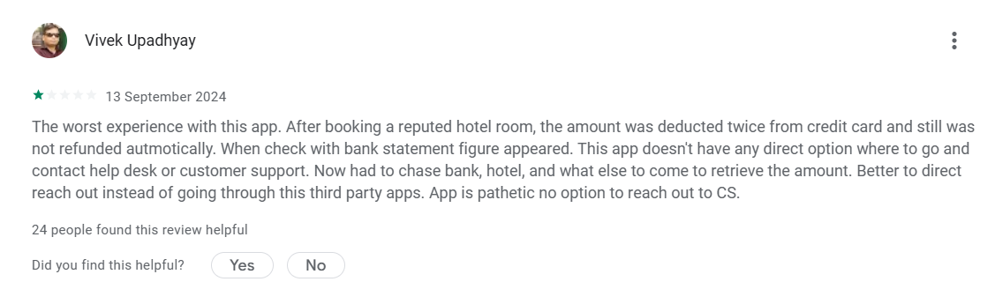

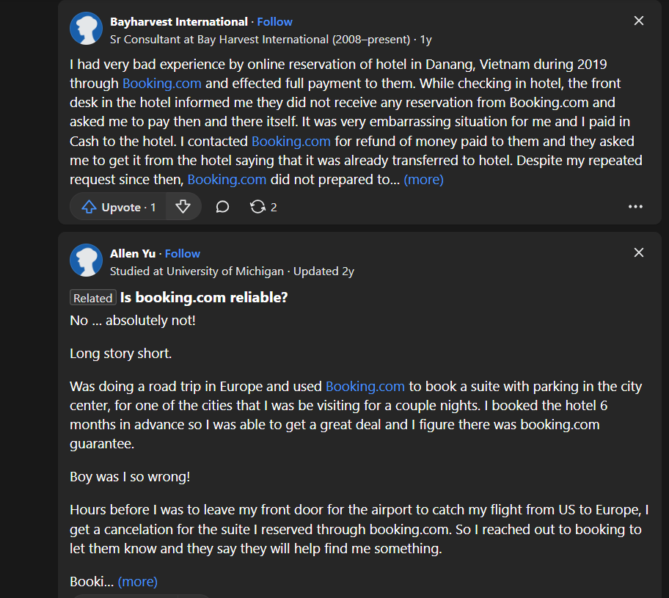

* Also, according to the article [HONEST review of Booking.com 2024 (is it trustworthy?) (lesboutiquehotels.com)](https://lesboutiquehotels.com/booking-com-reviews) :

they are not reliable anymore. They used to be, but not anymore. Read the reviews on trustpilot. Too many sudden cancellations and no customer service. Waiting for refunds. No call backs.

* According to [BOOKING Reviews, Feedback, Complaint, Experience, Customer Care Number - MouthShut.com](https://m.mouthshut.com/websites/booking-reviews-925757811) :

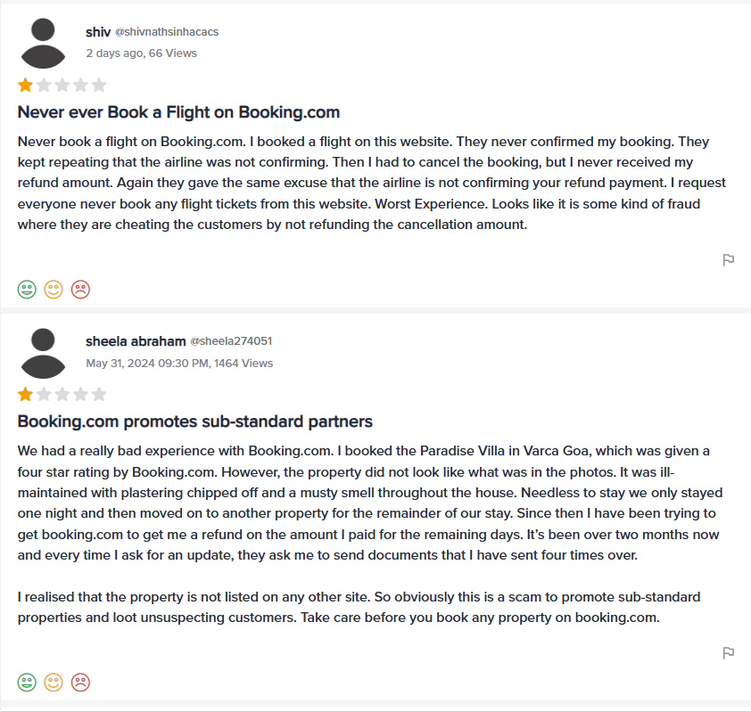

1. [**Townhouse Super Hotel O Townhouse 094 HOTEL MORO**4](https://www.oyorooms.com/hotels-in-delhi/)
2. [**Super Townhouse Rohini Sector 18**4](https://www.oyorooms.com/hotels-in-delhi/)
3. [**Super Townhouse Vikaspuri**4](https://www.oyorooms.com/hotels-in-delhi/)
4. [**Super Townhouse Shahdara**4](https://www.oyorooms.com/hotels-in-delhi/)

These hotels are already using OYO booking engine.

* According to the reviews on -

https://www.trustpilot.com/review/www.oyorooms.com

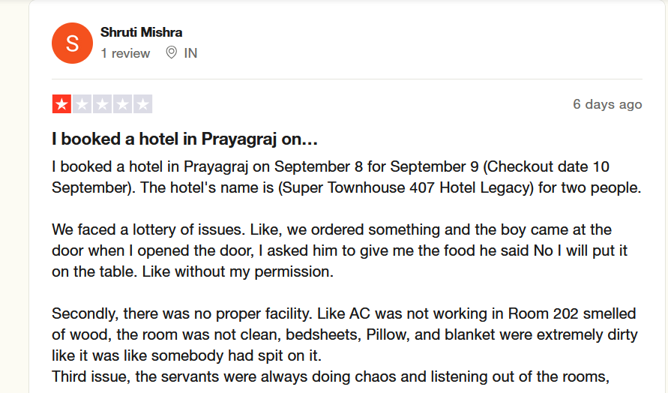

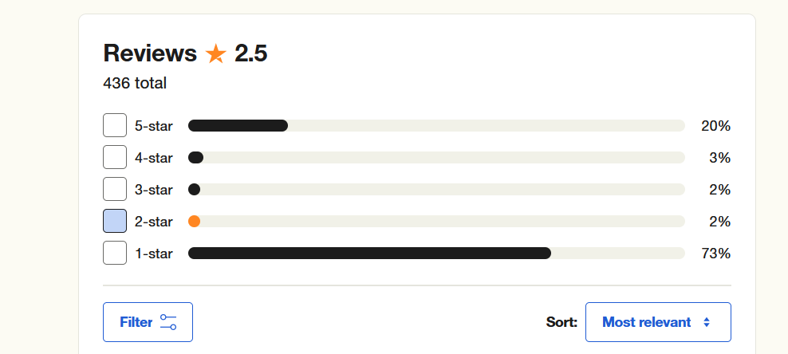

* Also according to - <https://www.mouthshut.com/websites/oyorooms-reviews-925774445>

