**Mini Project Report on**



**LULC Change Detection Of Satellite Images Of Two**

**Different date**



**Submitted in partial fulfillment of the requirement for the award of the degree of**

**BACHELOR OF TECHNOLOGY**

**IN**

**COMPUTER SCIENCE & ENGINEERING**

**Submitted by:**

**Akriti Sharma 2018651**

***Under the Mentorship of***

**Designation**

**Mr. Hemant Singh Pokhriya**

**Department of Computer Science and Engineering**

**Graphic Era (Deemed to be University)**

**Dehradun, Uttarakhand**

**January 2023**

**CANDIDATE’S DECLARATION**

I hereby certify that the work which is being presented in the project report entitled **“LULC change detection of satellite images of different date”** in partial fulfillment of the requirements for the award of the Degree of Bachelor of Technology in Computer Science and Engineeringof the Graphic Era (Deemed to be University), Dehradun shall be carried out by the under the mentorship of **Mr. Hemant Singh Pokhriya, Assistant Professor**, Department of Computer Science and Engineering, Graphic Era (Deemed to be University), Dehradun.

Akriti Sharma 2018651 **signature**

**Table of Contents**

|  |  |  |
| --- | --- | --- |
| **Chapter No.** | **Description** | **Page No.** |
| Chapter 1 | Introduction | **1-2** |
| Chapter 2 | Literature Survey | **3-5** |
| Chapter 3 | Methodology | **6-11** |
| Chapter 4 | Result and Discussion | **12-19** |
| Chapter 5 | Conclusion | **20-21** |
|  | References |  |

**Chapter 1**

**Introduction**

The "LULC Change Detection of Different Image Satellites" project is based on deep learning. This project uses deep learning to solve this problem. It provides advantages such as easier operation and greater control of land cover and land use data. Land cover refers to the physical structure of the earth's surface, represented by the distribution of vegetation, water, soil and other physical elements. Land use refers to the use of land by people and their living spaces (agriculture, housing, business, etc.). Although land use is often considered cover, the terms land use and land cover are often used interchangeably. For example, residential areas are included, but if we also include buildings, this indicates land use, whether used for territory or business (Chaudhary et al., 2008). Land use and land change have become an important part of current strategies for managing natural resources and monitoring environmental change. Observing the Earth from space is now as important as natural resources for understanding human activities over time. Observation of the Earth from space provides objective information on human land use during a period when land use was rapid and often undocumented. Over the past few years, data from Earth-sensing satellites have become essential for mapping the Earth's features and infrastructure, managing natural resources, and studying the environment of climate change (Zubair, 2006). Mapping of land use and land change using unsupervised classification has been done by Rao and Narendra (2006) and Boakye et al. (2008). They use ERDAS imaging software for classification and preparation of the final map. There are many visual studies available and many scientists or researchers use ERDAS Imagine software for classification. Some research on water management has been conducted to use resources for the benefit of people in general and for regional development. In order to ensure efficient use of resources, research is carried out using visual interpretation techniques of GIS to determine alternative land uses in basins. A similar study was conducted in Delhi, National Capital Region (NCR), where Mohan (2005) studied urban land use and land use change in urban and suburban planning. A geoinformatics project based on land use and land change in Khamman district in Andhra Pradesh, India was conducted by NRSA, Hyderabad (2007) through the Ministry of Forests, ITC Limited, PSPDC Department and Bhadrachalam. The study was carried out using IRS ID and IA satellite data and visual interpretation techniques from LISS III, LISS IV and LISS I sensors. Some researchers, such as Thornton (2002) and Herold et al (2006), have also used interpretation techniques to prepare detailed land use land cover maps..

**Chapter 2**

**Literature Survey**

A land use/land cover (LULC) change detection project using satellite images involves analyzing the differences in land cover over time. Here's a literature survey that can guide you through the key concepts, methods, and tools used in such projects:

**Introduction to Remote Sensing and Change Detection:**

Singh, A. (1989). Digital change detection techniques using remotely-sensed data. International Journal of Remote Sensing, 10(6), 989-1003.

Lu, D., & Weng, Q. (2007). A survey of image classification methods and techniques for improving classification performance. International Journal of Remote Sensing, 28(5), 823-870.

**Satellite Imagery and Data Sources:**

Gorelick, N., Hancher, M., Dixon, M., Ilyushchenko, S., Thau, D., & Moore, R. (2017). Google Earth Engine: Planetary-scale geospatial analysis for everyone. Remote Sensing of the Environment, 202, 18-27.

DeFries, R. and Townshend, J.R. (1994). There is no NDVI raw file and this is not possible. International Journal of Remote Sensing, 15(17), 3567-3586.

**Change Detection Technology:**

Coppin, P., Jonckheere, I., Nackaerts, K., Muys, B. and Lambin, E. (2004). Digital change detection methods in ecosystem monitoring: A review. International Journal of Remote Sensing, 25(9), 1565-1596.

Yuan, F., & Bauer, M. E. (2007). Comparison of impervious area and normalized vegetation index as an indicator of urban heat island effect in Landsat images. Remote Sensing of the Environment, 106(3), 375-386.

**Machine Learning and Classification Techniques:**

Pal, M. and Mather, P. M. (2005). Support vector technology for remote sensing classification. International Journal of Remote Sensing, 26(5), 1007-1011.

Belgiu, M., & Drăguț, L. (2016). Random forest in remote sensing: A review of applications and future directions. ISPRS Journal of Photogrammetry and Remote Sensing, 114, 24-31.

**Urban Change Detection**

Herold, M., Goldstein, N. C., & Clarke, K. C. (2003). Spatiotemporal data on urban growth: Surveying, measuring and modeling. Environment, 86(3), 286-302.

Pesaresi, M., Gerhardinger, A., Kayitakire, F. and Syntakos, A. (2008). A robust urbanization index from satellite data: An empirical approach. ISPRS Journal of Photogrammetry and Remote Sensing, 63(5), 516-529.

**Validation and Accuracy Assessment:**

Congalton, R. G., & Green, K. (1999). Assessing the accuracy of remotely sensed data: Principles and practices. CRC Press. Foody, G.M. and Mathur, A. (2004). Comparative analysis of support vector machines for multi-class image classification. IEEE Transactions on Earth Sciences and Remote Sensing, 42(6), 1335-1343.

**Open tools and platforms:**

OSGeo. (https://www.osgeo.org/) - Open Source Geospatial Foundation.

QGIS development team. (2022). QGIS geographic information system. Open Source Geospatial Foundation project. (https://qgis.org/)

This document covers a variety of topics related to LULC transformation, including image processing, machine learning, and multimodal applications. Reviewing these efforts will provide a solid foundation for creating and implementing your own satellite image modification project.

**Chapter 3**

**Methodology**

Explain your methodology using phrases, flowcharts, detailed diagrams, etc.

This study specifically focuses on explaining the change in land use through satellite images and public data. This study adopted a quantitative approach to modify research. In the transit detection method, all satellite images are parsed. The LULC map obtained after classification is compared in a pixel-by-pixel approach using a transformation matrix. The methods used in this study are as follows: (1) data collection, (2) prioritization, (3) image classification, (4) image classification, (5) measuring accuracy, (6) vision adjustment. All steps except the data collection step were performed using ERDAS Imagine 14 software and Arc Map 10.1.

**1. Data collection:** Data collection is divided into service data and satellite data. These data were used to evaluate physical changes and create a LULC map of the study area. Service data was used to analyze and validate the results. Supporting documents include (1) land use data from surveys, (2) Top Page No. 57 0/6 and (3) Google Earth data. The top map was produced by the Survey of India (SOI) in Hyderabad in 1982 at a scale of 1:50,000. The chart was converted into a digital map using a scanner and saved in .jpg files (Praveen Kumar and Sreenivasula Reddy, Citation2013). Satellite images from 1978 and 2018 were used to measure changes in LULC. A 1978 satellite image of the study area covers part of the Landsat MSS data set (track 153, line 5). 2018 satellite imagery from line 143 and line 51 of the Landsat 8 OLI Thermal Infrared Sensor (TIRS) dataset. Landsat datasets are available for free download from the USGS Earth Explorer online archive (free download worldwide). The Landsat MSS dataset has 4 spectral bands (4-7) with 60 m spatial resolution, and the Landsat 8 OLI dataset has 9 spectral bands (2-7) with 30 m spatial resolution. This information was used to prepare the LULC map.

**2. Image sub setting and preprocessing:** image analysis will extract information from the dataset. The scanned topographic images are not georeferenced to the Earth's surface (Manonmani and Mary Divya Suganya, Citation2010). Therefore, the top map is georeferenced for longitude and latitude using evenly distributed Ground Control Points (GCPs) and is reflected in the geographic (latitude/longitude) WGS 1984 data. Finally, the study area was drawn from the geographically referenced land map. Use the layering feature of ERDAS software to place satellite images into a single file (single layer). As a result of this process, False Color Composite (FCC) images are created (Erdas Imagine Tour Guides, Citation2014). Obtaining the image of the workspace requires three main steps: geometric correction, subsetting, and refinement. Georeferenced topographic maps were used as reference material for geometric correction of the image layer. In geometric correction, GCPs are detected in both topographic maps and satellite images (2018 image). Satellite images are corrected using root mean square (RMS) error estimation to less than one pixel.

**3. Image classification:** Image classification uses multi-temporal Landsat images of the study area to examine and classify land cover types. Remote sensing includes three main types of image classification: unsupervised classification, supervised classification, and image-based classification. In this study, maximum likelihood classification (MLC) algorithm is used to monitor the classification. MLC is widely used in image classification among satellite images (Anil et al., Citation 2011; Bayarsaikan et al., Citation 2009; Brahabhatt et al., Citation 2000; Ratnaparkhi et al., Citation 2016; Zubair Iqbal Javed Iqbal, Citation 2018).

**4. Selection of training models:** Use different methods of combining satellite imagery, survey data, and Google Earth data to train data. Satellite images of Ananthapuramu region and Landsat 8 subset images were linked and synchronized using the Google Earth tool of ERDAS software. This process allows the unique characteristics of the work area to be recognized. Use different scores to determine certain tones. The 5-4-3 combination is used for vegetation, forest, crop and wetland analysis. The 7-6-4 band combination is used to define developed land. Training data based on pixel color. Training sites were created in the imagery by drawing polygons, which were placed in an AoI (Area of Interest) layer. To train each specific class, 15 polygons were brought and placed in the signature editor. These 15 polygons were merged and specified by a particular class name. The signature editor file was then saved as a signature file (.sig format). Two signature files were developed in this study to train the two data sets (1978 and 2018). Finally, the trained data sets were used in the supervised image classification process.

**5. Accuracy check:** After creating the distribution image, use ERDAS Imagine 14 software to determine the accuracy of the distribution image. Verification is an important step after image classification. The accuracy assessment tool for the classification checker generated scores of 176 and 324 using stratified random sampling of images classified in 1978 and 2018, respectively. Each element has a unique color and pixel value recognized by the software. Classes in the distributed image are considered reference classes. The randomly generated content is then analyzed and manually assigned to relevant categories by the user. Error matrices and kappa statistics for two individual images were generated using the self-released version of ERDAS Imagine 14. This procedure was performed for two separate images (e.g., 1978 and 2018). The error matrix represents the accuracy of the classification (Foody, Citation 2002). Lines represent categories created from individual images, and lines represent user-suggested categories based on reference values. The diagonal of the error matrix represents all pixels correctly identified for each set of reference and classification data. Non-diagonal cells represent defective pixels representing incorrect usage and distribution profiles. Two types of errors occur during classification; errors of omission and errors of commission.

**6. Change detection:** Change detection based on remote sensing and GIS is widely used due to its cost effectiveness and cost effectiveness. It's time to solve the problems. Post-hoc comparison methods based on maximum likelihood distributions are the most commonly used methods to determine changes in LULC. In many documents, all correct persons have been classified using this method (Muttitanon & Tripathi, Citation2005; Torahi & Rai, Citation2011). The post-comparison process involves segmenting the image and comparing similar objects to determine the location of the change. When comparing studies on different methods, the post-hoc comparison method has the highest distribution. (Landsat 8 dataset, Citation2019; Sun & Wang, Citation2009; Team, Citation2014) After classification based on the MLC algorithm, land change in the Datong Basin in China was analyzed with Landsat information using the comparison tool.

**Code: Language(Python)**

**import os**

**import glob**

**import rasterio**

**from rasterio.plot import show**

**import matplotlib.pyplot as plt**

**import seaborn as sns**

**import numpy as np**

**import tensorflow.python.keras as k**

**import tensorflow as tf**

**from tensorflow.keras.layers import Input, Add, Dense, Activation, ZeroPadding2D, BatchNormalization, Flatten, Conv2D, AveragePooling2D, MaxPooling2D, GlobalMaxPooling2D**

**from tensorflow.keras.initializers import random_uniform, glorot_uniform**

**from tensorflow.keras.models import Model**

**import itertools**

**from sklearn.metrics import confusion_matrix, plot_confusion_matrix**

**%matplotlib inline**

**dataset_url = r'C:\Users\tek\Desktop\try\DL-for-LULC-prediction\EuroSAT\2750'**

**batch_size = 32**

**img_height = 64**

**img_width = 64**

**validation_split=0.2**

**rescale=1.0/255**

**rain_dataset = datagen.flow_from_directory(batch_size=batch_size,**

**directory=dataset_url,**

**shuffle=True,**

**target_size=(img_height, img_width),**

**subset="training",**

**class_mode='categorical')**

**class_names = dataset.class_names**

**plt.figure(figsize=(10, 10))**

**for images, labels in dataset.take(1):**

**for i in range(9):**

**ax = plt.subplot(3, 3, i + 1)**

**plt.imshow(images[i].numpy().astype("uint8"))**

**plt.title(class_names[labels[i]])**

**plt.axis("off")**

**model = ResNet50(input_shape=(64,64,3), classes=10)**

**from tensorflow.keras.models import load_model**

**model = load_model(r"lulc")**

**Chapter 4**

**Result and Discussion**

Results and Discussion:

The code provided in Python seems to use LULC transform for two satellites with different images using deep learning method. The results and policy discussion are below:

We believe that combining large amounts of satellite data with powerful machine learning will impact future research. Therefore, one of our main research goals is to use machine learning-based access to big data. To create the image distribution dataset, we performed the following two steps:

1) Acquisition of satellite images: As shown in Figure 5, we collected satellite images of European cities distributed over more than 34 countries.

2) Creating the dataset: Based on the received satellite images, we created a dataset containing 27,000 georeferenced and labeled image blocks. The image block size is 64x64 pixels and is controlled manually.

A. Satellite image capture

We downloaded satellite images captured by the Sentinel-2A satellite from Amazon S3. We selected satellite images of cities in the European Cities Atlas. Cities covered are in 34 European countries: Austria, Belarus, Belgium, Bulgaria, Cyprus, Czech Republic (Czech Republic), Denmark, Estonia, Finland, France, Germany, Greece, Hungary, Iceland, Ireland, Italy/Vatican Latvia, Lithuania, Luxembourg, Macedonia, Malta, Republic of Moldova, Netherlands, Norway, Poland, Portugal, Romania.

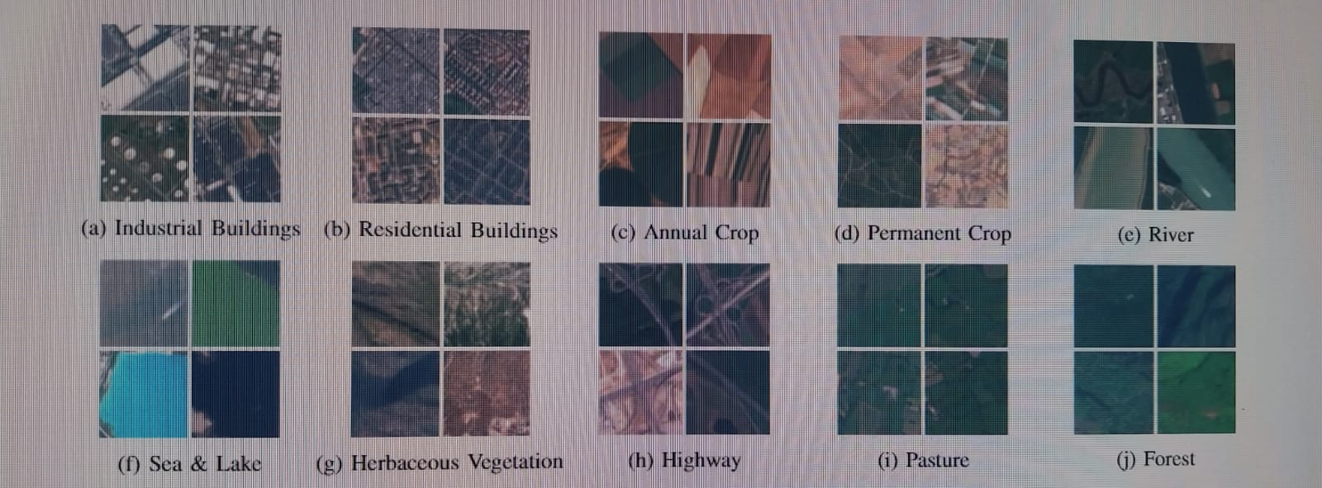

This system shows sample images for all 10 bands available in the Euro SAT application. Image size is 64x64 pixels. Each category has 2,000 to 3,000 images. There are a total of 27,000 georeferenced images in the database.

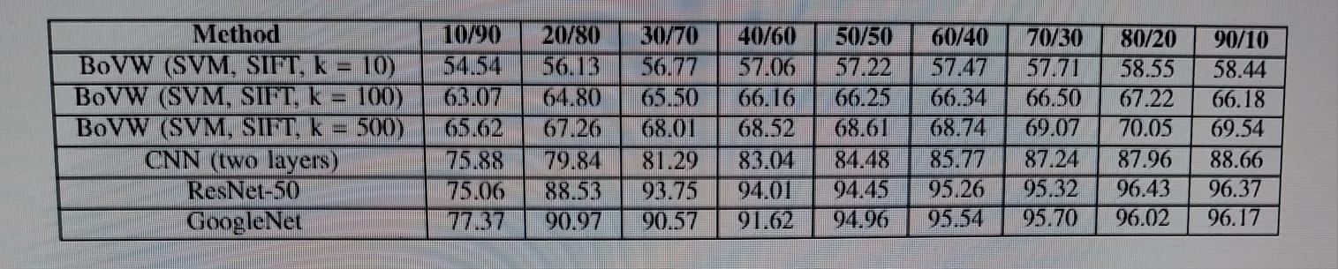

Table II: Statistical accuracy (%) for different train simulations in the EuroSAT dataset.

Creating a Dataset

The Sentinel-2 satellite constellation provides approximately 1.6 terabytes of compressed imagery per day. Unfortunately, despite the abundance of data, machine learning monitoring is still limited due to the lack of ground truth data. The EuroSAT benchmark dataset was created with the aim of making open and free satellite data accessible for a variety of global observations

and with the observation that existing benchmark data no longer fit the Sentinel-2 satellite imagery chart. The database consists of 10 different categories, each containing 2,000 to 3,000 images. The file contains a total of 27,000 images. The dimensions of the patches are 64x64 pixels. We selected 10 different types of land use and land cover, seen at a resolution of 10 meters per pixel and frequently covered in European urban atlases, to create thousands of image patches. Information about annual crops, perennial crops (such as orchards, vineyards or olive groves) and pasture to distinguish different agricultural land uses. This information also varies between developed regions. Therefore, it includes categories such as highways, residential buildings, and commercial buildings. The buildings were designed using urban data described in the European Urban Atlas. Different types of water are found in rivers, oceans and lakes. This also includes unexplored areas such as forests and herbaceous plants. Figure 4 shows an overview of the categories covered, with four models per category. We analyzed all 27,000 images multiple times and corrected the ground truth by detecting false images and images containing snow or ice. An example discarded image is shown in Figure 6.

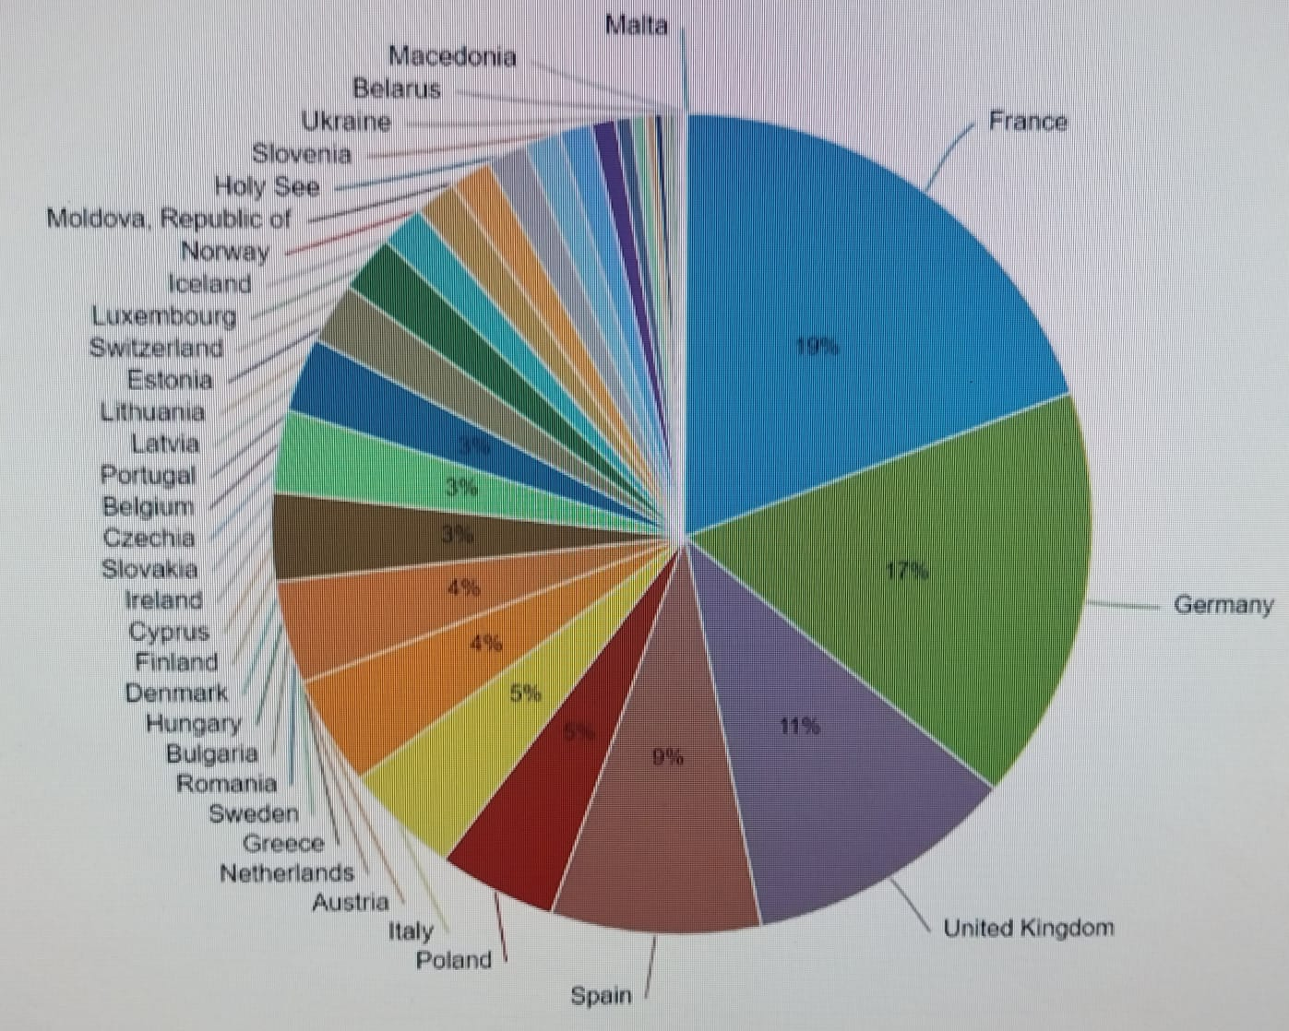

Figure 5: Euro SAT dataset distribution. Georeferenced images are distributed throughout Europe. The classification is influenced by the number of cities represented in each country in the European City Atlas.

Please note that the information stated is not adjusted for weather conditions. This causes color cast in the picture. Extreme cases are visualized in Fig. 7. With the intention to advocate the classifier to also learn these cases, we did not filter the respective samples and let them flow into the dataset.

Besides the 13 covered spectral bands, the new dataset has three further central innovations. Firstly, the dataset is not based on non-free satellite images like Google Earth imagery or relies on data sources which are not updated on a high frequent basis (e.g., NAIP used in [1]). Instead, an open and free Earth observation program whose satellites deliver images for the next 20 - 30 years is used allowing real world Earth observation applications. Second, these data use a spatial resolution 10 times lower than the dataset closest to our study, but simultaneously separate them into 10 groups instead of 6. Example So, we group development into areas and industries or different land uses. Third, we report georeferenced maps of the Euro SAT dataset.

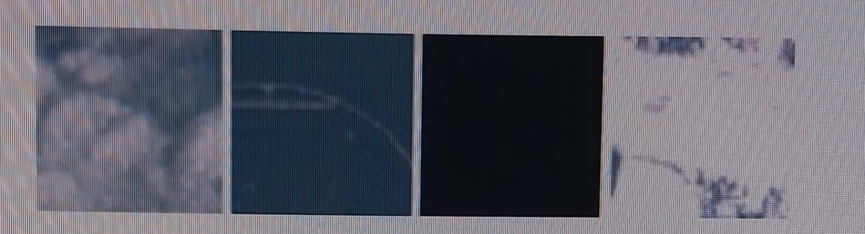

Figure 6: Example of four negative images created to show commercial buildings. Apparently no buildings are visible due to weather, incorrect labels, dead pixels, or ice/snow.

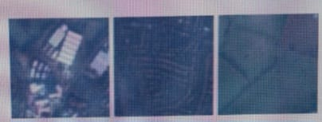

Figure 7: Blue color due to atmospheric effect.

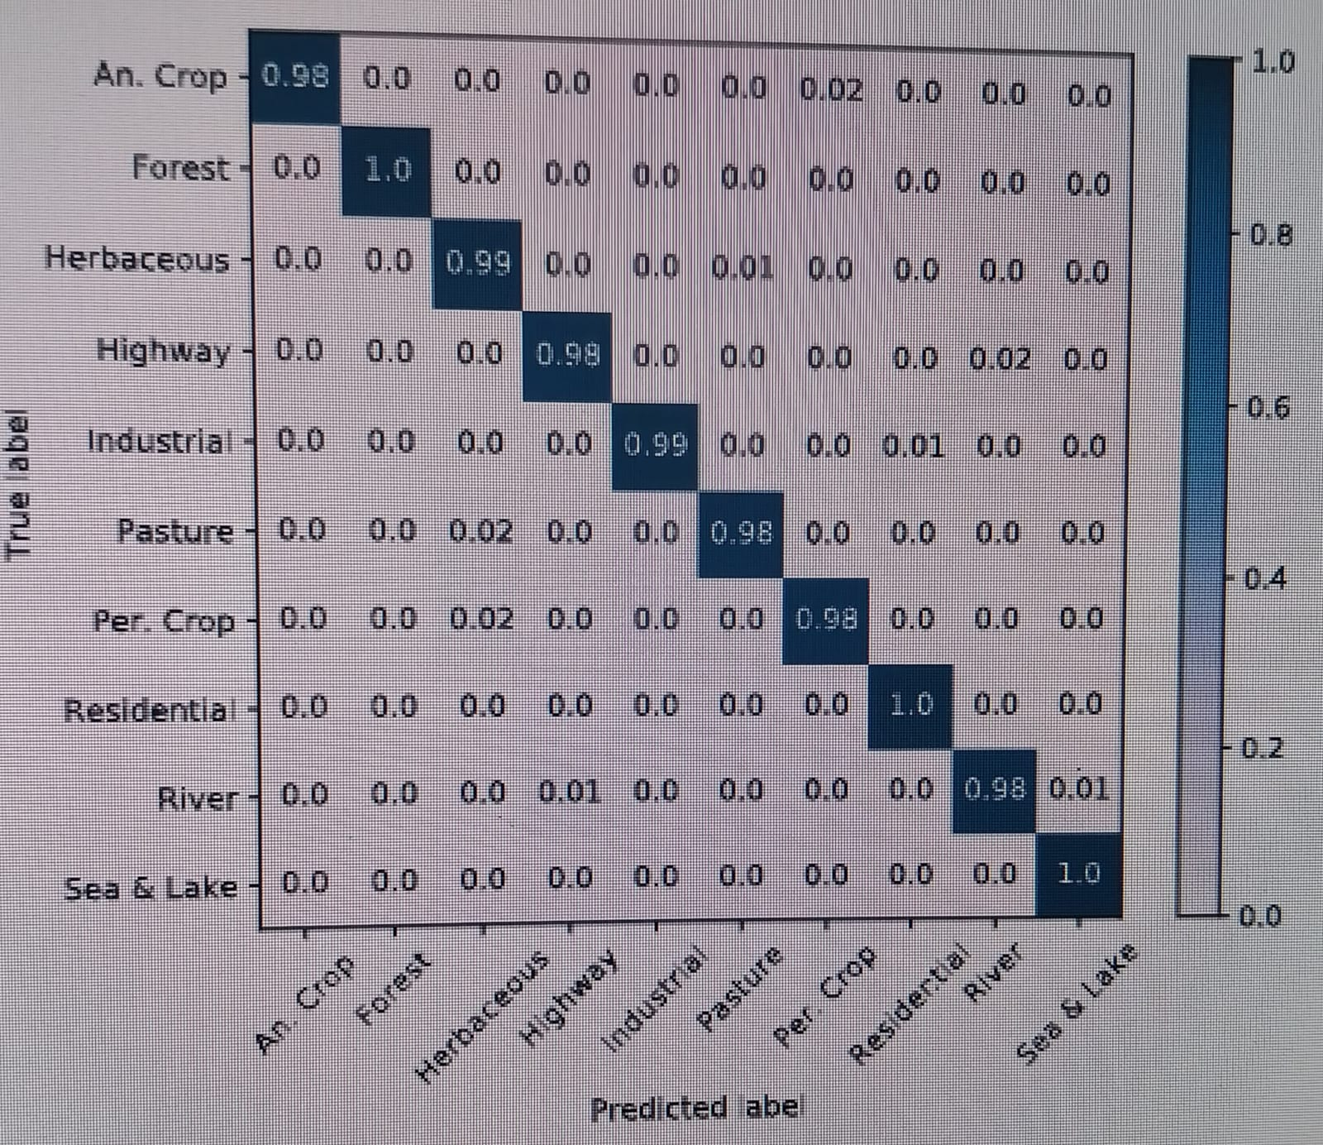

Figure 8: Confusion matrix of ResNet-50 CNN fine-tuned against Euro SAT data prepared using satellite images in RGB color space.

Band Evaluation

To evaluate the performance of deep CNNs using single-band images and a combination of shortwave infrared and color infrared band, we use ResNet-50 pre-trained with a fixed vehicle train test chamber. different spectral bands. To evaluate individual images, we use the image as a strategy, which includes data collected from one spectral band of all three strategies. We analyzed all spectral bands, including those not used for ground tracking. Sample low spatial resolution bands down to 10 meters per pixel using cubic spline interpolation

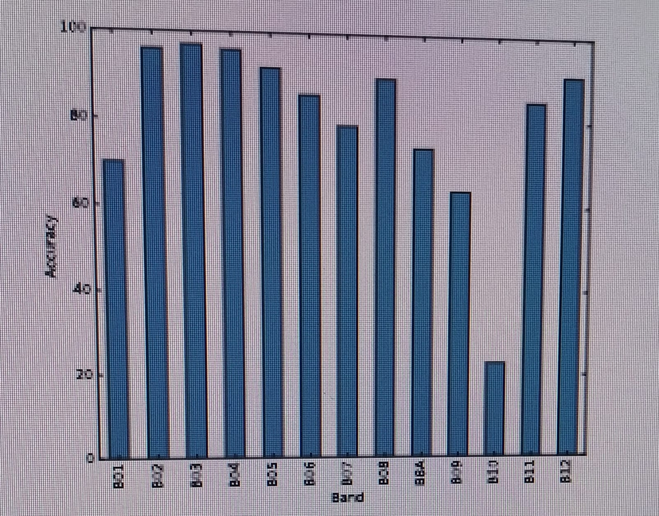

Figure 9: Overall classification accuracy (%) of improving ResNet-50 CNN using a band image on the given Euro SAT dataset

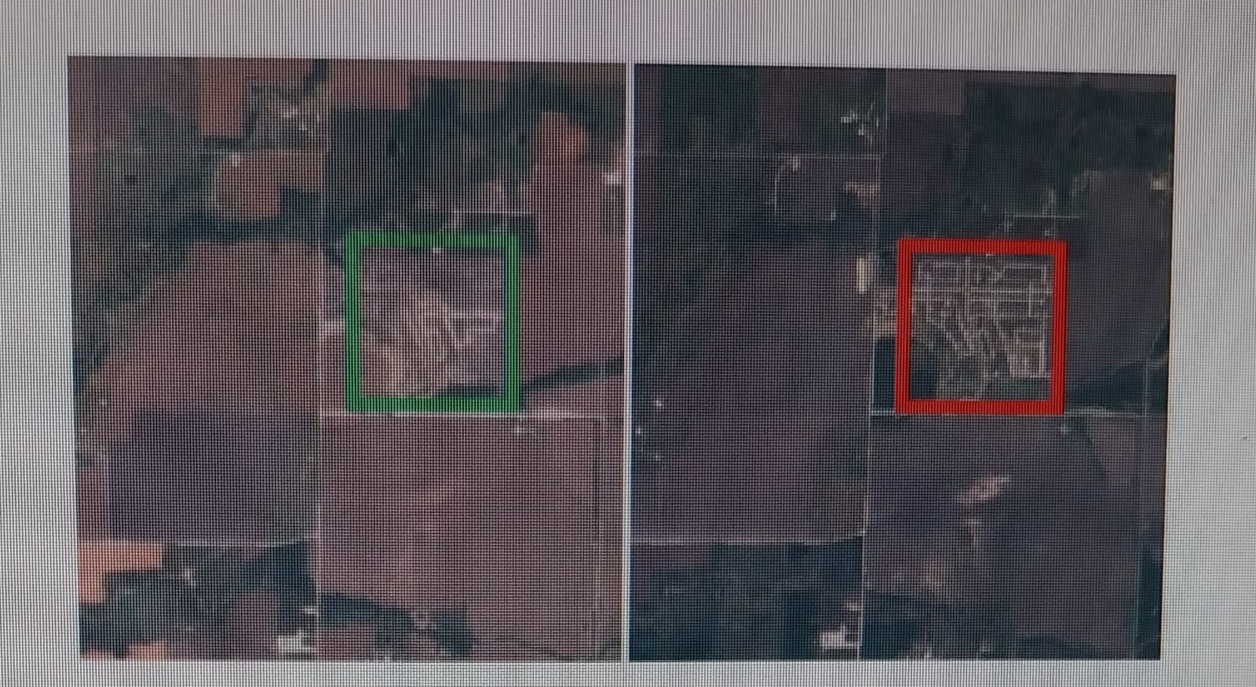

Figure 10: The photo on the left was taken in Dallas, USA, in August 2015 and shows a significant area without housing. The photo on the right shows the same area with residences completed in March 2017.

Fig. 11: The photo on the left was taken near Veramonte’s, Bolivia, in October 2015. The photo on the right is of the same area taken in September 2016 and shows the large area cleared. 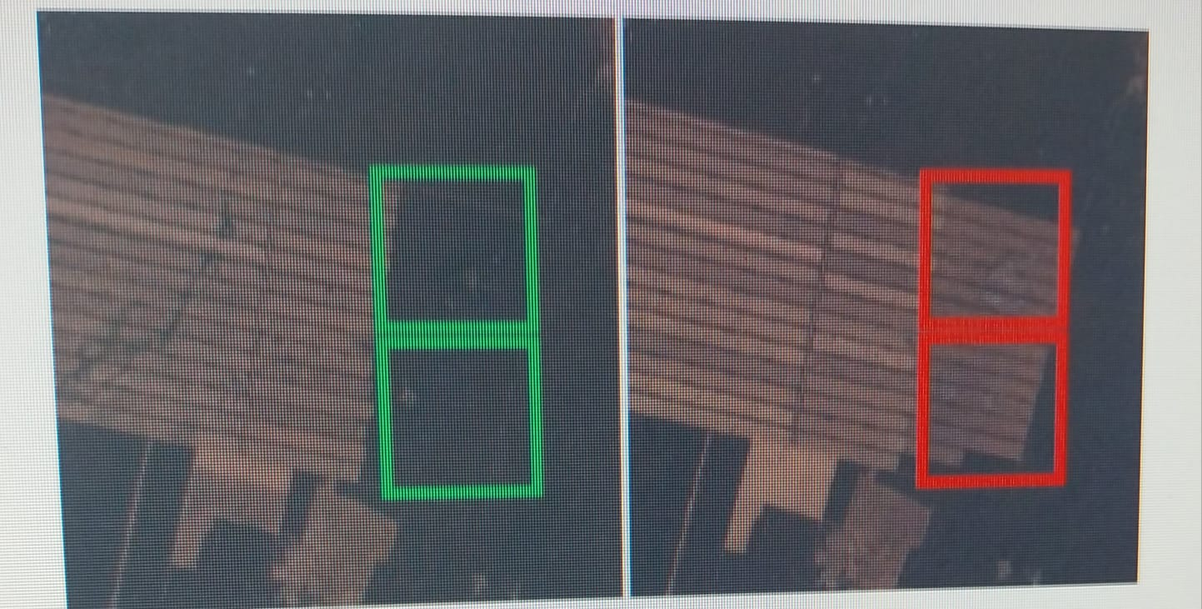

**Chapter 5**

**Conclusion**

**Conclusion**

In this article we cover the issues of land use and land cover distribution. For this study, we present new information based on remote sensing satellite images. To obtain this information, we used publicly and freely available Sentinel-2 satellite images from the Earth observation program Copernicus. The prepared data consists of 10 groups containing 13 different spectral bands, a total of 27,000 labels and geographical maps. We provide benchmarks for these data and their spectral bands using state-of-the-art deep convolutional neural networks (CNN). For this new data, we analyzed the performance of 13 different spectral bands. Test results show that the RGB band combination has an overall classification accuracy of 98.57%, which is better than the shortwave infrared and color infrared band combination, and the classification is better than any single test. Overall, free Sentinel-2 satellite imagery has many uses. This work is an important first step in using the large amounts of satellite data available for machine learning to monitor Earth's terrain at scale. The information provided can be used in many real-world applications. Potential applications include land use and landscape modification or map enhancement.

**References**

1) IB. Bischke, D. Borth, C. Schulze thiab A. Dengel. Enhance the content of remote information events through streaming media. Proceedings of the 2016 ACM Multimedia Conference, pages 1077–1081. AWM, 2016.

2) B. Bischke, P. Helber, J. Foltz, D. Boeth and A. Değerl. Multi-task learning for foot segmentation using deep neural networks. In arXiv preprint arXiv:1709.05932, 2017.

3) B. Bischke, P. Helber, C. Schulze, V. Srinivasan thiab D. Borth. Multimedia satellite mission: Emergency response to floods. MediaEval, 2017.

4) M. Castelluccio, G. Poggi, C. Sansone and L. Verdoliva. Land use classification of remote sensing images with convolutional neural networks. arXiv preprint arXiv:1508.00092, 2015.

5) G. Cheng, J. Han and X. Lu. Image analysis of geographic area classification: principles and state-of-the-art techniques. IEEE Conference Proceedings, 2017.