Intel 8550U

Cache Parameters

Cache size: 1344 KB

Associativity: 1 way

Line size: 64 bytes

Miss penalty: 18nsec

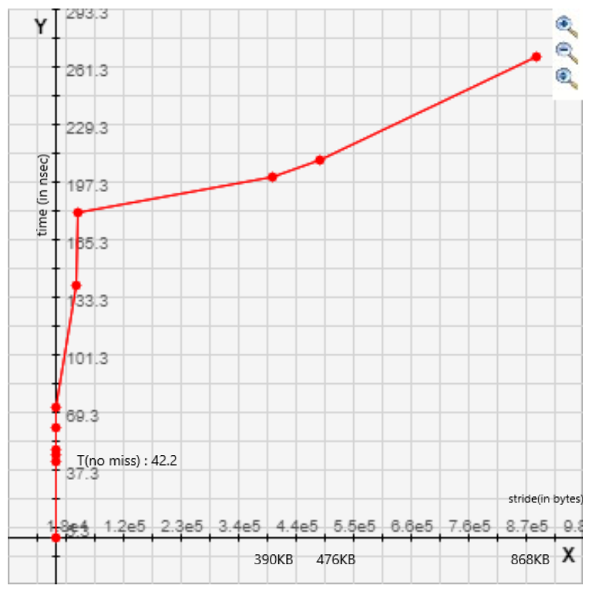

Intel 2367M

Cache Parameters

Cache size: 824 KB

Associativity: 1 way

Line size: 64 bytes

Miss penalty: 40nsec

