INFLATION RATE AND ITS EFFECT ON U.S ECONOMY

M.Sc. Agriculture Analytics

Programming For Geodata Processing

Akriti Dhyani

202319018

17-01-2024

Table of contents:-

* Abstract
* Introduction
* Datasets used
* Methodology
* Objective of the study
* Hypothesis
* Measures to support hypothesis
* Analysis of datasets
* Limitations
* Conclusion
* References

Abstract:-

With the present scenarios of the U.S. economy, there has been an urgent need to recover from the declining economy rate. One such crucial economic metric is inflation that plays an important role in driving economic growth. In this study various factors & indices are being considered while evaluating inflation data & how the market is being affected by inflation. Economic ups & downs are being decided by inflation. The  research provides detailed insights of factors leading to fluctuations in US inflation rate, keeping CPI (Consumer Price Index) (3.9% in December of 2023) in focus. Also explains cause & effect of decisions taken by the Federal Reserve over inflation. Interest rate for housing market (highest in 2022, 7.15%) is correlated with rising inflation rate that leads to increase in price of house, utility, labor which ultimately slows the development of new projects. By using python, datasets are analyzed to observe the rise in inflation rate over the years and other key factors affecting the economy of the U.S. The present study was done to analyze the factors affecting the United State’s economy as it has shown multiple variations within a very short period of time. The economic management has become an urgency with this evolving world where every nation wants to be at top at being financially stable.

Introduction:-

The term ‘economy’ holds greater power and so does the U.S. From being one of the most powerful economic entities globally, the U.S. has witnessed ups and downs in recent times. Especially in the month of December, the country has shown a great decline in economy and unexpectedly high inflation rate and Consumer Price Index(CPI). This has caused quite a stir in the nation and in the world as well. Covid-19 and Russia-Ukraine war were two of the major factors that impacted the surge. The consequences of the mentioned events left an impact in several sectors, leading to an increase in prices of sectors associated with food, housing, medical care, energy and others. If we look at the prices of commodities throughout the past couple of years it would be very easy to derive an analysis out of the data that will show the increase in level of prices and decrease in the purchasing power of currency.

Inflation is one such economic indicator, measured by the inflation rate that determines changes in commodity prices over the time. It very well indicates the decrease in the nation’s purchasing power and also the changes occurring in the level of prices. As mentioned above inflation being a crucial key, provides insights about the economic health and its stability. Continuous monitoring, analysis and good management is needed to ensure a country’s economic stability. The inflation rate has been increasing linearly year by year, for instance in the year 2022 the inflation rate was 8 percent more than the previous year. The entire world is now facing the inevitable consequences of inflation. This report aims to analyze the inflation rate throughout the years in the United States alone.

There was recent news from the previous year which shed light on the suddenly increased consumer prices in the month of December(3.4%). Now comes one major factor called the Consumer Price Index(CPI). This can be explained in easier terms as the rate of change in inflation over the time. As the name suggests, it measures the prices paid by the consumers for different types of services provided to them. There are many such services such as food, energy, fuel, housing, medical care, and many. Inflation and CPI are related in terms of changes occurring. Inflation rate indicates fluctuations in the CPI and vice versa.

With the datasets available one can see the fluctuations in the State’s economy in the past few years. The U.S. has been in the light since 2022 for this. The two major factors that affected the nation’s economy were the Russia-Ukraine war and Covid-19 pandemic. These gave rise to a very high annual inflation rate which was 9.1%. This also caused higher consumer prices that was nearly 7%, the highest in the last forty years. In the first quarter of the year 2023 the rate decreased to 4.93% which is the lowest-ever. By the end of 2023 in the month of December, CPI increased to 0.3% and it was seen that inflation rate rose suddenly. The Americans paid more for shelter and medical facilities.

The above mentioned factors play a major role in a country’s development. On the basis of these, this report is made after a thorough analysis to understand the background and current scenarios of these events.

Datasets used:-

* This shows the Consumer Price Index for Housing in the U.S. <https://fred.stlouisfed.org/series/CPIHOSSL>
* This shows the Consumer Price Index for Medical Care in the U.S. <https://fred.stlouisfed.org/series/CPIMEDSL>
* This dataset shows the economic indicators in a series of time. <https://www.bls.gov/eag/eag.us.htm>
* This is the dataset from Kaggle showing inflation rates over the years. <https://www.kaggle.com/datasets/pavankrishnanarne/us-inflation-dataset-1947-present?resource=download>

Methodology:-

* The first dataset contains the information about the seasonally adjusted Consumer Price Index(CPI) for housing for all urban consumers in the U.S. which was monthly recorded for a decade. The data is organized in a csv file with years in one column and yearly average Consumer Price Index for different years in another column. Average CPI is taken for every year for analysis.
* The second dataset contains the information about the seasonally adjusted Consumer Price Index for Medical Care for all the urban consumers in the U.S. that is recorded monthly. Data has been organized in a csv file with years in one column and average Consumer Price Index for different years in another column. Data manipulation is done for better analysis.
* The third dataset contains information about the monthly recorded inflation rate in the U.S. from 1st January 1947 up to 1st June 2023. The data is organized in a csv file with year in one column and average inflation rate for every year from 2016 in another column.
* The fourth dataset contains information about various indicators affecting the economy of the U.S. in the last six months of the previous year. Data is organized in a csv file with data series in one column and month-wise changes in other columns. In another file unemployment rate changes are taken. The values of indicators varied so data manipulation is done for better analysis.

Objective of the Study:-

* To analyze the housing CPI of the United States over the years.
* To analyze the medical care CPI of the U.S. over the years.
* To analyze economic factors affecting State’s economic growth.
* To analyze inflation rate through years.

Hypothesis:-

* Has the inflation gradually increased from the past couple of years or has it increased in an instant in a time period of a few months?
* How has the increase in inflation rate affected other fields such as medical and housing?
* What are other economic indicators of inflation?

<https://www.reuters.com/markets/us/us-consumer-prices-rise-more-than-expected-december-weekly-jobless-claims-fall-2024-01-11/#:~:text=The%20overall%20core%20CPI%20advanced,inflation%20target%20have%20improved%20significantly>

Measures to support hypothesis:-

* Dataset of Consumer Price Index for housing in the U.S. is taken and the pattern is analyzed.
* Dataset of Consumer Price Index for medical care in the U.S. is analyzed.
* Dataset of inflation rate through the years is analyzed.
* Dataset of various economic indicators is analyzed.

Analysis of Datasets:-

1. Annual Consumer Price Index for housing in the U.S.

To see the pattern of prices paid by the consumers in the last decade here we focus on the housing CPI. Average CPI for different years is shown in the figure. Throughout the years the prices have linearly increased. There were some fluctuations during 2022 which was recovered in 2023 but advancing towards the last month, December, there was a sudden rise in the CPI especially for the housing prices. CPI rose to around 3% in just one month giving rise to overall CPI for the year. The graph below very well shows the steady increase in the prices over the time and the sudden rise in the year 2023.

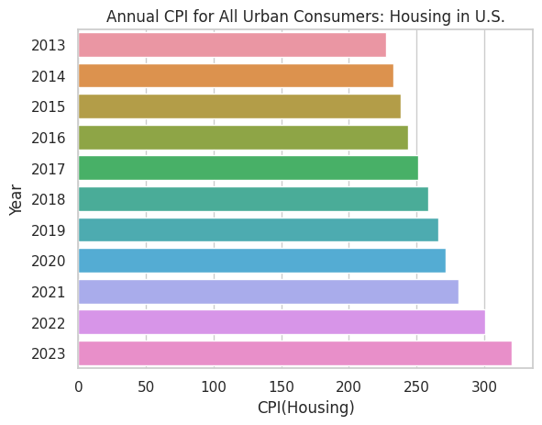

Fig 1. Annual CPI for Housing in the U.S.

1. Annual Consumer Price Index for medical care in the U.S.

The Medical expenses are one of the key factors in the economy of the nation and also the need of every citizen. Dataset containing CPI values for different years for analyzing the changes. The figure below shows the steady growth of medical care prices for the consumers which is consistently rising. After the COVID-19 pandemic there was an increase in the prices which rose suddenly. With the beginning of the year 2023, the CPI somehow stabilized and got its pace back. Although, in the month of December these prices got hyped to a great extent and rose the annual value unexpectedly.

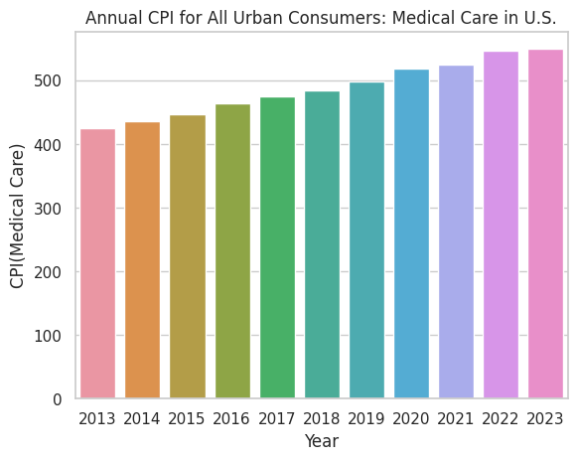

Fig 2. Annual CPI for Medical Care in the U.S.

1. Economic Indicators over time

There are many factors that affect the economy of the country which include unemployment rate, Producer Price Index(PPI) , Consumer Price Index(CPI), Import Price Index and others. There are two figures for this analysis of U.S. The data is of the last six months of 2023. Here these three indices have shown great fluctuations from rising in August to a great dip in the month of October.

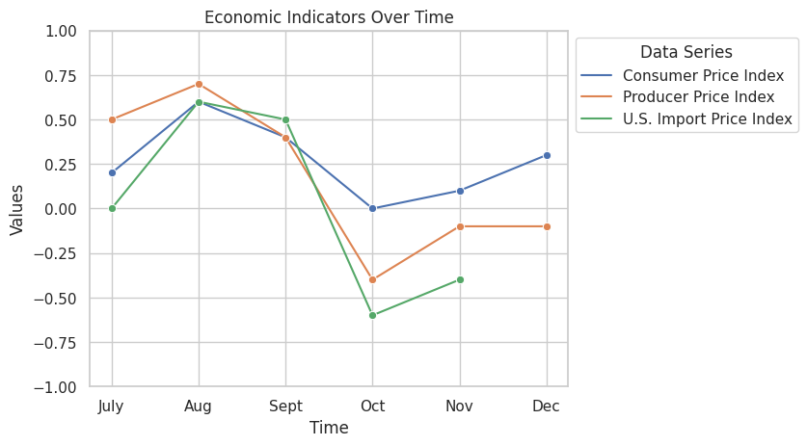

Fig 3. Economic indicators over time

The unemployment rate rose in the month of August and was consistent till October and dropped a little low during November.

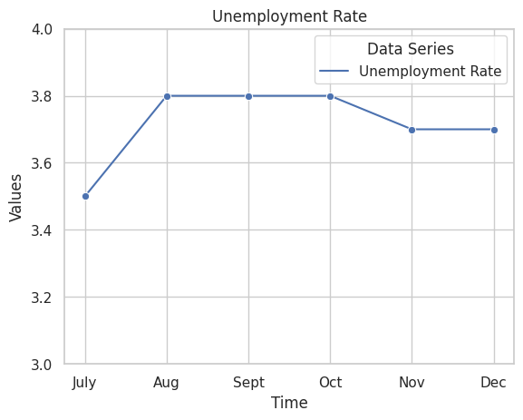

Fig 4. Unemployment rate over time

1. Inflation rate over the years

The figure below shows the rising inflation rates over the years with the highest increase from 2021 to 2022 that was caused due the COVID-19 pandemic and Russian-Ukraine war and shows a low increase in the year 2023.

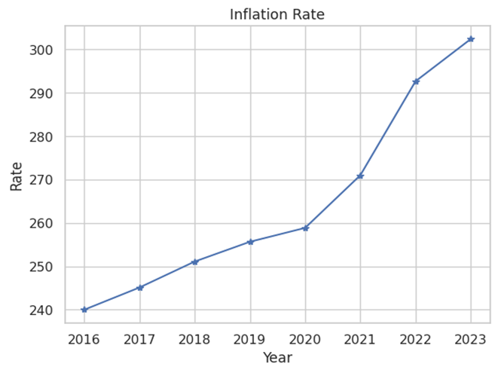

Fig 5. Inflation rate over the years

Limitations:-

* Dataset of economic indicators was considered for the last six months of the year 2023.
* The U.S. Import Index of December 2023 is not present in the dataset.
* Insights about services like food, fuel, energy and others are not considered here.
* The analysis does not contain information about the economic comparison of the U.S. with other countries.
* The CPI datasets contain information about the urban consumers only.

Conclusion:-

As discussed in the report, it is very well indicated that the inflation rate is rising continuously over the past few years. To reduce this inflation in the U.S., supply-side policy reforms should be implemented by the Congress. There should be some reduction in government spending and removal of obstruction to international supply. This would help the consumers to get access to cheaper goods and also increase the durability of supply chains. Inflation and CPI are major issues that need to be analyzed consistently over time to improve the economic growth of the country and the world as well.

References:-

* <https://www.jec.senate.gov/public/index.cfm/republicans/2022/11/policy-solutions-to-reduce-inflation>
* <https://www.enterpriseappstoday.com/stats/inflation-statistics-and-facts.html>
* <https://www.forbes.com/advisor/investing/cpi-consumer-price-index/>
* <https://economictimes.indiatimes.com/news/international/world-news/us-consumer-prices-rise-more-than-expected-in-december-weekly-jobless-claims-fall/articleshow/106735501.cms>
* <https://www.forbes.com/advisor/investing/current-inflation-rate/>