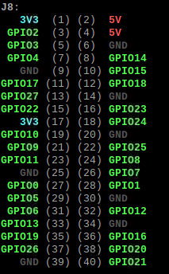

**PIR:**

GND -> pin 6

VCC -> pin 2

OUT -> pin 7 (GPIO4)

**Buzzer:** (through breadboard)

GND -> pin 14

OUT -> pin 10 (GPIO15)