**ROUTING**

R1

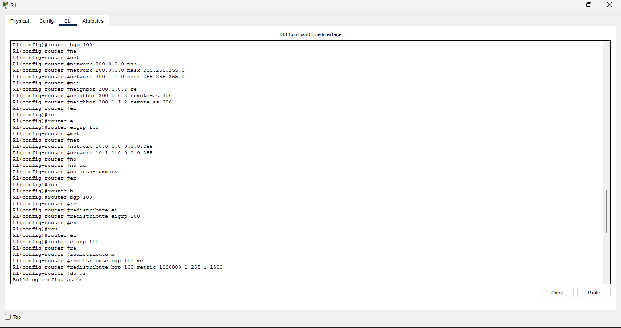

R1.1

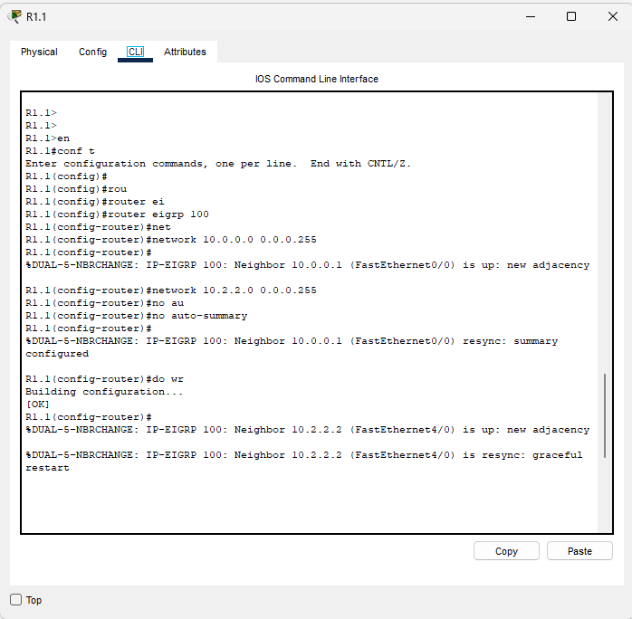

R1.2

R1.3

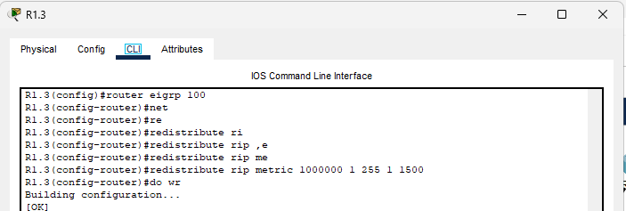

R2

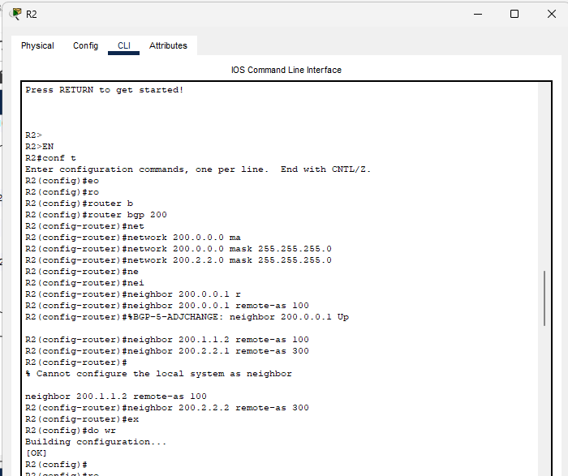

R2.1

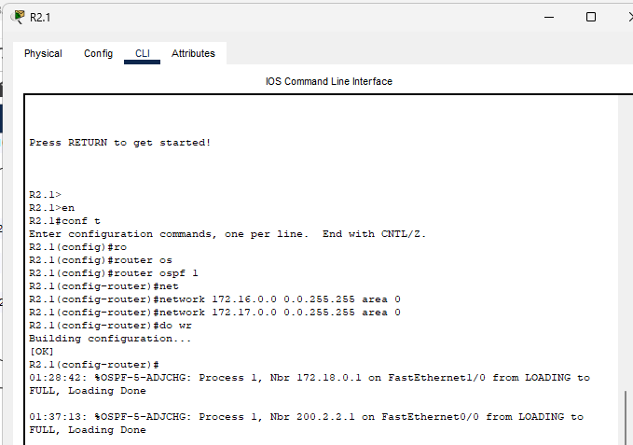

R2.2

R2.3

