Architecture Documentation

Karamel

created by

Dominik Damerow

We acknowledge that this document uses material from the arc 42 architecture
template, http://www.arc42.de. Created by Dr. Peter Hruschka & Dr. Gernot Starke.
.

Revision History

Version | Date | Reviser | Description
0.1 | 19.09.2014 | Dominik Damerow | initialized
1.0 | 09.12.2015 | Dominik Damerow | Inserted building blocks, decisions,...

Related documents

Document | Description
Table of Content
Architecture Documentation 1
Revision History 2
Related documents 2
1.Introduction and Goals 4
1.1Requirements Overview 4
1.2Quality Goals 4
1.3Stakeholders 4
2.Architecture Constraints 4
2.1Technical Constraints 4
2.2Organizational Constraints 5
3.System Scope and Context 5
3.1External Interfaces 5
4.Solution Strategy 5
5.Building Block View 5
5.1Level 1 5
6.Runtime View 1
7.Deployment View 1
8.Concepts 1
8.1Persistency 1
8.2User Interface 1
8.3Distribution 1
8.4Exception/Error Handling 1
9.Design Decisions 1
9.1Interop in own component 2
10.Quality Scenarios 2
10.1Quality Tree 2
10.2Evaluation Scenarios 2
11. Technical Risks 2
12.Glossary 3

Remark: The Microsoft-Word™ variant of this template contains hidden remarks and suggestions. You can toggle display of this text by the appropriate Word-command.

Introduction and Goals
The introduction to the architecture documentation should list the driving forces that software architects must consider in their decisions.
This includes on the one hand the fulfillment of functional requirements of the stakeholders, on the other hand the fulfillment of or compliance with required constraints, always in consideration of the architecture goals.
This section gives an overview on the requirements for which Karamel is implemented and shows some goals of the implementation.

Requirements Overview
Short description of the functional requirements.
Digest (or abstract) of the requirements documents.
Reference to complete requirements documents (incl. version identification and location).
Contents
A compact summary of the functional environment of the system. Answers the following questions (at least approximately):
- What happens in the system’s environment?
- Why should the system exist? Why is the system valuable or important? Which problems does the system solve?
Motivation
From the point of view of the end users a system is created or modified to improve execution of a business activity.
This essential architecture driver must not be neglected even though the quality of an architecture is mostly judged by its level of fulfillment of non-functional requirements.
Form
Short textual description, probably in tabular use-case format.
The business context should in any case refer to the corresponding requirements documents.
Examples
Short descriptions of the most important:
- business processes
- functional requirements
- non-functional requirements and other constraints (the most important ones must be covered as architecture goals or are listed in the “Constraints” section), and/or
- quantity structures
- background information
Here you can reuse parts of the requirements documents – but keep these excerpts short and balance readability against avoidance of redundancy.
Karamel is a Karaoke Player for private users but also for Karaoke bars. It provides an easy-to-use interface for beginners or private users but also some special functions for Karaoke bars.
Linked with Karamel, is a new Karaoke format that will also be playable by Karamel and is based on XML. The implementation of the player and the format will be open source, such that anybody can easily implement the playing functionality for their player.

Quality Goals
Here are the most important quality goals that Karamel tries to fulfill:
Quality | Goal
Usability | Inside a karaoke bar the typical user not only controls the player but also some technical equipment. It should be made as easy as possible for this operator to add new songs and announce new songs.
Performance | Import & Search are critical for a Karaoke Player and should be as fast as possible.
Reusability | At least the KML (kar-am-el) playing functionality should be highly reusable.

Stakeholders
Contents
A list of the most important persons or organizations that are affected by can contribute to the architecture.
Motivation
If you do not know the persons participating in or concerned with the project you may get nasty surprises later in the development process. Should your project manager maintain this list, make sure that all the people influencing the architecture are part of it.
Form
Simple table with role names, person names, their knowledge as pertaining to architecture, their availability, etc.
The developer of this player: Dominik Damerow

Architecture Constraints
Contents
Any requirement that constrains software architects in their freedom of design decisions or the development process.
Motivation
Architects should know exactly where they are free in their design decisions and where they must adhere to constraints.
Constraints must always be dealt with; they may be negotiable, though.
Form
Informal lists, structured by the sub-sections of this section.
Examples
see sub-sections
Background Information
In the optimal case constraints are defined by requirements. In any case, at least the architects must be aware of constraints.
The influence of constraints is described by [Hofmeister et al] (Software Architecture, A Practical Guide, Addison Wesley 1999) using the term “global analysis”.

Technical Constraints
Contents
List all technical constraints in this section. This category covers hard- and software infrastructure, applied technologies (operating systems, middleware, databases, programming languages, …).

Software-Constraints
<insert constraint here>
Operating System Constraints
The typical karaoke bar only has a low-end Windows laptop. Thus the application has to be executable in Windows.
Programming Constraints
The main programmer has his main experience in C# .NET.

Examples

Constraint | Description
Hardware infrastructure | Processors, memory, networks, firewalls and other relevant elements
Software infrastructure | Operating systems, database systems, middleware, communications systems, transaction monitors, web servers, directory services
System operations | Batch- or online operations of the system or of required external systems?
Availability of the runtime environment | Data center with 7x24 uptime?  Will there be service times that cause reduced availability of the system or important parts thereof?
Graphical user interface | Are there any restrictions related to GUI (style guide)?
Libraries, frameworks, components | Is there any COTS that must be used?
Programming languages | Object oriented, structured, declarative, or rule-based languages?  Compiled or interpreted languages?
Reference architectures | Are there any comparable or reusable reference projects in the organization?
Analysis and design methodologies | Object oriented or structured methodologies?
Data structures | Requirements for certain data structures, interfaces to existing databases or files?
Software interfaces | Interfaces to existing applications
Programming requirements | Programming guidelines, fixed program structure
Technical communications | synchronous or asynchronous; protocols

Organizational Constraints
Contents
Enter all organizational, structural, and resource-related constraints. This category also covers standards and legal constraints that you must comply with.

Resources (Budget, Time, Personnel)
Time | The application has to be programmed in the free time.
Personnel | The application has to be programmed by only one programmer.
Legal Factors
 | Check law on cdg playback and lyrics in XML.

Examples

Constraint | Description
Organization and Structure
Sponsor’s organizational structure | Potential changes of responsibilities?  Changes of contact persons?
Project team’s organizational structure | with/without subcontractors  decision-making power of the project manager
Decision makers | Experience with similar projects
Existing partnerships or co-operations | Are there any co-operations between the organizations and certain software companies?  Such partnerships often influence procurement decisions (independent of system requirements).
Internal development or outsourcing | Develop internally or outsource to external service companies?
Development of a product or for internal use? | Implies different processes in requirements analysis and decision making.  In the case of product development:  New product for a new market?  Improved product for an existing market?  Productizing of an existing (internal) system?  Development for internal use only?
Resources (Budget, Time, Personnel)
Fixed price or time/effort? | Is the project’s budget fixed or is it calculated by time or effort?
Schedule | Is the schedule flexible? Is there a fixed delivery date? Which stakeholders control the delivery date?
Schedule vs. functionality | What has higher priority: The delivery date or the functionality?
Release-schedule | At which dates should which functionality be available in which releases / versions?
Project’s budget | Fixed or flexible? What amount is available?
Budget for technical resources | Buy or rent development tools? (hardware and software)
Team | Number of team members, qualifications, motivation, availability.
Organizational Standards
Development process | Requirements concerning development process? This includes internal standards for modeling, documentation and implementation.
Quality standards | Is the organization required to adhere to quality standards (such as ISO-9000)?
Development tools | Requirements related to development tools (such as CASE-Tool, database, IDE, communications software, middleware, transaction monitor).
Configuration and version management | Requirements concerning processes and tools
Test tools and processes | Requirements concerning processes and tools
Acceptance- and release processes | Data modeling and database design  User interfaces  Business processes (workflow)  Usage of external systems (e.g. write access to external databases)
Service Level  Agreements | Requirements or standards related to availability or required service levels?
Legal Factors
Liability | Are there any legal aspects related to usage or operations of the system?  Could the system cause loss of human life or hazard to human health?  Could the system impact the operations of external systems or businesses?
Data privacy and security | Does the system store or process any data worthy of protection
Auditing | Are any aspects of the system under legal obligation to present evidence?
Aspects of international law | Will the system be used in an international context?  Are there varying constraints on system usage in different countries (example: use of encryption technology)?

System Scope and Context
Contents
The context view defines the boundaries of the system under development to distinguish it from neighboring systems. It thereby identifies the system’s relevant external interfaces.
Make sure that the interfaces are specified with all their relevant aspects (what is communicated, in which format is it communicated, what is the transport medium, …), even though some popular diagrams (such as the UML use case diagram) represent only a few aspects of the interface.
Motivation
The interfaces to neighboring systems are among most critical and risky aspects of a project. Ensure early on that you have understood them in their entirety.
Form
- Various context diagram (see below)
- Lists of neighboring systems and their interfaces.

External Interfaces
For many building blocks you can describe its interfaces directly in the black box template of the building block. For complex interfaces – and external interfaces are normally very complex – it is worth while to describe them in separate sections. Use the following interface template to guide you towards many questions that might be relevant for the interface.

Interface Id
Name | KCDGPlayer
Version | 1.0
Contact person | Kevin Lawson
Detailed information on this interface can be found in the KCDGPlayerInterfaceDescription.txt in Research\MediaPlayer.

Solution Strategy
Contents
A short summary and explanation of the fundamental solution ideas and strategies.
Motivation
An architecture is often based upon some key solution ideas or strategies. These ideas should be familiar to everyone involved into the architecture.
Form
Diagrams and / or text, as appropriate. Keep it short, i.e. 1 or 2 pages at most!

Building Block View
Contents
Static decomposition of the system into building blocks (modules, components, subsystems, subsidiary systems, classes, interfaces, packages, libraries, frameworks, layers, partitions, tiers, functions, macros, operations, data structures, …) and the relationships thereof.
Motivation
This is the most important view, that must be part of each architecture documentation. In building construction this would be the floor plan.
Form
The building block view is a hierarchical collection of black box and white box descriptions as shown in the following diagram:
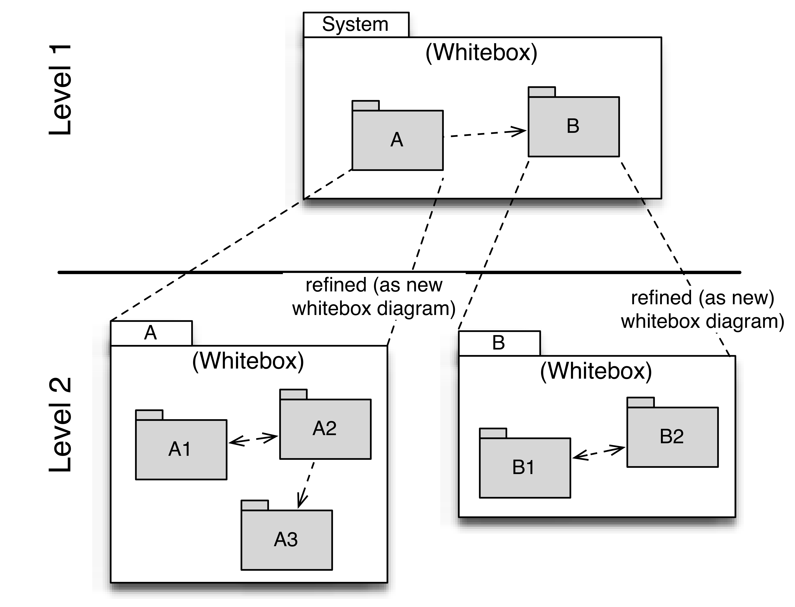
Level 1 contains the white box description of the overall system (system under development / SUD) made up of black box descriptions of the system’s building blocks.
Level 2 zooms into the building blocks of Level 1 and is thus made up of the white box descriptions of all building blocks of Level 1 together with the black box descriptions of the building blocks of Level 2.
Level 3 zooms into the building blocks of Level 2, etc.
The section is structured as follows:
============================
White Box Template:
Contains multiple building blocks with corresponding black box descriptions.
One or more black box templates:
Each building block appearing in the white box template should be described as follows:
- Purpose / Responsibility:
- Interface(s):
- Implemented requirements:
- Variability:
- Performance attributes:
- Repository / Files:
- Other administrative information: Author, Version, Date, Revision History
- Open issues:

Level 1
Here you describe the white box view of level 1 according to the white box template. The structure is given below.
The overview diagram describes the inner structure of the overall system in terms of building blocks 1 – n, as well as their relationships and interdependencies.
It is also useful to list the most important reasons that led to this structure, esp. as relevant to the interdependencies / relationships among the building blocks at this level.
You should also mention rejected alternatives incl. reasons for their rejection.
The following diagram shows the main building blocks of the system and their interdependencies:
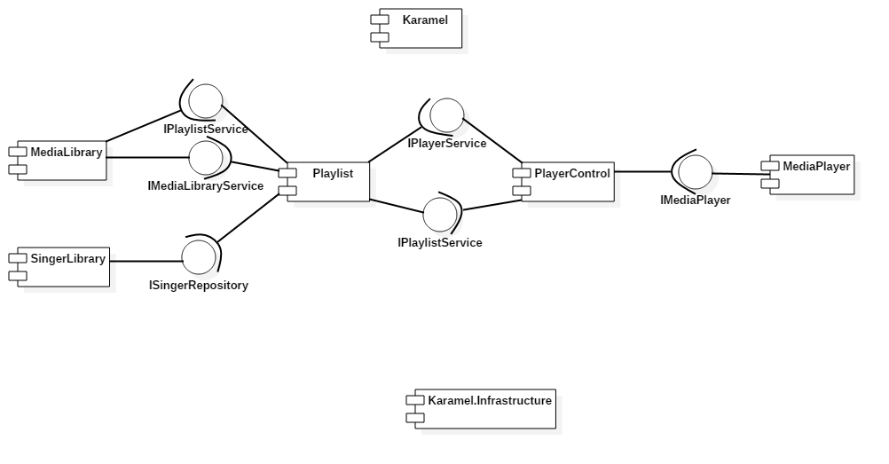
Comments regarding structure and interdependencies at Level 1:
The Karamel library is the starting point of the application and constructs all required components for the shell via PRISM (Unity).
The Karamel.Infrastructure library is used by every other library and only contains commonly used data types.

Media Library
Structure according to black box template:
- Purpose / Responsibility:
- Interface(s):
- Implemented requirements:
- Variability:
- Performance attributes:
- Repository / Files:
- Other administrative information: Author, Version, Date, Revision History
- Open issues:
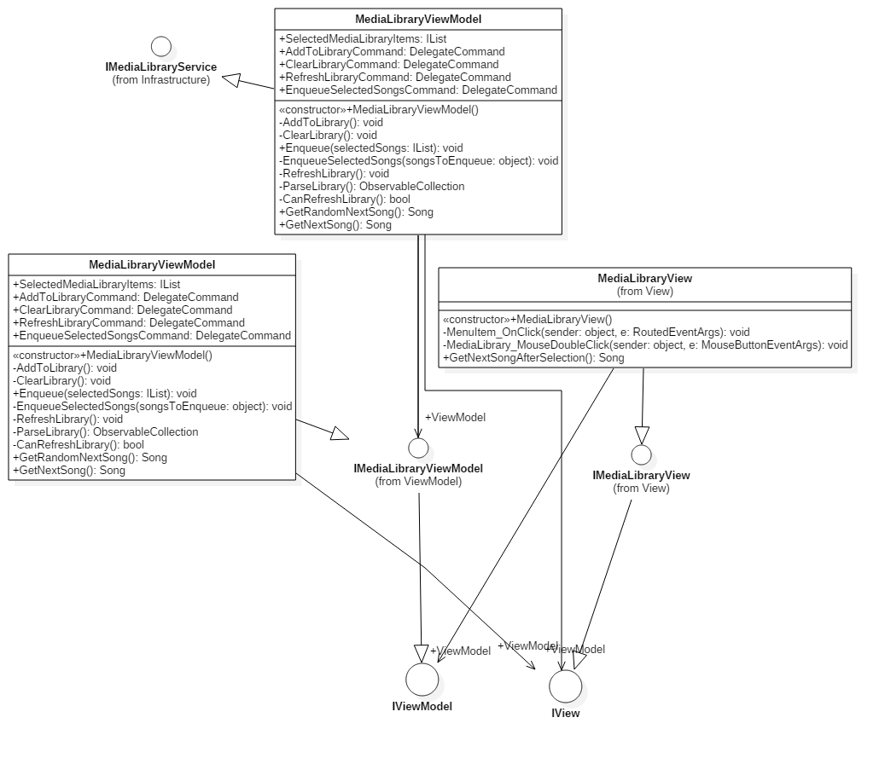
The class diagram for the MediaLibrary component is representative for all components that contain a view.
There is always one ViewModel derived from IViewModel or a more special ViewModel interface and always one View derived from IView or a more special interface.
Sometimes there is an additional class that implements the service and calls methods within the ViewModel.
Interactions between View and ViewModel are handled via Commands.

MediaPlayer
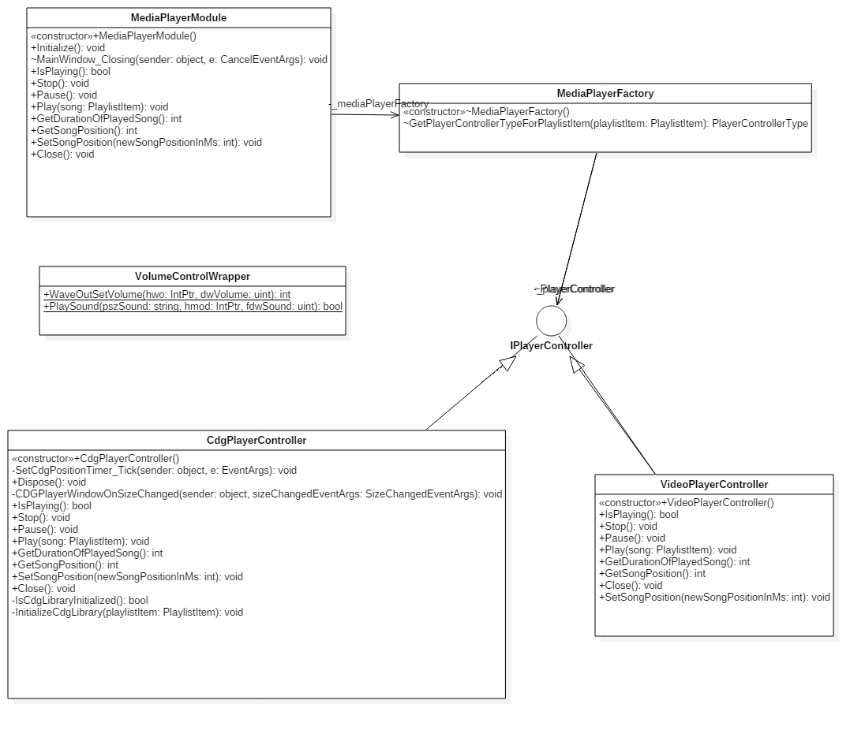
The MediaPlayer Module is the Module that was created to wrap the access to unmanaged libraries.
It contains the two possible players: a video player and the CDG player.
Both are hosted in the same Form and are created on demand by the MediaPlayerFactory.
The unmanaged windows volume control is also wrapped inside this component.

Playlist module
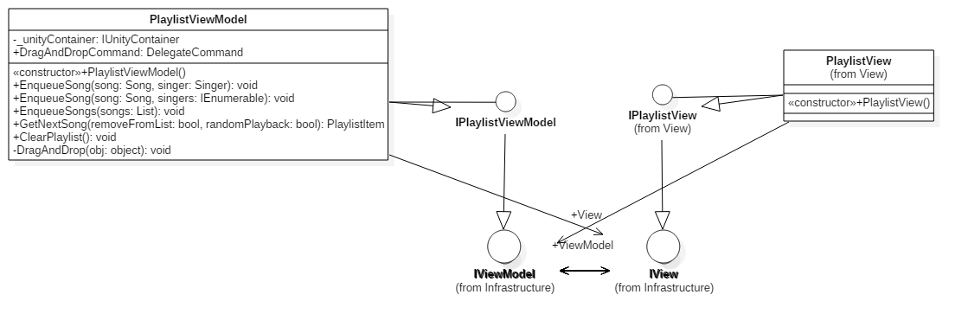
The Playlist Module is much like the MediaLibrary module. The Diagram shows that the IView contains an IViewModel and the IViewModel contains an IView.

Runtime View

Deployment View
The deployment view was omitted, since the program always runs on a single PC.
Contents
Additional deployment diagrams with similar structure as above, refining each node of infrastructure level 1 that needs more details to map the software blocks.
Motivation
To describe additional details of the infrastructure, as needed by software deployment.

Concepts
Contents
The following chapters cover examples of frequent cross-cutting concerns (a.k.a. aspects in some programming languages)
Fill in these chapters if there is NO building block that covers this aspect. If some of the concepts are not relevant for your project mention this fact instead of removing the section.
Motivation
Some concept cannot be “factored” into a separate building block of the architecture (e.g. the topic “security”). This section of the template is the location where you can describe all decision for such a cross cutting topic in one central place. Nevertheless, you have to make sure that all your building blocks conform to such decisions.
Form
.. can be varied. Some concepts are plain natural language text with a freely chosen structure, some others may include models/scenarios using notations that are also applied in architecture views.

Persistency
Persistency means moving data from (volatile) memory to a durable storage medium (and back).
Some of the data that a software system is processing must be written to and read from persistent storage media.
- Volatile storage media (main memory or cache) are not designed for permanent storage. Data is lost if the hardware is switched off.
- The amount of data processed by commercial software systems normally exceeds the capacity of main memory.
- Hard disks, optical media and tapes often contain large amounts of existing business data that represent a significant investment.
Persistency is a technical issue that normally does not appear as part of the actual business functionality. An architect must deal with this issue nevertheless because most software systems require efficient access to persistently stored data. This is relevant for essentially all commercial and most technical systems; embedded systems on the other hand often differ in their data management requirements.
Information on available media files is not being persisted at the moment. In future, the information will be persisted together with information on the singers. A simple database will be used in order to achieve this.

User Interface
Communication: Exchange of data between system components. Covers communications within one process or address space, between different processes (inter-process communication – IPC), and between different systems.
Integration: Combination of existing systems in a new context. Also known as: (Legacy) Wrapper, Gateway, Enterprise Application Integration (EAI).
The User Interface is a modern WPF interface that supports drag & drop and is closely modeled on other media players.

Distribution
Distribution: Design of software systems whose parts are executed on different – physically separated – hardware systems.
Distribution covers issues such as calling methods on remote systems (remote procedure call – RPC or remote method invocation – RMI), the transfer of data or documents among distributed parties, the choice of optimal modes of interaction or communications patterns (such as synchronous / asynchronous, publish-subscribe, peer-to-peer).
Karamel uses the NSIS installer. The installer should be kept as simple as possible.

Exception/Error Handling
How are exceptions and errors handled systematically and consistently?
How can the system reach a consistent state after an error? Is this done automatically or is manual interaction required?
This aspect is also related to logging and tracing,
Which kind of exceptions and errors are handled by the system? Which kinds of errors are forwarded to which external interface and which are handled fully internally?
How do you use the exception handling mechanisms of your programming language? Do you use checked or unchecked exceptions?
Most errors that occur will occur in the MediaPlayer component. The Player then shows an error message. Nothing will be logged. Some error handling is done by the KCDGPlayer internally. There is no way to change this.

Design Decisions
Contents
Document all important design decisions and their reasons!
Motivation
It is advantageous if all important design decisions can be found in one place. It is up to you to decide if a decision should be documented here or rather locally (e.g. in the white box descriptions of building blocks). In any case avoid redundancies.
Form
Informal list, if possible ordered by the decisions’ importance for the reader. Use the following template to structure your decisions.
9.x.1 Problem
What exactly is the challenge?
Why is it relevant for the architecture?
What consequences does the decision have?
9.x.2 Constraints
Which constraints do you have to keep in mind?
What factors influence the decision?
9.x.3 Assumptions
Which assumption have you made?
How can you check those assumptions?
Which risks are you facing?
9.x.4 Considered Alternatives
Which alternative options did you consider?
How do you judge each one?
Which alternatives are you excluding deliberately?
9.x.5 Decision
Who (if not you) has decided?
How has the decision been justified?
When did you decide?

Interop in own component

9.1.2 Constraints
An unmanaged CDG library had to be included in the component, since no managed library with the same features was available.

9.1.3 Assumptions
Using this unmanaged library is likely to be a source of errors.

9.1.4 Considered Alternatives
a) using an own component to wrap the unmanaged library
b) using a class to wrap the library

9.1.5 Decision
It was decided to use an own component. This makes it possible to choose another CDG library lateron and reduces the risk of including this library minimal.

Quality Scenarios
This chapter summarizes all you (or other stakeholders) might need to systematically evaluate the architecture against the quality requirements.
It contains:
- Quality Tree (sometimes called utility tree), an overview of the quality requirements
- Evaluation or quality scenarios - detailed descriptions of the quality requirements or goals.

Quality Tree
Content
The quality tree ( as defined in ATAM – Architecture Tradeoff Analysis Method) with quality / evaluation scenarios as leafs.
Motivation
When you want to evaluate the quality (especially risks to certain quality attributes) with methods like ATAM, you need to systematically refine your quality goals (from chapter 1.2). The quality tree shows the top-down refinement of the stakeholder-specific notion of quality.
Form
We personally prefer mind maps to a pure tree-like structure, as mind maps allow arbitrary cross-references between scenarios, attributes and intermediate nodes.
Often it is difficult to assign scenarios to single quality attributes, as the scenario refers to several qualities at once. Simply draw references from such scenarios to all affected nodes!

Evaluation Scenarios
Contents
Scenarios describe a system’s reaction to a stimulus in a certain situation. They thus characterize the interaction between stakeholders and the system. Scenarios operationalize quality criteria and turn them into measurable quantities.
Two scenarios are relevant for most software architects:
- Usage scenarios (also called application scenarios or use case scenarios) the system’s runtime reaction to a certain stimulus. This also includes scenarios that describe the system’s efficiency or performance. Example: The system reacts to a user’s request within one second.
- Change scenarios describe a modification of the system or of its immediate environment. Example: Additional functionality is implemented or requirements for a quality attribute change.
If you design safety critical systems a third type of scenarios is important for you:
- Boundary or stress scenarios describe how the system reacts to exceptional conditions. Examples: How does the system react to a complete power outage, a serious hardware failure, etc.
Source of
the Stimulus
System
artifact
Response measure
Stimulus
Response

Figure: Schematic depiction of scenarios (cf. [Bass+03])
Scenarios comprise the following major parts (according to [Starke05], original structure from [Bass+03]):
- Stimulus: Describes a specific interaction between the (stimulating) stakeholder and the system. Example: A user calls a functions, a developer implements an extension, an administrator installs or configures the system.
- Source of the stimulus: Describes where the stimulus comes from. Examples: internal or external, user, operator, attacker, manager.
- Environment: Describes the system’s state at the time of arrival of the stimulus. This should list all preconditions that are necessary for comprehension of the scenario. Examples: Is the system under normal or maximal load? Is the data base available or down? Are any users online?
- System artifact: Describes the part of the system is affected by the stimulus. Examples: The whole system, the data base, the web server.
- System response: Describes the system’s reaction to the stimulus as determined by the architecture. Examples: Is the function called by the user executed. How long does the developer need for implementation? Which parts of the system are affected by the installation / configuration?
- Response measure: Describes how the response can be measured or evaluated. Examples: Downtime in hours, correctness yes/no, time for code change in person days, reaction time in seconds.
Motivation
You need scenarios for the evaluation and review of architectures. They take the role of a “benchmark” and aid in measuring the architecture’s achievement of its objectives regarding the non-functional requirements and quality attributes.
Form
Tabular or free text. Explicitly highlight the scenario’s elements (source, environment, artifact, response, measure).
Alternatively, use similar notations as those suggested in 6. Runtime View.
Background Information
There are relations between scenarios and the runtime view. Often you can use scenarios of the runtime view fully or as a basis for evaluation. Evaluation scenarios additionally contain response measures that are often not considered in the pure execution focus of runtime scenarios.
- The controller inside a karaoke bar should be able to add a new song in below 15 seconds.
- The search for a song should be executable in a second even for large song databases (>30 GB)
- The import of a large song database (>30 GB) should be possible in under 1 minute.
- A new user should be able to control the simple interface without any instructions
- A new user should be able to control the karaoke-bar interface after a 1 minute instruction or after reading a one side tutorial.
- A programmer should be able to reuse the playing capability of the KML player in his or her own player nearly effortless.

Technical Risks
The biggest risks come up where the programmer has no experience up to now. On one hand, there is the database which should be very lightweight – while the programmer only has experience in MS-SQL Server, on the other hand, there is the WPF GUI with which the programmer has next to no experience.
Considering the KML format there are legal risks which have to be cleared. Is it allowed to not only enter the lyrics of a song inside a human readable file, but also supply other people with this file.
Contents
A list of identified technical risks, ordered by priority
Motivation
“Risk management is project management for grown-ups” (Tim Lister, Atlantic Systems Guild.) This should be your motto for systematic detection and evaluation of technical risks in the architecture, which will be needed by project management as part of the overall risk analysis.
Form
List of risks with probability of occurrence, amount of damage, options for risk avoidance or risk mitigation, …

Glossary
CDG - Compact Disc plus Graphic
Contents
The most important terms of the software architecture in alphabetic order.
Motivation
It should not be necessary to explain the usefulness of a glossary …
Form
A simple table with columns <Term> and <Definition>

