**TetraDENSITY 2.0 – Supplementary Information**

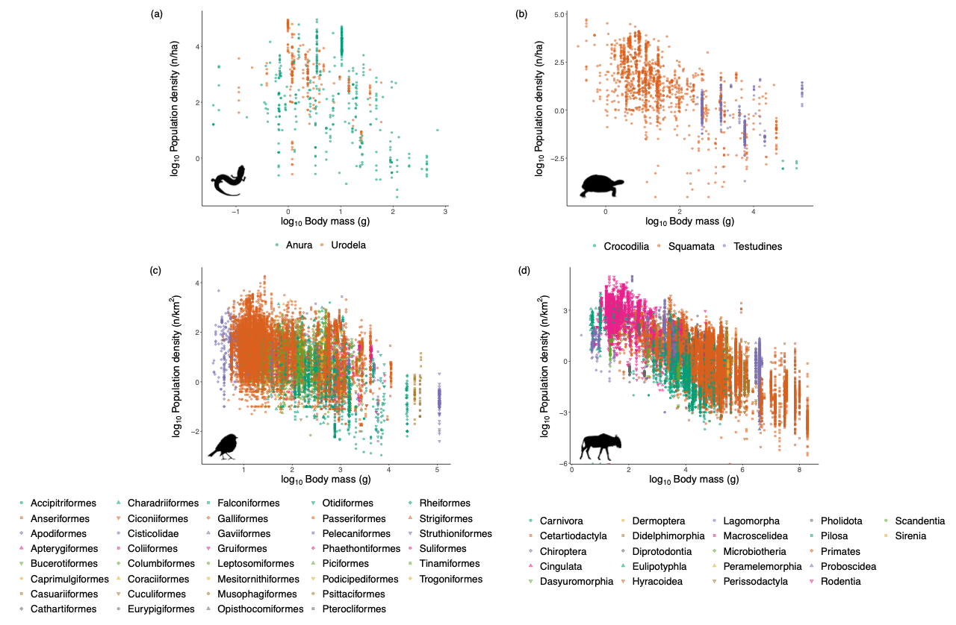**Fig. S1.** Relationship between log10-transformed body mass and log10-transformed population density for (a) amphibians, (b) reptiles, (c) birds and (d) mammals. Body mass data for amphibians are obtained using the allometric formulas in Santini et al. (2018) using SVL data from AmphiBIO database (Oliveira et al., 2017). Other body mass data were retrieved from the Amniote database for reptiles (Myhrvold et al., 2015), from Avonet database for birds (Tobias et al., 2022), and from PanTHERIA database for mammals (Jones et al., 2009).

**References**

Jones, K. E., Bielby, J., Cardillo, M., Fritz, S. A., O’Dell, J., Orme, C. D. L., Safi, K., Sechrest, W., Boakes, E. H., Carbone, C., Connolly, C., Cutts, M. J., Foster, J. K., Grenyer, R., Habib, M., Plaster, C. A., Price, S. A., Rigby, E. A., Rist, J., … Michener, W. K. (2009). PanTHERIA: a species-level database of life history, ecology, and geography of extant and recently extinct mammals. *Ecology*, *90*(9), 2648.

Myhrvold, N. P., Baldridge, E., Chan, B., Freeman, D. L., & Ernest, S. K. M. (2015). An amniote life-history database to perform comparative analyses with birds, mammals, and reptiles. *Ecology*, *96*(11), 3109. https://doi.org/10.5061/dryad.t6m96

Oliveira, B. F., São-Pedro, V. A., Santos-Barrera, G., Penone, C., & Costa, G. C. (2017). AmphiBIO, a global database for amphibian ecological traits. *Scientific Data*, *4*, 170123. https://doi.org/10.1038/sdata.2017.123

Santini, L., BenÍtez-LÓpez, A., Ficetola, G. F., & Huijbregts, M. A. J. (2018). Length–mass allometries in amphibians. *Integrative Zoology*, *13*(1), 36–45. https://doi.org/10.1111/1749-4877.12268

Tobias, J. A., Sheard, C., Pigot, A. L., Devenish, A. J., Yang, J., Sayol, F., Neate-Clegg, M. H., Alioravainen, N., Weeks, T. L., Barber, R. A., Walkden, P. ., MacGregor, H. E. A., Jones, S. E. I., Vincent, C., Phillips, A. G., Marples, N. M., Montaño-Centellas, F. A., Leandro-Silva, V., Claramunt, S., … Schleuning, M. (2022). AVONET: morphological, ecological and geographical data for all birds. *Ecology Letters*, *5*(3), 581–597.