**Consumer-Complaints**

# coding: utf-8

# In[1]:

import pandas as pd

df = pd.read_csv(r'C:\Users\akasriva2\Downloads\Consumer_Complaints.csv')

df.head()

# In[2]:

df = df[pd.notnull(df['Consumer complaint narrative'])]

# In[3]:

df.info()

# In[4]:

col = ['Product', 'Consumer complaint narrative']

df = df[col]

# In[5]:

df.columns

Index(['Product', 'Consumer complaint narrative'], dtype='object')

# In[6]:

df.columns = ['Product', 'Consumer_complaint_narrative']

# In[7]:

df['category_id'] = df['Product'].factorize()[0]

from io import StringIO

category_id_df = df[['Product', 'category_id']].drop_duplicates().sort_values('category_id')

category_to_id = dict(category_id_df.values)

id_to_category = dict(category_id_df[['category_id', 'Product']].values)

# In[8]:

df.head()

# In[9]:

import matplotlib.pyplot as plt

fig = plt.figure(figsize=(8,6))

df.groupby('Product').Consumer_complaint_narrative.count().plot.bar(ylim=0)

plt.show()

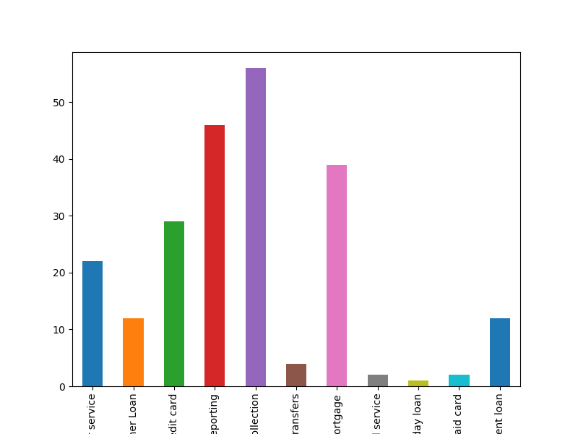

# In[10]:

from sklearn.feature_extraction.text import TfidfVectorizer

tfidf = TfidfVectorizer(sublinear_tf=True, min_df=5, norm='l2', encoding='latin-1', ngram_range=(1, 2), stop_words='english')

features = tfidf.fit_transform(df.Consumer_complaint_narrative).toarray()

labels = df.category_id

features.shape

# In[11]:

from sklearn.feature_selection import chi2

import numpy as np

N = 2

for Product, category_id in sorted(category_to_id.items()):

features_chi2 = chi2(features, labels == category_id)

indices = np.argsort(features_chi2[0])

feature_names = np.array(tfidf.get_feature_names())[indices]

unigrams = [v for v in feature_names if len(v.split(' ')) == 1]

bigrams = [v for v in feature_names if len(v.split(' ')) == 2]

print("# '{}':".format(Product))

print(" . Most correlated unigrams:\n . {}".format('\n . '.join(unigrams[-N:])))

print(" . Most correlated bigrams:\n . {}".format('\n . '.join(bigrams[-N:])))

# 'Bank account or service':

. Most correlated unigrams:

. funds

. overdraft

. Most correlated bigrams:

. 20 00

. closed account

# 'Consumer Loan':

. Most correlated unigrams:

. ally

. vehicle

. Most correlated bigrams:

. 00 xxxx

. received xxxx

# 'Credit card':

. Most correlated unigrams:

. annual

. card

. Most correlated bigrams:

. months later

. credit card

# 'Credit reporting':

. Most correlated unigrams:

. equifax

. experian

. Most correlated bigrams:

. information credit

. credit report

# 'Debt collection':

. Most correlated unigrams:

. collection

. debt

. Most correlated bigrams:

. collection agency

. debt collector

# 'Money transfers':

. Most correlated unigrams:

. buyer

. attention

. Most correlated bigrams:

. sent xxxx

. mortgage company

# 'Mortgage':

. Most correlated unigrams:

. modification

. mortgage

. Most correlated bigrams:

. short sale

. mortgage loan

# 'Other financial service':

. Most correlated unigrams:

. worked

. support

. Most correlated bigrams:

. score xxxx

. bank america

# 'Payday loan':

. Most correlated unigrams:

. finance

. principal

. Most correlated bigrams:

. xxxx month

. xxxx loan

# 'Prepaid card':

. Most correlated unigrams:

. faxed

. ability

. Most correlated bigrams:

. credit card

. federal law

# 'Student loan':

. Most correlated unigrams:

. repayment

. navient

. Most correlated bigrams:

. make payments

. student loan

# In[12]:

from sklearn.model_selection import train_test_split

from sklearn.feature_extraction.text import CountVectorizer

from sklearn.feature_extraction.text import TfidfTransformer

from sklearn.naive_bayes import MultinomialNB

X_train, X_test, y_train, y_test = train_test_split(df['Consumer_complaint_narrative'], df['Product'], random_state = 0)

count_vect = CountVectorizer()

X_train_counts = count_vect.fit_transform(X_train)

tfidf_transformer = TfidfTransformer()

X_train_tfidf = tfidf_transformer.fit_transform(X_train_counts)

clf = MultinomialNB().fit(X_train_tfidf, y_train)

# In[13]:

print(clf.predict(count_vect.transform(["This company refuses to provide me verification and validation of debt per my right under the FDCPA. I do not believe this debt is mine."])))

['Debt collection']

# In[14]:

df[df['Consumer_complaint_narrative'] == "This company refuses to provide me verification and validation of debt per my right under the FDCPA. I do not believe this debt is mine."]

|  | **Product** | **Consumer_complaint_narrative** | **category_id** |
| --- | --- | --- | --- |
| **12** | Debt collection | This company refuses to provide me verificatio... | 2 |

# In[15]:

from sklearn.linear_model import LogisticRegression

from sklearn.ensemble import RandomForestClassifier

from sklearn.naive_bayes import MultinomialNB

from sklearn.svm import LinearSVC

from sklearn.model_selection import cross_val_score

models = [

RandomForestClassifier(n_estimators=200, max_depth=3, random_state=0),

LinearSVC(),

MultinomialNB(),

LogisticRegression(random_state=0),

]

CV = 5

cv_df = pd.DataFrame(index=range(CV * len(models)))

entries = []

for model in models:

model_name = model.__class__.__name__

accuracies = cross_val_score(model, features, labels, scoring='accuracy', cv=CV)

for fold_idx, accuracy in enumerate(accuracies):

entries.append((model_name, fold_idx, accuracy))

cv_df = pd.DataFrame(entries, columns=['model_name', 'fold_idx', 'accuracy'])

# In[16]:

import seaborn as sns

sns.boxplot(x='model_name', y='accuracy', data=cv_df)

sns.stripplot(x='model_name', y='accuracy', data=cv_df,

size=8, jitter=True, edgecolor="gray", linewidth=2)

plt.show()

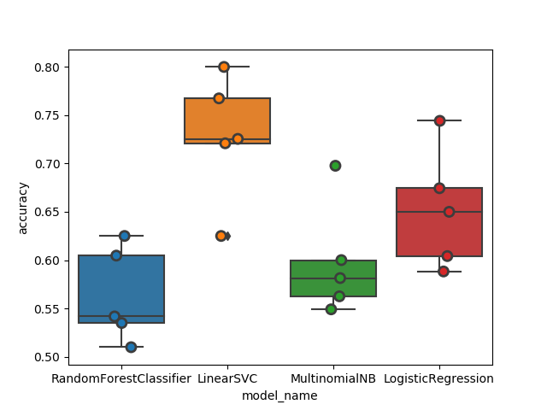

# In[17]:

cv_df.groupby('model_name').accuracy.mean()

model_name

LinearSVC 0.727772

LogisticRegression 0.652201

MultinomialNB 0.598118

RandomForestClassifier 0.563201

Name: accuracy, dtype: float64