**Fruits-Color Text-Classification**

# coding: utf-8

# In[1]:

import numpy as np

import pandas as pd

import matplotlib.pyplot as plt

# In[2]:

fruits = pd.read_table(r'C:\Users\akasriva2\Music\Analysis\fruit_data.txt')

fruits.head()

# In[3]:

print(fruits['fruit_name'].unique())

# In[4]:

print(fruits.shape)

# In[5]:

print(fruits.groupby('fruit_name').size())

# In[6]:

import seaborn as sns

sns.countplot(fruits['fruit_name'],label="Count")

plt.show()

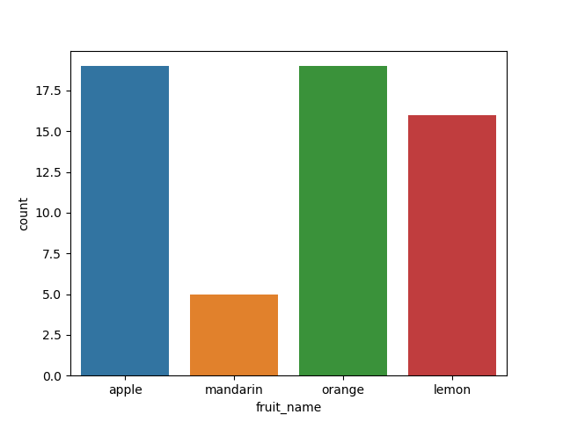

# In[7.1]

fruits.drop('fruit_label', axis=1).plot(kind='box', subplots=True, layout=(2,2), sharex=False, sharey=False, figsize=(9,9),

title='Box Plot for each input variable')

plt.savefig('fruits_boxplot')

plt.show()

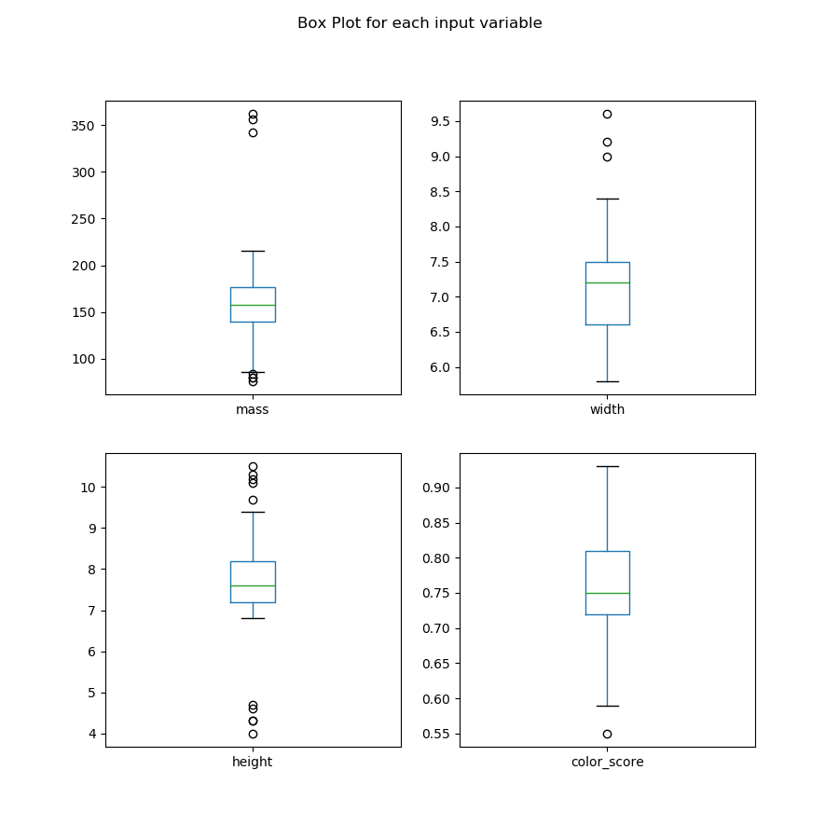

# In[7.2]:

import pylab as pl

fruits.drop('fruit_label' ,axis=1).hist(bins=30, figsize=(9,9))

pl.suptitle("Histogram for each numeric input variable")

plt.savefig('fruits_hist')

plt.show()

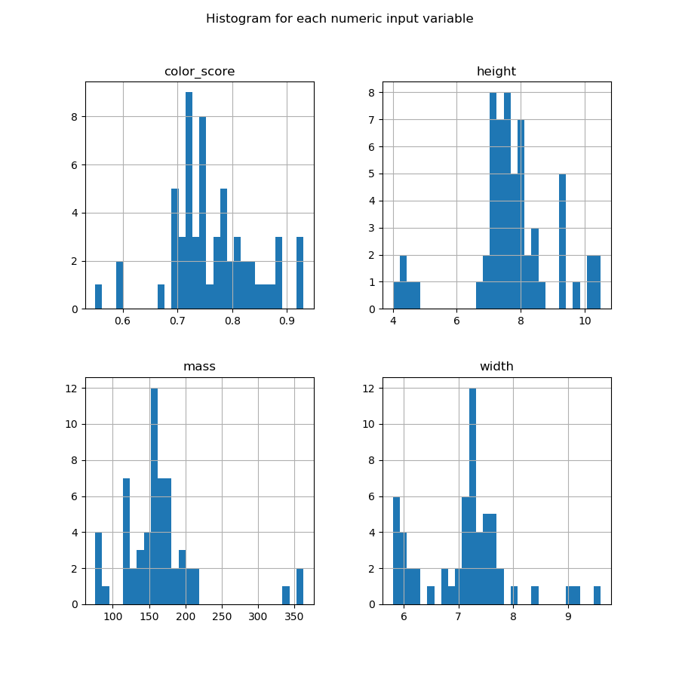

# In[7.3]:

feature_names = ['mass', 'width', 'height', 'color_score']

X = fruits[feature_names]

y = fruits['fruit_label']

# In[8]:

from sklearn.model_selection import train_test_split

X_train, X_test, y_train, y_test = train_test_split(X, y, random_state=0)

# In[9]:

from sklearn.preprocessing import MinMaxScaler

scaler = MinMaxScaler()

X_train = scaler.fit_transform(X_train)

X_test = scaler.transform(X_test)

**// Logistic Regression**

# In[10]:

from sklearn.linear_model import LogisticRegression

logreg = LogisticRegression()

logreg.fit(X_train, y_train)

print('Accuracy of Logistic regression classifier on training set: {:.2f}'

.format(logreg.score(X_train, y_train)))

print('Accuracy of Logistic regression classifier on test set: {:.2f}'

.format(logreg.score(X_test, y_test)))

Accuracy of Logistic regression classifier on training set: 0.70

Accuracy of Logistic regression classifier on test set: 0.40

**// Decision Tree**

# In[11]:

from sklearn.tree import DecisionTreeClassifier

clf2 = DecisionTreeClassifier(max_depth=3).fit(X_train, y_train)

print('Accuracy of Decision Tree classifier on training set: {:.2f}'

.format(clf2.score(X_train, y_train)))

print('Accuracy of Decision Tree classifier on test set: {:.2f}'

.format(clf2.score(X_test, y_test)))

Accuracy of Decision Tree classifier on training set: 1.00

Accuracy of Decision Tree classifier on test set: 0.87

**// KNN**

# In[13]:

from sklearn.neighbors import KNeighborsClassifier

knn = KNeighborsClassifier()

knn.fit(X_train, y_train)

print('Accuracy of K-NN classifier on training set: {:.2f}'

.format(knn.score(X_train, y_train)))

print('Accuracy of K-NN classifier on test set: {:.2f}'

.format(knn.score(X_test, y_test)))

Accuracy of K-NN classifier on training set: 0.95

Accuracy of K-NN classifier on test set: 1.00

**// LDA**

# In[14]:

from sklearn.discriminant_analysis import LinearDiscriminantAnalysis

lda = LinearDiscriminantAnalysis()

lda.fit(X_train, y_train)

print('Accuracy of LDA classifier on training set: {:.2f}'

.format(lda.score(X_train, y_train)))

print('Accuracy of LDA classifier on test set: {:.2f}'

.format(lda.score(X_test, y_test)))

Accuracy of LDA classifier on training set: 0.86

Accuracy of LDA classifier on test set: 0.67

**// GaussianNB**

# In[15]:

from sklearn.naive_bayes import GaussianNB

gnb = GaussianNB()

gnb.fit(X_train, y_train)

print('Accuracy of GNB classifier on training set: {:.2f}'

.format(gnb.score(X_train, y_train)))

print('Accuracy of GNB classifier on test set: {:.2f}'

.format(gnb.score(X_test, y_test)))

Accuracy of GNB classifier on training set: 0.86

Accuracy of GNB classifier on test set: 0.67

**// SVM**

# In[16]:

from sklearn.svm import SVC

svm = SVC()

svm.fit(X_train, y_train)

print('Accuracy of SVM classifier on training set: {:.2f}'

.format(svm.score(X_train, y_train)))

print('Accuracy of SVM classifier on test set: {:.2f}'

.format(svm.score(X_test, y_test)))

Accuracy of SVM classifier on training set: 0.61

Accuracy of SVM classifier on test set: 0.33

//Confusion Matrix

# In[17]:

from sklearn.metrics import classification_report

from sklearn.metrics import confusion_matrix

pred = knn.predict(X_test)

print(confusion_matrix(y_test, pred))

print(classification_report(y_test, pred))

[[4 0 0 0]

[0 1 0 0]

[0 0 8 0]

[0 0 0 2]]

precision recall f1-score support

1 1.00 1.00 1.00 4

2 1.00 1.00 1.00 1

3 1.00 1.00 1.00 8

4 1.00 1.00 1.00 2

avg / total 1.00 1.00 1.00 15